Mon/5/19/2025 | Day #4 of Civil Rights Movement 2

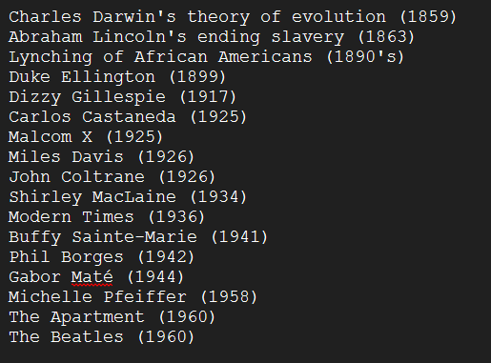

DJ Kumislime plays Michael Jackson’s XSCAPE, his album from 2014: @michaeljackson @YouTube: https://www.youtube.com/watch?v=GJDdBbgJafU&list=OLAK5uy_mQD3ABC6DOFqo0sV3PjlOt-NCwXs54U40

DJ Kumislime plays Buffy Sainte-Marie’s Starwalker: @BuffySteMarie @youtubemusic: https://music.youtube.com/watch?v=xlc0vsfmPuE&si=BUh2bueyE8_uSZHC

Sleep: 1) Regulates emotions, 2) Organizes information, and 3) Builds immune system.

DJ Kumislime plays Madonna’s American Life, her album from 2003: @Madonna @youtubemusic: https://music.youtube.com/playlist?list=OLAK5uy_kWjCTtJ6NaknPZK-MlY4ax3VaZiMX6Cd0&si=XHOIX8PMos6KDVnp

DJ Kumislime plays a playlist @youtubemusic: Joseph Hyden Piano Trio: https://music.youtube.com/playlist?list=PLT7degVqvonmW5IHyoq-zlXONljSaLIIw&feature=shared

DJ Kumislime plays Cardynal’s Practice @YouTube: https://youtu.be/fRAilxkUiME?feature=shared