Git SHH报错
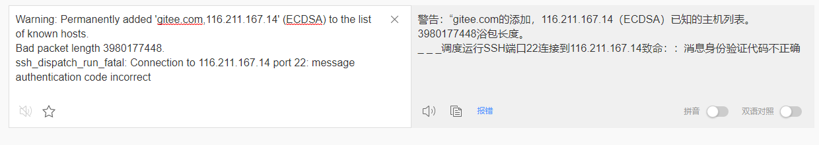
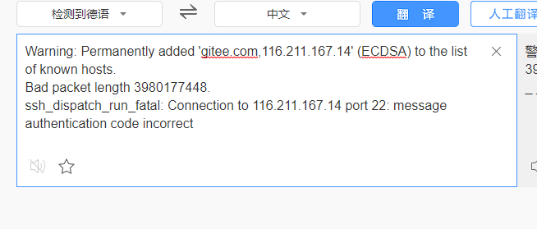
https://blog.csdn.net/jingtingfengguo/article/details/51892864

