Nevada’s young adults face a vastly different set of challenges than those faced by older generations. Many are starting their careers in the midst of the economic turmoil caused by the COVID-19 pandemic, while others are experiencing disruptions in their educations. Mental health issues among youth, especially anxiety and depression, have grown increasingly prevalent over the past decade.[1] Climate change threatens to transform the economy and introduce a range of new risks to the health and well-being of today’s youth.

The political priorities of America’s youth reflect these challenges. Results of the Fall 2020 Harvard Youth Poll showed that young Americans (aged 18 to 29) found healthcare, mental health, and education their most significant current struggles.[2] More than 70 percent of survey respondents stated that the government should be doing more to address healthcare issues, improve mental health services, address systemic racism, and address environmental issues.

Young people represent a growing proportion of the eligible voter population, and even those who cannot vote have the opportunity to impact public policy through other forms of activism and involvement with the policymaking process. This brief presents data on some of the key issues affecting Nevada’s youth, including the economy, health, and climate change.

# Youth and the Economy

In 2019, approximately 7.9 percent of Nevada’s workforce aged 20 to 24 was unemployed. This is higher than the unemployment rate for any older age group and higher than the statewide average 2019 unemployment rate of 4.0 percent.[3] Nationally, individuals under the age of 25 experienced unemployment related to the pandemic at much higher rates than those over the age of 25.

## Poverty by Age and Urban/Rural Divide

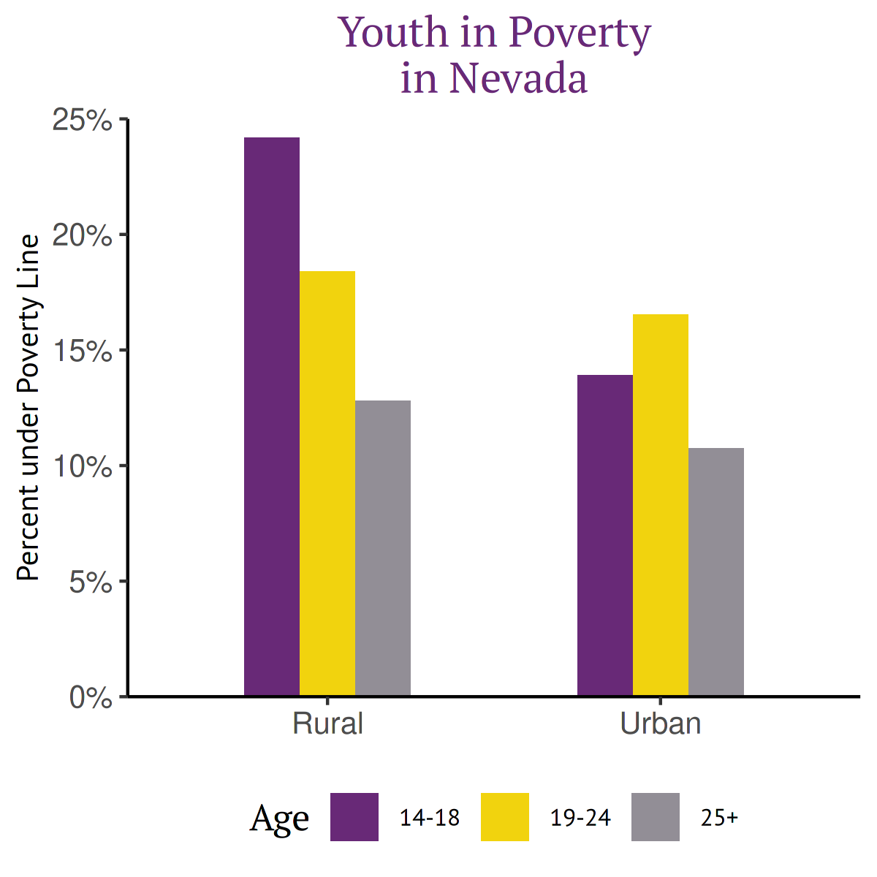

## Poverty by Age and Race

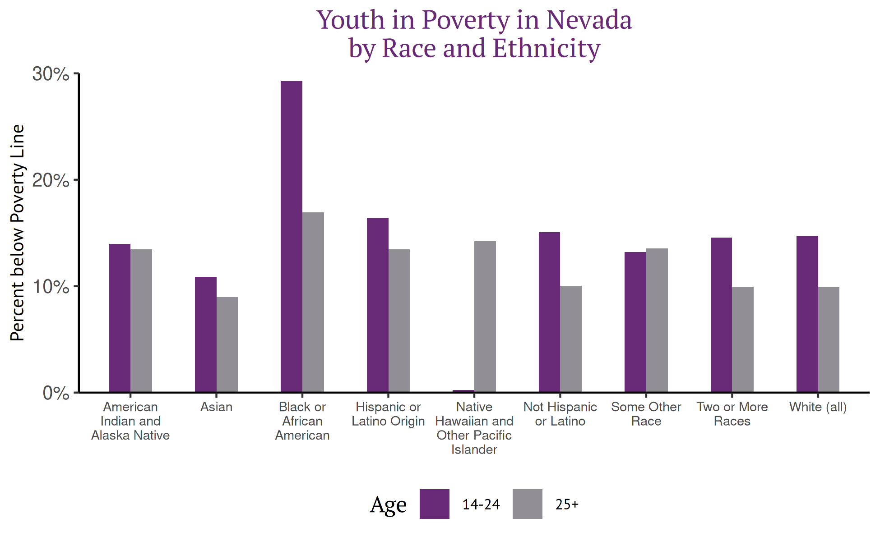

# Youth Health

## Lack of Health Insurance by Age and Urban/Rural Divide

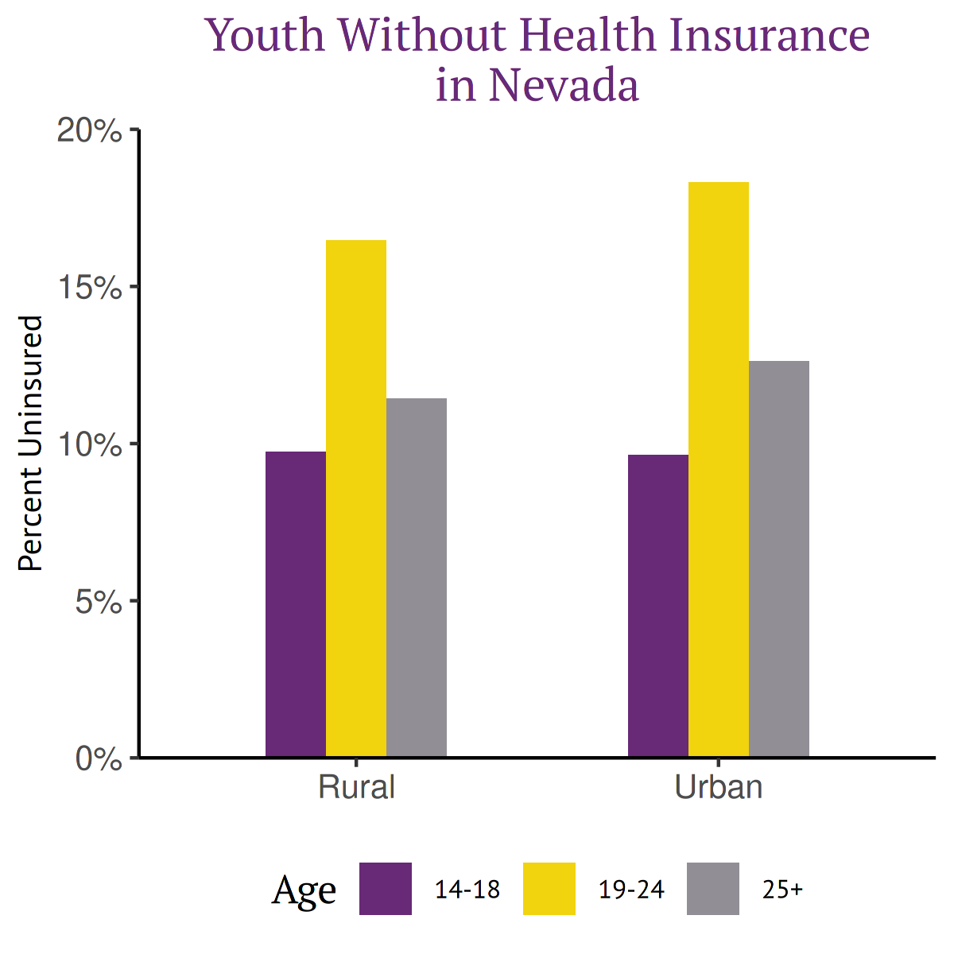

## Lack of Health Insurance by Age and Race

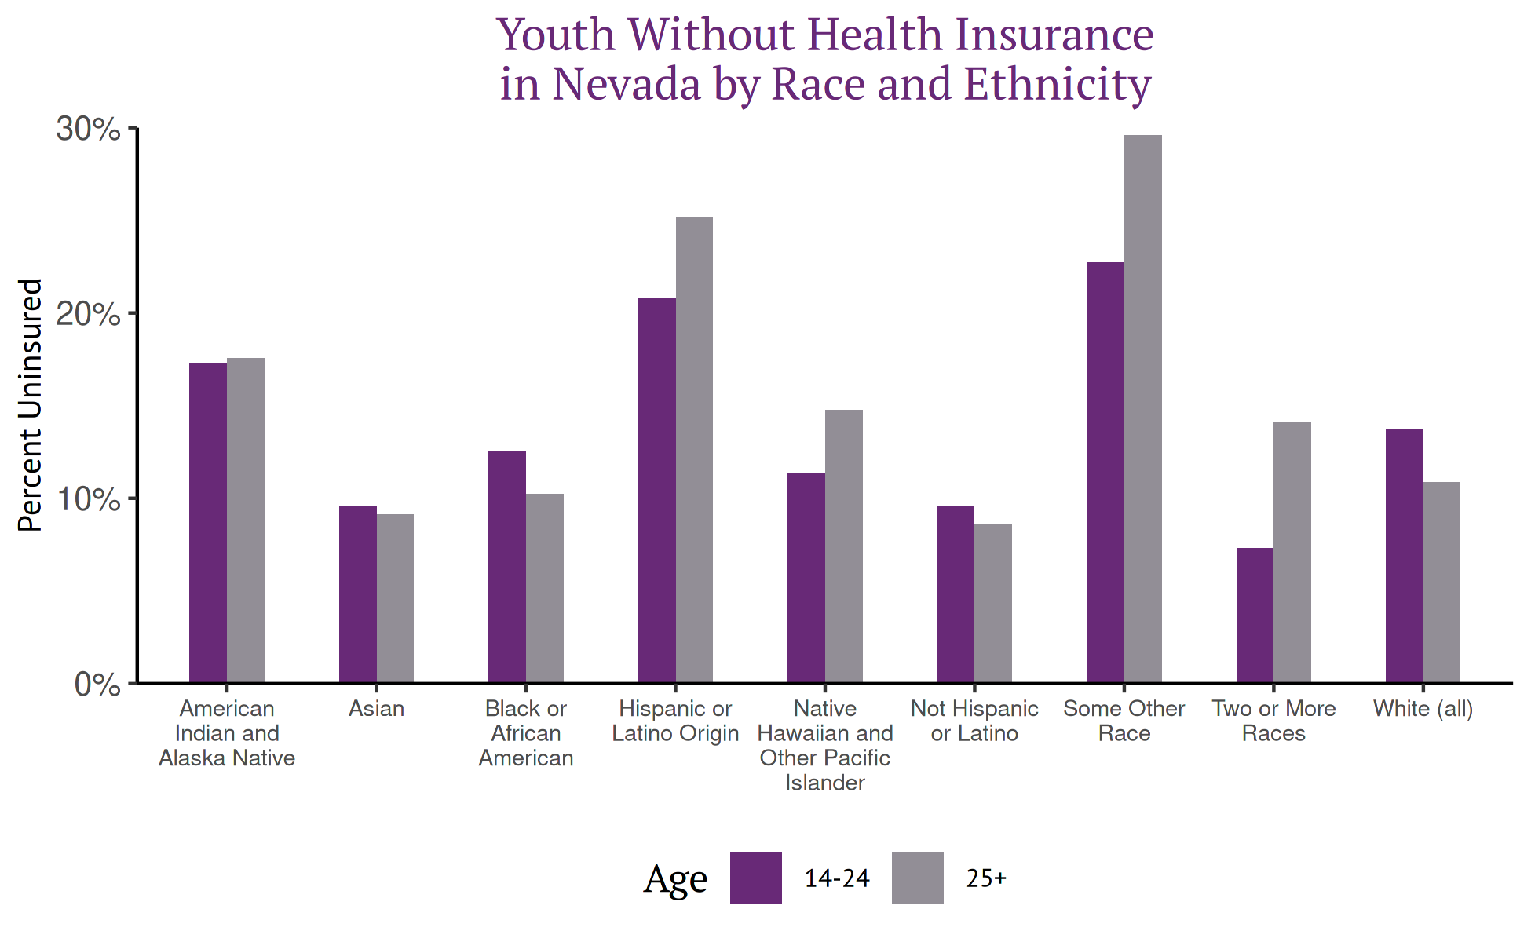

## Mental Health

* Suicide
* Depression/Anxiety/Drug Use/etc from behavioral health survey thing

# Youth Homelessness

1. “Mental Health Issues on the Rise Among Adolescents, Young Adults,” AJMC, accessed November 2, 2020, https://www.ajmc.com/view/mental-health-issues-on-the-rise-among-adolescents-young-adults.
2. “Harvard Youth Poll,” The Institute of Politics at Harvard University, accessed November 2, 2020, https://iop.harvard.edu/youth-poll/harvard-youth-poll.
3. “Expanded State Employment Status Demographic Data,” accessed November 2, 2020, https://www.bls.gov/lau/table14full19.htm.