10

CHAPTER 1 The Earth System

Mantle ( 40-2890 km ) Liquid iron outer core 67.1 % of Earth's mass ( 2890-5150 km )

30.8 % of Earth's mass

Crust ( 0-40 km ) 0.4 % of Earth's mass

Solid iron inner core ( 5150-6370 km ) 1.7 % of Earth's mass

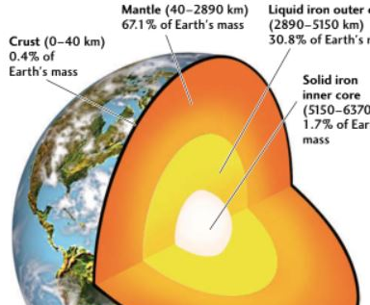

FIGURE 1.9 - Earth's major layers , showing their depths and their masses expressed as a percentage of Earth's total mass .