8

CHAPTER 1 The Earth System

Over millions of years , layers of sediments built up over the oldest rocks . The most recent layer - the top — is about 250 million years old .

About 50,000 years ago , the explosive impact of a meteorite ( perhaps weighing 300,000 tons ) created this 1.2 - km - wide crater in just a few seconds .

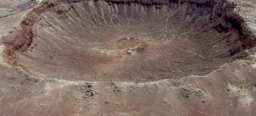

The rocks at the bottom of the Grand Canyon ( b )

are 1.7-2.0 billion years old . FIGURE 1.7 - Some geologic processes take place over thousands of centuries , while others occur with dazzling speed . ( a ) The Grand Canyon , Arizona . ( b ) Meteor Crater , Arizona . [ ( a ) John Wang / PhotoDise / Getty Images ; ( b ) lohn Sanford / Science Source ]