**DECLARATION:** I understand that this is an **individual** assessment and that collaboration is not permitted. I have read and I understand the plagiarism provisions in the General Regulations of the University Calendar for the current year, found at <http://www.tcd.ie/calendar>. I understand that by returning this declaration with my work, I am agreeing with the above statement.

1. **Introduction**

I mainly use Tableau software to draw the pictures. For the first task, I encode year by x-position and life-expectancy by y-position and seperate the different contients by colors. Then I get 3 variants of the charts by changing the shape of the points. For the second task, I encode gdp percap by x-position and life expectancy by y-position and do the same as the first task. For the last task, I create 5 channels by different contients, encode year by x-position and life-expectancy by y-position. Every point is a country and the size means the population of a country, different colors means different gdps percap.

1. **Task 1**

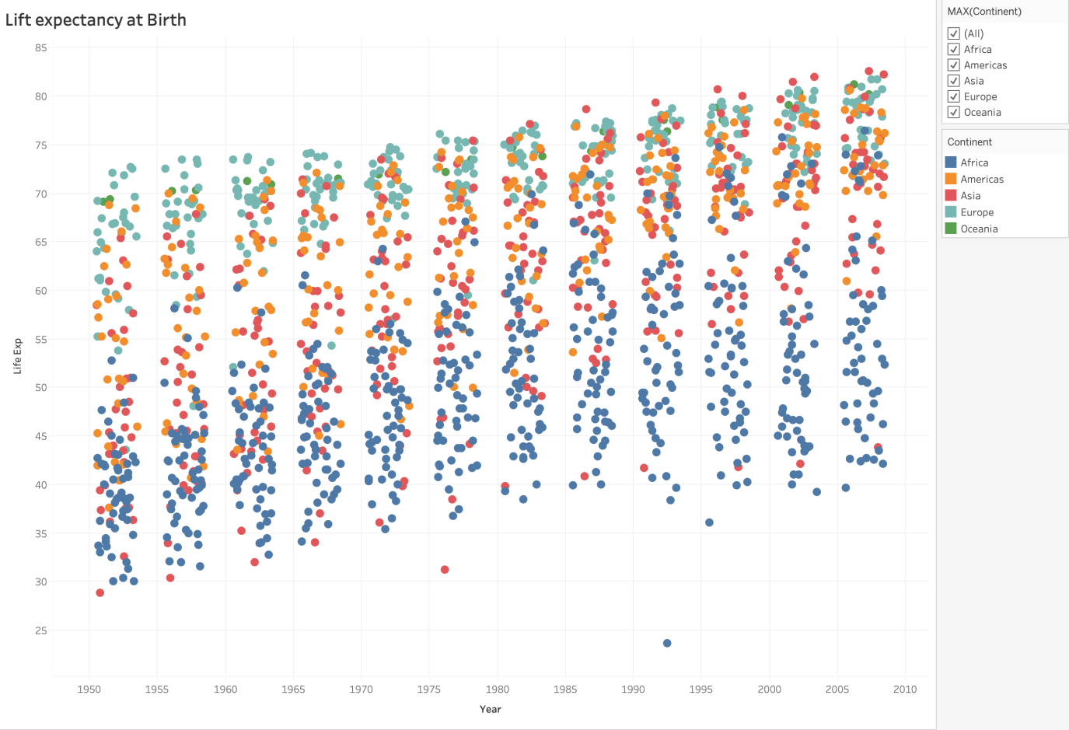

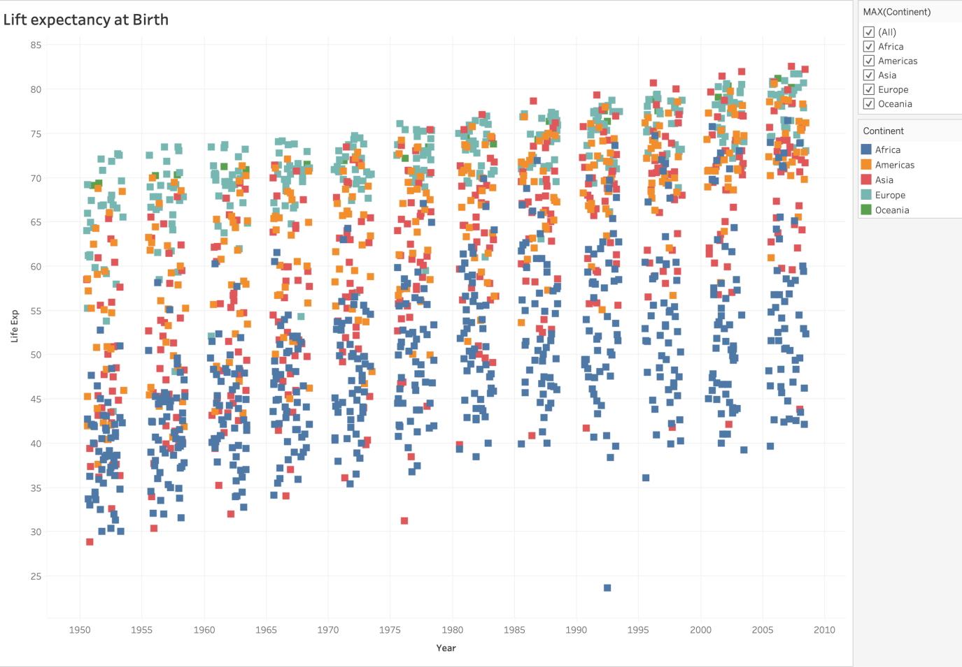

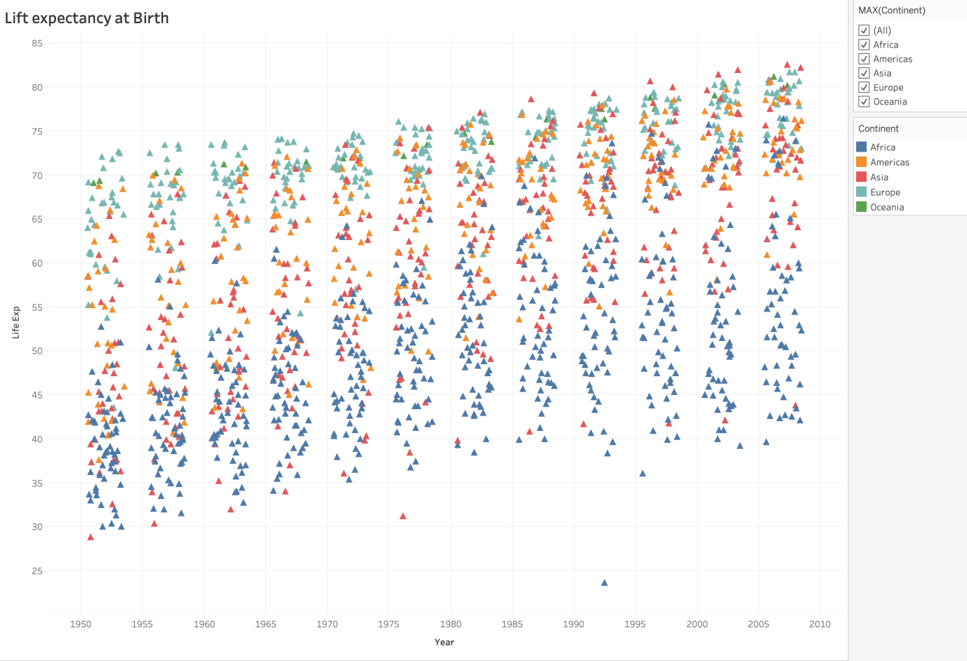

1. **Task 2**

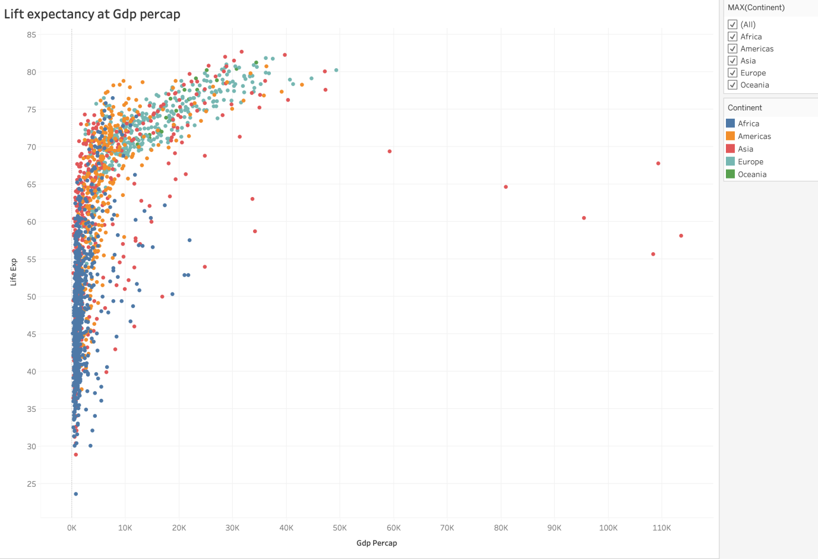

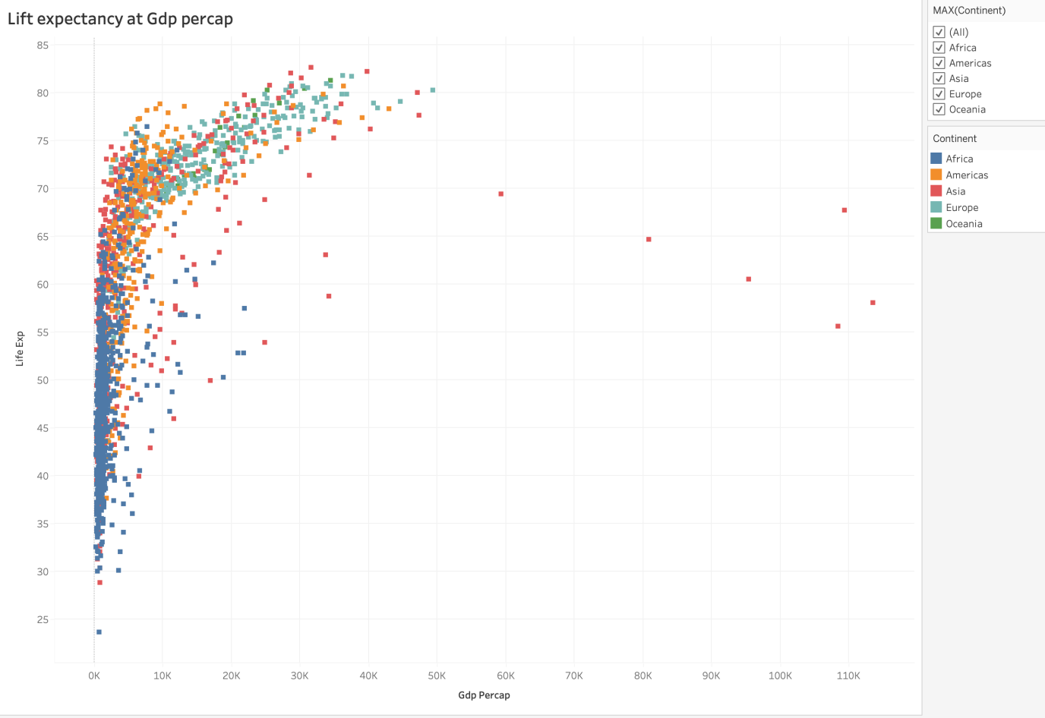

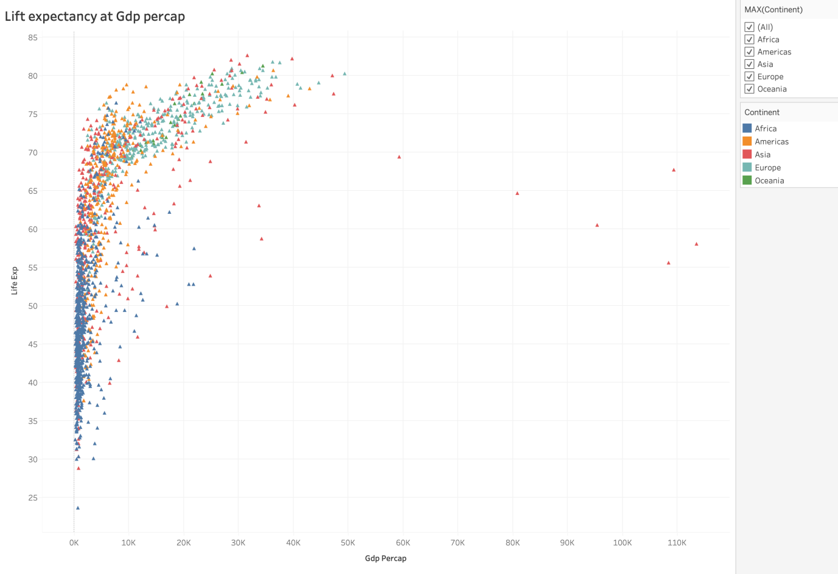

1. **Task 3**

