**Part 1**

The optimization algorithm I used is the Adam optimizer:

$$θ_{t+1}=θ_{t}-\frac{η}{\sqrt{\hat{v_{t}}}+ϵ}\hat{m_{t}}$$

$$θ=\text{Your weights and biases.} \\ η=\text{Stepping size} \\ \hat{m_{t}}=(Bias corrected) \text{First moment}\text{ - mean of gradients } \\ \hat{v_{t}}=(Bias corrected) \text{Second moment}\text{ - uncentered variance of gradients} \\ ϵ=\text{Small term that prevents division by 0}$$

Adam stands for Adaptive Moment Estimation. Its corrected moments allows the gradient to move towards the general trend without oscillating a lot or overshooting.

**Python code**

Best set of parameters:  
Test dataset error values:   
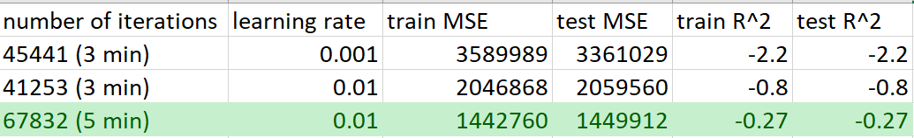

**Am I satisfied that I have found the best solution?**

I am not satisfied, as my model seemed to take forever to converge, and it never did. I was able to cut down a lot of time by doing feature selection, but the performance still paled in comparison to sklearn’s adam optimizer.

**Part 2**

**Python code**

Best set of parameters:  
Test dataset error values:

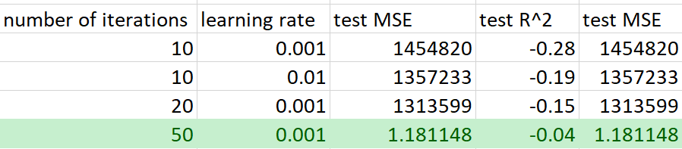

**Am I satisfied that the package has found the best solution?**

I am satisfied, even though I did not do several iterations. I can see that increasing the number of iterations would give me good results, as it gave lower R^2 and MSE values.