Jeopardy Review Game

Daniel McGuigan
IB Computer Science HL-Y2

Table of Contents
Page
3-6
3
4
5-6

7-11
7
8-10
11

12-35
12-33
34-35
35

36-46
36-45
45-46

Stage A: Analysis
A1: Analysis
A2: Criterion for Success
A3: Prototype Solution

Stage B: Detailed Design
B1: Data Structures
B2: Algorithms
B3: Modular Organization

Stage C: The Program
C1: The Code
C2: Handling Errors
C3: Success of the Program

Stage D: Documentation
D1: Annotated Hard Copy
D2: Evaluating Solutions

A1-Analysis:

The Problem

Many teachers try to review for a test in class. However, the best method to do so often eludes them. Some try and quiz the students, some give sample problems, and some play a ‘review game’ that challenges students and brings out their competitive side, while forcing them to remember critical information to win. A common game that I’ve experience over the years is a Jeopardy-type knockoff. It has also been my experience that this works rather well in reviewing because you can ask a broad variety of questions and include a large number of people.

Expanding on this idea, what if there was a way for students to use this format of review to study individually? They could have questions that are specific to a chapter, or perhaps a course review, such as would be good for an AP class before the exam. The potential for student success would greatly increase, and there wouldn’t be a need to have a large group of people to review, nor would valuable class time be taken up to review.

Though it would be intended for individual use, there will also be a ‘multiplayer’ type setting, allowing students to review together and challenge each other. This setting would allow up to two friends to join the user and have a traditional Jeopardy like competition.

In the future, it could be possible to expand beyond just one subject. The program will be compatible to add questions/answers for a broad subject variety, as in the true Jeopardy style.

The program would open with a window to allow the user to select the number of players, as well as a subject, if applicable. They would then be taken to the game screen, which would show the title of the set of questions and a grid of squares, each of which having a question that the user would then answer.

The initial version of this game will include questions to prepare for the AP Computer Science courses. In collaboration with Mr. Jason Parker, the course instructor for our school, he has provided me with a book of sample questions to use for the program. The book, which is a review book that he currently uses, contains both multiple choice sample tests, as well as sample free response questions. This program will only be including multiple choice type questions.

Sample Data

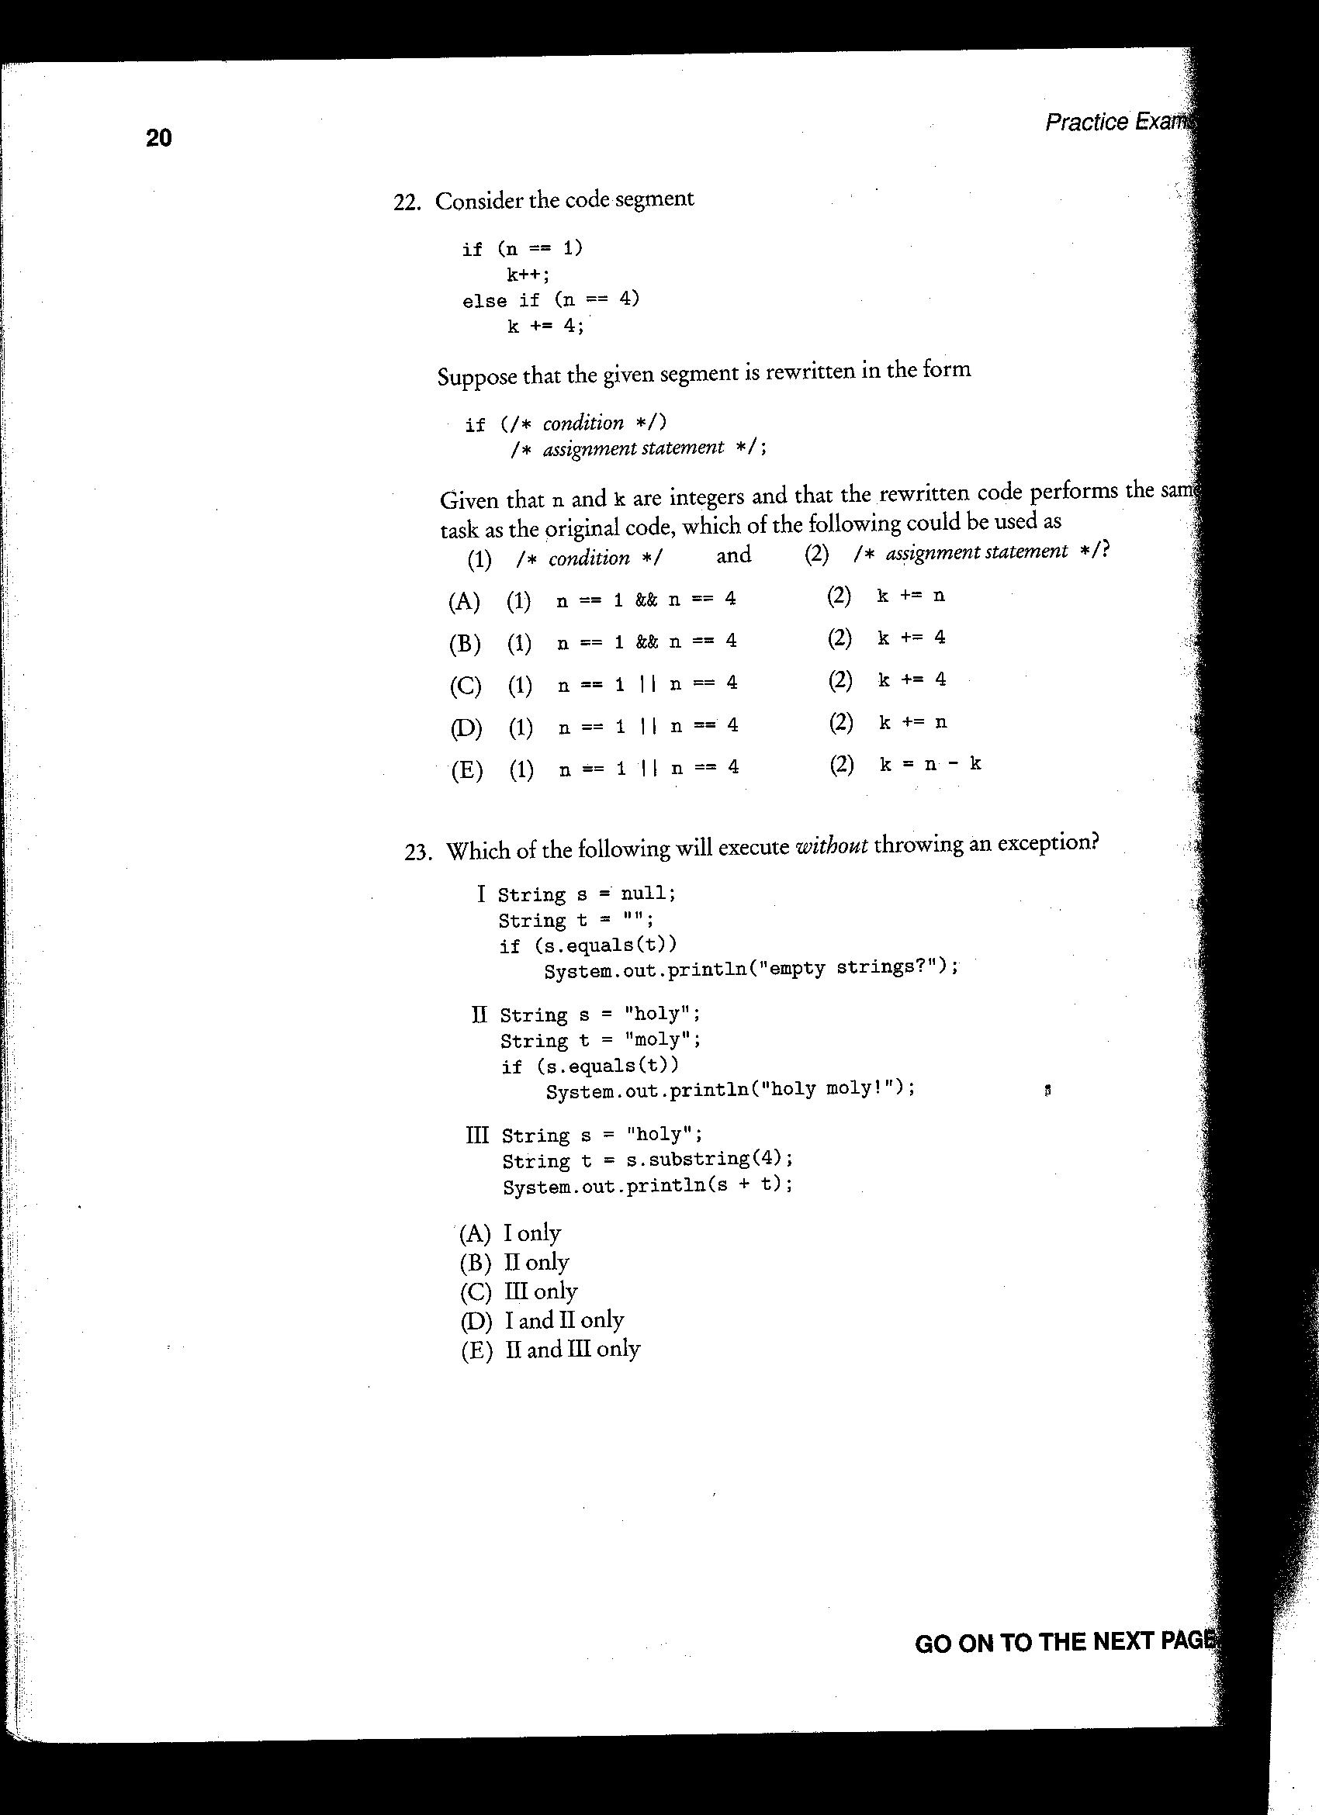
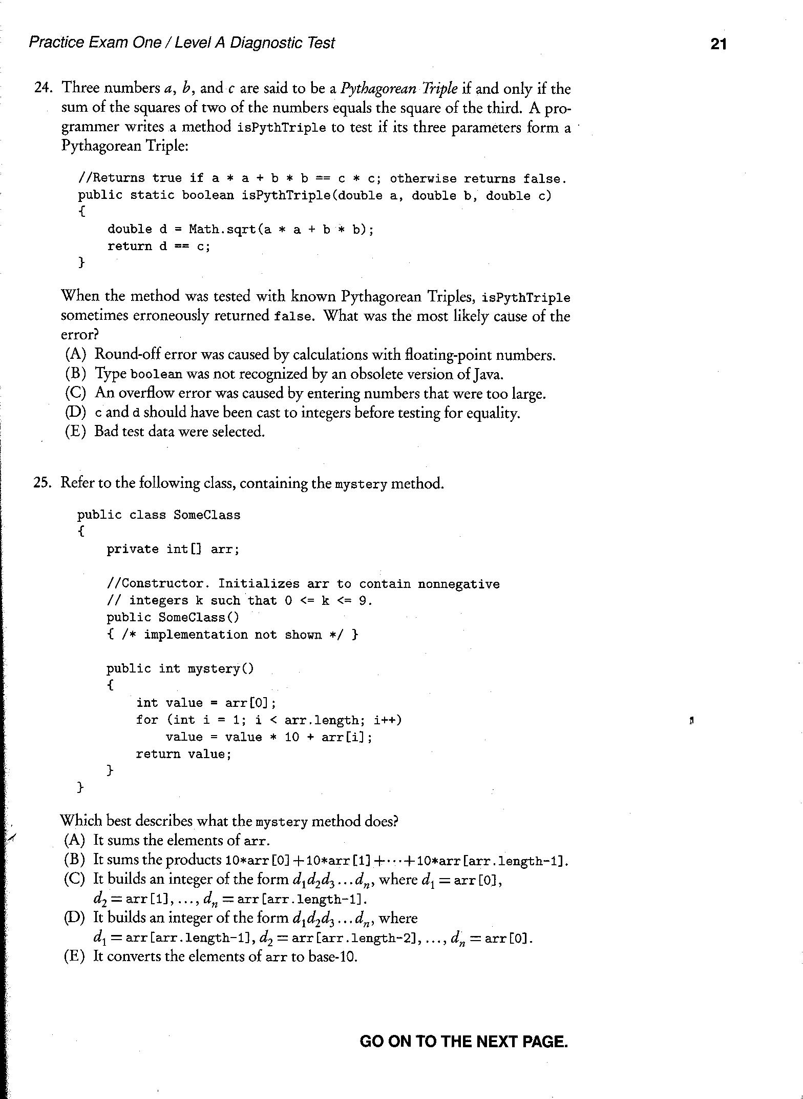
This is how the class currently prepares for tests, by simply taking pre-released tests as well as sample questions prepared by the Barron’s company (pictured above).

A2-Criterion for Success

An easy to use, straightforward interface.
The interface needs to function without much confusion, leaving the user with just the burden of choosing options and entering the answer. If the user cannot easily determine what is required of them and they don’t know how to do what they are supposed to do, then they will simply not use the program.

A smooth random question generator that doesn’t repeat itself continually.
There needs to be minimal repetition in order for the game to be effective. The point of the game is lost if half of the questions are repeated continuously. This will be obtained by selecting the questions at the beginning of the game and they will be set for the remainder of the game. It will be choosing randomly, and after a question is chosen, it’s ‘line index’ will not be available for adding.

Usable by teacher for large scale review by a class.
The game should not be limited to small groups of up to 3 people per game. The teacher should be able to use it in the classroom setting, whether they divide the group into 3 teams, or have an alternate setting for teacher that allows them to specify a number of teams for the game.

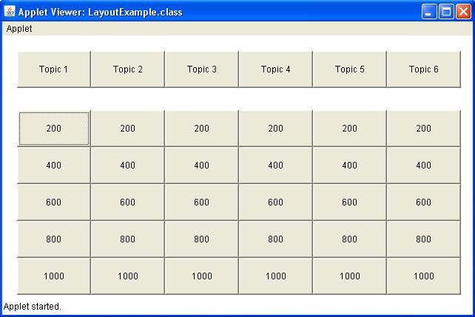
A3-Prototype Solution

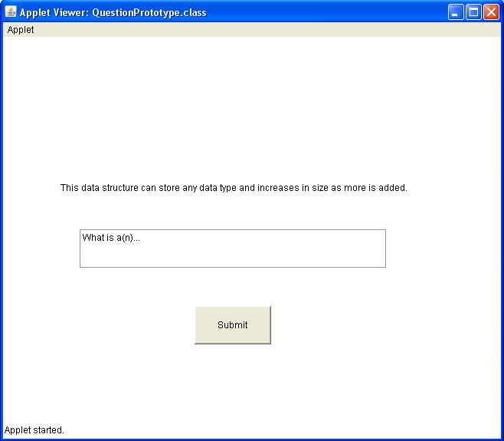
Above is a screenshot of what the question grid will look like when the Prototype is initially loaded. The user will select one of the amounts, much like in the TV game show. After clicking on the amount, the user will be presented with a new window:

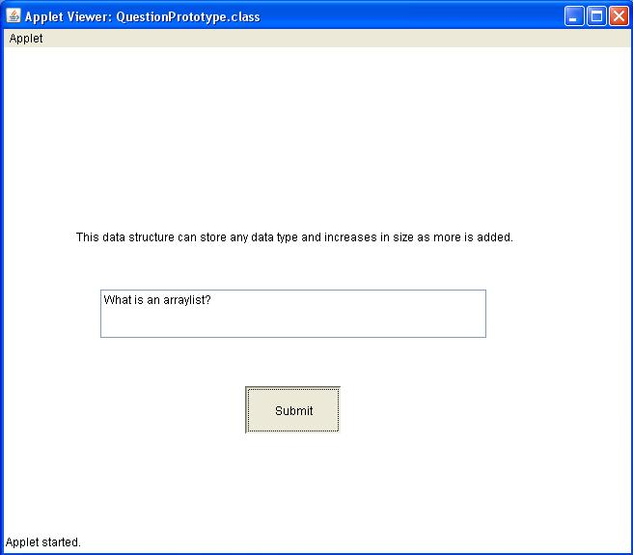
They will then enter their answer in the text field beneath the question. And following that, they would hit the submit button. Critical to getting the question correct, is answering in the correct form. Though not set in stone yet, it will be in the Jeopardy game standard, by answering in question form.
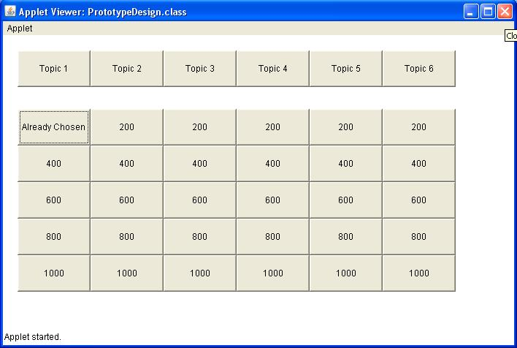
After answering the question, the grid will be updated to reflect that the option has been chosen to prevent repetition issues.

B1-Data Structures

Arrays: I am using 3 arrays in the main game class. One of these will store the buttons that make up the GUI portion, while the other 2 will be parallel and contain questions in one, and answers in the other. These
are loaded at the beginning of the game, and pulled from randomly throughout the game.
0 | 1 | … | 24
Question 1 | Question 2 | … | Question 25

0 | 1 | … | 25
Answer 1 | Answer 2 | … | Answer 25

Text Files: I will be using text files to hold the questions and answers for the game. Each time a new game is begun, it will randomly select from that file questions and their respective answer, which will be loaded into the aforementioned arrays. I am also contemplating on including a question writer, which will allow the user (most likely a teacher in this case) to create new questions and/or edit existing ones. With the new questions, they will be able to either create a new set of questions that can be played in a game, or they can add it to an existing set of questions that are already usable.

question
answer
question
answer
question
answer
question
answer
etc.

Swing: I am using the javax.swing packages to create the GUI for the program. This allows me to use buttons, text fields, etc. and also allows me to modify text files, and read from them as well.

B2-Algorithms

Load Interface: This is a rather self explanatory algorithm. It will assign questions and their answers to buttons on the game board, creating the data structure and filling it. At this point, the 2-D Array will be created and initialized, and filled with the arrays of question answer combos. Also, it will initialize the GUI, projecting the

try{
deathToTrees = new Scanner(new File(fileName));
int counter = 0;
int index = 1;
while(counter < questions.length){
questions[counter] = deathToTrees.nextLine();
answers[counter] = deathToTrees.nextLine();
counter++;
}
}catch(IOException io){
JOptionPane.showMessageDialog(panel, "File not found.", "Uh Oh......", JOptionPane.ERROR_MESSAGE);
return;
}

Display Question: This method will, quite ironically, display the question, with an answer dialog box. It will be triggered by the clicking of a corresponding button. It will then open a new window, containing the question and a spot for the user to enter their answer.

Create window;
SOP question from the selected slot;
Read answer;
checkAnswer();
updateBoard;
Check Answer: Compare answer given to correct answer. If the user enters the correct answer, then it will return true, add the respective number of points to their total, and display a message telling them it was correct. If wrong, it will return false, subtract the correct amount of points, and then display the correct answer.

If(answer.equals(this)){ //if answer and the given answer are the same
addPoints to total;
display message;
return true;
}
subtractPoints from total;
display correct answer;
return false;

Record High Score: Keeps track of high scores, storing top 10 scores in a text file. Compares player score at end of game to recorded scores and then updates if necessary. (Not Yet Implemented, still unsure.)

ArrayList <String[]> hiScores = new ArrayList <String[]>();
While(file.hasNext() && file.hasNext().hasNext()){
hiScores.add(new String[] = {next(), nextInt()});
}
While(n < hiScores.size()){
String[] temp = hiScores.get(n);
if(this.compareTo(temp[1]) > 0)
{
Prompt for name;
Store name and score in file;
Return;
}
Else if(this.compareTo(temp[1]) == 0)
{
Prompt for name;
store name and score;
return;
}
}
Display high score list;

Update Board: updates board with still available questions. If I button has been clicked, then its face is set to “Already Chosen”, signifying that nothing will happen if it is selected. Once a button has been clicked and completed, then once it has been clicked, a message will display, informing the user to select a different option. It also updates the counter for the choice of the next question.

if(temp.getLabel().equals("Already Chosen")){
JOptionPane.showMessageDialog(panel, "That option has already been chosen. Please choose another.", "Option Unavailable, nubber.....", JOptionPane.INFORMATION_MESSAGE);
}
else{
QuestionBox question = new QuestionBox(questions[choice], answers[choice], questionValue, score);
temp.setLabel("Already Chosen");
random = (int)(Math.random() * 25);
for(int n = 0; n < used.size(); n++){
if(random == used.get(n)){
random = (int)(Math.random() * 25);
}
}
choice = random;
}

Game Over: checks to see if the game has been completed. Displays a message if true and then closes the game window. Else, game continues on.

public static boolean gameOver(){
for(JButton button: field){
if(!(button.getLabel().equals("Already Chosen"))){
return false;
}
}
return true;
}
B-3: Modular Organization

ProgramStartup
QuestionWriter
Question/Answer
Gameboard
ModifySet
CreateSet
Help
Directions

CSQuestions.txt
Hiscores.txt

//potential new set created in create set

ProgramStartup: Essentially a “Welcome” screen. Will prompt the user to select a set of questions and number of players before beginning a game.
QuestionWriter: Contains universal methods for creating and modifying sets. Task completed with aid of sub-classes.
CreateSet: contains methods used to create a new set of questions. Creates a new file and stores questions and answers within it.
ModifySet: Prompts user to select a set to modify. They will then be able to add or remove questions, which are stored in a text file.
Gameboard: creates the game board. Contains the game board data structure and keeps track of player points.
HiScores.txt: Stores the top 10 hi scores in the game, updated when necessary following each game.
CSQuestions.txt: stores the questions and answers for this particular set. Can be modified using the modify function.
Still uncreated sets: stores any new sets of questions created using the question writer function. Will only be available for use if there are 30 questions in the set.
C-1: The Code
Class: Startup
/**
* Review Game: Startup Class
* Author: McGuigy
* Date: many days
* School: Valencia HS (OC)
* Computer: #19 (Dell Intel QuadCore)
* IDE: Blue J
* Purpose: Launch the program
*/

import java.awt.*;
import java.awt.event.*;
import java.util.*;
import javax.swing.*;
import java.io.*;

public class Startup extends JFrame implements ItemListener{
private Toolkit toolkit;
private JPanel panel;
private JLabel title;
private JComboBox gameChoices;
private JButton start;
private JButton help;
private JButton quit;
private final String[] gameOptions = {"Computer Science A", "Computer Science AB"};
private String gameChoice;
private String gameFile;
private int gameChoiceNum;

/**
* Constructor
*/
public Startup(){
setTitle("Welcome to Jeopardy");
setSize(800,700);

setDefaultCloseOperation(EXIT_ON_CLOSE);

panel = new JPanel();
getContentPane().add(panel);

panel.setLayout(null);

/**
* creates title of program object
*/
title = new JLabel("JEOPARDY");
title.setFont(new Font("Arial Bold", Font.PLAIN, 28));
title.setVisible(true);
title.setBounds(50,50,500,250);

/**
* creates selection box of game choices
*/
gameChoices = new JComboBox(gameOptions);
gameChoices.setSelectedIndex(-1);
gameChoices.setBounds(50,250,250,50);
gameChoices.addItemListener(this);

/**
* creates button that will launch the selected game
*/
start = new JButton("Begin");
start.setBounds(50,400,100,50);
start.addActionListener(new ActionListener(){
public void actionPerformed(ActionEvent eve){
try{
GameBoard game = new GameBoard(gameChoice, gameFile);
}catch(Exception bob){
JOptionPane.showMessageDialog(panel,"You need to select a game to play!","Selection Error",JOptionPane.ERROR_MESSAGE);
}
}
});

/**
* creates button that will launch the help menu
*/
help = new JButton("HELP");
help.setBounds(200, 400, 100, 50);
help.addActionListener(new ActionListener(){
public void actionPerformed(ActionEvent ev){
Help menu = new Help();
}
});

/**
* creates button that will cease the program execution
*/
quit = new JButton("QUIT");
quit.setBounds(500, 400, 100, 50);
quit.addActionListener(new ActionListener(){
public void actionPerformed(ActionEvent event){
System.exit(0);
}
});

/**
* creates button that will launch the question writer
*/
JButton writer = new JButton("Question Editor");
writer.setBounds(50, 475, 150,50);
writer.addActionListener(new ActionListener(){
public void actionPerformed(ActionEvent event){
QuestionWriter bob = new QuestionWriter();
}
});

/**
* adds all GUI elements to window
*/
panel.add(title);
panel.add(gameChoices);
panel.add(start);
panel.add(help);
panel.add(quit);
panel.add(writer);

//sets the window to be displayed on the screen
setVisible(true);
}

/**
*
* @param event the occurance that will trigger the method
* @return
*/
public void itemStateChanged(ItemEvent event){
JComboBox bob = (JComboBox) event.getSource();
int index = bob.getSelectedIndex();
gameChoiceNum = index;
gameChoice = (String)bob.getItemAt(index);
gameFile = gameChoice + ".txt";
}

/**
* creates instantiation when called
*
* @param args array of arguments
* @return
*/
public static void main(String[] args){
Startup test = new Startup();
}
}

Class: GameBoard
/**
* Review Game: GameBoard Class
* Author: McGuigy
* Date: many moons
* School: Valencia HS (OC)
* Computer: #19 (Dell Intel QuadCore)
* IDE: Blue J
* Purpose: create game board GUI and functionality
*/

import java.util.*;
import java.io.*;

import java.awt.Dimension;
import java.awt.Toolkit;
import java.awt.event.ActionEvent;
import java.awt.event.ActionListener;

import javax.swing.JButton;
import javax.swing.JFrame;
import javax.swing.JPanel;
import javax.swing.*;

public class GameBoard extends JFrame{
private static JButton[] field = new JButton[25]; //stores the buttons in the game board
private String[] questions = new String[25]; //stores questions for current game
private String[] answers = new String[25]; //stores answers for question array data
private Toolkit toolkit; //yeah
private int num; //used multiple times for various counting iterations
private int choice; //the selected random number to select the question
private int random; //the variable used to find a random number for question selection
private static int score; //the score duh
private ArrayList<Integer> used; //stores random numbers once used to select a question
private static JTextArea scoreboard; //displays current score
private JPanel panel; //contains the things the user sees
private int bounds = 0; //modifier for the x direction
private int questionValue = 0; //int version of the value of the question
private int modifier; //modifier for the y direction

public GameBoard(String gameTopic, String fileName){
toolkit = getToolkit();

setTitle("Jeopardy: " + gameTopic);
setSize(toolkit.getScreenSize());

setDefaultCloseOperation(DISPOSE_ON_CLOSE);

panel = new JPanel();
getContentPane().add(panel);

panel.setLayout(null);

JButton help = new JButton("Help Menu");
help.setBounds(250,800,100,50);
help.addActionListener(new ActionListener(){
public void actionPerformed(ActionEvent event){
Help meun = new Help();
}
});

score = 0;//------------------------------------------------------------------------------->sets default score to 0

scoreboard = new JTextArea();
scoreboard.setBounds(20, 800, 100, 50);
scoreboard.setEditable(false);
scoreboard.setText(score + "");

//fill questions/answers arrays with questions/answers
Scanner deathToTrees;
try{
deathToTrees = new Scanner(new File(fileName));
int counter = 0;
int index = 1;
while(counter < questions.length){
questions[counter] = deathToTrees.nextLine();
answers[counter] = deathToTrees.nextLine();
counter++;
}
}catch(IOException io){
JOptionPane.showMessageDialog(panel, "File not found.", "Uh Oh......", JOptionPane.ERROR_MESSAGE);
return;
}

used = new ArrayList<Integer>();

// initialize game board
num = 0;
random = returnRandom();

while(num < field.length){
if(num < 5){
questionValue = 200;
modifier = 0;
}
else if(num > 4 && num < 10){
questionValue = 400;
}
else if(num > 9 && num < 15){
questionValue = 600;
}
else if(num > 14 && num < 20){
questionValue = 800;
}
else if(num > 19 && num < 25){
questionValue = 1000;
}

field[num] = new JButton(questionValue + "");
if(num == 5){
bounds = 0;
modifier += 100;
}
else if(num == 10){
bounds = 0;
modifier += 100;
}
else if(num == 15){
bounds = 0;
modifier += 100;
}
else if(num == 20){
bounds = 0;
modifier += 100;
}
field[num].setBounds(100 + bounds, 200 + modifier, 200, 100);
field[num].addActionListener(new ActionListener(){
public void actionPerformed(ActionEvent event){
JButton temp = (JButton)event.getSource();
int index = 0;
while(!(temp.equals(field[index]))){
index++;
}
if(index < 5){
questionValue = 200;
}
else if(index > 4 && index < 10){
questionValue = 400;
}
else if(index > 9 && index < 15){
questionValue = 600;
}
else if(index > 14 && index < 20){
questionValue = 800;
}

else if(index > 19 && index < 25){
questionValue = 1000;
}
if(temp.getLabel().equals("Already Chosen")){
JOptionPane.showMessageDialog(panel, "That option has already been chosen. Please choose another.", "Option Unavailable, nubber.....", JOptionPane.INFORMATION_MESSAGE);
}
else{
QuestionBox question = new QuestionBox(questions[random], answers[random], questionValue, score);
temp.setLabel("Already Chosen");
random = returnRandom();
}
if(gameOver()){
dispose();
}
}
});
num++;
bounds += 200;
}

num = 0;
while(num < field.length){
panel.add(field[num]);
num++;
}
panel.add(help);
panel.add(scoreboard);
setVisible(true);

}

//checks to see if random choice selector has used that number before
private boolean contains(Integer num){
int k = 0;
while(k < used.size()){
if(num.equals(used.get(k))){
return true;
}
}
return false;
}

private int getQuestionValue(){
return questionValue;
}

//kind of self explanatory....
public static void updateScore(int newScore){
score = newScore;
scoreboard.setText(score + "");
}

//checks to see if all questions have been completed
public static boolean gameOver(){
for(JButton button: field){
if(!(button.getLabel().equals("Already Chosen"))){
return false;
}
}
return true;
}

//returns a random, unchosen integer for question selection
private int returnRandom(){
int rand = (int)(Math.random() * 25);
int counter = 0;
while(counter < used.size()){
if(used.get(counter) == rand){
rand = (int)(Math.random() * 25);
counter = 0;
}
counter++;
}
used.add(rand);
return rand;
}
}

Class: QuestionBox
/**
* Review Game: QuestionBox Class
* Author: McGuigy
* Date: many moons
* School: Valencia HS (OC)
* Computer: #19 (Dell Intel QuadCore)
* IDE: Blue J
* Purpose: create GUI for question and answer
*/

import java.awt.*;
import java.util.*;
import java.io.*;

import java.awt.Dimension;
import java.awt.Toolkit;
import java.awt.event.ActionEvent;
import java.awt.event.ActionListener;

import javax.swing.JButton;
import javax.swing.JFrame;
import javax.swing.JPanel;
import javax.swing.JTextField;
import javax.swing.*;

public class QuestionBox extends JFrame{
private Toolkit toolkit;
private String actualQ;
private String actualA;
private String entry;
private JPanel panel;
private JTextField text;
private boolean statsu;
private boolean answered;
private int value; ///////////////point value of question
private int score; ///////////////current game score

public QuestionBox(String question, String answer, int pointValue, int currentScore){
setTitle("Question: " + pointValue +"");
setSize(600, 500);

toolkit = getToolkit();
Dimension size = toolkit.getScreenSize();
setLocation((size.width - getWidth())/2, (size.height - getHeight())/2);

setDefaultCloseOperation(DISPOSE_ON_CLOSE);

panel = new JPanel();
getContentPane().add(panel);

panel.setLayout(null);

actualQ = question;
actualA = answer;

value = pointValue;
score = currentScore;

JLabel theQuestion = new JLabel(actualQ);
theQuestion.setFont(new Font("Georgia", Font.PLAIN, 14));
theQuestion.setVisible(true);
theQuestion.setBounds(50, 50, 600, 400);

text = new JTextField(50);
text.setBounds(50, 350, 200, 30);
text.addActionListener(new ActionListener(){
public void actionPerformed(ActionEvent event){

}
});

//creates SUBMIT button
JButton submit = new JButton("SUBMIT");
submit.setBounds(50,400,80,30);
submit.addActionListener(new ActionListener() {
public void actionPerformed(ActionEvent event){
entry = text.getText();
boolean result = checkAnswer(entry, actualA);
if(result == true){
JOptionPane.showMessageDialog(panel, "Correct Answer", "Good Job!", JOptionPane.INFORMATION_MESSAGE);
GameBoard.updateScore(score + value);
}
else{
JOptionPane.showMessageDialog(panel, "Wrong Answer. The Correct Answer was: " + actualA, "Woe is you....", JOptionPane.INFORMATION_MESSAGE);
GameBoard.updateScore(score - value);
}
if(GameBoard.gameOver()){
dispose();
JOptionPane.showMessageDialog(panel, "Congratulations, you've completed the game! Your score was " + score, "w00t", JOptionPane.INFORMATION_MESSAGE);
}
dispose();
}
});

panel.add(theQuestion);
panel.add(text);
panel.add(submit);

setVisible(true);

}

private boolean checkAnswer(String input, String correct){
if(input.equalsIgnoreCase(correct))
return true;
return false;
}

public boolean isCorrect(){
if(statsu == true)
return true;
return false;
}

public boolean isAnswered(){
if(answered == true){
return true;
}
return false;
}
}

Class: Help
/**
* Review Game: Help Class
* Author: McGuigy
* Date: 02/19/10-Present
* School: Valencia HS (OC)
* Computer: #19 (Dell Intel QuadCore)
* IDE: Blue J
* Purpose: Display a help menu
*/

import java.awt.*;
import java.awt.event.*;
import java.util.*;
import javax.swing.*;
import java.io.*;

public class Help extends JFrame{
private Toolkit toolkit;
private JPanel panel;

/**
* constructor for help menu window
*/
public Help(){
setTitle("Help Menu");
setSize(800,700);

setDefaultCloseOperation(DISPOSE_ON_CLOSE);

panel = new JPanel();
getContentPane().add(panel);

panel.setLayout(null);

/*
* creates direction for window
*/
JLabel intro = new JLabel("Please select a help topic:");
intro.setFont(new Font("Arial", Font.PLAIN, 22));
intro.setVisible(true);
intro.setBounds(20,20,500,200);

/*
* creates button to open Directions
*/
JButton directions = new JButton("Directions");
directions.setBounds(50,200,100,50);
directions.addActionListener(new ActionListener(){
public void actionPerformed(ActionEvent event){
Directions dirs = new Directions();
}
});

/*
* creates button to open WriterDirections
*/
JButton writer = new JButton("Q. W. Help");
writer.setBounds(200,200,100,50);
writer.addActionListener(new ActionListener(){
public void actionPerformed(ActionEvent event){
WriterDirections qw = new WriterDirections();
}
});

/*
* creates button to handle closing function
*/
JButton close = new JButton("Close");
close.setBounds(500,300,100,50);
close.addActionListener(new ActionListener(){
public void actionPerformed(ActionEvent event){
dispose();
}
});

/*
* adds objects to window pane
*/
panel.add(intro);
panel.add(directions);
panel.add(writer);
panel.add(close);

/*
* sets window to be displayed on screen
*/
setVisible(true);
}

/**
* creates instantiation when invoked
*
* @param args array of arguments
* @return
*/
public static void main(String[] args){
Help bobert = new Help();
}
}

Class: Directions
/**
* Review Game: Directions Class
* Author: McGuigy
* Date: 02/24/10-0226/10
* School: Valencia HS (OC)
* Computer: #19 (Dell Intel QuadCore)
* IDE: Blue J
* Purpose: Display directions for program in help menu
*/

import java.awt.*;
import java.awt.event.*;
import java.util.*;
import javax.swing.*;

public class Directions extends JFrame{
private Toolkit toolkit;
private JLabel info;
private JPanel panel;
private String directions;

/**
* Constructor for Direction window
*/
public Directions(){
setTitle("Jeopardy Help Desk");
setSize(600,500);

setDefaultCloseOperation(DISPOSE_ON_CLOSE);

directions = "<html> DIRECTIONS: <br>" +
"1. Select a topic <br>" +
"2. Click Begin <br>" +
"3. In game area, select a point value <br>" +
"4. Answer the question in the textfield and click submit. <br>" +
"5. After the game, if your score is in the top 10, then you will be prompted to enter your initials for the records. <br>";

panel = new JPanel();
panel.setLayout(null);

/*
* creates the text of the window
*/
info = new JLabel(directions);
info.setBounds(20,20,500,200);
info.setFont(new Font("Georgia", Font.PLAIN, 14));

/*
* creates button for close function
*/
JButton close = new JButton("Close");
close.setBounds(20,300,100,50);
close.addActionListener(new ActionListener(){
public void actionPerformed(ActionEvent event){
dispose();
}
});

/*
* adds objects to window pane
*/
panel.add(info, BorderLayout.CENTER);

getContentPane().add(panel);

panel.add(close);

/*
* sets window to be displayed on screen
*/
setVisible(true);
}

/**
* creates instantiation when invoked
*
* @param args array of arguments
* @return
*/
public static void main(String[] args){
Directions menu = new Directions();
}
}

Class: WriterDirections
/**
* Review Game: Directions Class
* Author: McGuigy
* Date: 02/24/10-0226/10
* School: Valencia HS (OC)
* Computer: #19 (Dell Intel QuadCore)
* IDE: Blue J
* Purpose: Display directions for program in help menu
*/

import java.awt.*;
import java.awt.event.*;
import java.util.*;
import javax.swing.*;

public class WriterDirections extends JFrame{
private Toolkit toolkit;
private JLabel info;
private JPanel panel;
private String directions;

/**
* Constructor for Direction window
*/
public WriterDirections(){
setTitle("Jeopardy Help Desk");
setSize(600,500);

setDefaultCloseOperation(DISPOSE_ON_CLOSE);

directions = "<html> DIRECTIONS: <br>" +
"1. Enter a name for a file. <br>" +
"2. Enter the question and answer into relative spot. <br>" +
"3. Click 'ADD' <br>" +
"4. Continue until you have added all desired questions. <br>" +
"5. Click 'DONE' when finished. <br>";

panel = new JPanel();
panel.setLayout(null);

/*
* creates the text of the window
*/
info = new JLabel(directions);
info.setBounds(20,20,500,200);
info.setFont(new Font("Georgia", Font.PLAIN, 14));

/*
* creates button for close function
*/
JButton close = new JButton("Close");
close.setBounds(20,300,100,50);
close.addActionListener(new ActionListener(){
public void actionPerformed(ActionEvent event){
dispose();
}
});

/*
* adds objects to window pane
*/
panel.add(info, BorderLayout.CENTER);

getContentPane().add(panel);

panel.add(close);

/*
* sets window to be displayed on screen
*/
setVisible(true);
}

/**
* creates instantiation when invoked
*
* @param args array of arguments
* @return
*/
public static void main(String[] args){
WriterDirections menu = new WriterDirections();
}
}

Class: QuestionWriter
/**
* Review Game: QuestionWriter Class
* Author: McGuigy
* Date: 03/01/10-Present
* School: Valencia HS (OC)
* Computer: #19 (Dell Intel QuadCore)
* IDE: Blue J
* Purpose: create interface to create review game files
*/

import javax.swing.*;
import java.util.*;
import java.awt.*;
import java.awt.event.*;
import java.io.*;

public class QuestionWriter extends JFrame{
private Toolkit toolkit;
private JPanel panel;
private JLabel fileTitle;
private JLabel enterQuestion;
private JLabel enterAnswer;
private JTextField question;
private JTextField answer;
private JTextField fileName;
private JButton save;
private JButton close;
private String name;

/**
* constructor for question writer objects
*/
public QuestionWriter(){
setTitle("Welcome to the Question Generator!");
setSize(800,700);

setDefaultCloseOperation(DISPOSE_ON_CLOSE);

panel = new JPanel();
getContentPane().add(panel);

panel.setLayout(null);

/*
* creates directions for title addition
*/
fileTitle = new JLabel("Please create a title for the set: ");
fileTitle.setFont(new Font("Arial", Font.PLAIN, 14));
fileTitle.setVisible(true);
fileTitle.setBounds(50, 50, 300,50);

/*
* creates field for user to input file name
*/
fileName = new JTextField(50);
fileName.setBounds(380, 50, 250, 30);
fileName.addActionListener(new ActionListener(){
public void actionPerformed(ActionEvent event){
name = fileName.getText();
}
});

/*
* creates label for user instruction
*/
enterQuestion = new JLabel("Please enter your question here ----> ");
enterQuestion.setFont(new Font("Arial", Font.PLAIN, 14));
enterQuestion.setBounds(50,150,250,50);
panel.add(enterQuestion);

/*
* creates field for user to input question
*/
question = new JTextField(200);
question.setBounds(325,150,200,30);
question.setVisible(true);
panel.add(question);

/*
* creates label for user instruction
*/
enterAnswer = new JLabel("Now enter your answer here ----> ");
enterAnswer.setFont(new Font("Arial", Font.PLAIN, 14));
enterAnswer.setBounds(50,300,250,50);
panel.add(enterAnswer);

/*
* creates field for user to input answer
*/
answer = new JTextField(200);
answer.setBounds(325,300,200,30);
answer.setVisible(true);
panel.add(answer);

/*
* creates button to save input question and answer combo
*/
save = new JButton("Save Question");
save.setBounds(50,500,125,50);
save.addActionListener(new ActionListener(){
public void actionPerformed(ActionEvent event){
try{
PrintWriter output = new PrintWriter(new FileWriter(fileName.getText() + ".txt", true));
if(question.getText().equals("")){
JOptionPane.showMessageDialog(panel, "Question ERROR", "ENTER a QUESTION!", JOptionPane.ERROR_MESSAGE);
}
if(answer.getText().equals("")){
JOptionPane.showMessageDialog(panel, "Answer ERROR", "ENTER an ANSWER!", JOptionPane.ERROR_MESSAGE);
}
else{
output.println(question.getText());
output.println(answer.getText());
output.close();
question.setText("");
answer.setText("");
}
}catch(IOException err){
JOptionPane.showMessageDialog(panel, err.getMessage(), "ERROR", JOptionPane.ERROR_MESSAGE);
}
// dispose();
}
});

/*
* creates button to close window
*/
close = new JButton("Finished");
close.setBounds(200, 500, 125, 50);
close.addActionListener(new ActionListener(){
public void actionPerformed(ActionEvent event){
dispose();
}
});

panel.add(fileTitle);
panel.add(fileName);
panel.add(save);
panel.add(close);

setVisible(true);
}

///////READ ONE QUESTION AT A TIME THEN ADD

public static void main(String[] args){
QuestionWriter author = new QuestionWriter();
}
}

File: Computer Science A (Test Data Set)
Name a data structure with a fixed length
Array
what data structure removes the last thing added?
stack
Define syntax
rules that govern a language
Instantiate an array that will contain Strings
String[]
What is the variable type that stores Ture/False options?
boolean
What variable type stores integer objects?
int
What variable type stores decimal numbers?
double
what would be returned by 6 % 4?
2
Convert 255 to hexidecimal.
FF
What is 10011001 in decimal?
153
What is the most inefficient search algorithm?
bubble sort
which searching algorithm uses recursion?
Merge Sort
What is it called when a method calls itself in the code?
recursion
What is IB collaboration?
cheating
What line of code returns a random number?
Math.random()
True or False: Is "Object bob = new String();" a correct initialization?
true
What is Mr. Jenkins' primary class in WoW?
Rogue
Can an abstract class be instantiated?
no
True or False: Arraylists can store ints.
false
What method allows you to find the length of an arraylist?
size()
How do we count nodes?
very carefully
What kind of loop is this: ____(int n = 0; n < 3; n++)
for loop
What does Karel put down on the grid?
beepers
What line of code do you put down at end of Karel programs?
turnOff()
h
fajiads
jfsdkla
jfdklasf
jfdlasj
\jfdklasj
jfdklsajf
fdsjklafja
jhfldasjf
jhflsdajf
NOTE: The random keystroke lines were simply to fill up lines so that game would work and compile. I have actually checked and none are repeated during gameplay.
C-2: Handling Errors

While system errors are possible, the greatest chance of errors is from user input. As such, I have included many information windows that will prevent users from proceeding with out entering info when it is required to keep program functionality.
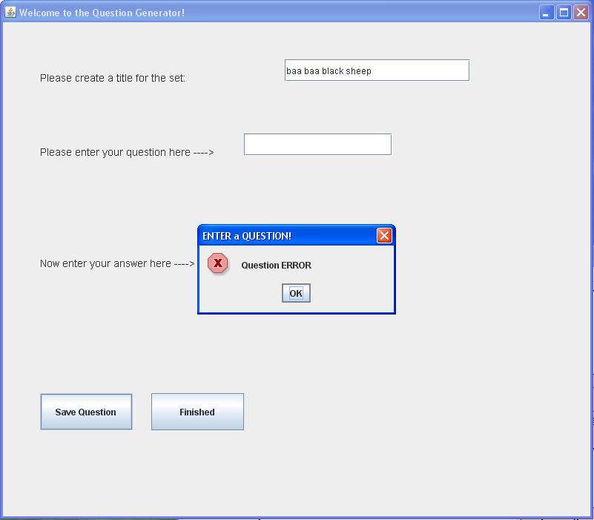
Here, this message appears when you have failed to enter a question when you click “Save Question”. Because of the way that questions and answers are stored, failing to enter one will cause problems later on in the game. As such, the code will prevent a user from entering a question without an answer, or an answer without a question. Also, it will prevent users from being able to add a blank question/answer combo.
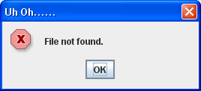
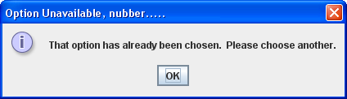
The code also catches errors where the file cannot be found. If this occurs, then it will display a message stating such, and allowing the user to choose a different topic or to solve the missing file issue. Also, if a user attempts to answer a question that has already been chosen, it will stop it and tell the user to pick another question.

C-3: Success of Program

Objectives | Evidence
An easy to use, straightforward interface  - Easy to maneuver thru program  - All user needs to do is pick a question and answer | 1. see annotations in D-1. (rather straightforward)  2. see page 36
A smooth random question generator that doesn’t repeat itself continually. | See page 19; [private int returnRandom()]
Usable by teacher for large scale review by a class. | Due to usage by a single individual, it can easily be used on a projector or smartboard system for a large scale review.

D-1: Test Run (Annotated)
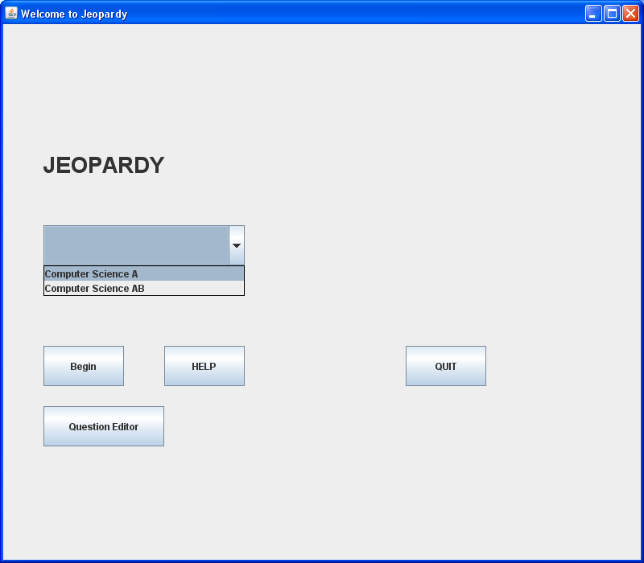
On this screen, the user will need to select one of multiple options.

The main option is to select a topic from the dropdown and then select BEGIN.

The HELP button launches the help menu.

The QUESTION EDITOR button launches the question editor.

QUIT closes the program.

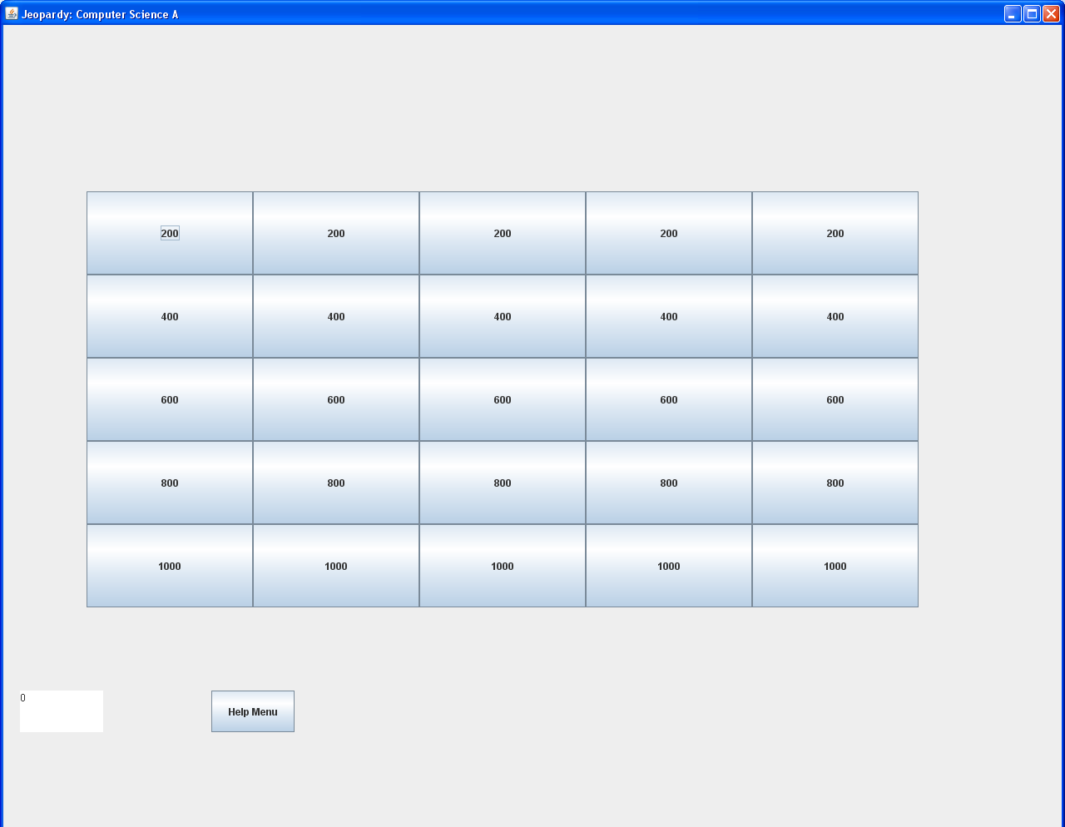
Here, the user will have selected a topic (CS for these purposes) and will then select a value and answer the corresponding question.

There is also a link to the help menu provided at the bottom for the user’s convenience.

Should the user desire to quit before finishing the game, they will need to click the ‘X’ in the upper right corner of the screen.

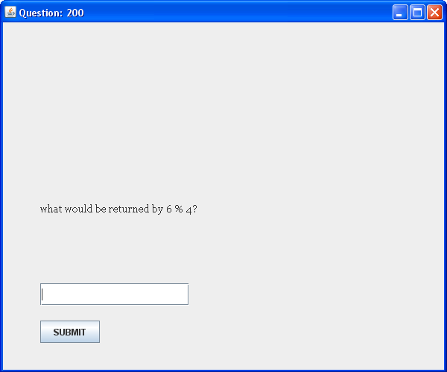
The user has chose an question, here of value 200.

The question is to be answered in the text field provided.

Once the user has entered an answer, they will click the SUBMIT button.

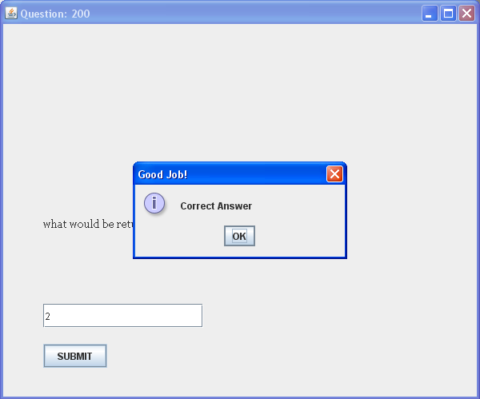
The user has here answered the question correctly, and the popup window has appeared to state such.

The user can continue by clicking the OK button.

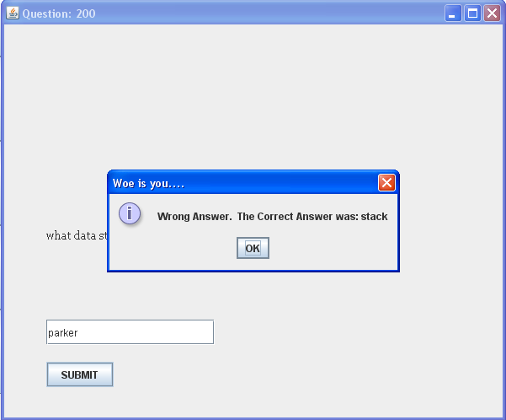
Here, the user has incorrectly answered a question, and the program displays a message dialog box to state such. Also, the correct answer to the question is displayed.

This window pops up after EVERY question has been answered.
It tells you what your final score was at the end of the game.
Click OK to continue.
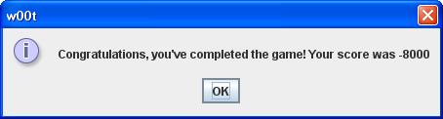

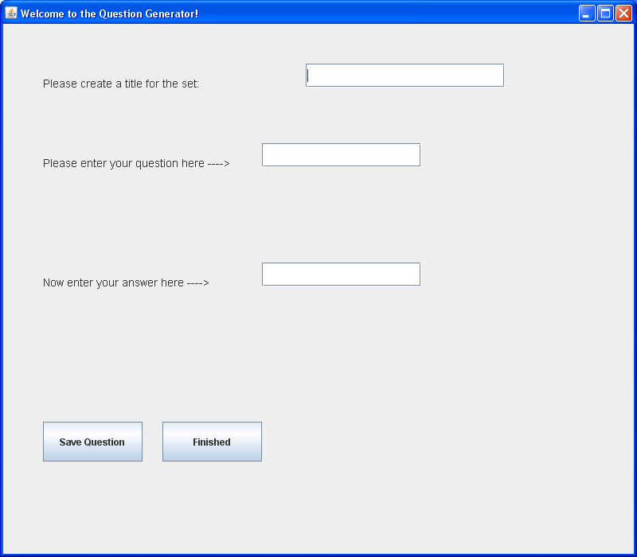
The user will here create a new set of question and answer combos for use in the game.

The user will enter a name for the set, which will then be added to the list of options on the startup screen.

The user will also need to enter 25 questions and 25 answers in order for the game to continue functioning properly.

After each question has been entered, the user will need to click SAVE QUESTION.

Click FINISHED when done.

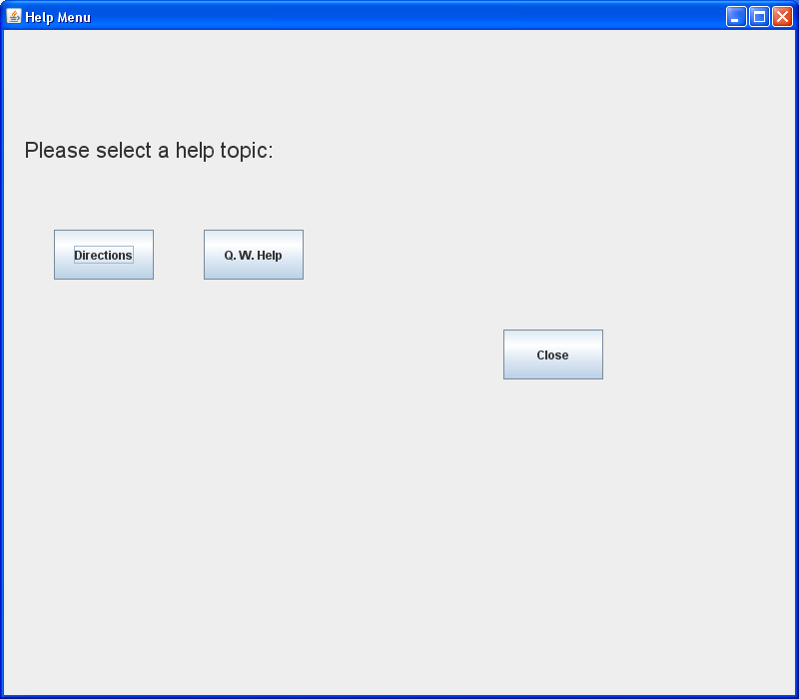
The user will need to select a topic for help.

DIRECTIONS will provide the user with info on the main game.

Q.W. HELP provides the user with directions on using the Question Writer portion of the program.

CLOSE to go back to main menu.
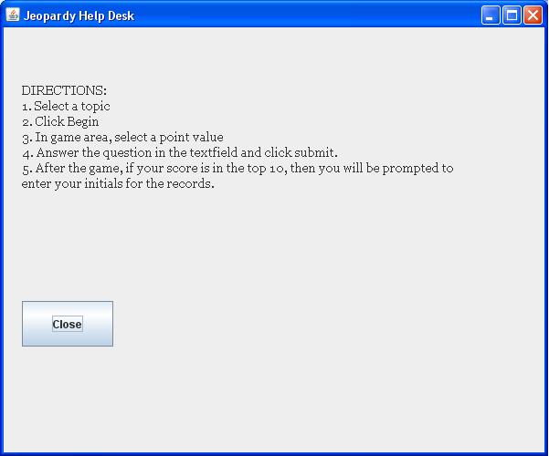
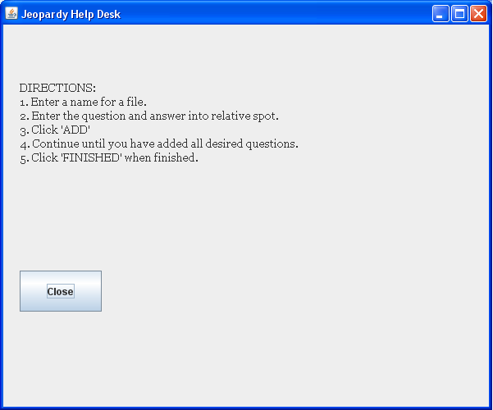
Here the user has selected a help desk option.

Information is provided.

User’s only option is to click CLOSE once finished.

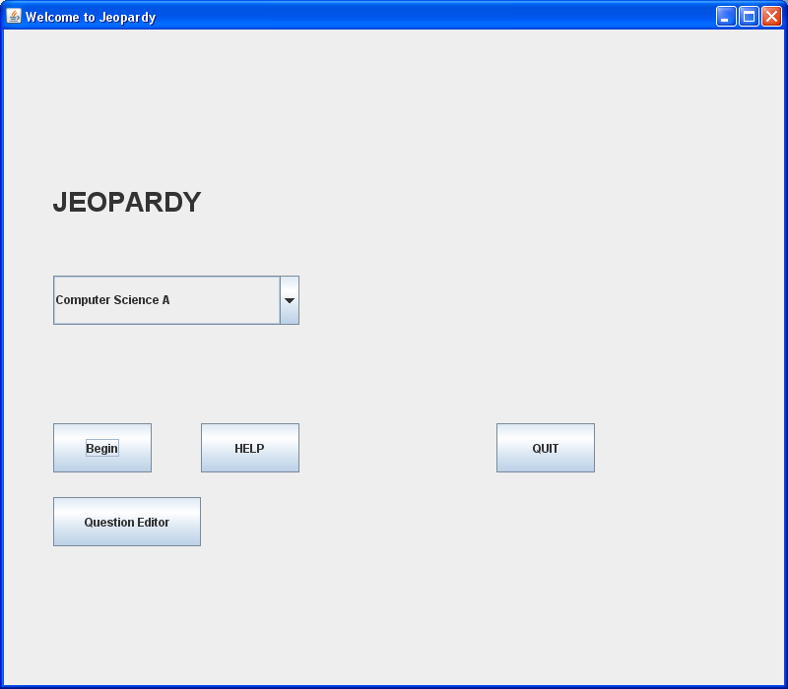
After completing a game, the user is brought back to this menu.

If the user is finished, then they can click the QUIT button to close the program.
D-2: Startup

To start up the program, the user will need to navigate to the folder that it is currently stored in.
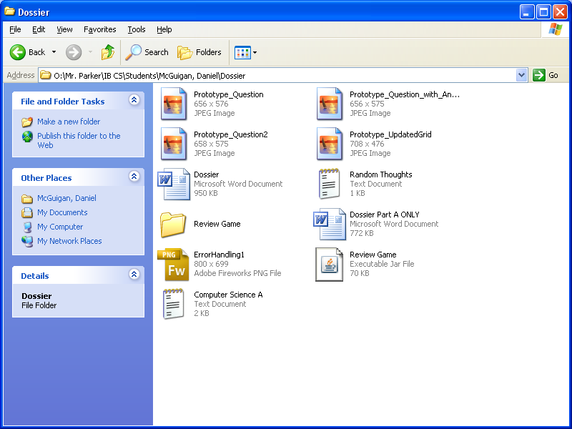
At this point, the user will need to double click on the Executable Jar File titled “Review Game”. This will launch the program. This will bring up the startup window, which will then require the user to pick a game topic and then begin (See Test Run for screenshots on following references).

D-2: Conclusion/Evaluation

Successful?
The program does successfully execute and run fine. It begins running smoothly, with a simple double click on the shortcut, launching the main menu. From there, the user has free reign to use the program to all its intended capabilities.

Criterion Addressed?
It did successfully meet the criterion that were determined at the beginning of this process. Because of the way it has been implemented, it can be used both individually and as a group thing, allowing for variety in game play. Also, everything is rather clearly labeled so that even the slowest of kretins will still be able to use the program without much difficulty. At the very least, they will be able to find the help directions. Also, the questions are displayed randomly, and not repeated, thanks to a simple code algorithm. It generates a random integer, and then checks to see if it has already been used. If it has, then it generates a new number.

Was Success Limited?
So far as my testing has shown, the program has been able to handle a variety of data sets. It is simply a review quiz type program, so it reads in String files from a text file. What it is in the file is irrelevant; it is converted and stored as a string variable in the program.

Any Limitations?
Yes, there are some limitations. Because it is a ‘free-response’ style quiz, exactly identical answers are required in order to get credit for answering correctly. If one word is missing or incorrect, then credit will not be awarded.

Also, because of the way the Question Writer portion is written, it does not yet require the user to enter a minimum number of questions before being usable in the game. This occurrence will cause a problem with the game, but I am in the process of finding an effective means of preventing this that I can add at a later date.

Additional Features?
One thing that I had contemplated putting in that didn’t make it was a record of the top 10 high scores. However, this missed being added in the current ‘final’ version due to time constraints and the need to eliminate the occurrences of exceptions.

Also, I am planning on creating a new and improved version of the Question Writer portion of the program. Its current condition works fine, but there is plenty of room for error that could be avoided by modifications in the coding.

Initial Design Appropriate?
Well, since I was initially using Applets, I’d say that it’s a pretty safe bet that it wasn’t. However, the overall idea lasted all the way to the final version. There is a startup window. From there, there is the game, and then from the game board, the user is taken to individual windows for each question. The final version is essentially an improved and expanded version of the initial design idea.

Future Enhancements?
There will most definitely be quite a few. As I mentioned above, the Question Writer class will have a priority in revamping. It really needs it.

Also, I am considering making the game follow a more multiple choice style game play, instead of free response. This will make it easier to ensure that people who know what they are talking about actually get credit for knowing the correct answer.

