Djamsmusic.com “Lets Jam”

|  |  |  |  |  |
| --- | --- | --- | --- | --- |
| Contact Us | About Us | Video Lessons | Chord Sheets  By Artist | Guitar Extras |

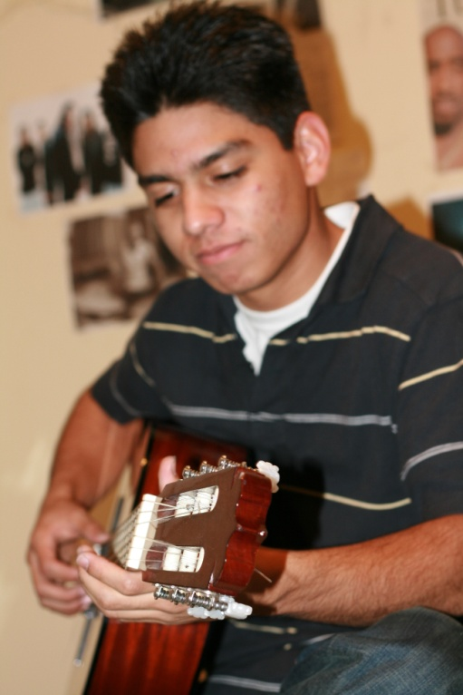

Welcome to Djamsmusic.com

Playing the guitar is fun and a great way to express your feelings through song.

In order to play the guitar you will need:

* A Guitar
* A tuner
* Patience

Here is a list of guitars that you can learn to play on:

ACOUSTIC GUITAR

ELECTRIC GUITAR