Djamsmusic.com “Lets Jam”

|  |  |  |  |  |
| --- | --- | --- | --- | --- |
| Contact Us | **About Us** | Video Lessons | Chord Sheets  By Artist | Guitar Extras |

Djamsmusic.com’s Purpose:

Thank you for visiting Djamsmusic.com. The purpose of this site is to share music with everyone that has a desire to learn how to play the guitar.

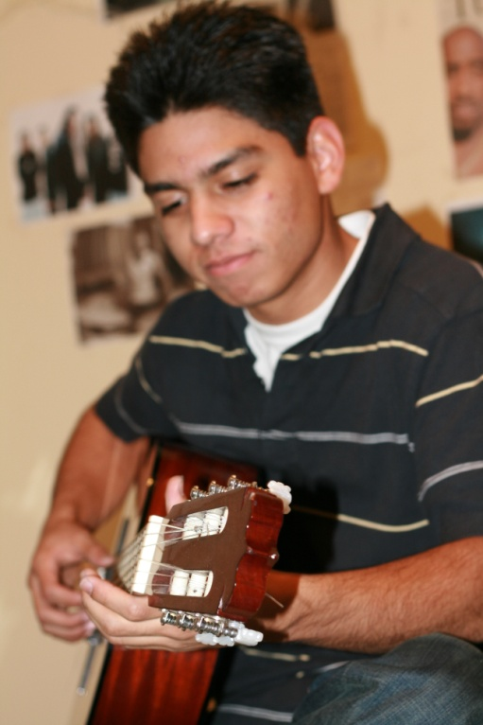

Hello my name is David and I created this site to teach beginners how to play the guitar and help my band members find chord sheets to the popular songs that we play.

This Website was started because our band needed to get better at finding, hearing, learning and practicing the music quickly and easily.

I hope you enjoy the content and feel free shoot me an email for any constructive criticism and suggestions.

Regards,

David Mendez