qlearning epsilon and its decrease rate per episode 1
reward: per training run, per timestep 1
capture the mean network reward 1
all these are subject to samplis as far too many datpoints otherwise 1
Main program 1
Plot position of nodes over time 1

qlearning epsilon and its decrease rate per episode

reward: per training run, per timestep

capture the mean network reward

all these are subject to samplis as far too many datpoints otherwise

Main program

Plot position of nodes over time
STARTING NEW EPISODE 1: 02-May-2017 11:56:44
Completed training run 1 out of total 1: 02-May-2017 11:57:18
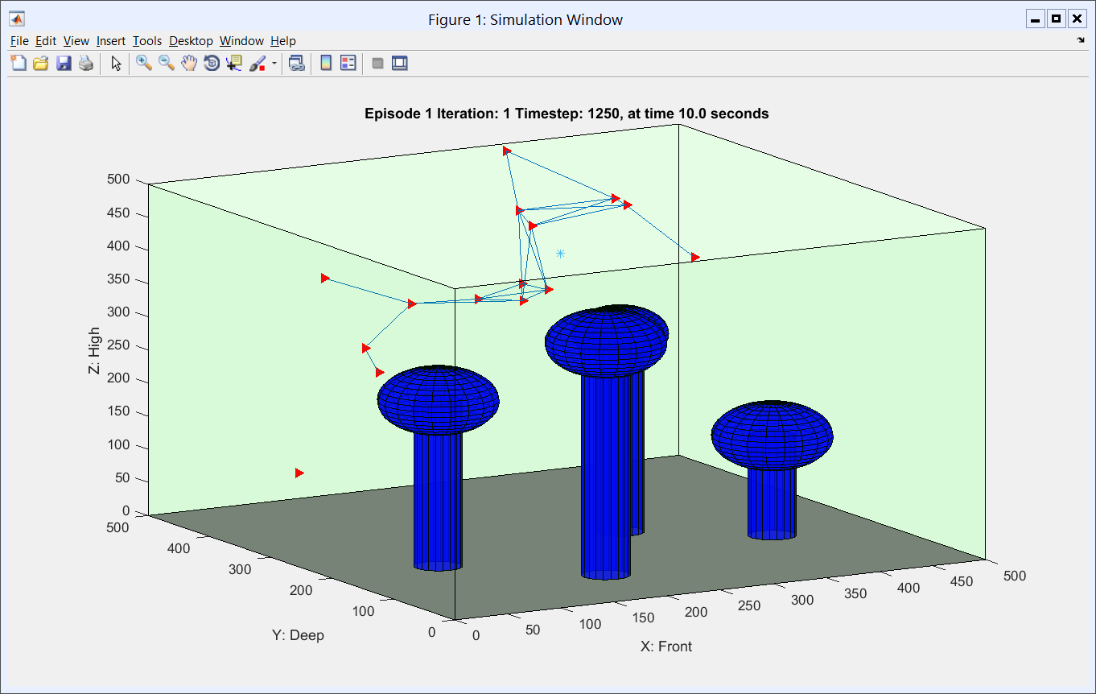
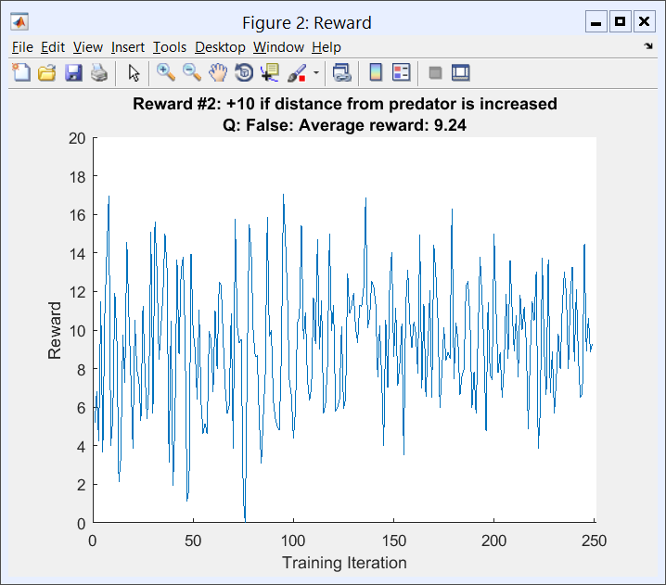
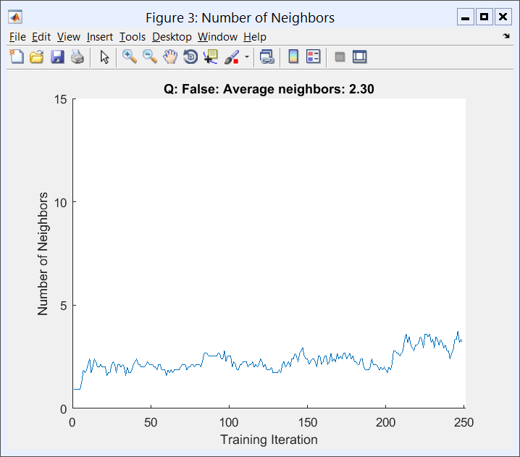
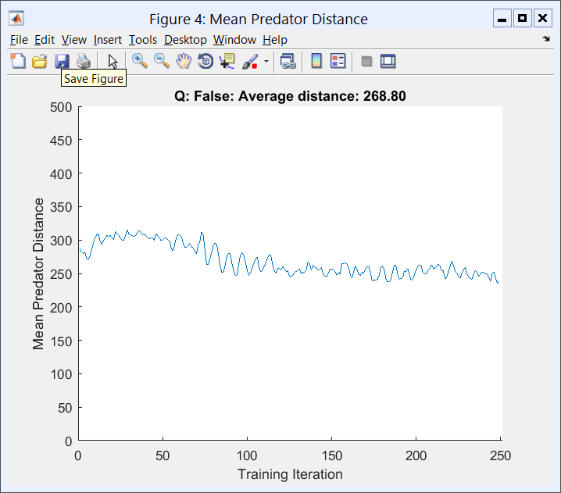
Published with MATLAB® R2016a

