Fortune Telling Fish.

A weird fish oracle that you can ask your fortune!

Trout which answers questions similar to a magic eight ball. Using a microcontroller similar to an Arduino called a propeller we can store many minutes of audio on an SD card and record the responses and lipsync the fish so that the responses and fish mouth match.

Possible additional features

* respond to sound with microphone. It would be ideal to be able to understand human speech but without a semi-powerful computer and internet, this would be difficult. If we wanted to use an internet connected Raspberry Pi this could be possible to some degree. For the standalone micro version, it would just respond to audio volume mainly and come to life and/or say something.
* Remote operation. Puppet the fish remotely! Using a camera and a microphone to give you fish telepresence. We would use a voice changer to make the fish voice. Essentially a puppet, it could be quite entertaining.
* Ask a question then touch the fish...or like press a button or touch a crystal ball....something that would trigger the response easier. Easier design
* wearable version! Mounted on your body in some form. Details to be determined. Need some sketches. (even crude is fine)

Mounting

Zee wants it to be sort of mounted in a tri-fold cabinet so when you approach it like a space you are entering...maybe install some lights. (Need illustration - crude is fine. I can fix them up)

Dates: End of June or June 11th for Maker Faire.

Fish measurements.

Nose to tail 29 cm

Dorsal fin tallest point 12 cm

Tail fin 8.5 cm

Kinda like this is s tent although this pic doesn't have the button

In a tent like A circus sideshow

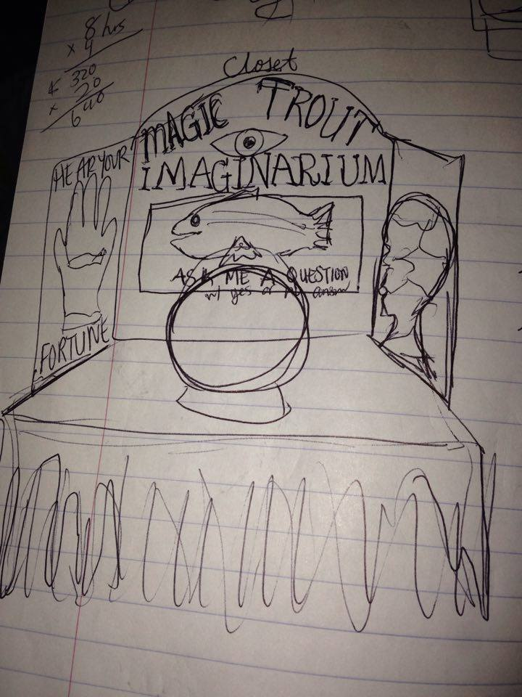



The button could be On the plaque.. I could make a new plaque if the one that it comes on isn't big enough, I could router out a place to fit the electronics in the back

New feature. Coin operation! Something like the following unit taking a loonie?



SAMPLE IMAGES

