C:\curs\Tema 2\qa-docker-compose-lab>docker compose up -d
[+] up 4/4
✔ Network qa-docker-compose-lab_default Created 0.0s
✔ Container qa-docker-compose-lab-cache-1 Started 0.5s
✔ Container qa-docker-compose-lab-db-1 Healthy 5.4s
✔ Container qa-docker-compose-lab-adminer-1 Started 5.4s

C:\curs\Tema 2\qa-docker-compose-lab>docker compose ps
NAME IMAGE COMMAND SERVICE CREATED STATUS PORTS
qa-docker-compose-lab-adminer-1 adminer:latest "entrypoint.sh docke…" adminer 11 seconds ago Up 5 seconds 0.0.0.0:8888->8080/tcp, [::]:8888->8080/tcp
qa-docker-compose-lab-cache-1 redis:7-alpine "docker-entrypoint.s…" cache 11 seconds ago Up 10 seconds 6379/tcp
qa-docker-compose-lab-db-1 postgres:16-alpine "docker-entrypoint.s…" db 11 seconds ago Up 10 seconds (healthy) 0.0.0.0:5432->5432/tcp, [::]:5432->5432/tcp

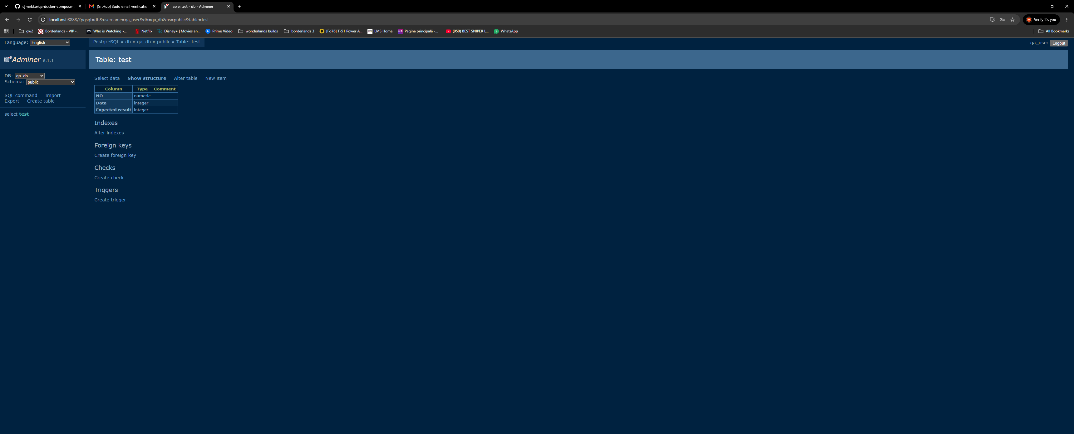

Flagul -v in comanda docker compose down -v ne garanteaza ca mediul de testare este curat la fiecare rulare. Flagul -v curata volumele si nu permite pastrarea datelor vechi care pot influenta rezulatele testelor actuale.

