# **Game Documentation**

## **Game Design**

A top down game (Like Pokemon/Among us/Don’t Starve) based round playing as the monsters in Transylvania such as vampires, frankensteins monster, werewolfs etc.

The player/s will start with an empty mansion which they will be able to fill with trophies, decorative items, traps etc. They can try to lure the local villagers to their mansion in secret to feed their hunger and not be caught. However to be able to do this the player will want to make their mansion attractable or else it can just end up scaring villagers away. By converting villagers, you can slowly build up your army of monsters to spread across the village. However at first you will want to convert villagers to help maintain your mansion to be able to attract more for example attracting the gardener and converting them can keep your gardens under control.

Depending on the type of monster you choose will decide the players strengths/weaknesses.

The vampire:

might seem like an attractive bachelor/bachelorette to lure in victims but he will struggle to go out in the day.

## **Screens**

In order the player will experience the following screens:

### **Main Menu**

New Game : Navigate to the New game character creation screen

Load Game : Navigate to the Loading an existing game screen

Options : Navigate to the options menu screen

Quit : Will show pop up if player is sure they want to close the game or not

### **New Game**

This screen will give the player the option as to what monster they want to play as with a image of the monster in the middle and their weaknesses and strengths on each side.

There will be a button to go back to the Main Menu screen and a button to create a new game. Note that a new game will have the option to invite others to play.

### **Load Game**

The load game screen will have a table of any games the player have previously saved with a button at the bottom of the screen to go back to the Main Menu screen and a button to load up the highlighted game. There will also be a button to delete the highlighted saved game.

### **Options**

The options menu screen will contain various buttons/sliders etc for the player to adjust the volume, screen resolution etc. There will also be a button to go back to the Main Menu Screen.

## **Multiplayer**

The player will have the option to invite friends through steam to their game, will need to investigate how this can be done early on. Currently have found the following videos:

[How To Connect Using Steam - Unity Multiplayer Tutorial](https://www.youtube.com/watch?v=QlbBC07dqnE)

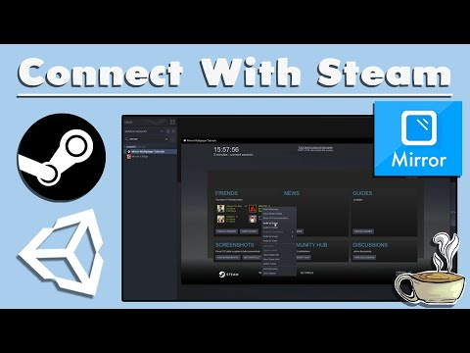

[How To Integrate Steam With Your Unity Game](https://www.youtube.com/watch?v=koeLpXVTVNU&ab_channel=DapperDinoDapperDino)

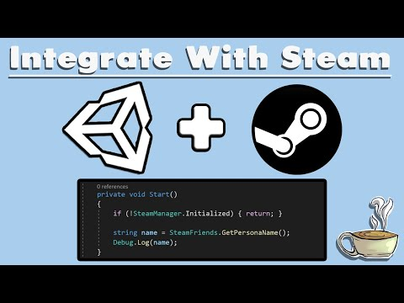

[HOW TO MAKE AN ONLINE MULTIPLAYER GAME - UNITY EASY TUTORIAL](https://www.youtube.com/watch?v=nmPukdOsYQA&ab_channel=diving_squid)

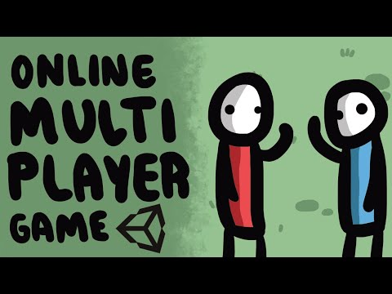

The players friend/s will then join the hosted players world where there will be the players Mansion which they will have the option to add to and lure villagers and help defend from any mobs and uninvited guests.

Note that if possible we will see if we can make it so the invited player be given the option to choose their own monster rather than be the same as the host. This means the host could end up with multiple types of monsters in their mansion.

## **Monsters**

Below are the list of monsters the player will be able to choose from with a description of their strengths and weaknesses.

### **Vampire**

The vampire requires to feed on blood to stay alive and will need to feed on villagers. Therefore when luring villagers back to their mansion they will have the choice to either feed or convert. Feeding will raise their blood meter back up and killing the villager, or the player can convert the villager to a vampire under their control. This will allow them to work for the player in the mansion.

**Strengths:**

The vampire will be able to lure their victims easier with their charm and good lucks.

The process to convert a villager is short and requires minimum effort

Can turn into a bat to hide but with a cool down

**Weaknesses:**

Vampires will be affected by day light and can show their more horrifying form frightening villagers away.

They require blood every so often to stay alive meaning they will need to feed off their victims.

Their bed is a coffin.

### **Werewolves**

The werewolf will require to feast on human flesh when he turns into his monstrous form every full moon. Therefore, they will have to keep track every night for in Transylvania a full moon could happen anytime. The player will only have the option to convert and feed on villagers during the full moon.

**Strengths:**

The werewolf can go out in the day and night as a ordinary looking human as long the full moon isnt out. Allowing them to lure their victims like any other human.

They gain a movement speed during their werewolf form if they need to chase down their victims and stop them from escaping.

**Weaknesses:**

During a full moon they are forced into their monstrous form which will immediately scare villagers from them.

They require to feast on human flesh during the full moon to stay alive and can become very messy.

They are hairy... everywhere

### **Frankenstein's Monster**

Frankenstein’s Monster is a terrifying monster and will need to lure villagers back to the mansion to replace used body parts for them to stay alive. Although requires time to perform the operation, they are very strong and can perform harder heavier tasks around the mansion with no need of assistance. They will have extra bars showing how long till certain limbs need replacing. To help lure in their victims they can wear a large cloak to hide their true form and can go out in the day or night.

With enough body parts they will be able to build more monsters like himself to help out round the mansion.

**Strengths:**

Very Strong for mansion tasks

Can go out during day or night without any negatives

Has cloak to cover monstrous identity for a time period.

**Weaknesses:**

Required to maintain limbs

Long time to create new monsters

Is weak to fire... so unable to install outside BBQ