STUDENT GUIDE
LMC Coding Lab
Thinking like a processor
A short tour of the Little Man Computer, how to drive LMC Coding Lab, and a set of exercises that take you from your first INP to programs that multiply and divide.
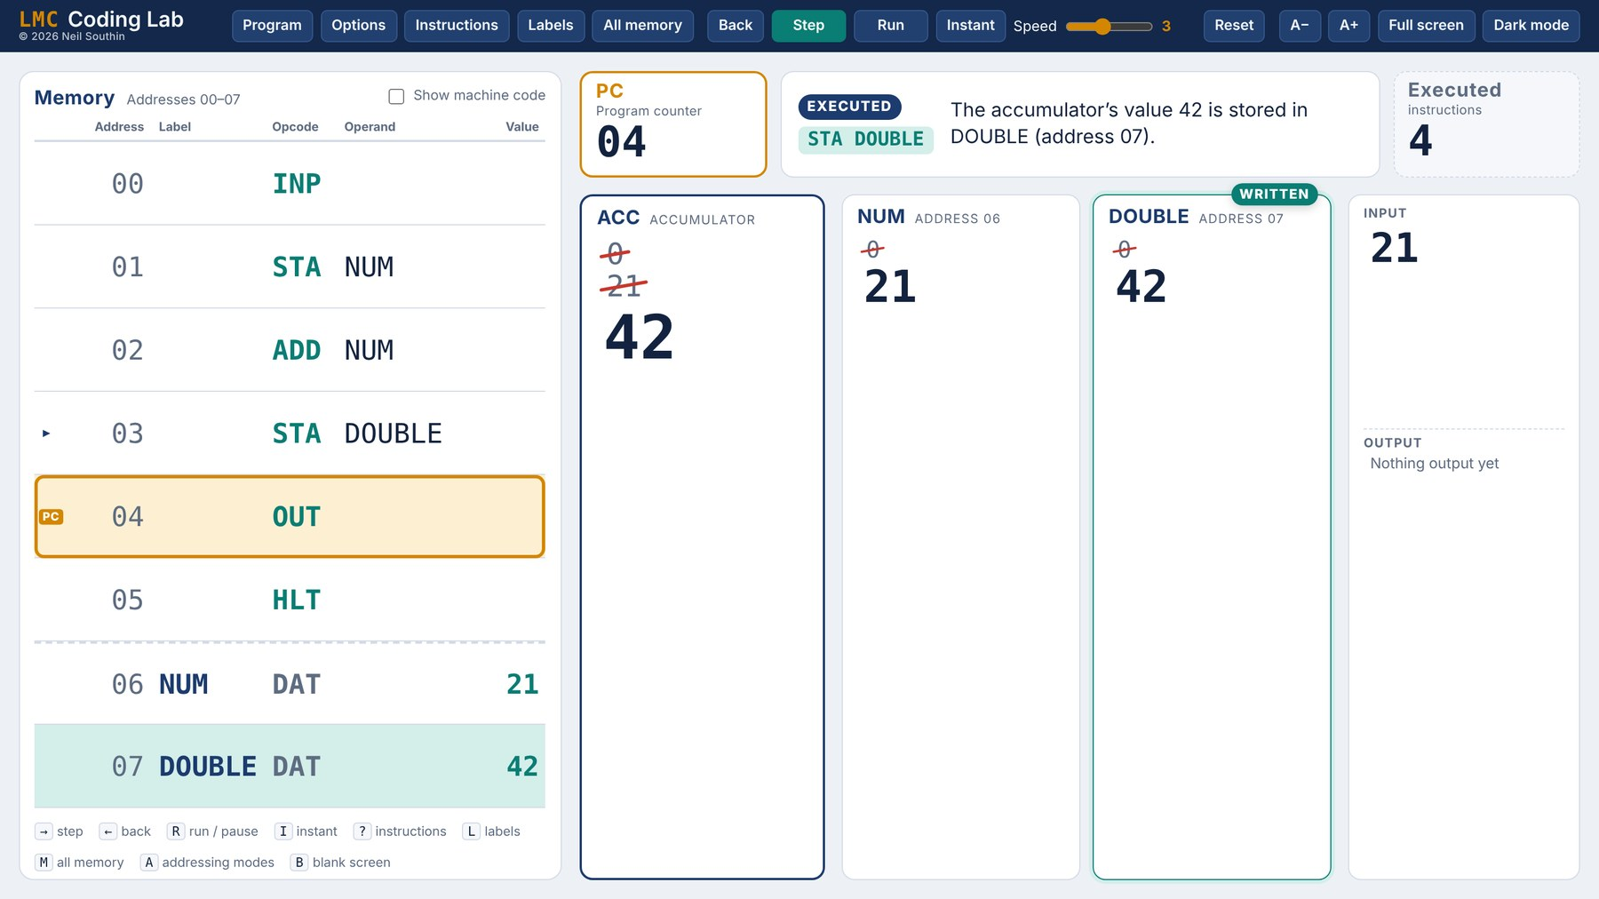
PART 1  What LMC is | PART 2  Tour of the app | PART 3  Habits that help | PART 4  Exercises and extensions

Work through it in order. Each exercise adds one new idea, and the hints are there for when you are stuck, not before you have tried. Keep the app open while you work.
Open the app: LMC Coding Lab

PART 1

What is the Little Man Computer?
The Little Man Computer was invented by Stuart Madnick at MIT in 1965 as a way of teaching how a processor really works, without the electronics getting in the way. It is small enough to understand completely, but it works on exactly the same principles as the processor in your phone.

The story
Picture a little man shut in a room. Along one wall are 100 mailboxes, numbered 00 to 99, and each one holds a single number. On his desk there is a calculator that can add and subtract, a counter that tells him which mailbox to visit next, an in-tray where numbers arrive from outside and an out-tray where he puts his answers.
All day long he does the same thing: read the counter, go to that mailbox, read the instruction inside, add one to the counter, then carry the instruction out. That is it. Everything clever that a computer does is built from this loop.
Part | In the story | What it does
Memory | 100 mailboxes | Holds the program and the data. Each location has an address (00–99) and holds one number from −999 to 999.
Accumulator (ACC) | The calculator | The only place where arithmetic happens. Every result lands here, and almost every value passes through it.
Program counter (PC) | The counter | Holds the address of the next instruction. Branch instructions work by changing it.
Input | The in-tray | INP takes a number from the user and puts it in the accumulator.
Output | The out-tray | OUT copies the accumulator to the output.
CIR, MAR, MDR | His notepad | Registers used while fetching and decoding. Hidden in the app to start with; switch them on in Options if your course needs them.

Fetch, decode, execute
The loop the little man repeats has a name you will need for exams: the fetch–decode–execute cycle.
1 Fetch  Go to the address in the PC and copy the instruction from that location. Add 1 to the PC, ready for next time. | 2 Decode  Split the instruction into its opcode (what to do) and its operand (which address to do it with). | 3 Execute  Do it: load, store, add, input, output, or jump somewhere else by putting a new address in the PC.

BIG IDEA
The program and its data share the same memory. This is the von Neumann (stored program) idea and it is how almost every computer works. It also means the little man cannot tell an instruction from a number: if the PC wanders into your data, he will try to run it.

The instructions
LMC has fewer than a dozen instructions. You will learn them a few at a time in the exercises, so do not try to memorise this table now; come back to it when you need it. In the app, press ? or click Instructions to see the same list. There is a copy in Appendix A too.
Mnemonic | Code | What it does | Example
INP | 901 | Wait for a number to be typed in, then put it in the accumulator. | INP
OUT | 902 | Copy the accumulator to the output. The accumulator keeps its value. | OUT
LDA | 5xx | Load: copy the value at address xx into the accumulator. | LDA NUM
STA | 3xx | Store: copy the accumulator into address xx. The accumulator keeps its value. | STA NUM
ADD | 1xx | Add the value at address xx to the accumulator. | ADD ONE
SUB | 2xx | Subtract the value at address xx from the accumulator. | SUB ONE
BRA | 6xx | Branch always: jump to address xx. | BRA LOOP
BRZ | 7xx | Branch if zero: jump to xx if the accumulator is 0. | BRZ DONE
BRP | 8xx | Branch if positive: jump to xx if the accumulator is 0 or more. | BRP LOOP
HLT | 000 | Stop the program. | HLT
DAT | – | Not an instruction. Reserves a memory location for data, with an optional starting value. | ONE DAT 1
OTC | 922 | Output the accumulator as a character (65 is A). An extra; not in every version of LMC. | OTC

Some textbooks write STO for STA and COB for HLT; the app accepts both.
WATCH OUT
BRP treats zero as positive. It branches when the accumulator is 0 or more, and only falls through when it is negative. Almost every LMC bug in a loop comes back to this.

Assembly language and machine code
You write programs in assembly language: short words called mnemonics such as LDA and ADD. The computer itself only stores numbers, so before a program can run it has to be assembled into machine code. Each instruction becomes a three-digit number: the first digit is the opcode, the last two are the address. For example, ADD 07 becomes 107 and STA 15 becomes 315.
In the app, the Assemble into memory button does this for you. Tick Show machine code above the memory table to see the numbers that are really stored.

How a line is laid out
Each line has up to four parts. Only the opcode is always needed.
LOOP | SUB | ONE | // take one off
LABEL | OPCODE | OPERAND | COMMENT

- A label is a name for that line’s address. Other lines can then say BRA LOOP instead of BRA 03, and the assembler works out the number.
- The opcode is the instruction.
- The operand is the address the instruction works with, usually written as a label.
- A comment starts with // and is ignored by the assembler. It is there for people.

Data is declared at the bottom with DAT. The label is the variable’s name and the number after DAT is its starting value:
VARIABLES LIVE AFTER THE PROGRAM
HLT
COUNT DAT 0 // a counter that starts at 0
ONE DAT 1 // a constant: LMC has no way to write "1" in an instruction
NUM DAT // no value given: starts empty (0)

PART 2

A tour of LMC Coding Lab
LMC Coding Lab shows the whole machine on one screen: memory on the left, the accumulator and your variables on the right, and a sentence at the top explaining what just happened. Old values are not wiped; they are crossed out and left in place, so you can see the history of every variable.
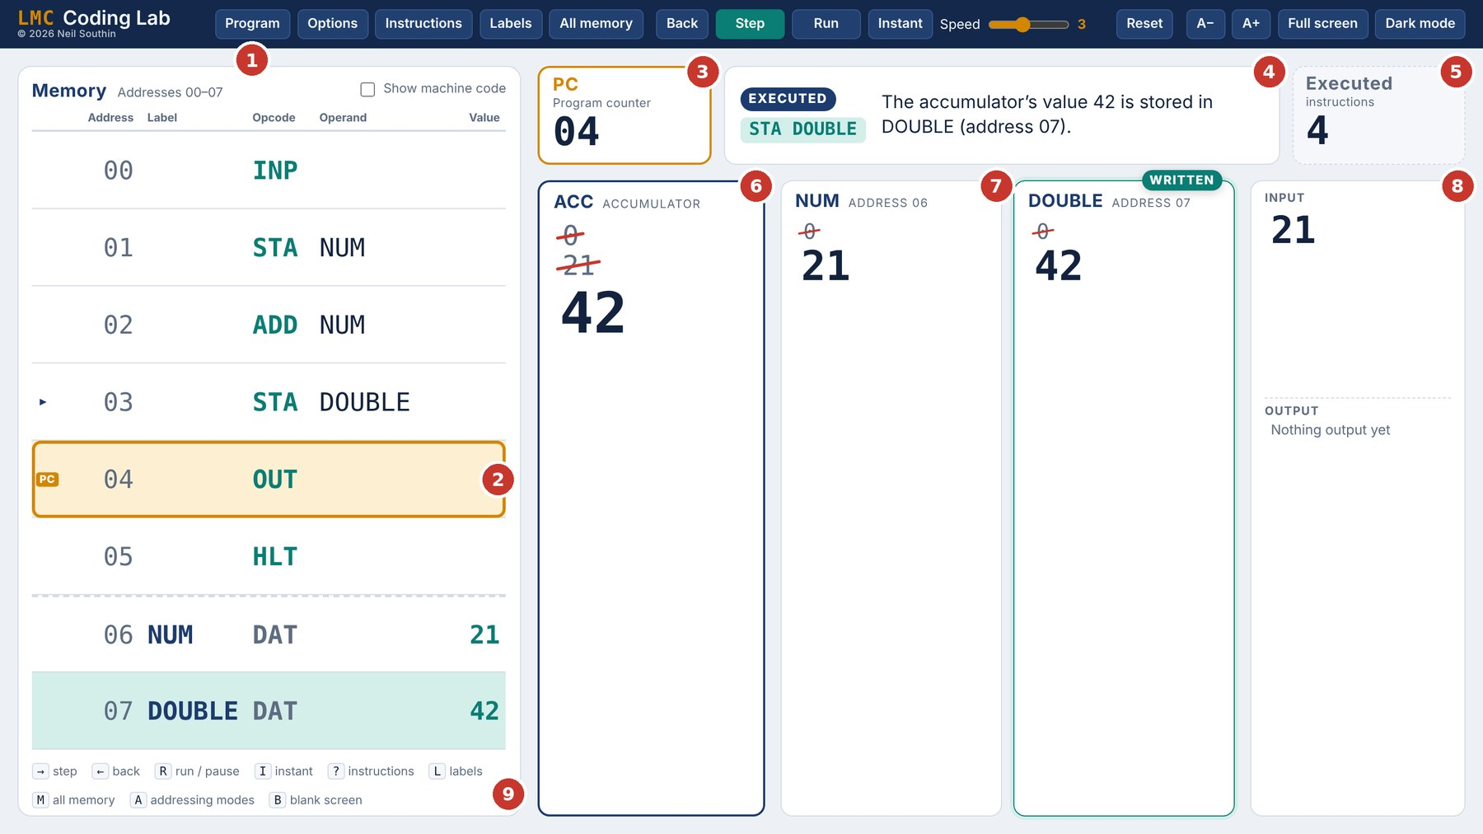
Part way through a program that doubles a number. The same program is traced in Part 3.
1 Top bar. Program opens the code editor; Step, Back, Run and Instant drive the program.  2 Memory table. The coloured box marks the PC: the instruction that will run next. The small arrow marks the one that just ran.  3 Program counter. The address of the next instruction.  4 Explanation. What the last instruction did, in plain English. Read it every step.  5 Executed instructions. How many instructions have run. Useful for comparing two versions of a program. | 6 Accumulator. The current value is large; earlier values are crossed out above it.  7 Variable cards. One card for each DAT, with its own history. A badge shows when it is read or written.  8 Input and output. Everything typed in and everything the program has output.  9 Shortcut strip. A reminder of the keys you can use.

Your first run
- Click Program. The code editor opens.
- Choose Add two numbers from the examples list, or type a program of your own.
- Click Assemble into memory. If there is a mistake, the editor stays open, the address turns red and a message tells you what is wrong.
- Press Step (or the right arrow key). One instruction runs. Read the explanation, then look at what changed.
- When the program reaches INP, an input box appears. Type a number and press Enter.
- Keep stepping until the status says Halted. Press Reset to run it again with the same code.

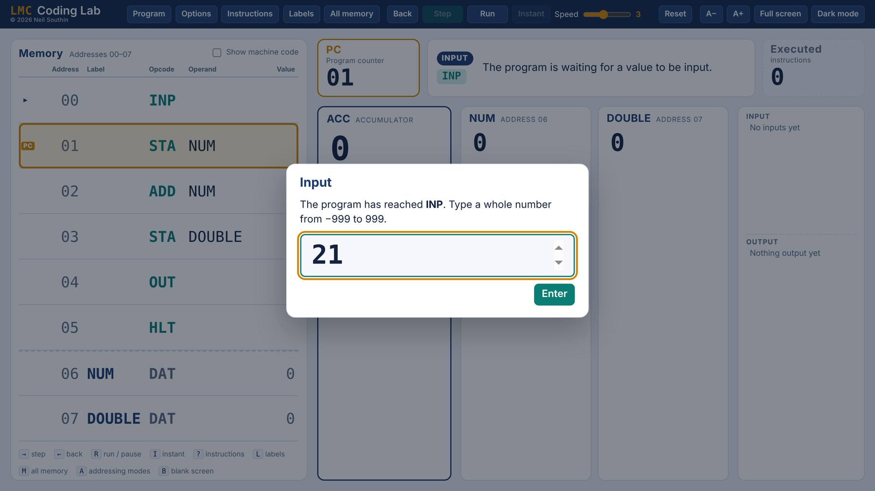
When the program reaches INP it waits for you to type a number.

The code editor
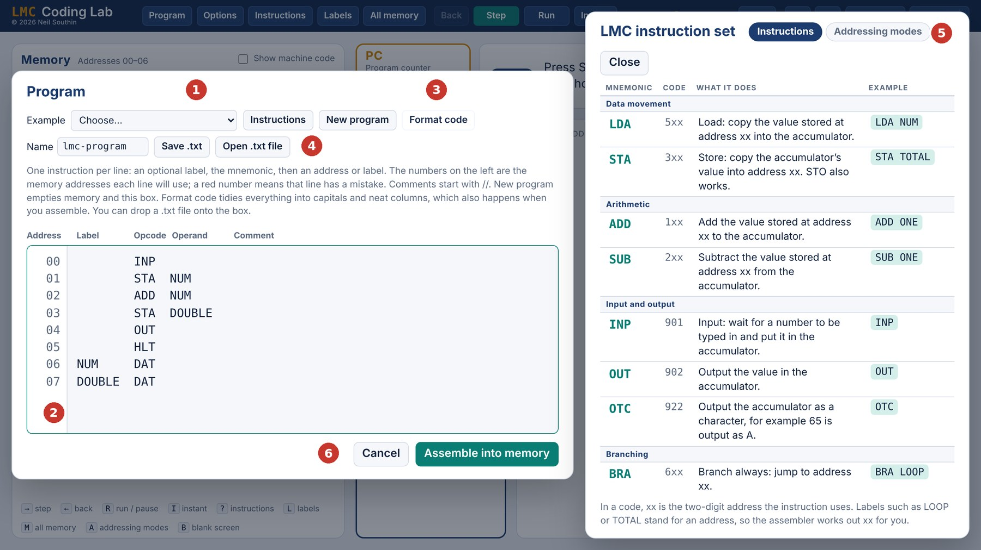
1 Examples. Ready-made programs, from the basics up to showcase programs.  2 Address column. Shows where each line will go in memory.  3 Format code. Tidies everything into capitals and columns. This also happens every time you press Enter. | 4 Save .txt and Open .txt file. Keep your work. Give it a sensible name first.  5 Instructions. The instruction list opens beside your code, so you can check an opcode while you type.  6 Assemble into memory. Turns your code into machine code and loads it, ready to run.

New program clears the editor and empties memory. If the assembler finds a problem, the address of the bad line turns red and the message underneath says what is wrong:
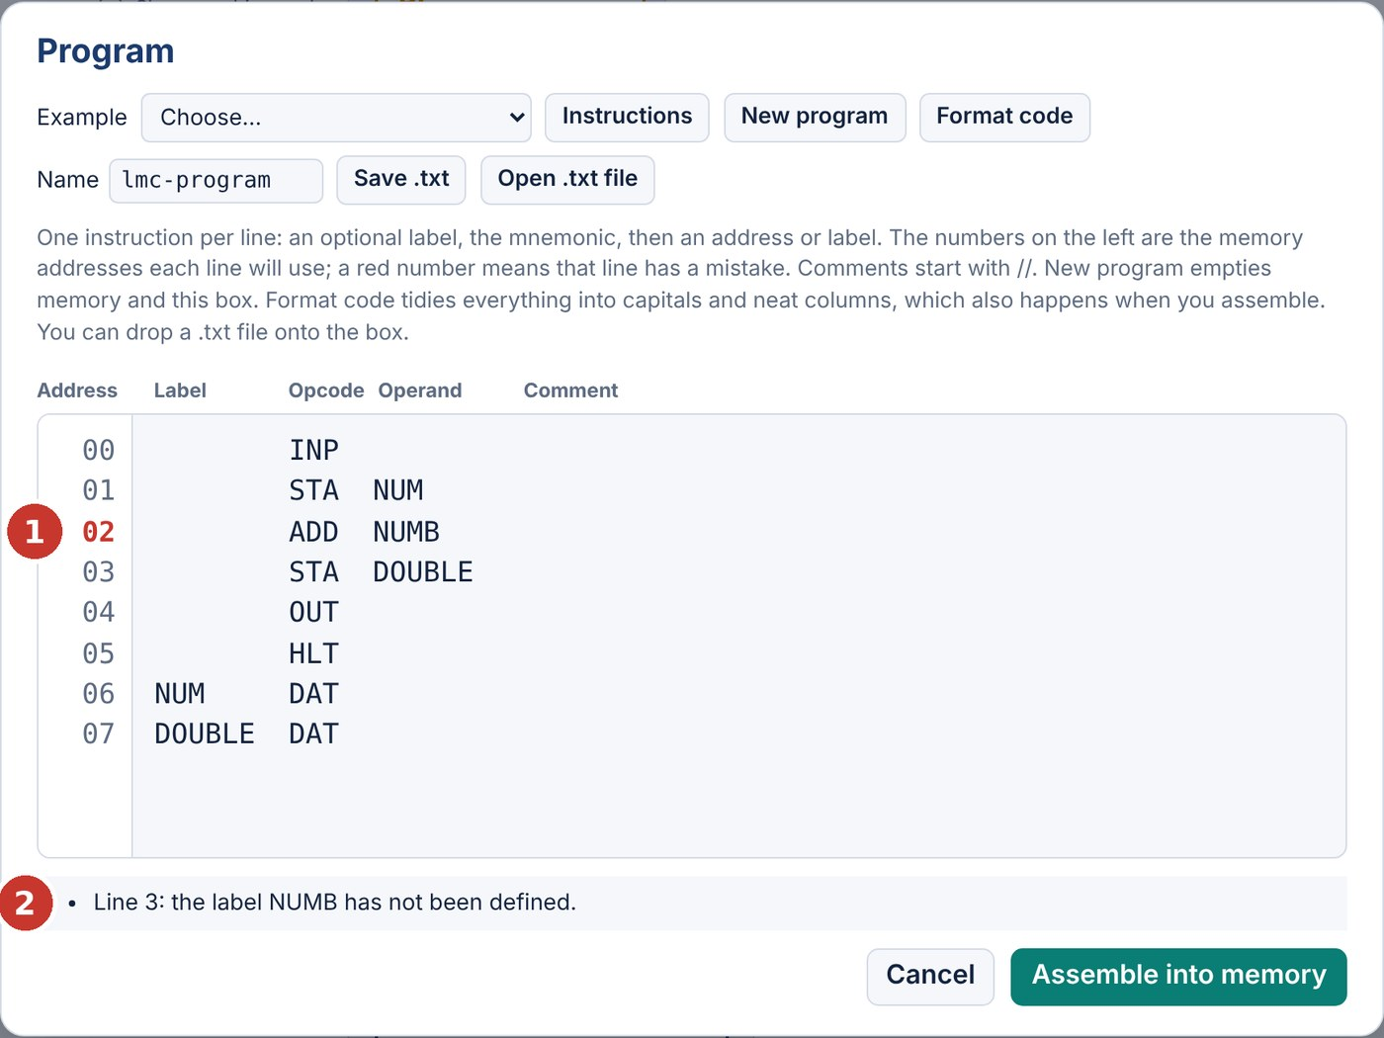
A spelling mistake in a label: NUMB has never been defined.

Running a program
Button | Key | What it does
Step | Right arrow, Space | Run one instruction. This is the button you will use most.
Back | Left arrow | Undo the last instruction. Go back as far as you like to see where something went wrong.
Run | R | Step automatically at the chosen Speed. Press again to pause.
Instant | I | Run straight to the end, stopping only for input. Use it once a program works, or when a loop runs hundreds of times.
Reset |  | Start the same program again from address 00, with fresh data.
A− / A+ |  | Make everything smaller or bigger.

Other things worth knowing
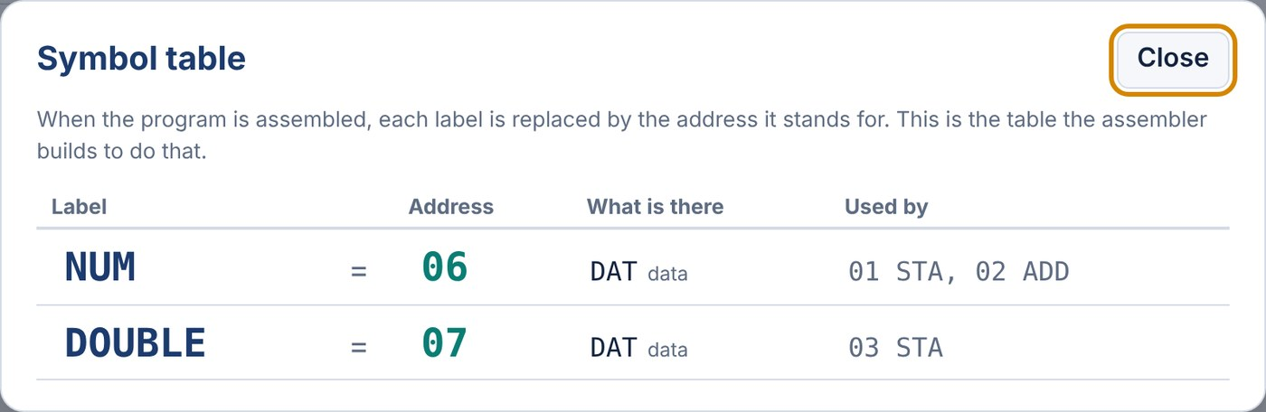
Labels (L): the symbol table the assembler builds.
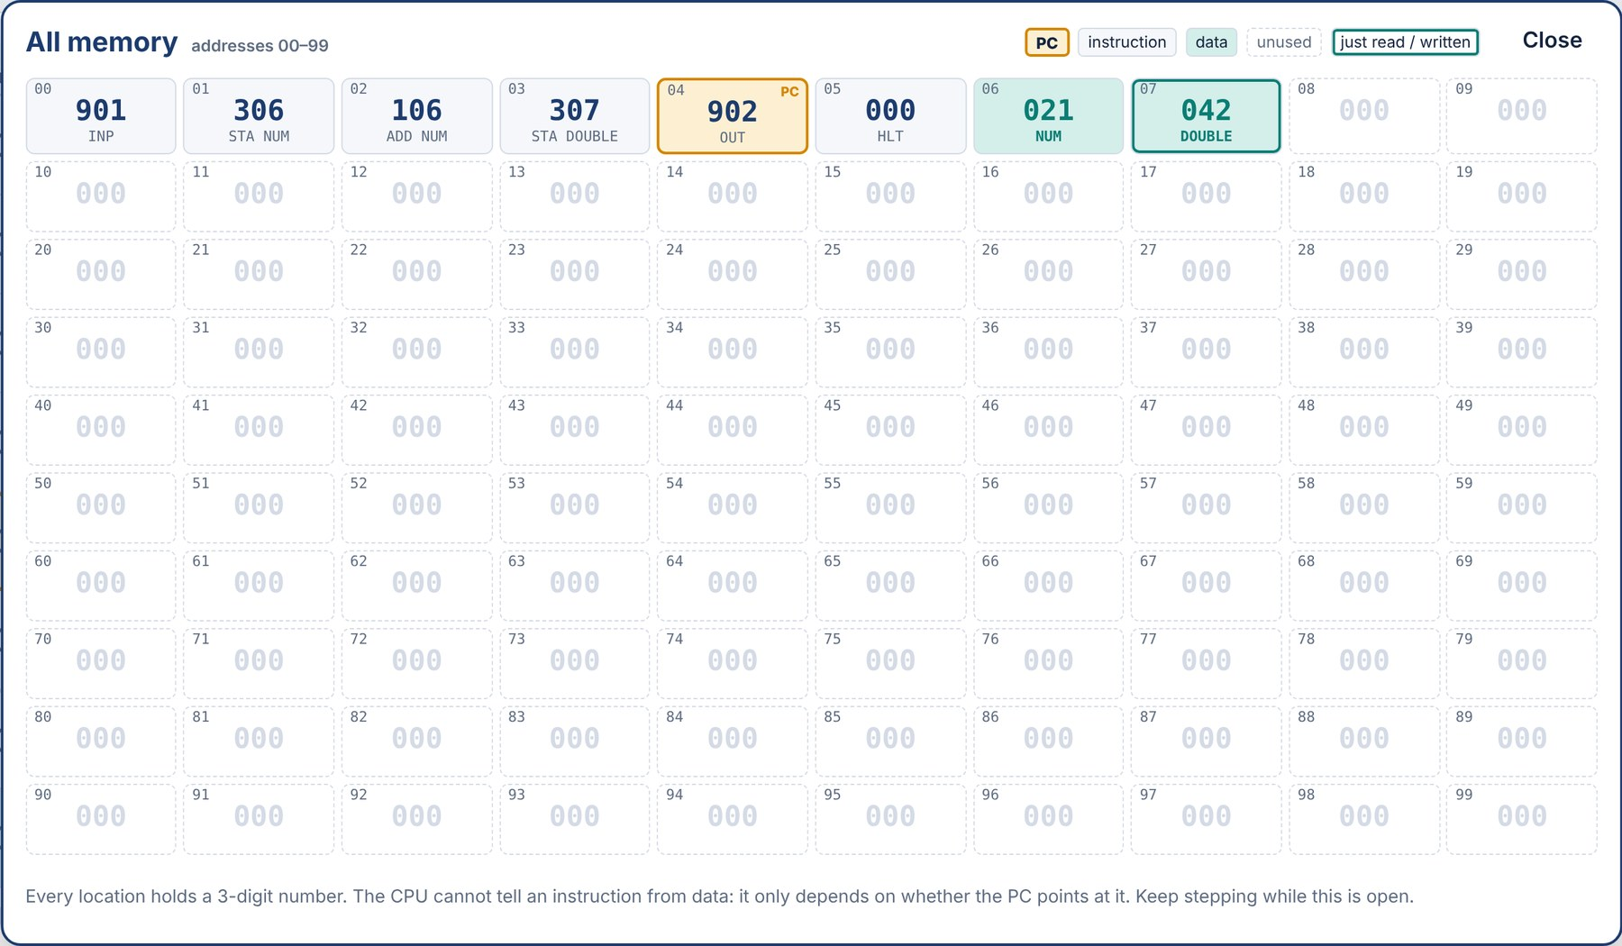
All memory (M): all 100 locations, updating live while the program runs.
LABELS (L)
The symbol table: every label, the address the assembler gave it, and which instructions use it. Handy for answering “where is NUM stored?”

ALL MEMORY (M)
All 100 locations in a 10×10 grid, as machine code. It keeps updating while the program runs, so you can watch your data change.

BREAKPOINTS
Turn them on in Options, then click an address in the memory table. Run and Instant pause when they reach it: ideal for skipping to the interesting part of a long loop.

OPTIONS
Themes, how many past values to show, output on separate lines or in a row, the CIR/MAR/MDR registers, and editing straight in the memory table.

Keyboard shortcuts
Key | Action | Key | Action
Right arrow, Space | Step | L | Labels (symbol table)
Left arrow | Back | M | All memory
R | Run / pause | ? | Instructions
I | Instant | A | Addressing modes (advanced)
Esc | Close a panel | F5 | Full screen

PART 3

Habits that help
Programming in LMC is mostly about keeping track of where each value is. These habits save a lot of time.
1. Predict, then step
Before you press Step, say out loud (or write down) what you expect to change. If the screen disagrees with you, you have learned something, either about LMC or about your program.
2. Plan in English first
Write the steps as plain sentences or pseudocode, then turn each one into a few LMC lines. It is much easier to fix a plan than to fix 20 lines of assembly.
3. Everything goes through the accumulator
You cannot add two memory locations together directly. One of them has to be loaded into the accumulator first, and the answer comes back into the accumulator. When you need a value later, store it, because the next INP, LDA, ADD or SUB will replace what is there.
4. Copying does not move
STA copies the accumulator into memory and LDA copies memory into the accumulator. In both cases the original is still there afterwards. OUT does not empty the accumulator either.
5. Data goes after HLT
Put all your DAT lines at the bottom, after the last HLT. If the program runs past its end, the little man will treat your data as instructions. (A value of 0 happens to mean HLT, so sometimes you get away with it, which only hides the bug.)
6. Use labels, never raw addresses
Write STA TOTAL, not STA 14. If you add a line later, every address after it moves, but labels move with them.
7. Test the awkward cases
A program that works for 6 and 7 might not work for 0, for two equal numbers, for a negative, or for an answer bigger than 999. Each exercise lists test data; use all of it.
8. Use Back
If something goes wrong, do not reset straight away. Step back until the moment just before it went wrong and look at the accumulator and the variables.
9. Keep a trace table
A trace table records each instruction and the values that change. It is the best way to check a program on paper, and exam questions love them. Here is one for a program that doubles a number, with 21 as the input. There is a blank one to photocopy in Appendix A.
DOUBLING PROGRAM
INP
STA NUM
ADD NUM
STA DOUBLE
OUT
HLT
NUM DAT
DOUBLE DAT

Step | PC | Instruction | ACC | NUM | DOUBLE | Output
1 | 00 | INP | 21
2 | 01 | STA NUM |  | 21
3 | 02 | ADD NUM | 42
4 | 03 | STA DOUBLE |  |  | 42
5 | 04 | OUT |  |  |  | 42
6 | 05 | HLT

Only write a value when it changes. The screenshot in Part 2 shows this same program after step 4: compare it with the table.
10. Know the limits
Every location holds a whole number from −999 to 999. If an answer goes outside that range the app stops with an overflow error. There are no fractions, so division gives a whole-number answer and a remainder.

PART 4

Exercises
Twelve exercises in five stages, finishing with multiplication and division. For each one:
- Read the task and the test data. Work out on paper what the program must do.
- Write it in the code editor, assemble it, and step through it once with the first test.
- Run every test. Only read a hint if you have been stuck for a while.
- Answer the Think about it questions, then compare with the model answer in Appendix B. Yours does not have to match; it just has to work.

Tick the Done box on each exercise as you finish it.
STAGE A In and out
Getting numbers into the machine, storing them and getting them back out.
1 | Echo  INP OUT HLT | ☐ Done

Write a program that inputs a number and outputs the same number.
TEST DATA
Input | Expected output
7 | 7

HINTS: ONLY IF YOU ARE STUCK
Hint It is three lines long. INP puts the number in the accumulator, and OUT outputs whatever is in the accumulator.

THINK ABOUT IT
- Tick Show machine code. What numbers are stored at addresses 00, 01 and 02?
- After OUT has run, what is in the accumulator?
- What would happen without the HLT?
Model answer: Appendix B, exercise 1.
NEW IDEA: VARIABLES
The accumulator holds only one number. When a second INP runs, the first number is replaced (watch it get crossed out). To keep a value, store it in a memory location with STA, and load it back later with LDA.
Make the locations at the bottom of the program with DAT and give each one a label. That label is the variable’s name.

2 | Two in, then two out  STA LDA DAT labels | ☐ Done

Input two numbers. Only after both have been entered, output them in the order they were typed.
TEST DATA
Input | Expected output
4, 9 | 4 9

HINTS: ONLY IF YOU ARE STUCK
Hint 1 You need two variables: one for each number. Call them FIRST and SECOND.
Hint 2 The pattern is: INP, STA FIRST, INP, STA SECOND. Then load each one in turn and output it.

THINK ABOUT IT
- Press L to open the labels. Which addresses did the assembler give FIRST and SECOND? Why those?
- What machine code is STA FIRST?
- Does STA change the accumulator?
Model answer: Appendix B, exercise 2.
3 | Backwards  practice a little puzzle | ☐ Done

Input three numbers, then output them in reverse order. Try to use only two variables.
TEST DATA
Input | Expected output
1, 2, 3 | 3 2 1

HINTS: ONLY IF YOU ARE STUCK
Hint Which number is output first? Where is it straight after the third INP?

THINK ABOUT IT
- How many instructions does your program execute? Can you find a version that uses fewer?
Model answer: Appendix B, exercise 3.
STAGE B Arithmetic
Adding and subtracting, and using constants.
NEW IDEA: ADD AND SUB
ADD NUM means “accumulator = accumulator + the value in NUM”. SUB NUM means “accumulator = accumulator − the value in NUM”. One value is always the accumulator, the other always comes from memory, and the answer always replaces what was in the accumulator.

4 | Add two numbers  ADD | ☐ Done

Input two numbers and output their total.
TEST DATA
Input | Expected output
8, 5 | 13
−4, 10 | 6

HINTS: ONLY IF YOU ARE STUCK
Hint You only need to store one of the numbers. When the second one arrives it is already in the accumulator, ready to have the first added to it.

THINK ABOUT IT
- Step through the ADD and watch the two values meet. Where does each one come from?
- Try 600 and 600. What happens, and why?
Model answer: Appendix B, exercise 4.
5 | Subtract  SUB order matters | ☐ Done

Input two numbers and output the first minus the second.
TEST DATA
Input | Expected output
8, 5 | 3
5, 8 | −3

HINTS: ONLY IF YOU ARE STUCK
Hint Copying the add program will not quite work: with INP, STA FIRST, INP, SUB FIRST you get second minus first. You need the first number in the accumulator when you subtract, so store both and load the first one back.

THINK ABOUT IT
- With 8 then 5, what would INP, STA FIRST, INP, SUB FIRST output?
- Why did the order not matter in exercise 4?
Model answer: Appendix B, exercise 5.
COMMON MISTAKE
ADD 10 does not add ten. It adds whatever is stored at address 10. To use a fixed number, store it in a variable with DAT and add that: ADD TEN with TEN DAT 10 at the bottom. A variable that never changes is called a constant.

6 | Three times and ten more  constants DAT 10 | ☐ Done

Input a number N and output 3N + 10.
TEST DATA
Input | Expected output
7 | 31
0 | 10

HINTS: ONLY IF YOU ARE STUCK
Hint 1 LMC cannot multiply, but 3N is N + N + N.
Hint 2 Store N straight after inputting it. The accumulator still holds N, so two more ADD NUM lines make 3N.

THINK ABOUT IT
- Change your program to output 5N − 4. Test it with 7 (you should get 31 again).
- What is the biggest N that works for 3N + 10?
Model answer: Appendix B, exercise 6.
STAGE C Loops
Making the program go round again, and deciding when to stop.
NEW IDEA: BRANCHING
Normally the PC just goes up by one each time. A branch puts a new address in the PC instead, so the next instruction comes from somewhere else.
BRA LOOP | Always jump to LOOP.
BRZ DONE | Jump to DONE only if the accumulator is exactly 0. Otherwise carry on to the next line.
BRP LOOP | Jump to LOOP only if the accumulator is 0 or more. Otherwise carry on.

A loop is a label at the top and a branch at the bottom that jumps back to it. Something inside the loop has to change, or it will go round for ever.
THE SHAPE OF A LOOP
LOOP ... // do the work
... // change something (a counter, usually)
BRP LOOP // decide: round again?
HLT

7 | Countdown  BRP loop | ☐ Done

Input a number and count down from it to 0, outputting every number on the way.
TEST DATA
Input | Expected output
5 | 5 4 3 2 1 0
0 | 0

HINTS: ONLY IF YOU ARE STUCK
Hint 1 Inside the loop: output, take one off, and if the result is still 0 or more, go round again. You need a constant ONE DAT 1.
Hint 2 The whole program fits in five lines plus the DAT. The number never needs to be stored: it just stays in the accumulator.

THINK ABOUT IT
- What is in the accumulator when the program halts?
- What happens if you input −3?
- Change it to count down to 1 instead of 0.
Model answer: Appendix B, exercise 7.
NEW IDEA: COMPARING BY SUBTRACTING
LMC has no “is equal to” or “is greater than”. Instead, subtract one value from the other and look at the answer:
- A − B is 0 when A equals B, so use BRZ.
- A − B is 0 or more when A is at least B, so use BRP.
The subtraction wrecks whatever was in the accumulator, so you will often need an LDA to get a value back afterwards.

8 | Count up to a target  BRZ BRA counter | ☐ Done

Input a number N, then output 1, 2, 3 and so on, stopping after N.
TEST DATA
Input | Expected output
4 | 1 2 3 4
1 | 1

HINTS: ONLY IF YOU ARE STUCK
Hint 1 Store N in LIMIT. Keep a variable COUNT that starts at 0.
Hint 2 Each time round: load COUNT, add one, store it, output it. Then work out COUNT − LIMIT. If that is zero you have finished; if not, go back to the top.

THINK ABOUT IT
- Why does the loop need to start with LDA COUNT, even though the count was in the accumulator a moment ago?
- What happens if you input 0? Try it with Instant.
Model answer: Appendix B, exercise 8.
STAGE D Decisions
Choosing between two paths, and looping until a special value turns up.
NEW IDEA: IF … ELSE
A branch can skip over code as well as loop back. The code straight after the branch is one path; the code at the label is the other. Each path needs its own ending, so it is normal to have more than one HLT.

9 | The bigger of two  selection comparing | ☐ Done

Input two numbers and output the larger one.
TEST DATA
Input | Expected output
3, 8 | 8
8, 3 | 8
5, 5 | 5
−2, −7 | −2

HINTS: ONLY IF YOU ARE STUCK
Hint 1 Store both as A and B. Work out B − A. If that is 0 or more, B is the bigger (or they are equal).
Hint 2 After BRP BBIG, the next lines handle “A is bigger”: load A, output, halt. At the label BBIG, load B, output, halt.

THINK ABOUT IT
- Which path does 5, 5 take? Does it matter?
- What would go wrong if you left out the first HLT?
- How would you change it to output the smaller number?
Model answer: Appendix B, exercise 9.
10 | Running total  rogue value loop + decision | ☐ Done

Keep inputting numbers until a 0 is entered, then output the total of all the numbers.
TEST DATA
Input | Expected output
5, 10, 20, 0 | 35
0 | 0

HINTS: ONLY IF YOU ARE STUCK
Hint 1 The 0 is a rogue value (sometimes called a sentinel): a special input that means “stop”. Check for it straight after each INP, before adding.
Hint 2 The input is in the accumulator, so you can ADD TOTAL and then STA TOTAL to keep the new total.

THINK ABOUT IT
- Why can 0 not be one of the numbers in the list?
- Why does TOTAL need to start at 0?
Model answer: Appendix B, exercise 10.
STAGE E Multiply and divide
LMC can only add and subtract. These two programs show how a computer builds bigger operations out of tiny ones.
11 | Multiply  key program repeated addition counter loop | ☐ Done

Input two numbers A and B, and output A × B.
TEST DATA
Input | Expected output
6, 7 | 42
25, 4 | 100
9, 0 | 0

Multiplying is repeated adding: 6 × 7 is six added up seven times. So keep a TOTAL, add A to it, and use B to count how many more times to go.
PLAN
total = 0
input A
input B
while B is not 0
total = total + A
B = B - 1
output total

HINTS: ONLY IF YOU ARE STUCK
Hint 1 You need four DAT locations: A, B, TOTAL (starting at 0) and the constant ONE.
Hint 2 Test B at the top of the loop, before adding anything. That way 9 × 0 never adds at all. The top of the loop is LDA B then BRZ DONE.
Hint 3 A skeleton. Fill in the three gaps.
INP
STA A
INP
STA B
LOOP LDA B
??? DONE // finished when B is 0
SUB ONE
STA B
LDA TOTAL
??? A
STA TOTAL
??? LOOP
DONE LDA TOTAL
OUT
HLT
A DAT
B DAT
TOTAL DAT 0
ONE DAT 1

THINK ABOUT IT
- How many instructions does 6 × 7 take? Can you write a formula for the number of instructions in terms of B?
- What is in B when the program finishes?
- Why test B at the top of the loop rather than the bottom? Try 9 × 0 to see.
- Compare 2 × 450 with 450 × 2. Same answer; how many instructions does each take?
Model answer: Appendix B, exercise 11.
12 | Divide, with a remainder  key program repeated subtraction comparing | ☐ Done

Input A and then B. Output how many times B goes into A (the quotient), then what is left over (the remainder). You can assume both numbers are positive.
TEST DATA
Input | Expected output
47, 5 | 9 2
20, 4 | 5 0
3, 7 | 0 3

Dividing is repeated subtracting: 47 ÷ 5 asks “how many 5s can I take away from 47?” Nine of them leaves 2, and a tenth will not fit. So 47 ÷ 5 = 9 remainder 2.
PLAN
quotient = 0
input A
input B
while A - B is 0 or more
A = A - B
quotient = quotient + 1
output quotient
output A (whatever is left is the remainder)

HINTS: ONLY IF YOU ARE STUCK
Hint 1 Work out A − B in the accumulator and use BRP: if it is 0 or more, B fits. Only then store the answer back into A.
Hint 2 This time the test is the subtraction itself, so the “fits” path goes to a label further down and the “does not fit” path, straight after the BRP, outputs the answers and halts.
Hint 3 The shape of the loop.
LOOP LDA A
SUB B
BRP FITS // B fits: go and count it
... // B does not fit: output QUOT, then A, then stop
FITS STA A // make the subtraction stick
... // add one to QUOT, then go round again

THINK ABOUT IT
- Why does the FITS part start with STA A, with no SUB before it?
- How many instructions does 47 ÷ 5 take?
- What happens if B is 0? Predict first, then try it with Instant.
Model answer: Appendix B, exercise 12.
WELL DONE
If you have finished exercise 12 you have used every core LMC instruction, and built multiplication and division out of nothing but adding, subtracting and branching. That is genuinely how early computers did it.

GOING FURTHER

Extensions
For when you have finished and want something harder. They get tougher as you go down. Each one builds on ideas from the exercises; nothing new is needed except thinking.
X1 | Faster multiply  efficiency swapping | ☐ Done

Your multiply program takes 3609 instructions for 2 × 450 but only 25 for 450 × 2. Improve it so it always loops the smaller number of times.
TEST DATA
Input | Expected output
2, 450 | 900
450, 2 | 900
6, 7 | 42

HINTS: ONLY IF YOU ARE STUCK
Hint Before the loop, compare B with A. If B is bigger, swap them. Swapping two variables needs a third one to hold a value temporarily, just like swapping the drinks in two full glasses.

Model answer: Appendix B, extension X1.
X2 | Safe divide  validation | ☐ Done

Make your divide program output −1 and stop if B is 0, instead of looping until it overflows.
TEST DATA
Input | Expected output
10, 0 | −1
47, 5 | 9 2

HINTS: ONLY IF YOU ARE STUCK
Hint Straight after STA B, B is still in the accumulator. One branch is all you need, plus a constant holding −1.

Model answer: Appendix B, extension X2.
X3 | Times table  counting down | ☐ Done

Input N and output the first ten multiples of N: N, 2N, 3N … 10N.
TEST DATA
Input | Expected output
7 | 7 14 21 28 35 42 49 56 63 70

HINTS: ONLY IF YOU ARE STUCK
Hint You do not need to multiply at all. Each multiple is the previous one plus N. Use a counter that starts at 10 and counts down to 0.

Model answer: Appendix B, extension X3.
X4 | Square root  a maths trick | ☐ Done

Input N and output its whole-number square root, then the remainder.
TEST DATA
Input | Expected output
200 | 14 4
144 | 12 0

Here is the trick. Add up the odd numbers and you get the square numbers: 1 = 1², 1 + 3 = 4 = 2², 1 + 3 + 5 = 9 = 3², and so on. So take 1, 3, 5, 7 … away from N for as long as they fit. The number you managed to take away is the root, and what is left is the remainder.
HINTS: ONLY IF YOU ARE STUCK
Hint It has the same shape as your divide program. The difference is that the number being subtracted goes up by 2 each time round.

Model answer: Appendix B, extension X4.
X5 | Is it prime?  nested loops | ☐ Done

Input a number N (2 or more). Output 1 if it is prime and 0 if it is not.
TEST DATA
Input | Expected output
97 | 1
91 | 0
2 | 1

HINTS: ONLY IF YOU ARE STUCK
Hint 1 Try every divisor D from 2 up to N − 1. If any of them goes into N exactly, N is not prime.
Hint 2 “Does D go into N exactly?” is its own small loop: keep subtracting D from N. Hitting exactly 0 means yes; going below 0 means no. So you need a loop inside a loop.

Model answer: Appendix B, extension X5.
X6 | Highest common factor  a 2300-year-old algorithm | ☐ Done

Input two positive numbers and output their highest common factor.
TEST DATA
Input | Expected output
252, 105 | 21
17, 5 | 1

Euclid described this around 300 BC: keep taking the smaller number away from the larger one. When the two numbers are equal, that number is the HCF.
HINTS: ONLY IF YOU ARE STUCK
Hint Each time round, work out A − B once and use both BRZ (equal: finished) and BRP (A is bigger) on the same result.

Model answer: Appendix B, extension X6.

Open challenges
No model answers for these. Each one has a finished version in the app’s Showcase examples, so write yours first, then compare.
Challenge | What makes it hard
Fibonacci  Output 0, 1, 1, 2, 3, 5, 8 … up to the largest one under 1000. | Keeping two previous values and sliding them along. Stopping before an overflow, not after.
Hailstone sequence  If N is even halve it, otherwise make it 3N + 1. Repeat until you reach 1. | Testing for even and halving with only subtraction. Try 27 for a surprise.
Decimal to binary  Input 0–255 and output its eight bits. | Subtracting 128, 64, 32 … in turn. The Showcase version changes its own instructions while it runs.
Guess my number  The user guesses; output H for too high, L for too low. | Using OTC to output letters (72 is H, 76 is L).
Pi to six decimal places  355 ÷ 113 is 3.141592…. Output 3 and then the next six digits. | Long division. Ten times the remainder can reach 1120, which does not fit in LMC, so you need another way to do it.

BEYOND STANDARD LMC
Real processors have addressing modes: ways of saying “use this number itself”, “follow this pointer” or “look up item X of a list”. Turn on Addressing modes in Options and press A for an explanation. Then try totalling a list of numbers stored in memory using indexed addressing, and compare with the example Indexed: total of a list.

APPENDIX A

Quick reference

Instruction set
Mnemonic | Code | What it does | Example
INP | 901 | Wait for a number to be typed in, then put it in the accumulator. | INP
OUT | 902 | Copy the accumulator to the output. The accumulator keeps its value. | OUT
LDA | 5xx | Load: copy the value at address xx into the accumulator. | LDA NUM
STA | 3xx | Store: copy the accumulator into address xx. The accumulator keeps its value. | STA NUM
ADD | 1xx | Add the value at address xx to the accumulator. | ADD ONE
SUB | 2xx | Subtract the value at address xx from the accumulator. | SUB ONE
BRA | 6xx | Branch always: jump to address xx. | BRA LOOP
BRZ | 7xx | Branch if zero: jump to xx if the accumulator is 0. | BRZ DONE
BRP | 8xx | Branch if positive: jump to xx if the accumulator is 0 or more. | BRP LOOP
HLT | 000 | Stop the program. | HLT
DAT | – | Not an instruction. Reserves a memory location for data, with an optional starting value. | ONE DAT 1
OTC | 922 | Output the accumulator as a character (65 is A). An extra; not in every version of LMC. | OTC

BRP branches when the accumulator is 0 or more. Each location holds −999 to 999. Data (DAT) goes after the last HLT.

Trace table
Photocopy this page, or draw your own. Add a column for each variable.
Step | PC | Instruction | ACC |  |  |  | Output

APPENDIX B

Model answers
FOR TEACHERS
These pages hold the model answers and the answers to the Think about it questions. Leave them out when printing for students, or hand them out once an exercise is finished. Every answer has been run in LMC Coding Lab against all of its test data.

1 Echo
INP
OUT
HLT

THINK ABOUT IT: ANSWERS
- 901, 902 and 000.
- Still 7. OUT copies; it does not empty the accumulator.
- Memory after the program is empty (0), and 0 means HLT, so it would stop anyway, but only by luck. Always finish with HLT.
2 Two in, then two out
INP
STA FIRST
INP
STA SECOND
LDA FIRST
OUT
LDA SECOND
OUT
HLT
FIRST DAT
SECOND DAT

THINK ABOUT IT: ANSWERS
- 09 and 10. The program uses 00 to 08, so the data comes straight after.
- 309: opcode 3 (store), address 09.
- No. It copies the accumulator into memory and leaves the accumulator as it was.
3 Backwards
INP
STA FIRST
INP
STA SECOND
INP
OUT // the third number is still in the accumulator
LDA SECOND
OUT
LDA FIRST
OUT
HLT
FIRST DAT
SECOND DAT

THINK ABOUT IT: ANSWERS
- 11. The third number is never stored: it is already in the accumulator when it needs to be output, so storing it and loading it back would add two wasted instructions.
4 Add two numbers
INP
STA FIRST
INP
ADD FIRST
OUT
HLT
FIRST DAT

THINK ABOUT IT: ANSWERS
- One comes from the accumulator (the second input) and one from memory (FIRST).
- 1200 is too big for a location that can only hold −999 to 999, so the program stops with an overflow error.
5 Subtract
INP
STA FIRST
INP
STA SECOND
LDA FIRST
SUB SECOND
OUT
HLT
FIRST DAT
SECOND DAT

THINK ABOUT IT: ANSWERS
- −3, because it works out 5 − 8.
- Addition gives the same answer either way round (it is commutative); subtraction does not.
6 Three times and ten more
INP
STA NUM
ADD NUM
ADD NUM
ADD TEN
OUT
HLT
NUM DAT
TEN DAT 10

THINK ABOUT IT: ANSWERS
- Four lots of ADD NUM after the store (N plus four more N), then SUB FOUR with FOUR DAT 4.
- 329: 3 × 329 + 10 = 997. With 330, 3 × 330 = 990 and adding 10 gives 1000, which overflows.
7 Countdown
INP
LOOP OUT
SUB ONE
BRP LOOP
HLT
ONE DAT 1

THINK ABOUT IT: ANSWERS
- −1. That is what made BRP fall through.
- It outputs −3, takes one off to get −4, and stops, because −4 is not 0 or more.
- Replace BRP LOOP with BRZ DONE then BRA LOOP, and label the HLT as DONE. Now it stops as soon as it reaches 0, before 0 is output.
8 Count up to a target
INP
STA LIMIT
LOOP LDA COUNT
ADD ONE
STA COUNT
OUT
SUB LIMIT
BRZ DONE
BRA LOOP
DONE HLT
COUNT DAT 0
ONE DAT 1
LIMIT DAT

THINK ABOUT IT: ANSWERS
- SUB LIMIT replaced the count with COUNT − LIMIT, so it has to be loaded again.
- COUNT never equals 0 again, so it counts 1, 2, 3 … all the way to 999, then overflows and stops. Changing BRZ DONE to BRP DONE makes it stop once COUNT has reached or passed LIMIT, so an input of 0 outputs just 1 and stops. Testing for “reached or passed” rather than “exactly equal” is a good habit.
9 The bigger of two
INP
STA A
INP
STA B
SUB A
BRP BBIG
LDA A
OUT
HLT
BBIG LDA B
OUT
HLT
A DAT
B DAT

THINK ABOUT IT: ANSWERS
- B − A is 0, and BRP counts 0 as positive, so it outputs B. Both are 5, so the answer is right either way.
- After outputting A it would carry straight on into BBIG and output B as well.
- Swap the two loads: LDA B on the first path and LDA A at BBIG.
10 Running total
LOOP INP
BRZ DONE
ADD TOTAL
STA TOTAL
BRA LOOP
DONE LDA TOTAL
OUT
HLT
TOTAL DAT 0

THINK ABOUT IT: ANSWERS
- Because 0 is the signal to stop: the program cannot tell “add 0” from “I have finished”. Adding 0 changes nothing anyway, so here it does not matter.
- A total has to start from nothing. An empty DAT is 0 in this app, but writing DAT 0 makes the intention clear.
11 Multiply
INP
STA A
INP
STA B
LOOP LDA B // B counts how many A's are still to add
BRZ DONE
SUB ONE
STA B
LDA TOTAL
ADD A
STA TOTAL
BRA LOOP
DONE LDA TOTAL
OUT
HLT
A DAT
B DAT
TOTAL DAT 0
ONE DAT 1

THINK ABOUT IT: ANSWERS
- 65. Four instructions to input, eight for each time round the loop, and five to finish: 8B + 9.
- 0. The program uses B up as its counter, so the original value is lost. If you needed it later, you would copy it to another variable first.
- If the test were at the bottom, the loop would add A once before checking anything, then count B down from −1, −2 … and never reach 0. It would keep going until it overflowed.
- 2 × 450 takes 3609 instructions; 450 × 2 takes 25. Extension X1 fixes this.
12 Divide, with a remainder
INP
STA A
INP
STA B
LOOP LDA A // can B be taken away again?
SUB B
BRP FITS
LDA QUOT // no: output quotient, then remainder
OUT
LDA A
OUT
HLT
FITS STA A
LDA QUOT
ADD ONE
STA QUOT
BRA LOOP
A DAT
B DAT
QUOT DAT 0
ONE DAT 1

THINK ABOUT IT: ANSWERS
- The accumulator already holds A − B from the test. Storing it makes the subtraction permanent, but only once we know it fits.
- 84.
- A − 0 is always 0 or more, so B “fits” for ever. The quotient climbs until it passes 999 and the program stops with an overflow error. Extension X2 fixes this.
X1 Faster multiply
INP
STA A
INP
STA B
SUB A // if B >= A, swap so B is the smaller
BRP SWAP
BRA LOOP
SWAP LDA A
STA TEMP
LDA B
STA A
LDA TEMP
STA B
LOOP LDA B
BRZ DONE
SUB ONE
STA B
LDA TOTAL
ADD A
STA TOTAL
BRA LOOP
DONE LDA TOTAL
OUT
HLT
A DAT
B DAT
TEMP DAT
TOTAL DAT 0
ONE DAT 1

2 × 450 now takes 33 instructions instead of 3609.
X2 Safe divide
INP
STA A
INP
STA B
BRZ OOPS // dividing by 0 would loop for ever
LOOP LDA A
SUB B
BRP FITS
LDA QUOT
OUT
LDA A
OUT
HLT
FITS STA A
LDA QUOT
ADD ONE
STA QUOT
BRA LOOP
OOPS LDA ERROR
OUT
HLT
A DAT
B DAT
QUOT DAT 0
ONE DAT 1
ERROR DAT -1

X3 Times table
INP
STA N
LOOP LDA TOTAL
ADD N
STA TOTAL
OUT
LDA COUNT
SUB ONE
STA COUNT
BRZ DONE
BRA LOOP
DONE HLT
N DAT
TOTAL DAT 0
COUNT DAT 10
ONE DAT 1

Set Output to “In a row, spaced” in Options to see the table on one line.
X4 Square root
INP
STA N
LOOP LDA N // take away 1, 3, 5, 7 ... while they fit
SUB ODD
BRP FITS
LDA ROOT
OUT
LDA N
OUT
HLT
FITS STA N
LDA ROOT
ADD ONE
STA ROOT
LDA ODD
ADD TWO
STA ODD
BRA LOOP
N DAT
ROOT DAT 0
ODD DAT 1
ONE DAT 1
TWO DAT 2

14² = 196 and 200 − 196 = 4. There is a version of this in the app under Showcase → Square root.
X5 Is it prime?
INP
STA N
LDA TWO
STA D
TRY LDA D // tried every divisor below N?
SUB N
BRZ PRIME
LDA N // does D go into N exactly?
MOD SUB D
BRZ NOTPRIME
BRP MOD
LDA D // no: try the next divisor
ADD ONE
STA D
BRA TRY
PRIME LDA ONE
OUT
HLT
NOTPRIME LDA ZERO
OUT
HLT
N DAT
D DAT
ZERO DAT 0
ONE DAT 1
TWO DAT 2

97 takes 2144 instructions, so use Instant. Want more? The program only needs to try divisors up to the square root of N. Can you make it stop early? The app’s Showcase → Prime numbers lists every prime up to a limit.
X6 Highest common factor
INP
STA A
INP
STA B
LOOP LDA A
SUB B
BRZ DONE
BRP ABIGGER
LDA B // B is bigger: B = B - A
SUB A
STA B
BRA LOOP
ABIGGER STA A // A is bigger: A = A - B
BRA LOOP
DONE LDA A
OUT
HLT
A DAT
B DAT

