TEACHER GUIDE
LMC Coding Lab
Every feature, and how to use it in the classroom
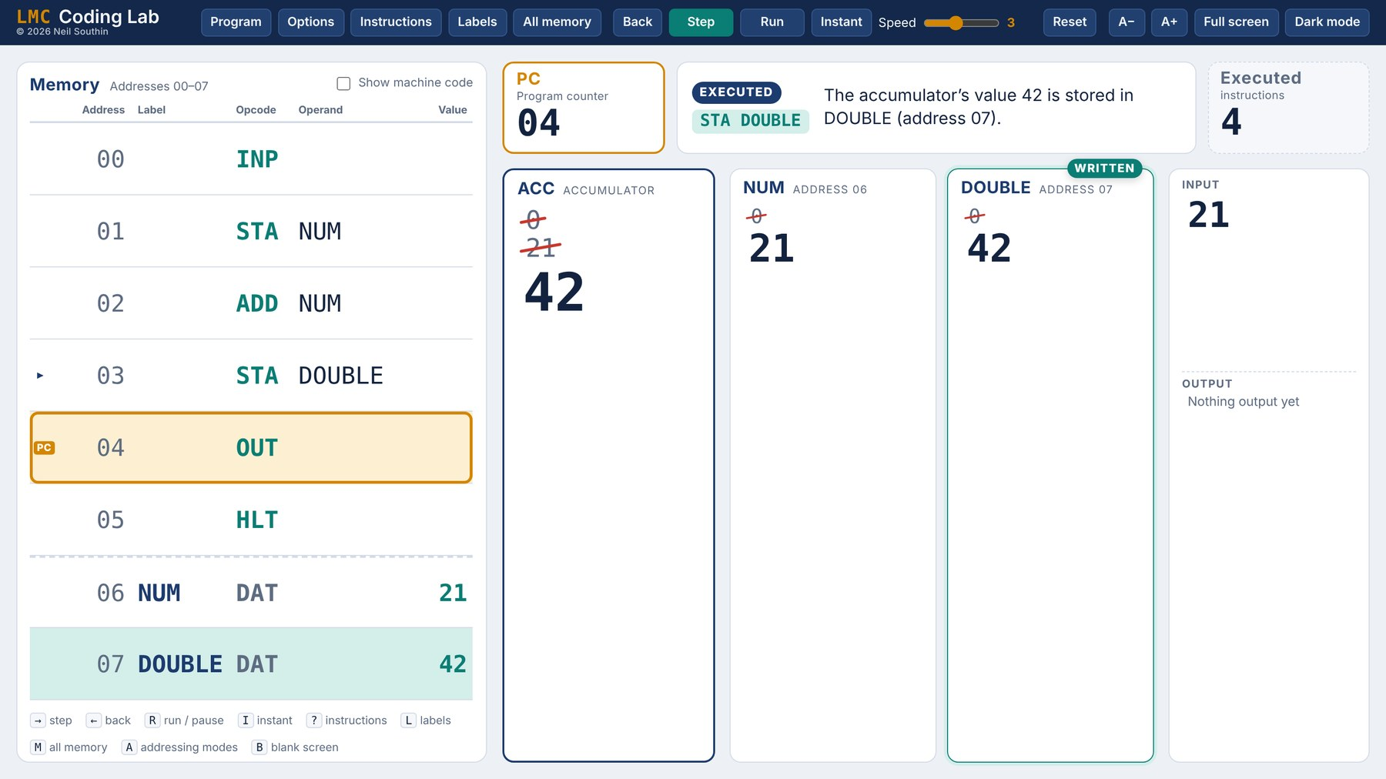
LMC Coding Lab is a Little Man Computer simulator built for the front of the classroom. It shows the whole machine on one screen in large type, explains every instruction in plain English, and keeps a crossed-out history of every value so the board doubles as a trace table. It runs in any modern browser, with nothing to install.
Open the app: LMC Coding Lab
CONTENTS
1 The main screen  2 Writing and loading programs  3 Running a program  4 Seeing inside the machine  5 Presenting | 6 Options  7 Breakpoints, editing and output  8 Addressing modes  9 Quick reference

SECTION 1

The main screen
Everything a class needs to follow a program is on one screen, sized to be read from the back of the room. Old values are never wiped: they are crossed out and left in place, so the board itself is a running trace of the program.
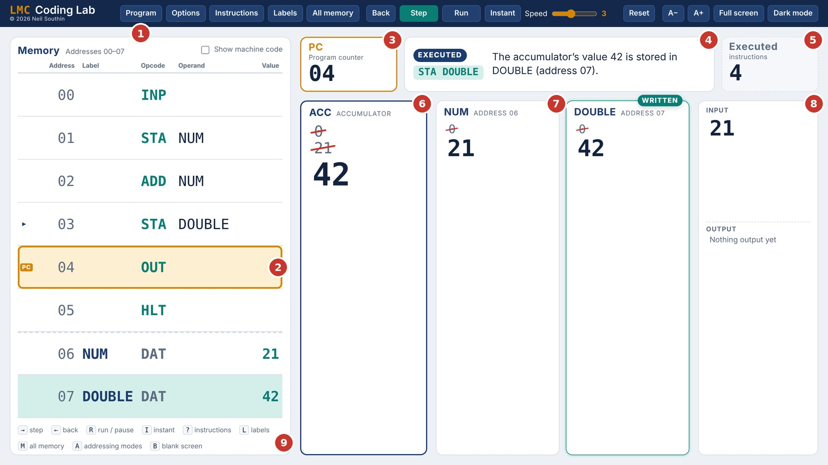
1 Top bar. Program opens the code editor; Back, Step, Run and Instant drive the program.  2 Memory table. The orange box marks the PC: the instruction that runs next. The small arrow marks the one that has just run.  3 Program counter. The address of the next instruction.  4 Explanation. What the last instruction did, in a single plain-English sentence, with a tag for the stage (Ready, Executed, Input, Halted and so on).  5 Executed instructions. A running count. Good for comparing the efficiency of two versions of a program. | 6 Accumulator. The current value large, with earlier values crossed out above it.  7 Variable cards. One card for each DAT location, with its own history. READ, WRITTEN and UPDATED badges show what the last instruction touched, then fade after a few seconds.  8 Input and output. Every value typed in and every value output.  9 Shortcut strip. A reminder of the keys, so students can drive it too.

DESIGN CHOICES WORTH KNOWING
- One click runs one whole instruction, so each step on the board is one line of a trace table.
- Back undoes any step, as far back as you like. Ideal for "what just happened?"
- Extras such as breakpoints and addressing modes are off by default, so the screen stays simple for beginners.
- Settings are remembered in each browser, so a classroom PC keeps your choices between lessons.

SECTION 2

Writing and loading programs
Click Program to open the code editor. Type a program, paste one in, open a saved file or choose an example, then click Assemble into memory.
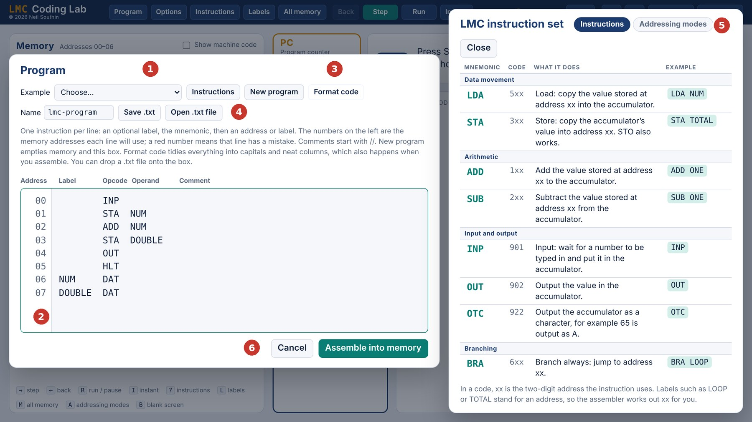
1 Examples. 26 ready-made programs in three groups (see the table below).  2 Address column. Shows the memory address each line will be assembled into.  3 Format code. Tidies the program into capitals and aligned columns. With the default settings this also happens each time you press Enter. | 4 Save .txt and Open .txt file. Programs are plain text. You can also drop a .txt file onto the editor.  5 Instructions. Opens the instruction set beside the code, so it can be checked while typing.  6 Assemble into memory. Checks the program, loads it and resets the machine ready to run.

New program empties both the editor and memory, for a blank start in front of the class.

Assembler errors
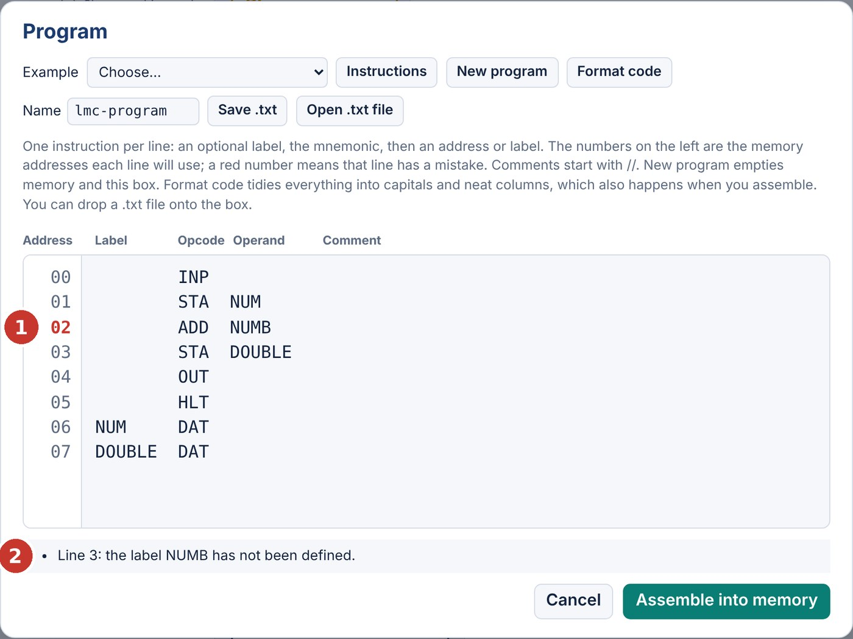  A misspelt label. The address turns red and the message names the line. | If a line cannot be assembled, the editor stays open, the address of the faulty line turns red (1) and a message underneath explains the problem in plain English (2).  The checks cover unknown mnemonics, labels that are used but never defined or defined twice, missing or extra operands, addresses outside 00–99, DAT values outside −999 to 999 and programs too big for 100 locations.

Example programs
Choosing an example loads it into the editor, ready to assemble. Each one starts with a comment saying what it does.
Example | What it shows
Basics
Add two numbers | INP, STA, ADD, OUT: the first program most classes write.
Add two stored values | DAT with starting values; no input needed.
Countdown | A BRP loop that counts down to 0.
Larger of two numbers | Selection: compare by subtracting, then branch.
Count up to a number | A counter with BRZ and BRA.
Overflow (endless loop) | Runs until the accumulator passes 999, then stops with an overflow error.
Multiply (repeated addition) | A counted loop that builds multiplication from addition.
Showcase
Fibonacci numbers | Every Fibonacci number up to 999, stopping before it overflows.
Pi from 355/113 | Long division to six decimal places, avoiding overflow. Best with joined-up output.
Square root | Subtracting 1, 3, 5, 7 … gives the root and the remainder. Try 200.
Hailstone (Collatz) sequence | Halve or 3N + 1 until reaching 1. Try 7, then 27.
Prime numbers | Every prime up to a limit, by trial division.
Decimal to binary | The 8 bits of a number from 0 to 255, using self-modifying code.
Hello world (OTC) | Prints text from character codes; self-modifying code.
Highest common factor | Euclid’s algorithm by subtraction. Try 252 and 105.
Guess my number | H, L and = feedback with OTC. Can the class find the secret in memory?
Addressing modes
What modes make 17? | Predict which mode gives an output of 17.
Slide exercise (12-24) | Memory set up for a predict-the-output exercise.
arrayName[4] | Base address plus index register.
Immediate vs direct | The same digits with two different meanings.
Immediate: add 5 | A constant inside the instruction, so no DAT is needed.
Indirect: follow a pointer | LDA #PTR fetches whatever PTR points at.
Hello world (indirect) | A pointer moves along the message; no self-modifying code.
Hello world (indexed) | The index register steps along the message.
Indexed: total of a list | Add up a list that ends with 0.
Indexed: list backwards | Count IX down to output a list in reverse.

Choosing an addressing-modes example switches the Addressing modes option on automatically.
SECTION 3

Running a program
Control | Keys | What it does
Step | Right arrow, Space, Page Down | Runs one instruction and explains it.
Back | Left arrow, Page Up | Undoes the last instruction. Repeat to go back as far as you like.
Run | R | Steps automatically at the chosen speed. Press again to pause.
Speed |  | 1 (slowest, 2 seconds a step) to 5, then Max, which runs as fast as possible without animation.
Instant | I | Runs to the end straight away, stopping only for input. After 50,000 instructions it pauses and warns that the program may be an infinite loop.
Reset |  | Back to address 00 with fresh data, keeping the same program.

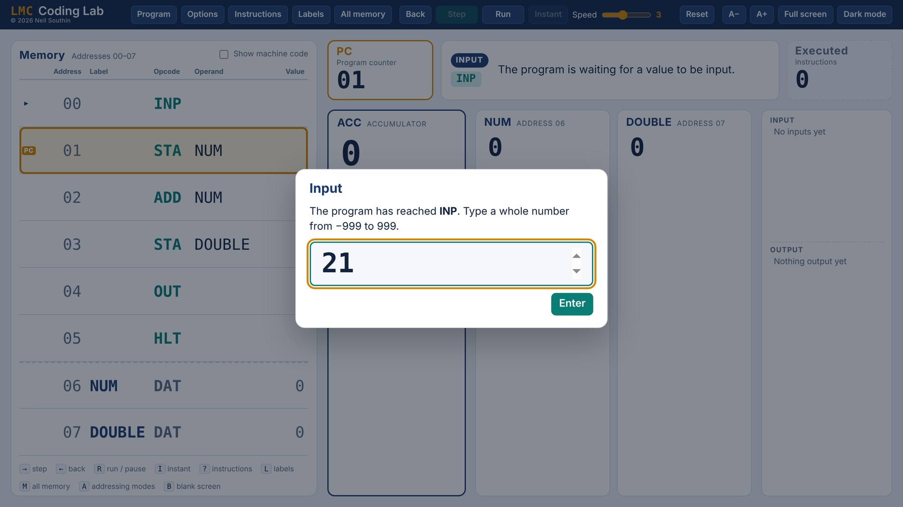  INP waits for a number from the class. | Input  When the program reaches INP, a large input box appears over the board. Type a whole number from −999 to 999 and press Enter. The keyboard is handed straight back to the board, so a presenter remote keeps working.

Animation
With Animate values moving on (the default), each copy is shown as a value gliding from where it comes from to where it goes. ADD and SUB go further: the two values meet and the sum is written out before the answer lands in the accumulator.
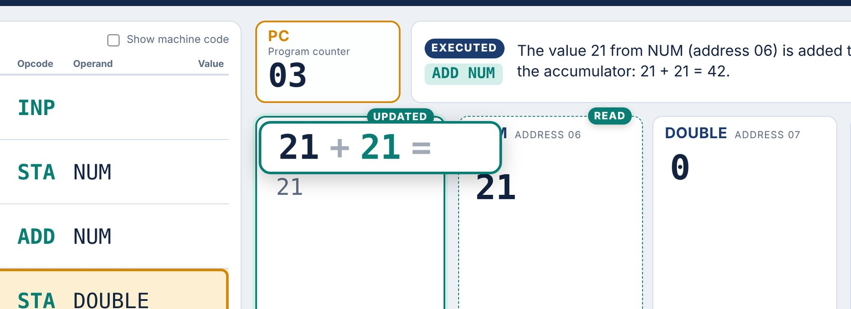
ADD NUM mid-animation: the accumulator and NUM meet as 21 + 21 = before the answer, 42, lands.

When things go wrong
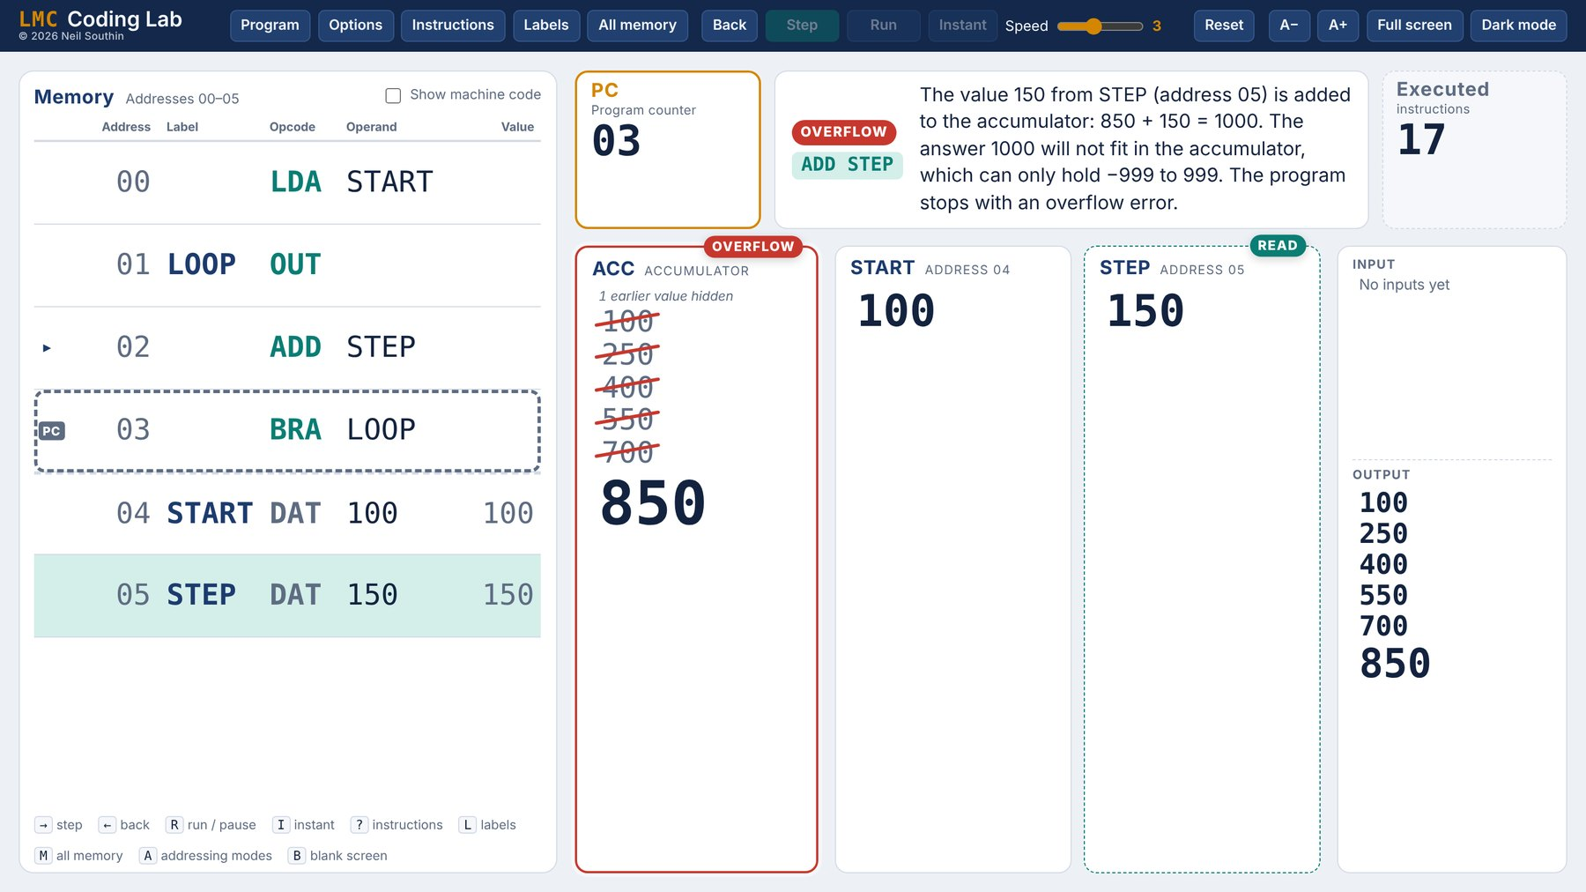  An overflow stops the program. | Overflow. If a result goes outside −999 to 999 the program stops with an OVERFLOW tag and an explanation of the sum that did not fit.  Running off the end. If the PC moves past the last instruction, a warning appears above the memory table. This is a good way to show why DAT belongs after HLT.  Halted. HLT shows the HALTED tag; press Reset to run the program again.

SECTION 4

Seeing inside the machine
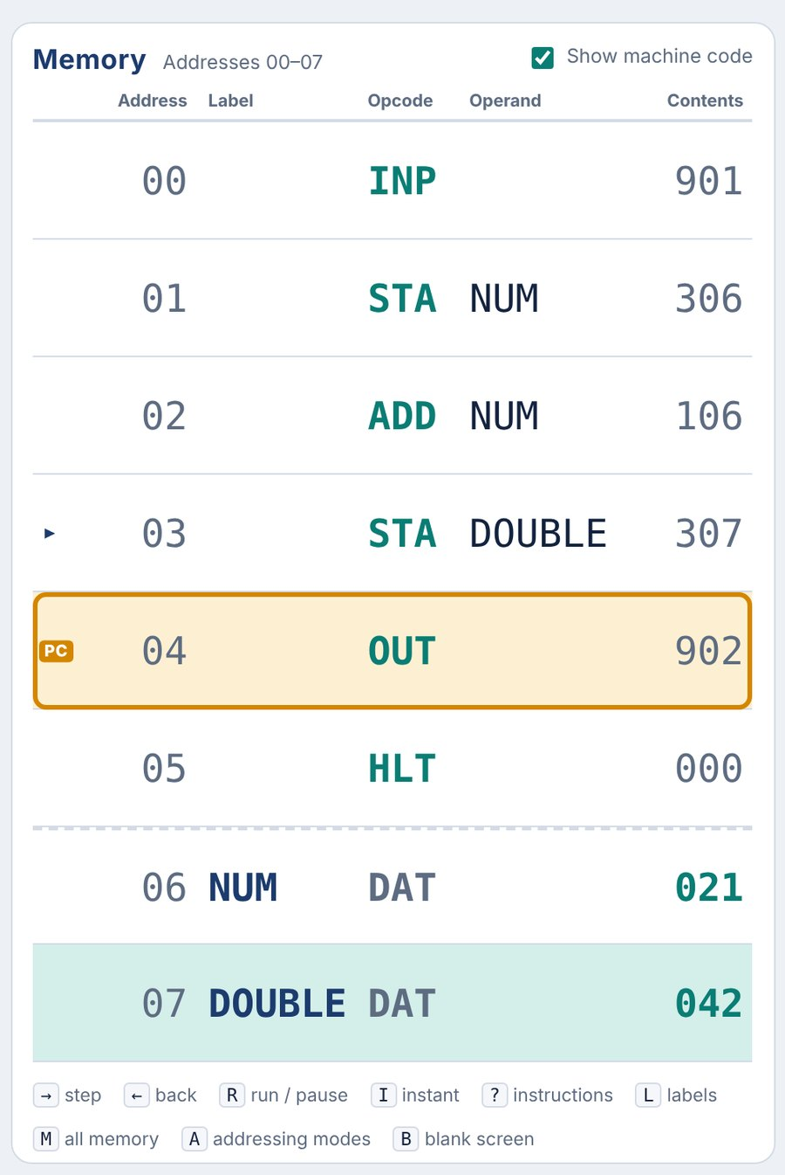 | Machine code  Tick Show machine code above the memory table to add the stored three-digit codes, such as 306 for STA 06. It is off by default so that beginners see only the assembly language.  Data locations show their value in the same column, which makes the point that instructions and data are both just numbers.  Past values  By default each card shows its last five values, with a note saying how many older ones are hidden. Options can change the number (1 to 12) or switch to a scrolling column that keeps every value. Registers (PC, CIR, MAR, MDR) only ever show their current value.

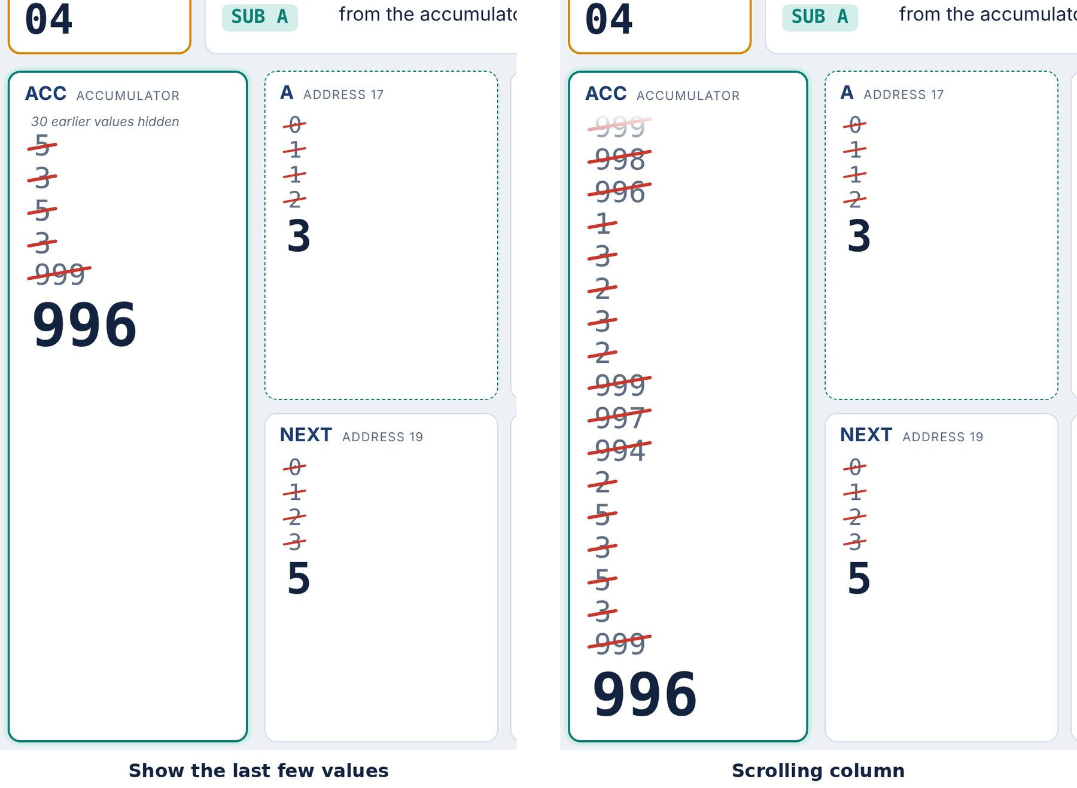
Fibonacci after 60 steps: the last few values (left) against a scrolling column (right).

CIR, MAR and MDR
For courses that need the fetch–decode–execute registers, tick Show the CIR, MAR and MDR in Options. They appear along the top and the explanation moves to the bottom of the screen.
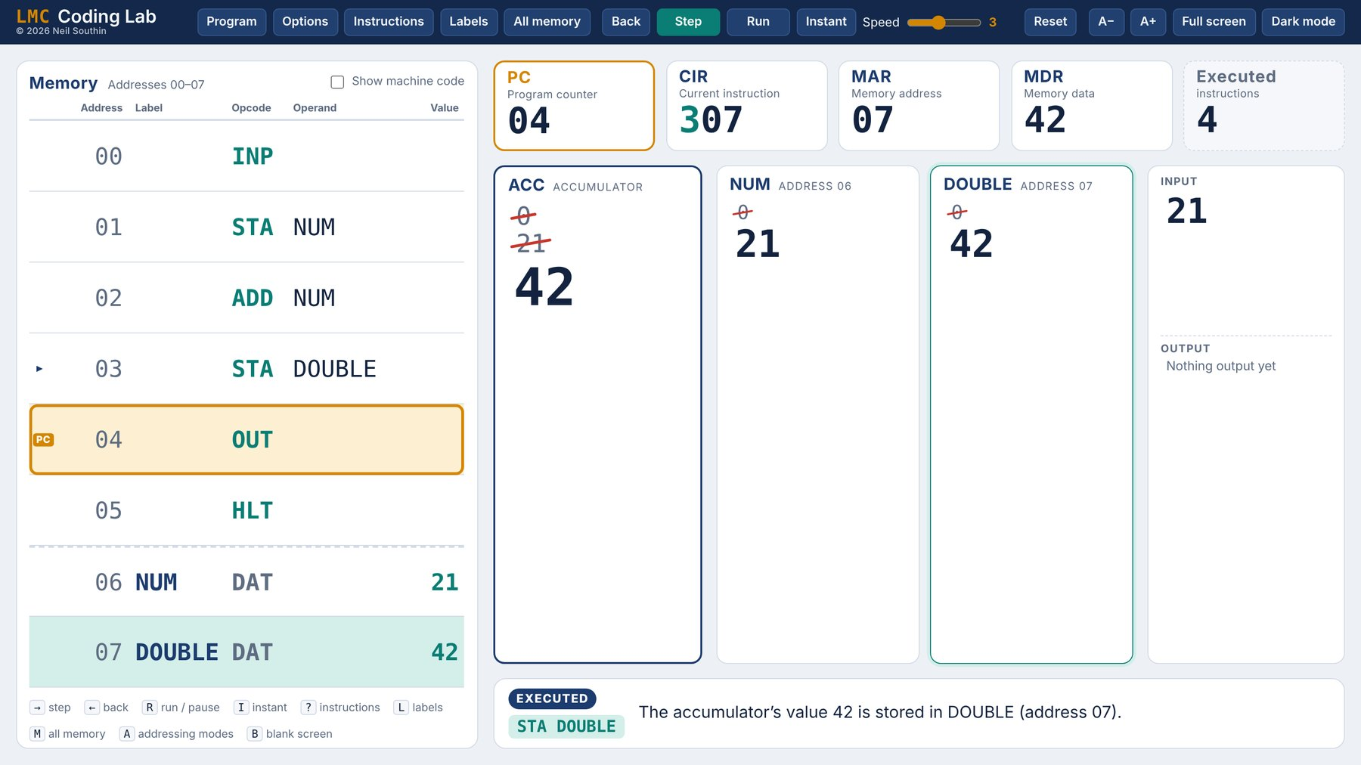

Labels (symbol table)
Press L or click Labels to see every label, the address the assembler gave it and which instructions use it. It is a direct way to explain what an assembler does with labels.
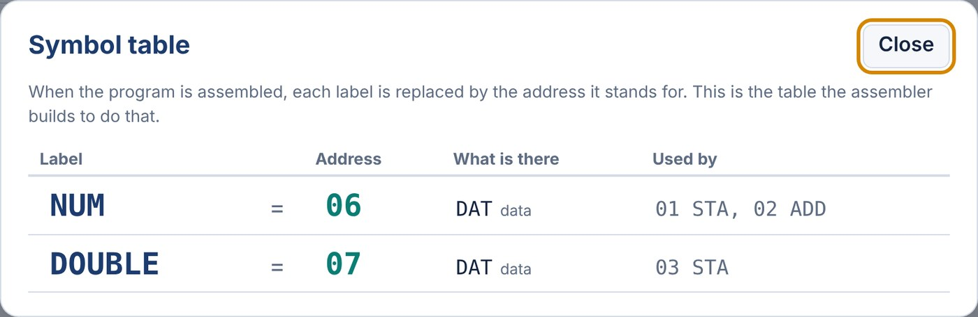

All memory
Press M or click All memory for all 100 locations as machine code in a 10×10 grid, colour-coded for instructions, data, unused locations and the PC. It updates live, and you can keep stepping while it is open: try it with self-modifying programs such as Decimal to binary.
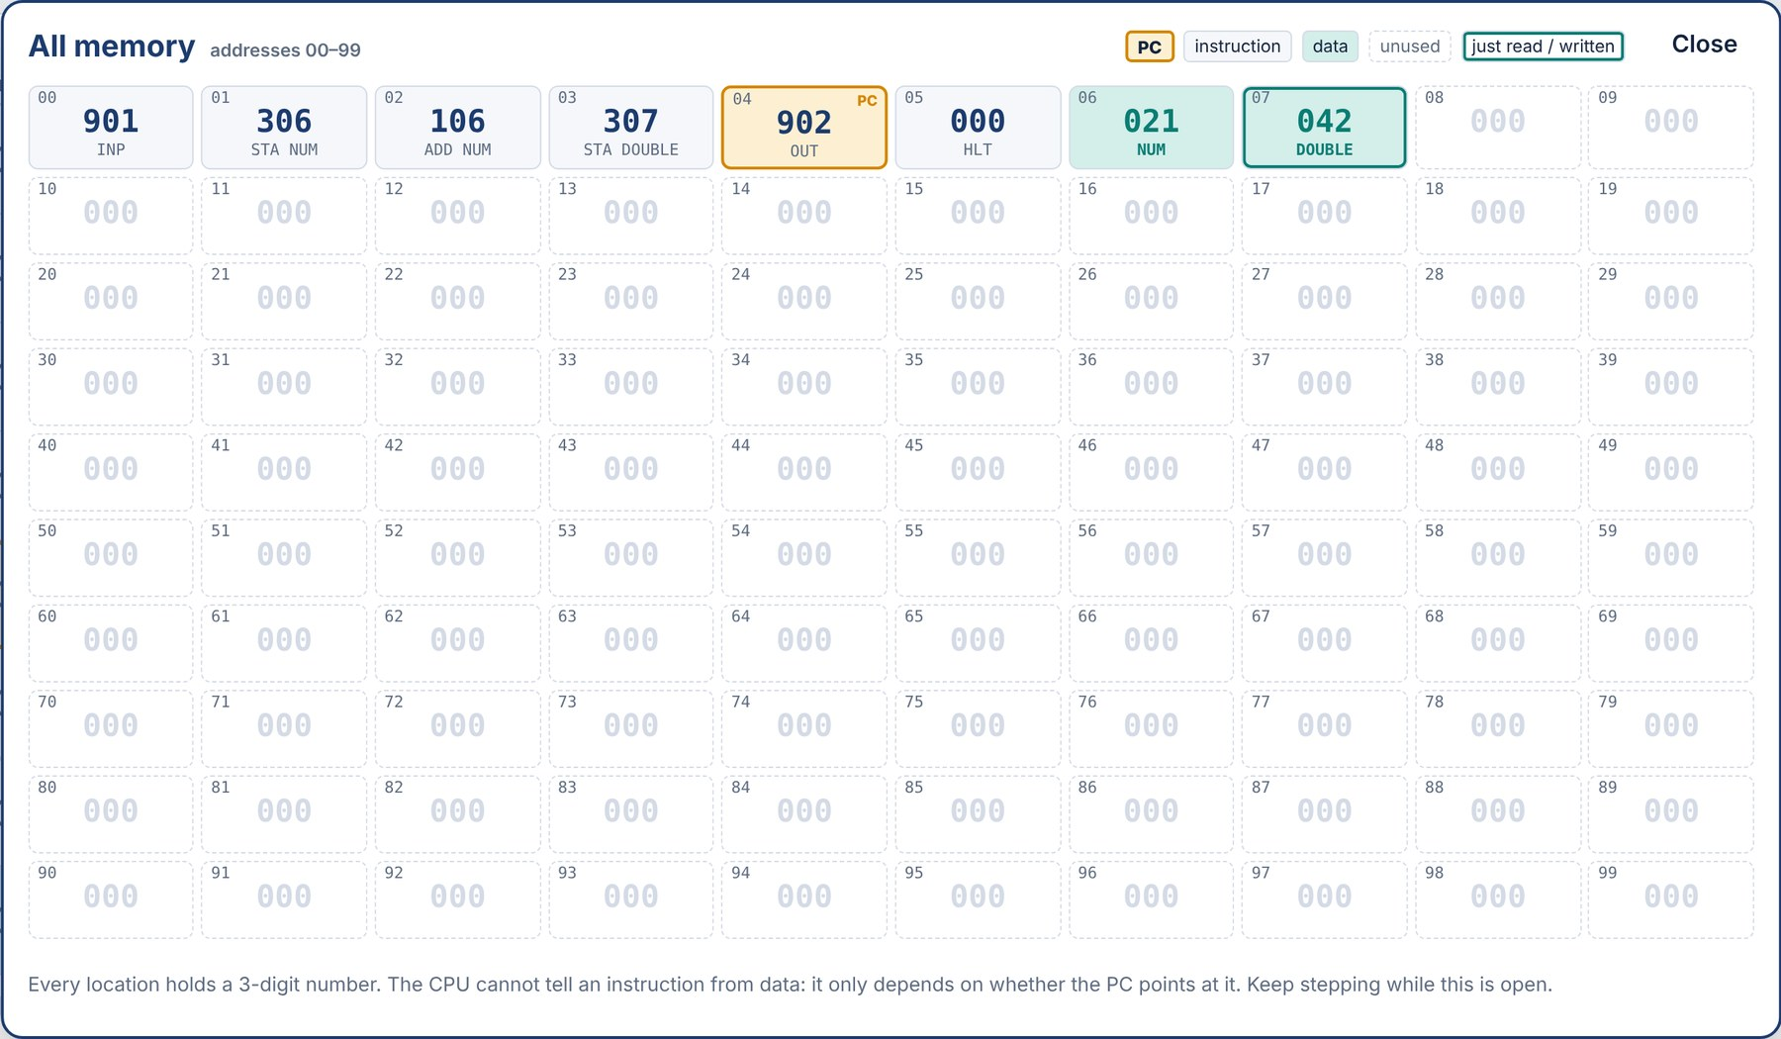
SECTION 5

Presenting

Keyboard and presenter remote
The app answers to the same keys as a slideshow, so a standard presenter remote (such as a Targus clicker) drives it with no setup.
Remote button | Key it sends | Effect in the app
Forward | Page Down | Step
Back | Page Up | Back
Start slideshow | F5 / Shift+F5 | Full screen on or off
Blank screen | B or . | Blanks the screen; any key brings it back

Key | Action | Key | Action
Right arrow, Space | Step | L | Labels
Left arrow | Back | M | All memory
R | Run / pause | ? | Instructions
I | Instant | A | Addressing modes explanation
B or . | Blank screen | F5 | Full screen
Esc | Close a panel

Size, full screen and themes
A− and A+ scale everything on screen. Full screen hides the browser. Dark mode switches the light and dark versions of the theme. Five themes are in Options; Classic, Blueprint and High contrast each have a light and dark version.
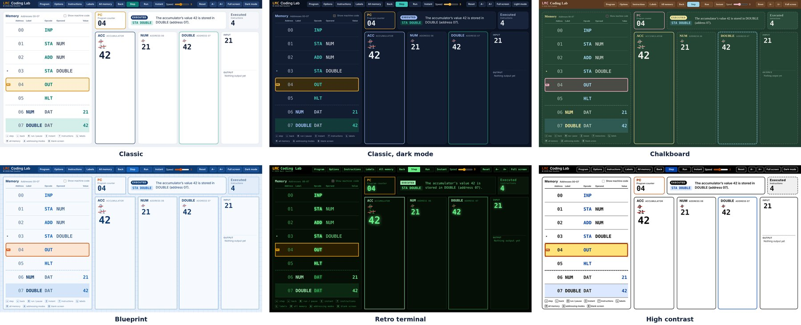
Classic, Classic dark, Chalkboard, Blueprint, Retro terminal and High contrast.
CLASSROOM TIP
High contrast with A+ works well on older projectors and for students at the back. Blank the screen (B) while the class predicts the next step, then bring it back to check.

SECTION 6

Options
Click Options to change how the app looks and behaves. Every choice is saved in the browser.
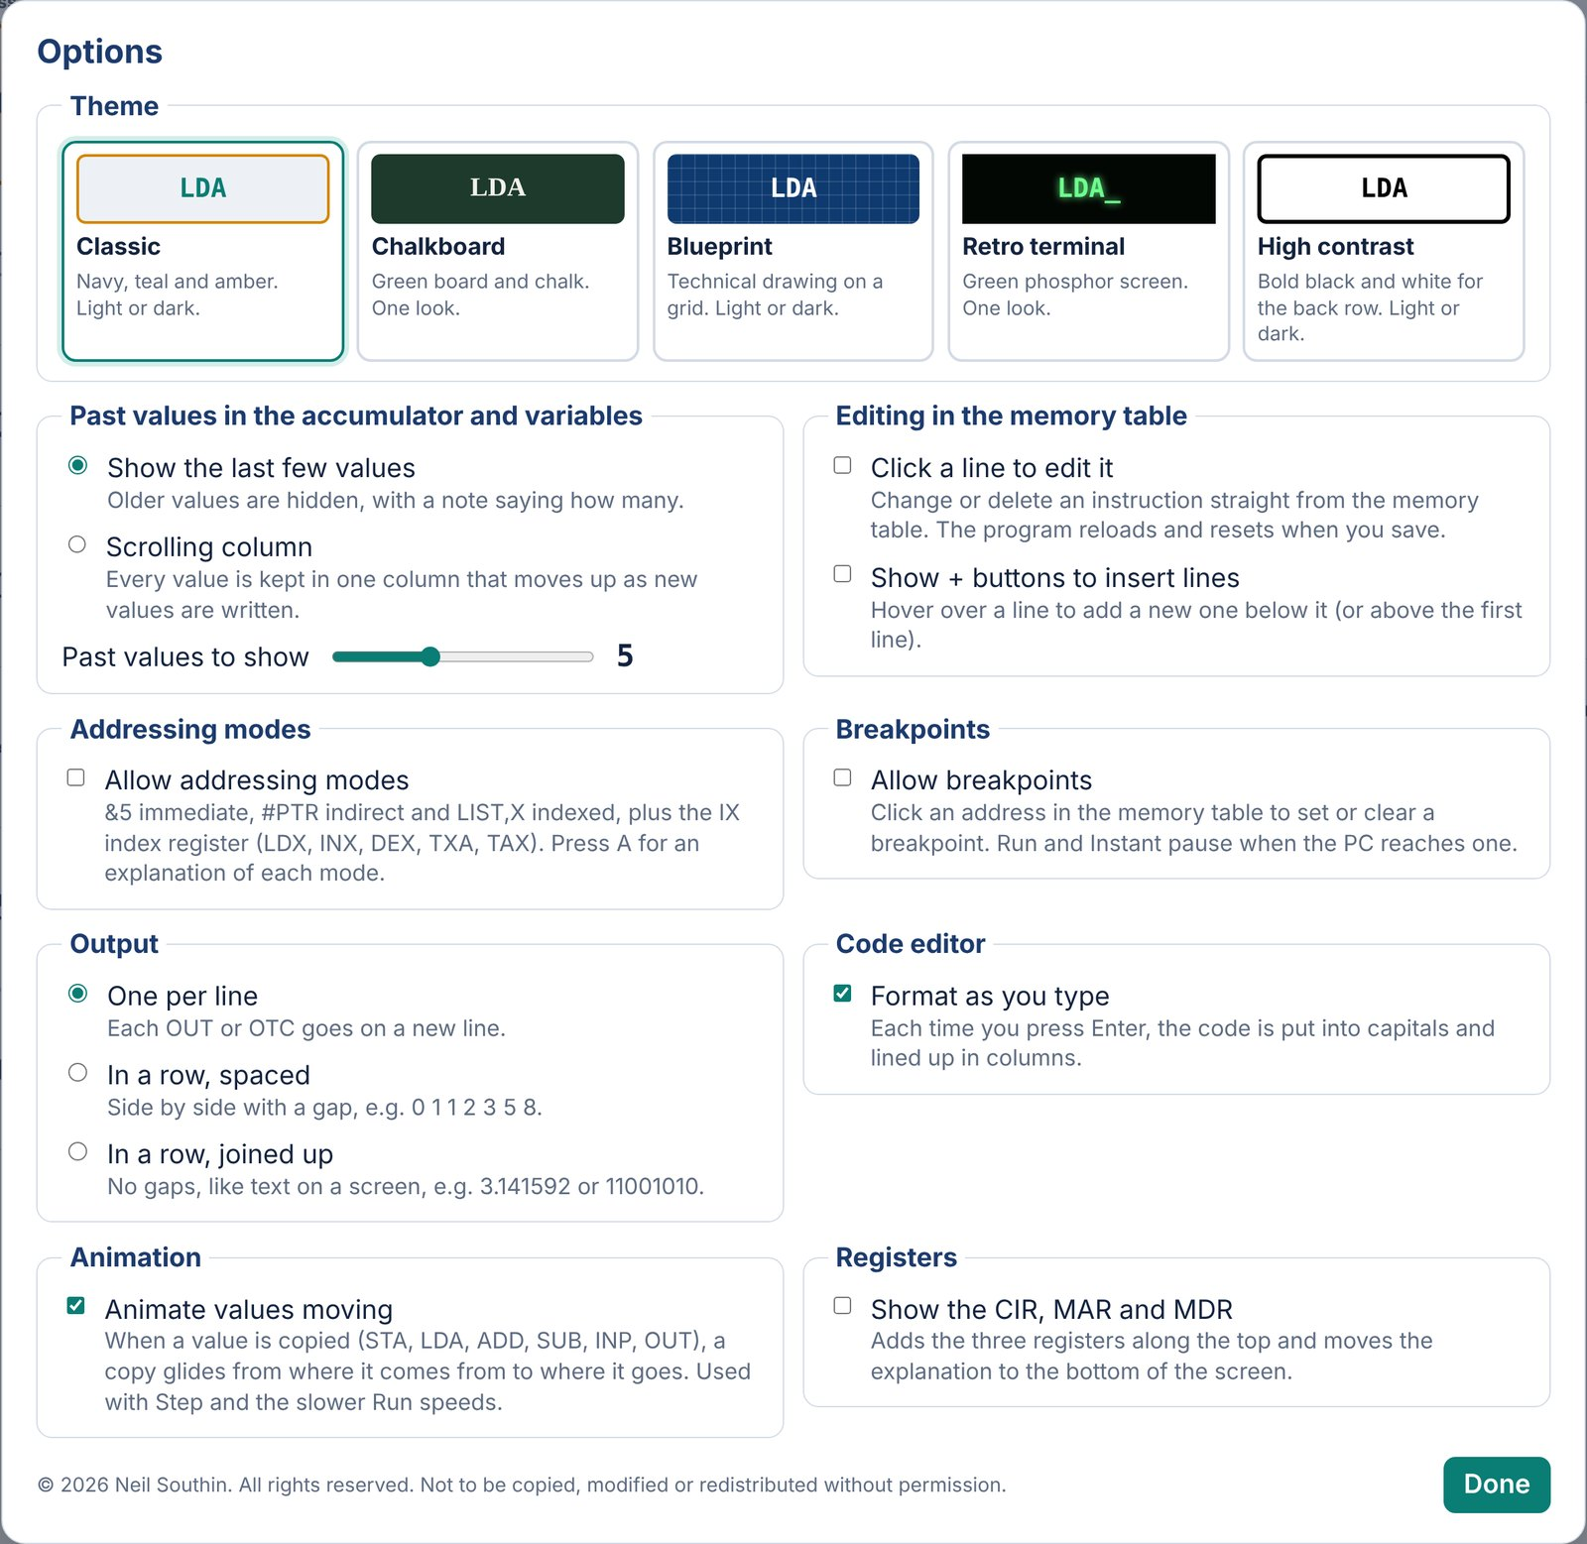
Setting | Choices | Default
Theme | Five looks | Classic
Past values | Last few (1–12) or scrolling | Last 5
Edit lines in memory table | On / off | Off
+ buttons to insert lines | On / off | Off
Addressing modes | On / off | Off
Breakpoints | On / off | Off
Output | One per line, spaced row, joined row | Lines
Format as you type | On / off | On
Animate values | On / off | On
CIR, MAR, MDR | On / off | Off

The defaults are chosen for a first LMC lesson. Section 7 covers the features you can switch on as the class progresses; addressing modes are in Section 8.

SECTION 7

Breakpoints, editing and output

Breakpoints
With Allow breakpoints on, click an address in the memory table to set a breakpoint (it turns red); click it again to clear it. Run and Instant pause when the PC reaches it, before that instruction runs, and the explanation says so. This is useful for skipping the dull part of a long loop.
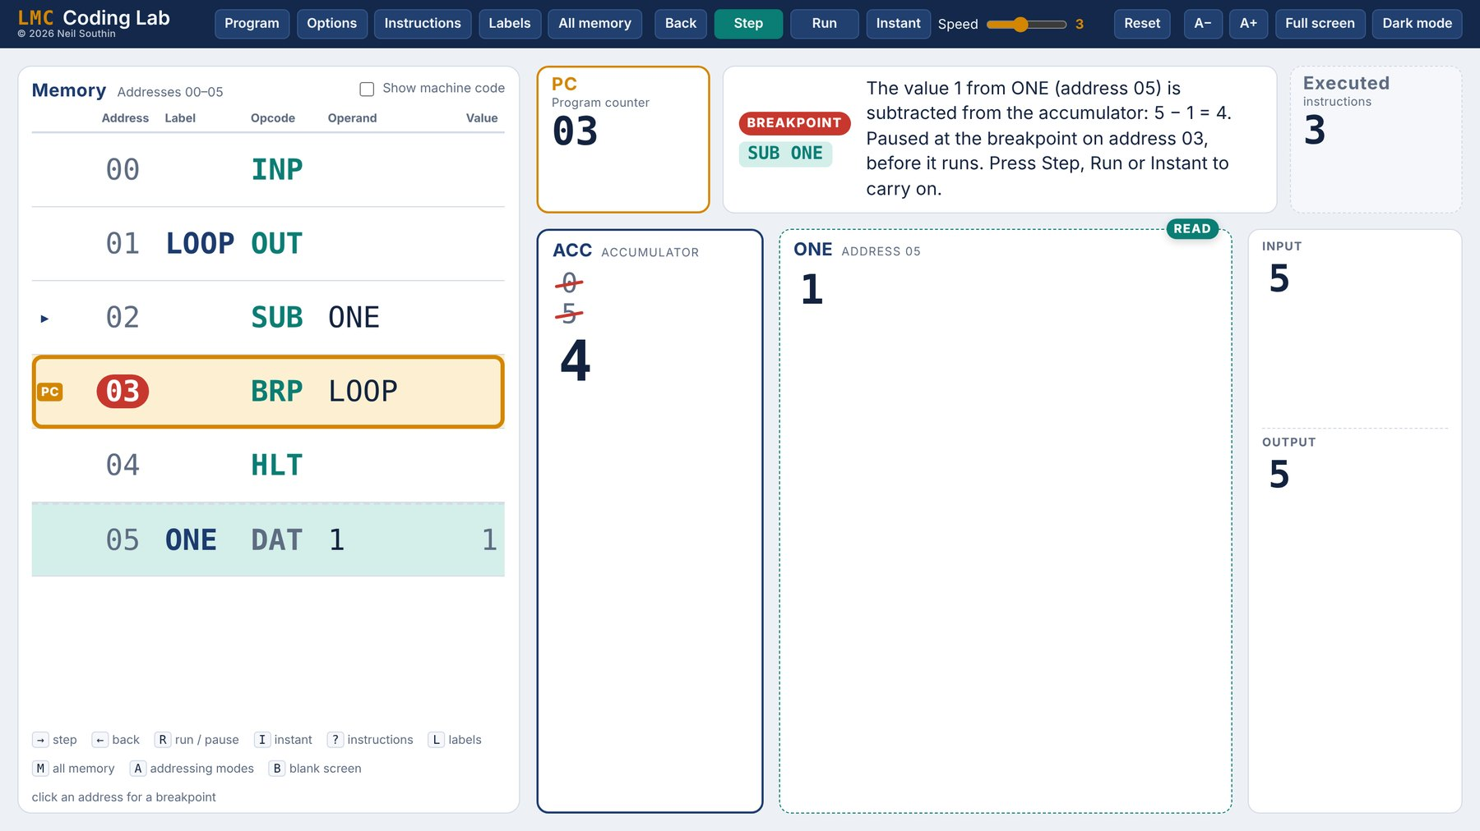
Instant has paused at a breakpoint on address 03.

Editing in the memory table
Two separate options let you change a program without opening the editor. Click a line to edit it opens the line for editing in place: Enter saves, Esc cancels, and clearing the line deletes it. Show + buttons to insert lines adds a + to each line on hover, for inserting a new line below it. The program reassembles and resets after each change.
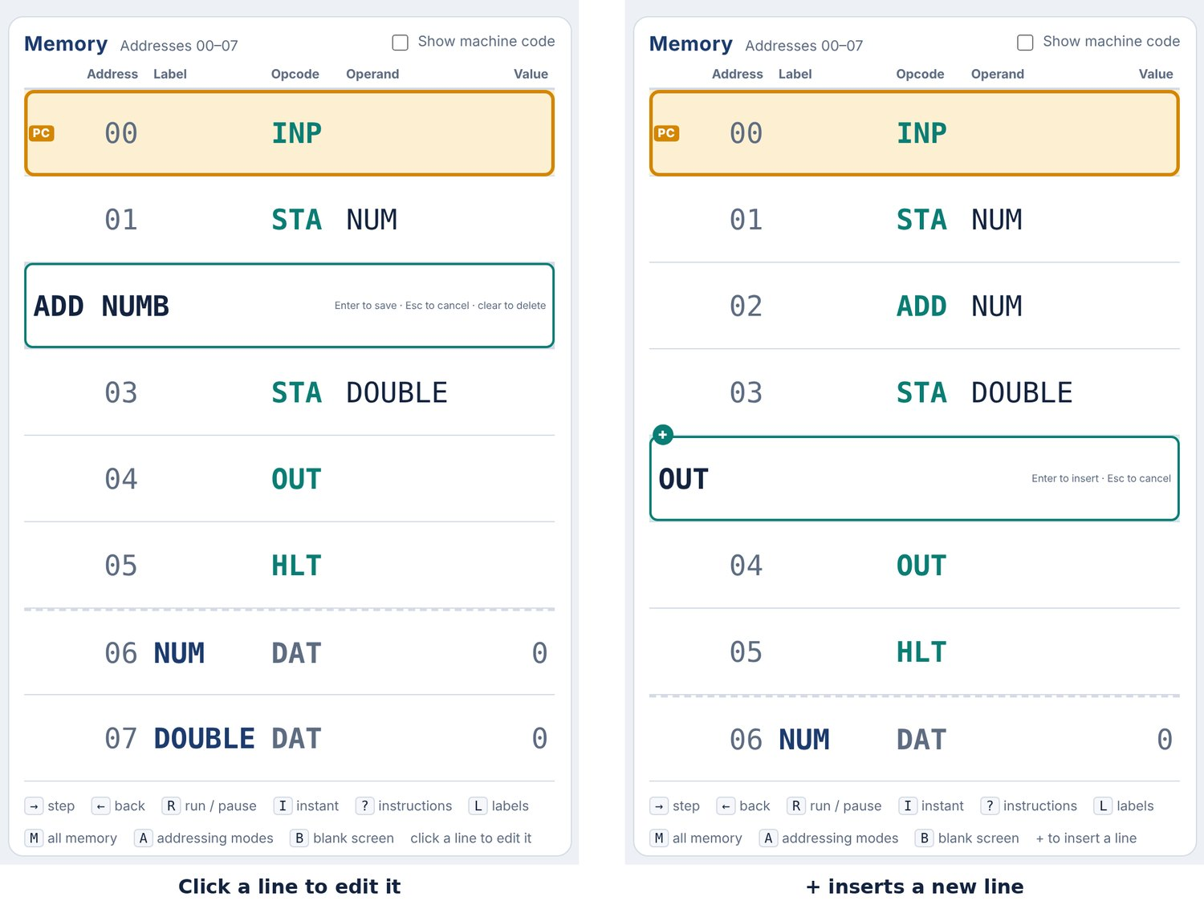

Output layouts
Output can be one value per line, a spaced row (good for sequences) or a joined row with no gaps (good for digits and for text from OTC, which shows the character itself).
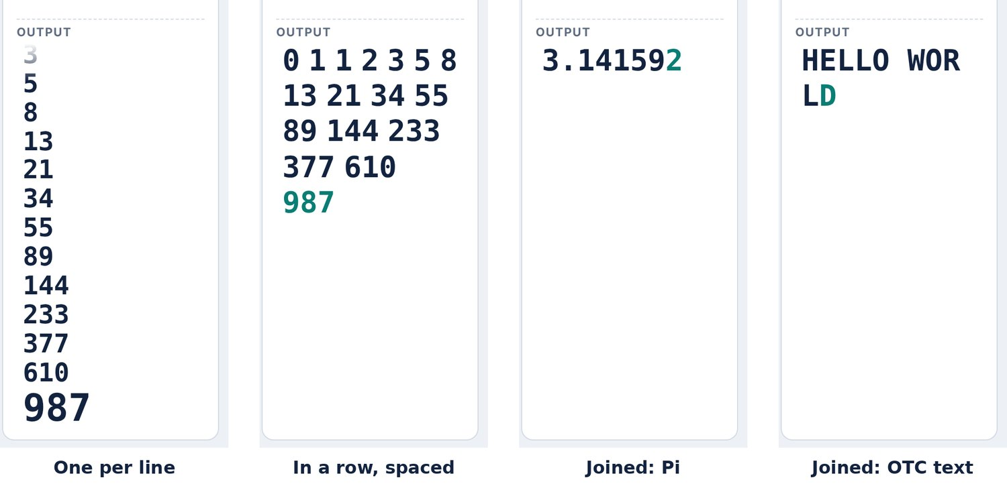
SECTION 8

Addressing modes
For A level, the app can go beyond standard LMC. Tick Allow addressing modes in Options (or choose any Addressing modes example) to unlock three extra modes and an index register, IX. Press A for an explanation screen that can be shown to the class.
Mode | Written | Example | Meaning
Immediate | &n | LDA &10 | The operand is the value itself (0–99). No DAT needed.
Direct | ADDR | LDA 10 | Standard LMC: the operand is an address.
Indirect | #ADDR | LDA #PTR | The operand is the address of a pointer.
Indexed | ADDR,X | LDA LIST,X | The operand plus the index register gives the address.

Instruction | Code | What it does
LDX | 4xx | Load IX with a number (LDX &0) or from an address.
INX | 903 | Add 1 to IX.
DEX | 904 | Take 1 from IX.
TXA | 905 | Copy IX into the accumulator, so BRZ or BRP can test it.
TAX | 906 | Copy the accumulator into IX.

Branches always use direct addresses, STA cannot be immediate, and LDX takes &n or an address. The app stores each instruction’s mode alongside it, because a two-digit LMC operand has no spare bits; the explanation screen says so.
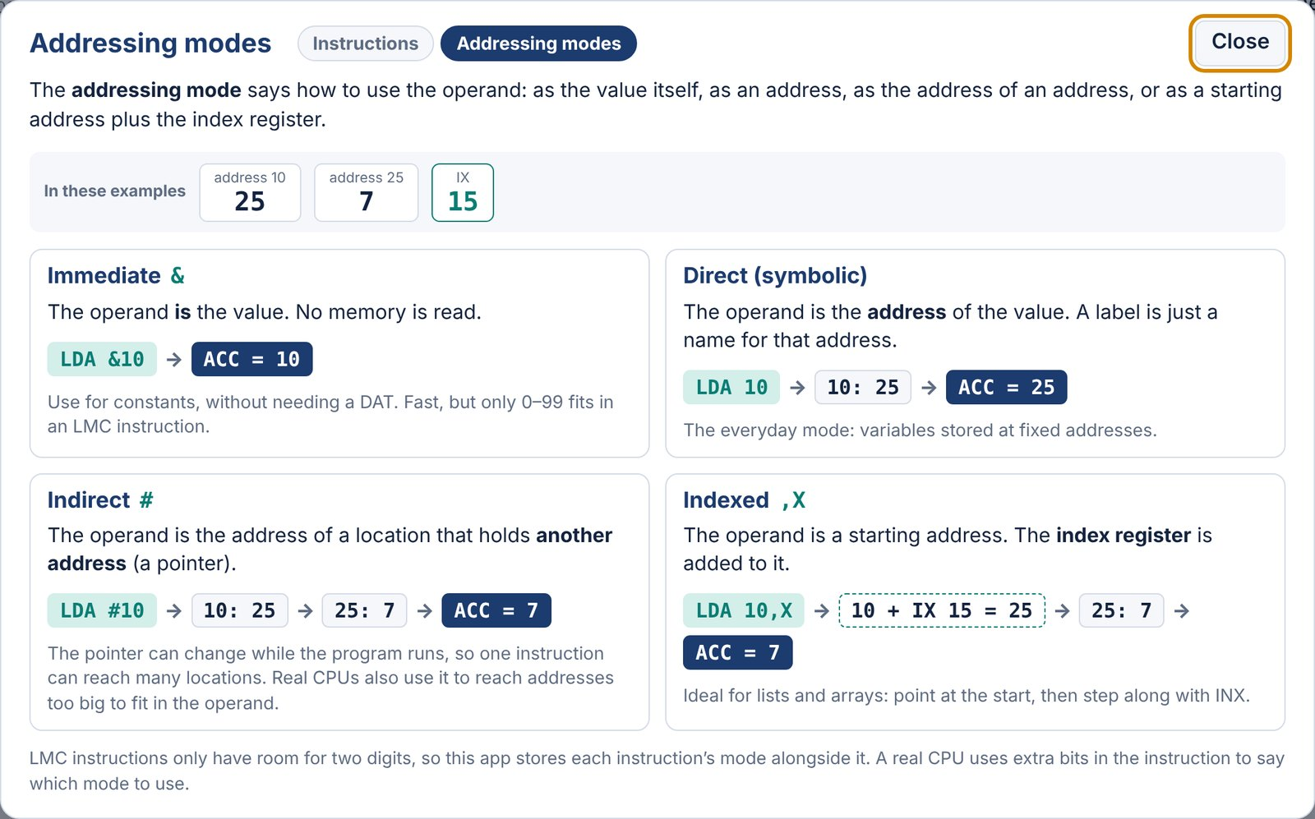
The explanation screen (press A), with worked examples of each mode.
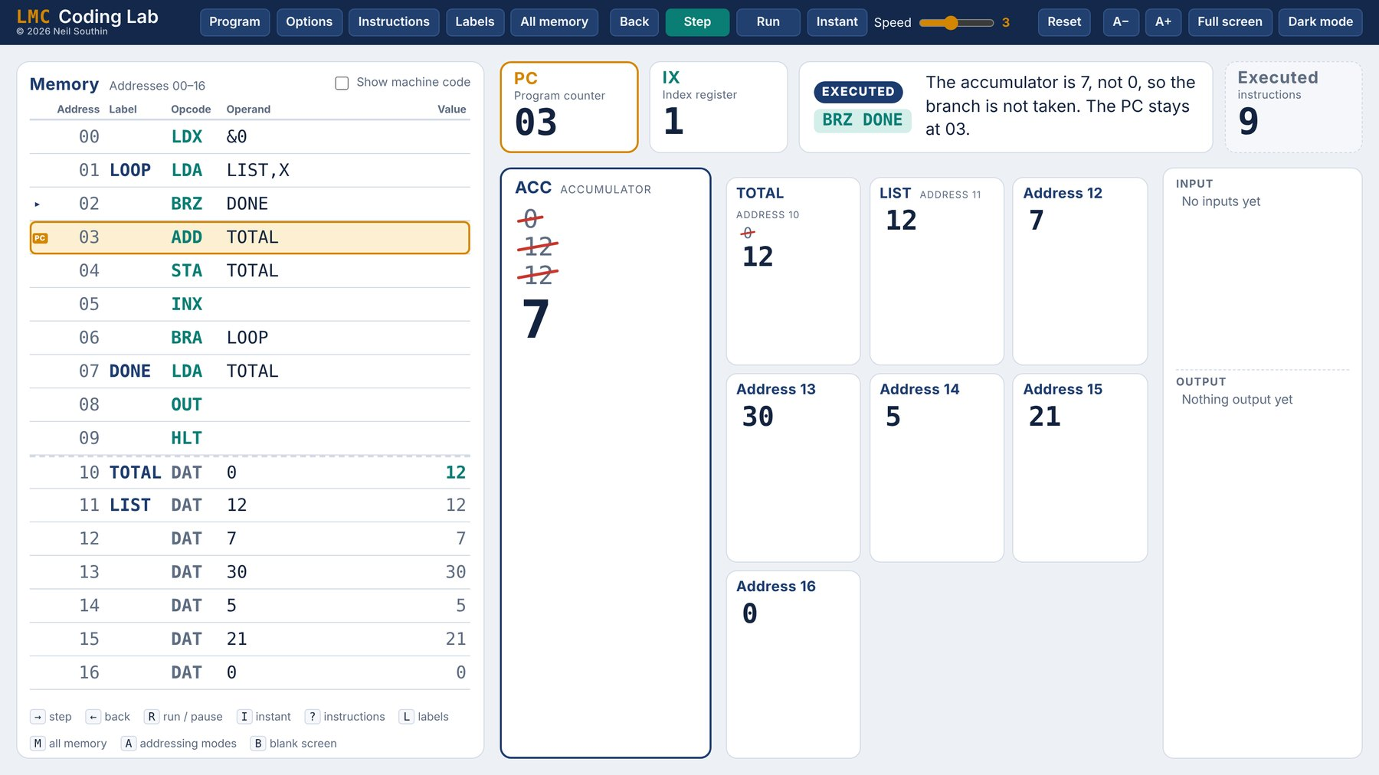
Indexed: total of a list, part way through. IX appears next to the PC.
SECTION 9

Quick reference

Instruction set
Mnemonic | Code | What it does | Example
INP | 901 | Wait for a number to be typed in, then put it in the accumulator. | INP
OUT | 902 | Copy the accumulator to the output. The accumulator keeps its value. | OUT
LDA | 5xx | Load: copy the value at address xx into the accumulator. | LDA NUM
STA | 3xx | Store: copy the accumulator into address xx. The accumulator keeps its value. | STA NUM
ADD | 1xx | Add the value at address xx to the accumulator. | ADD ONE
SUB | 2xx | Subtract the value at address xx from the accumulator. | SUB ONE
BRA | 6xx | Branch always: jump to address xx. | BRA LOOP
BRZ | 7xx | Branch if zero: jump to xx if the accumulator is 0. | BRZ DONE
BRP | 8xx | Branch if positive: jump to xx if the accumulator is 0 or more. | BRP LOOP
HLT | 000 | Stop the program. | HLT
DAT | – | Not an instruction. Reserves a memory location for data, with an optional starting value. | ONE DAT 1
OTC | 922 | Output the accumulator as a character (65 is A). | OTC

Also accepted: STO for STA and COB for HLT. BRP branches when the accumulator is 0 or more. Every location holds −999 to 999.

Panels
Panel | Key | Shows
Program (code editor) |  | Write, format, save, open and assemble programs; examples.
Instructions | ? | The instruction set, with an Addressing modes tab.
Addressing modes | A | Worked explanation of immediate, direct, indirect and indexed.
Labels | L | The symbol table built by the assembler.
All memory | M | All 100 locations, live, as machine code.
Options |  | Themes, past values, output, editing, breakpoints, registers.

COMPANION RESOURCE
A separate student guide covers what LMC is, a tour of the app, good habits and twelve exercises building up to multiplication and division, with extensions and model answers.

