Towards Agrichain 4.0: challenges and future trends

Quadras, Djonathan; Frazzon, Enzo

Abstract:

Keywords:

INTRODUCTION

Talk about:
- The importance of agribusiness;
- Main agribusiness problems;
- Objectives
- Paper structure

The technical equipment of farms has reached today a comparable level to that of industries (Zambon et al., 2019)⁠.

# Rural Systems

Rural Logistics System (RLS) is supply chain networks involving upstream and downstream farmers, outlets, logistics terminal, wholesalers, industries or retailers, and final consumers who need agricultural products or services (Sinaga & Bahagia, 2019)⁠.

# The Agricultural supply chain challenges

Agricultural value creation takes place under strong environmental exposure. Stochastic events lead to a low deterministic behavior, and result in unspecified process descriptions. The influence of weather and associated system behaviors contribute to the lack of predictability. Examples of this include soil and nutrient dynamics, photosynthesis activity or pest infestation. The modeling of these systems is the subject of agronomic research, but this can only provide an approximation to the real behavior. Farmers must therefore deal implicitly with this supply chain uncertainty (Braun et al., 2018)⁠.

Rationalization effects through division of labor have decisively determined the development of the industrial production. By contrast, a small division of labor, analogous to craft, characterizes agriculture. Agricultural supply chains recruit their workforce in a family environment and rely heavily on seasonal workers. These two situations make the demand of employees fundamentally different to the one in the industry. Employees in the industrial sector are highly specialized in their skill levels - from repetitive serial work to product specialists. In agriculture, a few employees carry out a large range of tasks. This requires a broad spectrum of knowledge and experience, as well as a high degree of specialization. If these capabilities are not available, farmers have to rely on external services, such as contractors or consultants (Braun et al., 2018)⁠.

The abolition of the separation between the physical and the virtual world is the central paradigm of the Industry 4.0 concept (Braun et al., 2018)⁠

# Industry 4.0

The concept proposed by the Industry 4.0 approach relies on creating an environment in which all elements are connected to each other in a seamless and effortless way. All devices (CPSs, cyber-physical systems) and functionalities are addressed as services, which constantly communicate with each other, and thus achieve a high level of coordination (Braun et al., 2018)⁠.

METHODOLOGICAL PROCEDURES

The selected documents are limited to journal papers or papers published in conference proceedings, written in English, Portuguese, Spanish or Italian language.

Used keywords: `( "Agro*" OR "Agri*" ) AND ( "Chain*" OR "Logistic*" ) AND ("Industr* 4.0" OR “Cyber Physical Systems”) `

RESULTS

Bibliometrical Results

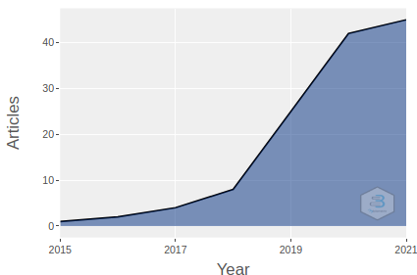

Keywords co-occurrence Network

Factorial Analysis

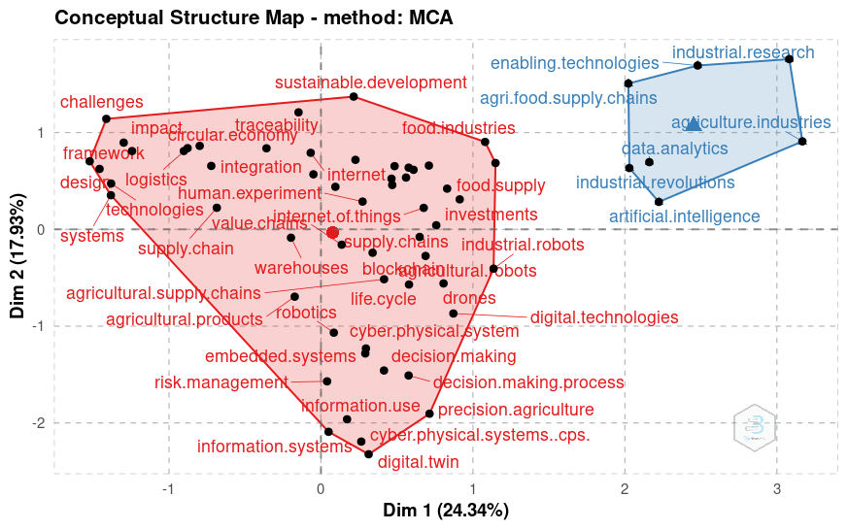

Corresponding Author’s Country

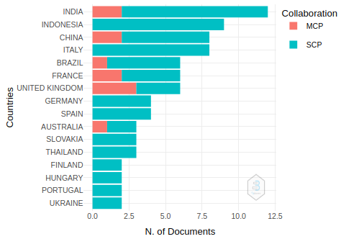

(Sinaga & Bahagia, 2019) aimed to optimize the annual cost for an RLS, considering order, inventory and transportation costs.

Main technologies

- Blockchain
- Precision Farming
- Global Positioning System (GPS)
- Sensors
- Internet of Things and Services (IoTS)
- Bluetooth
- Radio Frequency Identification (RFID)
- Big Data
- Digital Twin
- Cloud Computing

However, the focus is mainly on measuring and increasing the productivity of machines, installations, and fields. The logistic optimization along the agricultural supply is either missing or considered as a simple communication problem [7], disregarding the complexity of the issues (Braun et al., 2018)⁠
The Internet of Things and Services closes the media gap between the physical and the virtual world and enables the provision of value-added services based on a current and comprehensive understanding of reality (Braun et al., 2018)⁠

Problems
- Continuous data flows in agricultural regions cannot be assured
- Connectivity
- Flexible access
- Modularity
- Machines heterogeneity
- Connection among stakeholders

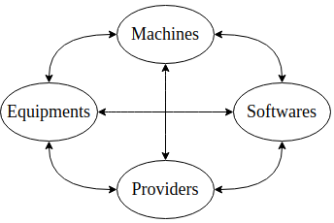Figure 1: Focus in the digitalization of agriculture

Nevertheless, the digitization of the information exchange within the agricultural supply chain has been greatly neglected. Communications between farmers, vendors and clients are done mostly analogously, with the usage of e-mail, digital invoicing, and some rudimentary software in the best cases. With an increased degree of development, machinery rings already offer their services on platforms (marketplaces). However, the exchange of information is far from being standardized (Braun et al., 2018).⁠

# DIFFERENCES BETWEEN INDUSTRY AND THE AGRINDUSTRY

One big difference is the division of work (rationalization) in industry, where a lot of employees are in charge of a small part of the production system vs. the small division in the agribusiness, where a few employees are in charge of all the production system. (Zambon et al., 2019)⁠. Furthermore, employees in the industrial sector are highly specialized in their skill levels, while farmers carry out a great variety of responsibilities.

# CUSTOS

The decreasing cost of sensor technology has allowed farmers to monitor factors (Zambon et al., 2019)⁠

CONCLUSION

ACKNOWLEDGMENT

REFERENCES

Braun, A. T., Colangelo, E., & Steckel, T. (2018). Farming in the Era of Industrie 4.0. 51st CIRP Conference on Manufacturing Systems 28th, 979–984. https://doi.org/10.1016/j.procir.2018.03.176
Sinaga, T. S., & Bahagia, S. N. (2019). Integrated Logistics and Transportation Routing in Rural Logistics System. IOP Conference Series: Materials Science and Engineering, 528(1), 8. https://doi.org/10.1088/1757-899X/528/1/012081
Zambon, I., Cecchini, M., Egidi, G., Saporito, M. G., & Colantoni, A. (2019). Revolution 4.0: Industry vs. agriculture in a future development for SMEs. Processes, 7(1). https://doi.org/10.3390/pr7010036

