Frigel Group is a globally recognized leader in the design and manufacture of advanced industrial cooling and temperature control systems. Frigel specializes in engineering and producing integrated cooling solutions tailored for various industries, including plastics and rubber, food and beverage, power generation, data centers, pharmaceuticals, and metal processing. Over the decades, Frigel has expanded its operations globally.



Frigel's mission is to engineer more efficient and sustainable industrial processes. Their vision is to be a global innovator in high-performance, sustainable, and quality-engineered solutions for process cooling and temperature control technologies. By focusing on productivity, efficiency, sustainability, and reliability, Frigel aims to meet the evolving needs of industries worldwide.



TEXTO 3

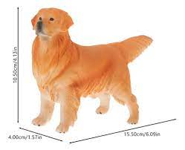

TEXTO 4

