The Architecture of Entrepreneurial Theories and
New Venture Survival

Introduction
Survival is a critical antecedent to new venture value creation, often described as the ‘the de facto measure of performance’ for new ventures (Josefy, Harrison, Sirmon, & Carnes, 2017: 778). Over the last decades, a proliferating literature stream has explored the antecedents of new venture survival, pointing to environmental, entrepreneur-level, and startup related factors (for a review see Soto‐Simeone, Sirén, & Antretter, 2020). The theory-based view (TBV) speaks to this debate by maintaining that when entrepreneurs formulate their business ideas in the form of causal theories, they increase their chances of building a venture that survives and creates value amidst the pervasive uncertainty that characterizes the startup context. While there is mounting empirical evidence for the value of causal theories for new venture survival and performance (e.g., Agarwal et al., 2023; Camuffo, Cordova, Gambardella, & Spina, 2020; Camuffo et al., 2024), there is a dearth of insight into what the exact features of a valuable entrepreneurial theory are. This question is consequential as it appears dubious whether any entrepreneurial theory will have the qualities to actually drive startup survival and value creation.
With our paper we seek to explore the quality of entrepreneurial theories, asking a straightforward research question: what constitutes a successful entrepreneurial theory? To answer this research question we draw from extant work in the TBV (Felin, Gambardella, & Zenger, 2024; Felin & Zenger, 2017) and on the design of intelligent artificial systems (Baldwin & Clark, 2000; Simon, 1996). The TBV maintains that valuable theories rest on a restricted set of premises, with premises being defined as the major contingencies under which the theory is valuable (Ehrig & Schmidt, 2022). Reflecting the argument that strong theories balance the competing demands of parsimony and comprehensiveness (cf. Felin & Zenger, 2017; Whetten, 1989), we explore the relationship between the number of premises a theory entails and startup survival, and propose an inverted U-shaped effect between premise count and the likelihood of startup survival. We further build on the argument that intelligent artificial systems, such as humanly-devised conjectures about what novel product may be of value, are more productive when they can be decomposed into coherent domains because decomposition produces specialization benefits in learning (Simon, 1996; Yayavaram & Ahuja, 2008). Building on Simon’s classical argument that valuable artificial systems are near-decomposable, and hence can be modularized into quasi-independent strategic domains (Campagnolo & Camuffo, 2010), we propose a positive relationship between the near-decomposability of entrepreneurial theories into strategic domains and startup survival.
We analyzed 345 startup pitches from the TechCrunch Startup Battlefield idea competition, using large language models (LLMs) to extract premise count, strategic domains in which premises aggregate, and the degree of theory decomposition. In line with our predictions we find an inverted U-shaped relationship between premise count and the likelihood of startup survival. Our results reveal that entrepreneurial theories rest on 3.5 to 14 premises, with an average of 7.8 premises. The likelihood of startup survival peaks at around 9.5 premises. Our inductive analysis finds that premises cluster in four recurring types of strategic domain, namely a problem module, a product mechanism module, a money module, and a route-to-market module. We further find that the degree to which premises are differentiated across these domains, a measure in the tradition of near-decomposability cal measurement of near-decomposability (e.g., Baldwin, MacCormack, & Rusnak, 2014; Yayavaram & Ahuja, 2008),, also has an inverted U-shaped relationship with startup survival: survival is highest where one domain carries substantive weight while the others remain subordinate but substantial. We leverage multiverse analyses (Götz, Carnes, Hill, & O’Boyle, 2025), to show the robustness of our results across 13,824 universes (alternative varying empirical designs, samples, and configurations of our dependent variable).
Our paper makes three contributions to the literature. First, we advance the TBV by moving beyond the argument that theories matter, showing what structural features of theories matter for startup survival, and by implication, value creation. We find that theories can be too narrow or too broad, and entrepreneurs must seek an optimum in the tension between pursuing narrow, elegant theories, and wide, comprehensive ones that seek to accommodate all sorts factors that may matter for success (Felin & Zenger, 2017). Furthermore, we shed additional light on the modularity, and concomitantly the hierarchical structure, of entrepreneurial theories, whereby strategic domains group related aspects of the theory into a coherent module (Coali, Novelli, Sirigiri, & Spina, 2024; Felin et al., 2024). Our analysis reveals the type of modules in which entrepreneurial theories are typically decomposed, and that decomposability, and less so the exact content of the theory, matters for startup survival. Our findings suggest that moderately broad, near-decomposable theories increase the chances of startup survival.
Second, our paper speaks to the entrepreneurship literature, in particular to studies exploring the antecedents of new venture survival (e.g., Cristofaro, Hristov, Cimini, & Lovallo, 2025; Linder, Lechner, & Pelzel, 2020; Wennberg & Lindqvist, 2010; Wiklund, Baker, & Shepherd, 2010). While extant work is focused on environment-, entrepreneur-, or startup-level antecedents, our paper adds an important missing piece to this debate by exploring the theories maintained by entrepreneurs. Theories are an intriguing level of analysis in the study of entrepreneurship as they boil down what the entrepreneur believes is a valuable business idea, and thus represents a foundational look at what the entrepreneur is “up to”. We point to specific structural features of entrepreneurial theories that increase entrepreneurs’ chances of survival and value creation.
Perhaps third contribution to the decomposability and modularity literature… to be written later.

Theoretical foundations
Theory-based view. From Ehrig & Schmidt: “A theory is then a strategist’s subjective formulation of the necessary and jointly sufficient conditions under which the conjecture will be true. We call such conditions “premises,” which encapsulate what strategists believe to be the major contingencies and how they map on the conjecture.”

The design of intelligent artificial systems. zzjzz

Hypotheses

Theory breadth
We define theory breadth as the number of premises the theory holds.
What are premises, from Zellweger & Djokovic, submitted:
Intuitive theories thus illuminate the conditions, or the premises underlying these theories, that entrepreneurs claim to be critical for value creation (Ehrig & Schmidt, 2022). Premises essentialize theories and encapsulate the necessary and sufficient conditions for theories’ success and thus compress what entrepreneurs consider to be critical or “salient and diagnostic” for their theories to become valuable (Miller & Johnson-Laird, 1976; Murphy & Medin, 1985: 299).
When entrepreneurs specify the premises of their theories, they learn more effectively because critical information is brought to the forefront and irrelevant information is suppressed (Nickerson & Argyres, 2018). The rationale for this focus on premises is that if these “bottlenecks” are resolved, critical impediments for a theory to be valuable are removed, which derisks the theory and provides important evidence that the theory is indeed valuable (Dong, Garbuio, & Lovallo, 2016). An important requirement for a valuable theory is limiting the hypothesis space via the provision of normative constraints about what the focal entrepreneur thinks needs to work and be true instead of trying to solve all sorts of subordinate problems (Van den Steen, 2017). This focus on critical “value drivers” for a theory resonates with Eisenhardt et al., who found that when strategizing under uncertainty, superior entrepreneurs relieve bottlenecks that impede success (Eisenhardt & Bingham, 2017; Ott & Eisenhardt, 2020).
Abstracting a theory to a set of premises also creates the opportunity to reconfigure them in novel ways and to generate an innovative new theory (Durand & Vaara, 2009; Newell & Simon, 1972). A focus on critical premises helps entrepreneurs engage in counterfactual reasoning, simulating if/then relationships among the premises and how they combine to produce value, enabling entrepreneurs to mentally simulate and explore “What happens if I do this or that?” (Schmidhuber, 2015). Entrepreneurs’ cognitive flexibility allows them to violate established views about what is critical to create value in the market and to propose a different assemblage of premises that form a contrarian new theory (Baldwin, 2024; DeLanda, 2019; Pearl, 2018).

Arguments for narrow theories with few premises
From (Felin & Zenger, 2017: 263): Valuable theories are simple and elegant: Better theories explain and predict more with less. For the same reason that one-to-one maps of reality are useless, valuable theories must be parsimonious and simple. As Aristotle suggests in Posterior Analytics, better scientific theories demonstrate and derive more “from fewer postulates or hypotheses” (McKeon 1941, p. 150). In a similar manner, better economic theories of value demand fewer variables, central choices, or conceptual levers to unveil far-reaching consequences for value creation. Simpler theories provide greater clarity to the choice of strategic actions.

Defintion of premises: see definition provided in the intro and: or the problems and questions that need to be overcome for the theory to create value (Felin & Zenger, 2017)
From Zellweger & Djokovic, submitted: Narrow entrepreneurial theories specify few premises. While narrow theories constrain the search space and thus make learning more efficient, very narrow theories leave critical preconditions for value creation unaddressed.

The problem of very broad theories is that they are overspecified and thus lose the very properties that makes premises useful in the first place—namely, constraining the search space and limiting the number of causal relationships to be learned.
When premises proliferate, the number of conceivable causal relationships among them and with value grows exponentially, resulting in the “curse of dimensionality,” characterized by the explosive growth of the state space and causal relationships to be learned (Bellman, 1961). The problem is that human short-term memory is capable of processing only a small number of information chunks in parallel such that the span of any system the human mind can learn is severely constrained (Cowan, 2001; Yue, Newton, & Marois, 2025). In consequence, very broad theories collide with the limits of human cognition.
Returning to the sportscar example, a very broad theory might enumerate a large number of premises, including secondary ones, such as seat ergonomics, paint options, infotainment features, charging cable design, dealership atmosphere, and roadside assistance provisions, which likely play a subordinate role for the sportscar to be valuable in the market. The entrepreneur must then learn among an exploding set of candidate causal relationships rather than a focused set of critical premises about what must hold for value creation. When feedback arrives from the market, the search among the proliferating premises and causal relationships overwhelms the attribution of errors to the appropriate part of the theory. In turn, the theory is no longer tractable for the entrepreneur.

Arguments for broad theories with many premises
From Zellweger & Djokovic, submitted: Broad theories cover an extensive catalogue of premises on all sorts of contingencies, trying to embrace a vast array of conceivable conditions and circumstances that may have some bearing on the theories’ value. Broad theories with a vast set of premises may appear thorough and complete, reflecting entrepreneurs’ impetus to hedge their bets in the face of uncertainty (Adams, Converse, Hales, & Klotz, 2021).

From Zellweger & Djokovic, submitted: When an entrepreneur disregards critical premises, important bottlenecks are overlooked, and the resulting theory provides an underspecified causal mental model (Dong et al., 2016; Eisenhardt & Bingham, 2017). The consequence is an entrepreneurial theory with blind spots that overlooks important facets of the problem the entrepreneur seeks to solve in the market (Nickerson & Zenger, 2004; Nisbett & Ross, 1980).
Returning to the sportscar example, if the entrepreneur reduced the theory to a single premise about an electric powertrain, they would likely miss further premises, such as agile steering and social media campaigns, that together define what city dwellers actually look for. When the rollout of the car disappoints, the feedback from the market cannot be mapped onto a set of premises, prohibiting the entrepreneur from determining whether the failure implicates the powertrain, sales channel, or some other part of the theory. The entrepreneur receives undifferentiated feedback as the theory lacks the resolution to identify which premise to revise.

In search for a productive middle ground between very narrow and very broad theories, we propose that entrepreneurial theories that effectively support learning balance theory parsimony (by being narrow and considering only few critical premises) against theory comprehensiveness (by being broad and containing many premises) (Murphy & Medin, 1985). We thus propose:
Hypothesis 1: Theory breadth has an inverted U-shaped relationship with the value of the theory.

Theory near-decomposability
The literature on the design of intelligent artificial systems (Baldwin & Clark, 2000; Simon, 1996), suggests that humanly-designed artifacts, such as entrepreneurial theories, are nearly-decomposable into distinct parts or modules, wherein learning can be specialized and theory revision can proceed locally. Failures can be contained and solved within a domain rather than propagating across the entire theory.
Look at these papers:
• Yayavaram & Ahuja 2008, ASQ
• Yayavaram & Chen 2015, SMJ
• Ahuja, Lampert & Novelli 2013, AMR
• MacCormack, Rusnak & Baldwin 2006, Management Science
• Baldwin, MacCormack & Rusnak, Hidden Structure
• Tanriverdi & Venkatraman 2005, SMJ
• Levinthal & Workiewicz 2018, Organization Science
What are strategic domains: From Zellweger & Djoovic, submitted: As premises accumulate, so do the possible connections among them and with value, and entrepreneurs require a principled way to organize them to facilitate their learning. In this regard, a critical insight from work on the architecture of intelligent artificial systems is that learning about the value of a theory becomes easier when the theory can be decomposed into coherent modules, often called strategic domains (Tenenbaum, Griffiths, & Kemp, 2006; Tenenbaum, Kemp, Griffiths, & Goodman, 2011). In line with Simon’s (1996) concept of near-decomposable systems, learning becomes more effective when it can be specialized inside strategic domains because the interdependencies within a domain are stronger than those between domains, allowing entrepreneurs to analyze these domains almost—albeit not perfectly—independently from each other (Ethiraj & Levinthal, 2004; Sanchez & Mahoney, 1996). An entrepreneurial theory is thus near decomposable when it can be divided into semi-independent strategic domains.

Theories can be decomposed into semi-independent parts or modules, which fosters specialization in learning as entrepreneurs can focus on coherent subparts of theory and revise only the parts of the theory that need revision in light of critical feedback, without disturbing those parts of the theory that work. Strategic domains thus group related premises underlying a theory in coherent learning modules.

Yet decomposition can also be carried too far. A theory split into many small, weakly connected domains loses the coherence that makes its parts add up to a single account of value: each domain may be locally sound while the interfaces between them are left unspecified (Ethiraj &amp; Levinthal, 2004; Yayavaram &amp; Ahuja, 2008). Effective theories therefore balance the short-run independence of strategic domains against their long-run interdependence, which implies an interior optimum rather than a monotonic benefit of decomposition.
Hypothesis 2: Theory modularity has an inverted U-shaped relationship with the value of the theory.
Breadth and modularity are, finally, complementary. The organising work that strategic domains perform matters little when a theory rests on few premises, because a handful of premises can be held in mind and revised together. As premises proliferate, however, the number of causal relationships that must be learned grows rapidly (Bellman, 1961), and the way premises are grouped becomes decisive for whether the theory remains tractable. We therefore expect the curvature of modularity to be more pronounced for broader theories.
Hypothesis 3: The inverted U-shaped relationship between theory modularity and the value of the theory is more pronounced for theories of greater breadth.

Contingencies
May be something to add on theory testability

Methods
4.1. Data and sample
We test our hypotheses using ventures that presented their ideas at the TechCrunch Startup Battlefield, an idea competition staged at TechCrunch Disrupt conferences across the globe (Huang, Ivković, Jiang, & Wang, 2023; Kanze, Huang, Conley, & Higgins, 2018). Ventures are selected from a large applicant pool, pay no fee to participate, and compete for a cash prize of $100,000. Each venture is allotted approximately twelve minutes to present their ideas: roughly six minutes of uninterrupted presentation followed by roughly six minutes of questioning by a panel of judges composed of angel investors, venture capitalists, and experienced entrepreneurs. The competition is a visible venue in the entrepreneurial ecosystem; its alumni include founders of Dropbox, Fitbit, and Mint, and as of 2025 participating ventures had collectively raised more than $32 billion in funding and produced over 250 exits (Kanze et al., 2018).
4.2. Data collection
Data collection. We collected the data by obtaining all available, unedited video recordings from TechCrunch’s YouTube account. Thus, our sample included all available pitches with video recordings between 2009 and 2023, yielding a total of 376 pitch presentations. We used the video recordings, LinkedIn, Crunchbase, and TechCrunch’s websites to collect additional data on the entrepreneurs. From those 376 ventures we made two further exclusions before estimation. We dropped six ventures whose transcripts contained fewer than 300 words, because a transcript that short does not permit a meaningful reconstruction of a venture’s theory, and 25 ventures for which the venture’s status could not be resolved. T-tests revealed no differences between our final sample and the initial sample in terms of venture type and entrepreneurs’ gender. This yields 345 ventures, nested within 37 competition events.
Of our 345 ventures, 68 (19.7%) had failed, 79 (22.9%) had exited through acquisition (75) or an initial public offering (4), and 198 (57.4%) were still operating independently.
4.3. Measures
Dependent variable. Our dependent variable is a binary indicator of new venture survival, coded 1 for ventures that had not failed as of the census date of our study (August 2026) and 0 for ventures that had failed. Following Blohm, Antretter, Sirén, Grichnik, and Wincent (2022), we performed an automated company search on the internet to obtain information on whether the company was still operating (see also Raz & Gloor, 2007). Specifically, a new venture was coded as “dead” when the website returned an error or the content of the website indicated that operations had ceased. New ventures that were acquired or went public were coded as “survivors,” because neither constitutes a failure of the venture’s initial theory.
We then used the internet archiving tool Wayback Machine (https://archive.org), which regularly stores versions of publicly accessible websites, to infer each of the new ventures’ time of death. The Wayback Machine has been used regularly in management and entrepreneurship research to investigate archived website content and infer company age (e.g., Blohm et al., 2022; Funk, 2014; Scott, Shu, & Lubynsky, 2020; Wry, Lounsbury, & Jennings, 2014). If a venture was still alive, we inferred that a new venture was surviving until the end of our study period (i.e., right- censoring data), which is a common approach in survival analysis (Blohm et al., 2022). The data was measured monthly. For each venture, we collected the time span between the time of the pitch and the time of death/end of the study period in months.
Independent variables. We operationalize theory breadth is the number of distinct causal premises contained in the theory a founder articulates on stage. We retrieve it through a structured, premise-level content analysis of the founders’ presentation content. Each presentation transcript was parsed by a large language model (GPT-4o-mini, temperature set to zero) following a detailed codebook that defines a premise as a distinct causal claim linking a resource, activity, or design choice to a value outcome, and that specifies decision rules for splitting compound claims and for excluding purely descriptive or promotional statements (see Appendix X for technical details). We conducted six independent runs, and measured theory breadth as the median premise count across those runs (pairwise correlations of premise counts between runs range from .79 to .81).
To operationalize theory modularity, we build on Simon's (1962) notion of near-decomposability and its application to strategic problem-solving (Nickerson & Zenger, 2004), we treat an entrepreneurial theory as decomposable into strategic domains — sets of premises that address a common aspect of the venture’s value proposition (Felin & Zenger, 2017). Our interest is not in whether such domains exist, which the coding procedure establishes, but in how the theory’s premises are distributed across them. We define theory modularity as the differentiation of that distribution: a theory is modular to the degree that one domain carries substantive weight while others remain subordinate but substantial. At one extreme, premises are spread evenly across domains, so that no domain anchors the theory and no part can be revised without touching the rest. At the other, a single domain absorbs nearly all premises while the remainder fragment into isolated claims that contribute nothing to the whole.
Specifically, we measure theory modularity as the standard deviation of individual domain sizes within a pitch. For each pitch and run we record the number of premises assigned to each domain and compute the sample standard deviation of those counts; the venture-level measure is the mean across the three runs. Low values indicate an evenly partitioned theory in which no domain anchors the whole; high values indicate a single dominant domain surrounded by isolated residual claims. For example, a theory of eight premises distributed 3–3–2 score 0.58; eight premises distributed as 4–2–1–1 score 1.41; and a 7–1 theory scores 4.24.
Control variables. We adjust for eleven pitch-, founder-, and environment-level control variables. First, on the pitch level, we control for pitch length, measured in hundreds of words, to account for the fact that longer pitches mechanically afford more opportunity to state premises, and without this adjustment breadth would partly proxy for verbosity. Premise similarity controls for the mean pairwise semantic similarity among a venture’s premises; it separates the number of distinct premises from their redundancy, so that a founder who states the same idea in several ways is not credited with a broad theory.
At the founder level we control for gender (coded 1 for female founders) age and race, both estimated from video stills using an automated deep-learning face-analysis model (Serengil & Ozpinar, 2020, 2021); race is operationalized as the model’s predicted probability that the founder is classified as white (see also Antretter, Lekkas, Djokovic, Souitaris, & Wincent, 2025). These adjustments follow evidence that founder demographics shape founders’ survival probabilities in the market place (see Soto‐Simeone et al., 2020 for an overview).
At the venture level we control for stage of development, proxied by firm age (Geroski, Mata, & Portugal, 2010; Wennberg, Delmar, & McKelvie, 2016). We also control for whether the venture is US-based and for cohort year, entered linearly, which absorbs secular trends in survival rates, in funding conditions, and in the scale of the competition (Antretter et al., 2025; Blohm et al., 2022).
At the environment level we adjust for the research and development intensity of the venture’s industry and for GDP growth in the year of the pitch (Wesemann & Antretter, 2022). Finally, we include sector fixed effects based on two-digit VEIC codes (Antretter, Sirén, Grichnik, & Wincent, 2020; Matusik & Fitza, 2012); categories containing fewer than 25 ventures are pooled into a single residual category, which leaves three sector dummies and 159 ventures in the pooled reference group.

Analysis Approach
Multiverse analysis. To estimate our models, we rely on a series of analytic decisions, each of which could reasonably be made differently. We thus follow recent recommendations and conduct our investigation as multiverse analysis (Götz et al., 2025; Steegen, Tuerlinckx, Gelman, & Vanpaemel, 2016). Specifically, we identified ten decision nodes at which a defensible alternative model specifications exists, enumerated the options at each node, and estimated our full model in every possible combination. Table 4 lists the nodes, their options, and the reasoning. The full design yields 13,824 universes.
Before discussing the full multiverse results, we first present a main model (see Table 2). We then report the share of all universes in the multiverse in which the estimate falls in the hypothesized direction and attains significance among all 13,824 universes; Table 6 reports these quantities separately for each option at each node. Johnson (2000) relative weights, reported in Table 7, quantify how much of the variance in each focal estimate is attributable to each decision node. We also plot the specification curves in Figures 2 to 4 (Götz et al., 2025).
4.3. Results
Table 1 reports means, standard deviations, and correlations. Table 2 shows the results of the main model. Tables 5 to 7 show the results of the multiverse analysis.
Theory breadth. The results of Model 2 show that breadth alone is not significantly associated with survival (b = 0.187, SE = 0.143, p = .191). However, adding the quadratic term in Model 3 shows that the linear term becomes positive and marginally significant (b = 0.237, SE = 0.122, p = .051) and the quadratic term is negative and significant (b = −0.069, SE = 0.030, p = .020), improving fit over Model 1 (ΔLR = 7.51, df = 2, p = .023). The curvature diagnostics in Table 3 further support an inverted U. The marginal effect of breadth is positive and significant at the lower bound of the observed range (b = 0.833, p = .005) and negative but only marginally significant at the upper bound (b = −0.626, p = .096); the joint Sasabuchi test is significant at the conventional threshold (p = .048), and the turning point lies at 9.50 premises which falls comfortably inside the observed range of 3.5 to 14. These results support H1. Figure 1, panel A, plots the curvilinear effect of theory breadth on new venture survival.
Among the 13,824 universes, the squared coefficient of theory breadth is negative in 100% of universes and reaches significance in 22.6% at the 1% level, in 64.8% at the 5% level, and in 88.5% at the 10% level. The joint Sasabuchi test is significant at the 5% level in 34.6% of universes and at the 10% level in 76.6%. The median turning point across all universes is at 9.66 premises, with 95% of universes between 8.88 and 10.26. Variation in the squared breadth coefficient is driven mainly by outlier treatment (42.0% of explained variance), the survival horizon (21.5%), and the granularity of sector fixed effects (14.2%). The abovementioned share of 64.8% at the 5%-level is the average of two equally sized halves of the multiverse: winsorizing the focal predictors rather than leaving them raw lifts the share of significant estimates from 51.6% to 78.0% and shifts the median coefficient from −0.098 to −0.122 — the opposite of what one might expect, and an indication that the curvature is not driven by a few extreme observations but, if anything, attenuated by them.
Theory modularity. Like theory breadth, the linear term (Model 4) of theory modularity is unrelated to survival (b = −0.057, SE = 0.185, p = .758). However, adding the quadratic term in Model 5 produces a negative and significant curvature (b = −0.207, SE = 0.076, p = .007; ΔLR = 7.95, df = 2, p = .019 against Model 1), and the diagnostics in Table 3 satisfy the full inverted-U criterion: the slope is positive and significant at the lower bound (b = 0.990, p = .016) and negative and significant at the upper bound (b = −1.940, p = .007), with a joint test p of .008 and a turning point at 1.67, again well inside the observed range. Thus, H2 is supported. Figure 1, panel B, plots the curvilinear effect of theory modularity on new venture survival.
From the multiverse analysis, estimated here without the product terms so that the quadratic term is unconditional (additive panel of Table 5), we can see that the squared modularity coefficient is negative in every one of the 13,824 universes, and significant at a 1%-level in 75.3% of universes, at a 5%-level in 98.1% of universes, and at a 10%-level in 99.9% of universes. The stricter joint Sasabuchi test for an inverted U is satisfied at p < .05 in 92.9% of universes. The median turning point across all universes is at 1.52, which would reflect, for example, a 4-3-1 or a 4-3-1-1 distribution of premises among strategic domains, with 95% of turning points in all universes lying between 1.33 and 1.67.
The interaction of breadth and modularity. Model 7 of Table 2 adds the two product terms. The three-way structure implied by H3 is supported in our data: the coefficient on the interaction between squared modularity and breadth is negative and significant (b = −0.209, SE = 0.046, p < .001), and the pair of product terms improves fit over Model 6 (ΔLR = 9.41, df = 2, p = .009), raising McFadden’s pseudo R-squared from .184 to .211. Because the product terms shift the meaning of the lower-order coefficients, the coefficient on squared modularity in Model 7 (b = −0.167, p = .054) is the curvature at mean breadth, not an average curvature.
The substantive content of the interaction is best seen in the simple curvatures. For a venture at the 25th percentile of breadth (6.5 premises), the estimated curvature of modularity is positive and nonsignificant (b = 0.102, SE = 0.109, p = .350). In other words, among narrow theories, concentrating premises into a few domains carries no detectable penalty, and the relationship is essentially flat over most of the range. At mean breadth (7.8 premises) the curvature turns negative and marginally significant (b = −0.168, SE = 0.086, p = .053) with a turning point at 2.20. At the 75th percentile (9 premises) it is clearly negative and significant (b = −0.420, SE = 0.099, p < .001) with a turning point at 1.82, and at the 90th percentile (10 premises) it is stronger still (b = −0.629, SE = 0.128, p < .001) with a turning point at 1.74.
Two things therefore happen as theories become broader: the inverted U in modularity becomes more sharply expressed, and its turning point shifts toward lower levels of modularity. Panel C of Figure 1 makes the consequence visible. For a narrow theory the predicted survival curve is nearly flat across the range of modularity, from .77 to .97. For a broad theory the same range spans predicted probabilities from .36 at zero modularity, up to a peak of .94 near a modularity of 1.75, and down to .06 at the maximum. Broad theories are thus far more sensitive to how their premises are organized, supporting H3.
Among the 13,824 universes, the coefficient on the interaction between squared modularity and breadth is negative in 100% of universes, and significant at a 1%-level in 35.8% of universes, at a 5%-level in 71.3% of universes, and at a 10%-level in 86.4% of universes. The estimates run from −0.371 to −0.085, so no universe places the interaction near zero, and none yields a significant estimate of the opposite sign. Variation in the coefficient is driven mainly by the sampling frame (53.4% of explained variance), the survival horizon (14.4%), and the definition of survival (11.9%). Restricting the sample to the 2012–2020 core cohorts raises the share of significant estimates to 95.7%, whereas treating only continued independent operation as survival lowers it to 53.0%, largely because dropping acquired and publicly listed ventures reduces the median analysis sample from 250 to 212. Unlike the curvature of breadth, the interaction is almost unaffected by outlier treatment (73.5% versus 69.2% significant), which indicates that the moderation is not carried by the tails of the predictor distributions.
  - Additional analyses
In our study, H1-H3 predict how different architectural properties of an entrepreneurial theory affect new venture survival: how many premises it contains, and how unevenly those premises are distributed across strategic domains. However, neither statement says anything about what the premises should be about. A founder who follows our results knows that a theory should have a load-bearing core and two or three subordinate but substantial domains, but not what that core should address.
Our coding procedure partitions each pitch into strategic domains inductively. Across the three coding runs it produced 3,752 domains bearing 1,859 distinct labels. Inspecting these labels suggests four recurring types: a problem module (what is wrong, who suffers, how large the shortfall is), a product mechanism module (how the offering works and what it can do), a money module (pricing, margins, revenue model), and a route-to-market module (channels, partnerships, adoption, growth). For this analysis, we assign each domain to one module by matching its label against four keyword sets, applying them in a fixed priority order so that a label matching more than one set is assigned to the narrower module first. Labels matching none of the four remain unclassified (18.9% of domains). For each venture we then compute the share of premises falling in domains of each type, averaged across the three coding runs. Table 8 summarizes the descriptive statistics. The product mechanism is by far the largest module: it accounts for 45.9% of premises, is present in 91% of pitches, and carries 3.40 premises on average. The money and route-to-market modules are comparatively rare — each appears in no more than a third of pitches and carries well under one premise on average.
Results. First, we find that emphasis on the product mechanism is associated with survival. A one standard deviation increase in the share of premises devoted to how the offering works corresponds to an increase in the odds of survival of 74% (odds ratio of 1.74; b = 0.552, SE = 0.157). The problem and route-to-market modules point in the opposite direction, and the money module is indistinguishable from zero. These estimates hold breadth and modularity constant, so they describe how the weight of a theory is allocated rather than how much theory there is.
Because theory modularity is itself a measure of unevenness, one might suspect that module emphasis and modularity capture the same thing. They do not. The correlation between mechanism share and modularity is r = 0.20, and the correlation with the number of domains is r = −0.18. A theory devoted entirely to the mechanism is not a theory with one domain: among the 3% of ventures whose domains are all mechanism-type, the average pitch still contains 2.3 distinct domains. Nor does the mechanism effect depend on the level of modularity: interacting mechanism share with modularity and its square yields coefficients of 0.059 (SE 0.150) and 0.025 (SE 0.047), neither significant. The two work additively, as the raw survival rates in Table 9 show.
Our results suggest that structure determines whether a theory can be revised at all; focus determines what the revision is about. A founder with a well-balanced theory gains further from placing its core on the mechanism — not instead of balance, but in addition to it. Specifically, evaluated at the estimated optima for breadth and modularity, a founder who places the emphasis of the theory on the mechanism has a predicted survival probability 6.8 percentage points higher than the same founder who places the emphasis on the problem module, 5.2 points higher than for the route-to-market module, and 5.1 points higher than for the money module.
Here, we also conducted a multiverse analysis (Götz et al., 2025) with a total of 1,536 universes, varying how to resolve labels that match more than one keyword set, whether single-premise domains should count, how to express module emphasis, the survival window, the control set, and the sector fixed effects. Figure 5 shows that product mechanism is positive in 100% of specifications and significant in 80%; its credibility interval excludes zero. Problem and route-to-market are negative in 94% and 99% of specifications respectively. The money module straddles zero.

TABLE 1
Descriptive Statistics and Correlations
Variable | M | SD | Min | Max | 1 | 2 | 3 | 4 | 5 | 6 | 7 | 8 | 9 | 10 | 11 | 12 | 13
1. Venture survival | 0.80 | 0.40 | 0.00 | 1.00
2. Theory breadth | 7.80 | 1.76 | 3.50 | 14.00 | .16
3. Theory modularity | 1.19 | 0.70 | 0.00 | 4.95 | −.01 | .25
4. Pitch length (100 words) | 9.24 | 2.16 | 3.16 | 23.44 | −.07 | .02 | −.05
5. Female founder | 0.23 | 0.42 | 0.00 | 1.00 | .13 | .05 | −.03 | −.11
6. Founder age (estimated, z) | −0.01 | 0.88 | −1.87 | 3.30 | −.02 | .04 | −.03 | .01 | .13
7. Founder race (estimated, z) | 0.01 | 1.01 | −1.36 | 2.06 | .03 | −.09 | .05 | .08 | −.05 | .13
8. Premise similarity (z) | −0.02 | 1.00 | −1.92 | 5.16 | .07 | −.19 | .02 | .11 | −.05 | −.03 | .06
9. Cohort year | 2015 | 3.63 | 2009 | 2023 | .28 | .30 | .01 | −.31 | .18 | .04 | −.07 | −.09
10. U.S. venture | 0.74 | 0.44 | 0.00 | 1.00 | −.06 | −.11 | .03 | .19 | .00 | .06 | −.03 | .12 | −.21
11. Firm age at pitch (z) | 0.00 | 0.87 | −1.24 | 5.92 | .16 | .00 | .03 | −.09 | −.01 | .02 | −.06 | .02 | .37 | −.04
12. Firm age missing | 0.25 | 0.43 | 0.00 | 1.00 | .05 | .02 | −.06 | .08 | .10 | .02 | −.05 | −.02 | −.09 | .02 | .00
13. R&D intensity | 2.65 | 0.54 | 0.27 | 4.30 | .07 | −.10 | .01 | .03 | .06 | .02 | .03 | .17 | .14 | .66 | .11 | −.03
14. GDP growth | 2.30 | 0.96 | −2.58 | 7.41 | .06 | .12 | .06 | −.17 | .03 | −.02 | −.19 | −.16 | .24 | −.01 | .12 | −.04 | .07
Note. n = 345 ventures. Correlations with an absolute value of .11 or greater are significant at p < .05 (two-tailed). Theory breadth is the median number of premises across six independent encoding runs; theory modularity is the standard deviation of domain sizes averaged across three runs. Firm age at pitch is standardized after mean imputation; the associated indicator flags imputed cases. Founder age and race are estimated from video stills using an automated face-analysis model and are standardized; race is scored as the predicted probability of being classified as white.

TABLE 2
Logistic Regression Models Predicting Venture Survival
Variable | Model 1 | Model 2 | Model 3 | Model 4 | Model 5 | Model 6 | Model 7
Breadth (centered) |  | 0.187 (0.143) | 0.237† (0.122) |  |  | 0.265* (0.118) | 0.461*** (0.121)
Breadth squared |  |  | −0.069* (0.030) |  |  | −0.073* (0.035) | −0.096* (0.038)
Modularity (z) |  |  |  | −0.057 (0.185) | 0.286  (0.196) | 0.243  (0.218) | 0.485* (0.220)
Modularity squared |  |  |  |  | −0.207** (0.076) | −0.217** (0.072) | −0.167† (0.086)
Modularity x Breadth |  |  |  |  |  |  | 0.228* (0.113)
Modularity squared x Breadth |  |  |  |  |  |  | −0.209*** (0.046)
Pitch length (100 words) | 0.022  (0.074) | 0.006  (0.073) | 0.023  (0.072) | 0.019  (0.075) | 0.019  (0.079) | 0.014  (0.076) | 0.032  (0.082)
Female founder | 0.783  (0.487) | 0.739  (0.479) | 0.707  (0.467) | 0.785  (0.493) | 0.802  (0.492) | 0.728  (0.477) | 0.654  (0.498)
Founder age (AI, z) | −0.136 (0.191) | −0.148 (0.188) | −0.150 (0.185) | −0.135 (0.193) | −0.140 (0.193) | −0.158 (0.187) | −0.158 (0.196)
Founder race (AI, z) | 0.164  (0.111) | 0.175† (0.102) | 0.168  (0.103) | 0.170  (0.114) | 0.171  (0.112) | 0.182† (0.103) | 0.171† (0.099)
Premise similarity (z) | 0.289* (0.146) | 0.313* (0.150) | 0.317* (0.157) | 0.294† (0.150) | 0.318* (0.132) | 0.365** (0.134) | 0.392* (0.177)
Cohort year | 0.211*** (0.050) | 0.173** (0.053) | 0.179*** (0.053) | 0.210*** (0.050) | 0.215*** (0.053) | 0.180** (0.058) | 0.167** (0.061)
U.S. venture | −0.231 (0.449) | −0.300 (0.458) | −0.228 (0.457) | −0.221 (0.449) | −0.140 (0.428) | −0.146 (0.431) | −0.165 (0.453)
Firm age at pitch (z) | 0.276  (0.249) | 0.311  (0.247) | 0.351  (0.228) | 0.282  (0.260) | 0.266  (0.269) | 0.354  (0.253) | 0.364  (0.261)
R&D intensity | 0.250  (0.419) | 0.368  (0.454) | 0.321  (0.442) | 0.246  (0.423) | 0.126  (0.463) | 0.220  (0.460) | 0.217  (0.534)
GDP growth | 0.046  (0.144) | 0.034  (0.134) | 0.041  (0.145) | 0.052  (0.147) | 0.054  (0.150) | 0.049  (0.152) | 0.088  (0.171)
Sector | Included | Included | Included | Included | Included | Included | Included
Constant | −423.6*** (102.0) | −347.7** (107.6) | −360.0*** (107.4) | −422.8*** (101.8) | −431.6*** (106.9) | −361.6** (116.8) | −336.1** (122.2)
Observations | 345 | 345 | 345 | 345 | 345 | 345 | 345
Log likelihood | −147.96 | −146.26 | −144.20 | −147.88 | −143.98 | −139.74 | −135.04
Pseudo R² | .136 | .146 | .158 | .136 | .159 | .184 | .211
ΔLR (df) |  | 3.39† (1) | 7.51* (2) | 0.16 (1) | 7.95* (2) | 16.43** (4) | 9.41** (2)
Nested comparison |  | vs. Model 1 | vs. Model 1 | vs. Model 1 | vs. Model 1 | vs. Model 1 | vs. Model 6
Note. n = 345 ventures nested in 37 competition events. Unstandardized logit coefficients with event-clustered standard errors in parentheses. Theory breadth is mean-centered; theory modularity is standardized. Sector fixed effects are two-digit VEIC categories with fewer than 25 ventures pooled into the reference category (159 ventures). Model 4 is reported for completeness: modularity has no linear association with survival. The ΔLR row reports likelihood-ratio tests against the nested model named in the final row, with degrees of freedom in parentheses. The indicator for imputed firm age is included in every model but not shown. Pseudo R² is McFadden's. † p < .10; * p < .05; ** p < .01; *** p < .001 (two-tailed).

TABLE 3
Curvature Diagnostics for the Estimated Inverted U-Shaped Relationships
Relationship | Model | Slope at lower bound | Slope at upper bound | Joint test p | Turning point | 95% Fieller interval
Theory breadth | Model 3 | 0.833 (.005) | −0.626 (.096) | .048 | 9.50 | [7.39, 11.60]
Theory breadth | Model 6 | 0.891 (.006) | −0.642 (.142) | .071 | 9.60 | [7.36, 11.84]
Theory modularity | Model 5 | 0.990 (.016) | −1.940 (.007) | .008 | 1.67 | [1.16, 2.18]
Theory modularity | Model 6 | 0.982 (.016) | −2.092 (.002) | .008 | 1.58 | [1.00, 2.16]
Note. n = 345. Slopes are marginal effects on the log odds of survival evaluated at the lowest and highest observed value of the focal variable (breadth: 3.5 and 14.0 premises; modularity: 0.00 and 4.95), with p values in parentheses. The joint test is the Sasabuchi (1980) test as implemented by Lind and Mehlum (2010), which requires the slope to be positive at the lower bound and negative at the upper bound. Turning points are expressed in the original metric of each variable. Fieller intervals are the 95% confidence intervals for the turning point.

TABLE 4
Multiverse Decision Nodes, Options, and Justification
Decision node | Options | Rationale for treating the decision as defensible
1. Sampling frame | 2009–2023 (all cohorts);  2009–2020 (excluding cohorts with limited time at risk);  2012–2020 (core cohorts) | Later cohorts have been observed for less time, which mechanically raises measured survival; earlier cohorts differ in competition scale and in the composition of applicants. Restricting the window trades statistical power against cohort comparability (Gelman & Loken, 2013).
2. Outlier treatment | Raw values;  Winsorized at the 1/99 percentiles | Winsorizing limits leverage from extreme observations. We apply it to the focal predictors as well as the covariates, which is the more demanding test because it compresses precisely the tails that identify curvature (Simmons, Nelson, & Simonsohn, 2011).
3. Transcript length | No threshold;  ≥ 300 words,  ≥ 400 words,  ≥ 500 words | Very short transcripts limit how much of a venture’s theory can be recovered, but any threshold is arbitrary and removes cases nonrandomly (Steegen et al., 2016).
4. Survival horizon | Status at census date;  failure within 3 years of the pitch;  failure within 5 years of the pitch;  failure within 8 years of the pitch; | A status-at-census measure uses all information but confounds cohort with exposure. Fixed windows equalize exposure and align with the horizons typically used in entrepreneurship research, at the cost of discarding cases observed for less than the window (Soto‐Simeone et al., 2020).
5. Founder covariates | Gender, age, and race;  gender only;  none | Evidence that founder demographics shape survival chances (Linder et al., 2020) supports adjustment, but the age and race measures are machine-estimated from video stills and carry measurement error, which can make adjustment counterproductive.
6. Premise similarity | Included;  excluded | Adjusting for the semantic redundancy of premises isolates breadth from repetition; because similarity is itself derived from the encoded premises, it may also be a post-treatment variable that absorbs part of the construct of interest.
7. Firm age | Included (standardized, with missingness indicator);  excluded | Older ventures at pitch have survived longer by construction. The variable is unusable for 85 of 345 ventures, so including it requires imputation, and the imputation model is itself a research decision.
8. Market environment | R&D intensity and GDP growth;  excluded | Macroeconomic and industry conditions at the time of pitching shape both the content of theories and survival odds; however, these variables are measured at a coarse level and overlap with the cohort and sector adjustments.
9. Sector fixed effects | Two-digit VEIC;  one-digit VEIC;  none | Sector adjustment removes between-industry differences in failure rates and in the elaborateness of typical business models. Finer categories absorb more heterogeneity but leave sparse cells and consume degrees of freedom.
10. Survival definition | Not closed (exits as survival);  still independent (acquired and public ventures excluded) | Acquisitions and public offerings are not failures, but they end the venture as an independent organization, and research disagrees about whether they should count as survival.
Note. The ten decision nodes are fully crossed, yielding 3 × 2 × 4 × 4 × 3 × 2 × 2 × 2 × 3 × 2 = 13,824 universes. Decisions held constant across all universes are the estimator (logistic regression), the clustering unit (competition event), the adjustment for pitch length, cohort year, and U.S. location, and the operationalization of theory breadth and theory modularity. Within every universe the analysis sample, the imputation of firm age, the centering and standardization of the focal variables, and the sector categories are re-derived from that universe's own data.

TABLE 5
Multiverse Inference Table for the Focal Estimates
Estimate | M | SD | Mdn | Range | % negative | % p < .01 | % p < .05 | % p < .10
Breadth squared | −0.109 | 0.022 | −0.109 | −0.18, −0.05 | 100.0 | 22.6 | 64.8 | 88.5
Modularity squared  (at mean breadth) | −0.188 | 0.042 | −0.193 | −0.30,  0.01 | 99.99 | 1.3 | 20.6 | 44.2
Modularity squared × breadth | −0.212 | 0.050 | −0.212 | −0.37, −0.08 | 100.0 | 35.8 | 71.3 | 86.4
Breadth squared (additive model) | −0.080 | 0.018 | −0.078 | −0.14, −0.03 | 100.0 | 7.2 | 32.6 | 60.2
Modularity squared (additive model) | −0.217 | 0.029 | −0.217 | −0.30, −0.13 | 100.0 | 75.3 | 98.1 | 99.9
Note. Each universe estimates one logistic regression; all 27,648 models converged. The interactive model is the specification of Model 7 and the additive model the specification of Model 6 in Table 2. We follow the reporting conventions of Götz, Carnes, Hill, and O'Boyle (2025). "% negative" is the share of universes in which the estimate is in the hypothesized direction; the significance columns report the share of universes in which the estimate is both negative and significant at the stated level. No universe produced a significant estimate in the opposite direction for any of the five quantities. Because the interactive model includes the product terms, the modularity squared coefficient in the upper panel is the curvature at the mean level of breadth within each universe, not an unconditional curvature.

TABLE 6
Variability of the Focal Estimates by Decision Node and Option
Decision node | Option | Median | Mdn b (breadth²) | % sig | Mdn b (modularity²) | % sig | Mdn b (mod.² × breadth) | % sig
Sampling frame | 2009–2023 | 250 | −0.102 | 67.6 | −0.209 | 39.6 | −0.188 | 58.6
 | 2009–2020 | 229 | −0.107 | 71.5 | −0.199 | 21.7 | −0.193 | 59.7
 | 2012–2020 | 201 | −0.115 | 55.3 | −0.159 | 0.5 | −0.260 | 95.7
Outlier treatment | Raw | 225 | −0.098 | 51.6 | −0.171 | 12.9 | −0.217 | 73.5
 | Winsorized | 225 | −0.122 | 78.0 | −0.212 | 28.3 | −0.208 | 69.2
Transcript length threshold | None | 227 | −0.101 | 64.0 | −0.183 | 15.0 | −0.212 | 77.2
 | ≥ 300 words | 225 | −0.111 | 66.1 | −0.196 | 22.3 | −0.209 | 70.0
 | ≥ 400 words | 225 | −0.113 | 67.7 | −0.196 | 23.0 | −0.214 | 70.3
 | ≥ 500 words | 222 | −0.110 | 61.4 | −0.197 | 22.3 | −0.214 | 67.8
Survival horizon | Status at census | 260 | −0.117 | 91.7 | −0.192 | 23.6 | −0.236 | 100.0
 | 3-year window | 236 | −0.094 | 46.7 | −0.212 | 47.0 | −0.184 | 58.5
 | 5-year window | 227 | −0.109 | 77.9 | −0.183 | 11.6 | −0.205 | 66.9
 | 8-year window | 190 | −0.113 | 42.9 | −0.183 | 0.3 | −0.199 | 59.9
Founder covariates | Gender, age, race | 224 | −0.110 | 63.8 | −0.183 | 18.5 | −0.219 | 70.9
 | Gender only | 226 | −0.107 | 63.5 | −0.202 | 23.9 | −0.207 | 69.1
 | None | 226 | −0.109 | 67.1 | −0.192 | 19.6 | −0.211 | 73.9
Premise similarity | Included | 225 | −0.107 | 54.1 | −0.202 | 26.1 | −0.210 | 66.3
 | Excluded | 225 | −0.111 | 75.5 | −0.183 | 15.2 | −0.214 | 76.3
Firm age at pitch | Included | 225 | −0.113 | 63.5 | −0.193 | 16.8 | −0.223 | 77.9
 | Excluded | 225 | −0.105 | 66.1 | −0.192 | 24.5 | −0.196 | 64.8
Market environment | Included | 224 | −0.106 | 56.3 | −0.187 | 19.0 | −0.208 | 69.8
 | Excluded | 229 | −0.111 | 73.3 | −0.199 | 22.3 | −0.217 | 72.9
Sector fixed effects | Two-digit VEIC | 225 | −0.105 | 61.0 | −0.196 | 20.9 | −0.207 | 67.3
 | One-digit VEIC | 225 | −0.118 | 77.6 | −0.183 | 18.6 | −0.229 | 79.5
 | None | 225 | −0.103 | 55.8 | −0.200 | 22.4 | −0.202 | 67.1
Survival definition | Not closed | 250 | −0.110 | 75.4 | −0.184 | 27.9 | −0.222 | 89.7
 | Still independent | 212 | −0.107 | 54.2 | −0.200 | 13.4 | −0.198 | 53.0
Note. Each row summarises the universes in which the stated option was selected; every option appears in either 3,456, 4,608, or 6,912 of the 13,824 universes. Entries are the median coefficient and the percentage of universes in which the coefficient is negative and significant at p < .05. All estimates come from the full model, so the modularity squared column is the curvature at mean breadth.

TABLE 7
Johnson Relative Weights: Share of Variance in Each Focal Estimate Explained by Each Decision Node
Decision node | Breadth squared | Modularity squared | Modularity squared × breadth
Sampling frame | 6.9 | 33.8 | 53.4
Outlier treatment | 42.0 | 30.6 | 1.6
Survival horizon | 21.5 | 11.4 | 14.4
Sector fixed effects | 14.2 | 3.2 | 6.5
Survival definition | 0.8 | 4.7 | 11.9
Firm age at pitch | 7.0 | 0.0 | 8.5
Premise similarity | 1.6 | 6.2 | 0.5
Founder covariates | 0.4 | 5.3 | 1.7
Market environment | 1.4 | 2.1 | 1.5
Transcript length threshold | 4.2 | 2.6 | 0.1
Note. Entries are relative weights expressed as a percentage of the variance explained by all ten decision nodes jointly; columns sum to 100. Weights are obtained by regressing the 13,824 estimates on dummy indicators for the options selected in each universe and decomposing the model R² with Johnson's (2000) relative weights, following Götz and colleagues (2025). The ten nodes jointly account for approximately 80% of the variance in each focal estimate.

TABLE 8
Module Emphasis and Venture Survival
Module | Share of premises | Premises per pitch | Present in | Coefficient (per SD) | OR | MV: positive | MV:  p < .05 | 80% CV
Product  mechanism | 45.9% | 3.40 | 91% | 0.552*** (0.157) | 1.74 | 100% | 80% | [+0.244, +0.615]
Problem / pain | 22.0% | 1.71 | 66% | −0.288 (0.197) | 0.75 | 6% | 1% | [−0.340, −0.054]
Route to market | 6.6% | 0.51 | 29% | −0.117 (0.144) | 0.89 | 1% | 3% | [−0.268, −0.071]
Money module | 7.9% | 0.62 | 34% | −0.071 (0.147) | 0.93 | 16% | 2% | [−0.197, +0.025]
Note. n = 345 ventures. Coefficients come from logistic regressions of venture survival on the module share, entered standardized, with theory breadth, breadth², modularity and modularity² and the full control set; standard errors clustered by competition event are in parentheses. Share of premises is the mean across ventures of the proportion of premises falling in domains of that type, averaged over three coding runs; a further 17.6% of premises fall in domains that match no keyword set (18.9% of domains). Present in is the share of ventures for which the module appears in at least one coding run. The MV columns summarize the 384 specifications per module described in the text, and the 80% CV is the 10th to 90th percentile of the coefficient distribution across them. † p < .10; * p < .05; ** p < .01; *** p < .001.

TABLE 9
Survival by Structure and Focus
 | Below-median mechanism share | Above-median mechanism share
Modularity below the optimum (< 1.4) | 74% (n = 135) | 83% (n = 113)
Modularity at or above the optimum (≥ 1.4) | 74% (n = 38) | 88% (n = 68)
Note. Raw survival rates, no controls. The optimum of 1.4 is the turning point of the modularity curve estimated in Model 5.

FIGURE 1
Predicted Probability of Venture Survival as a Function of Theory Breadth and Theory Modularity
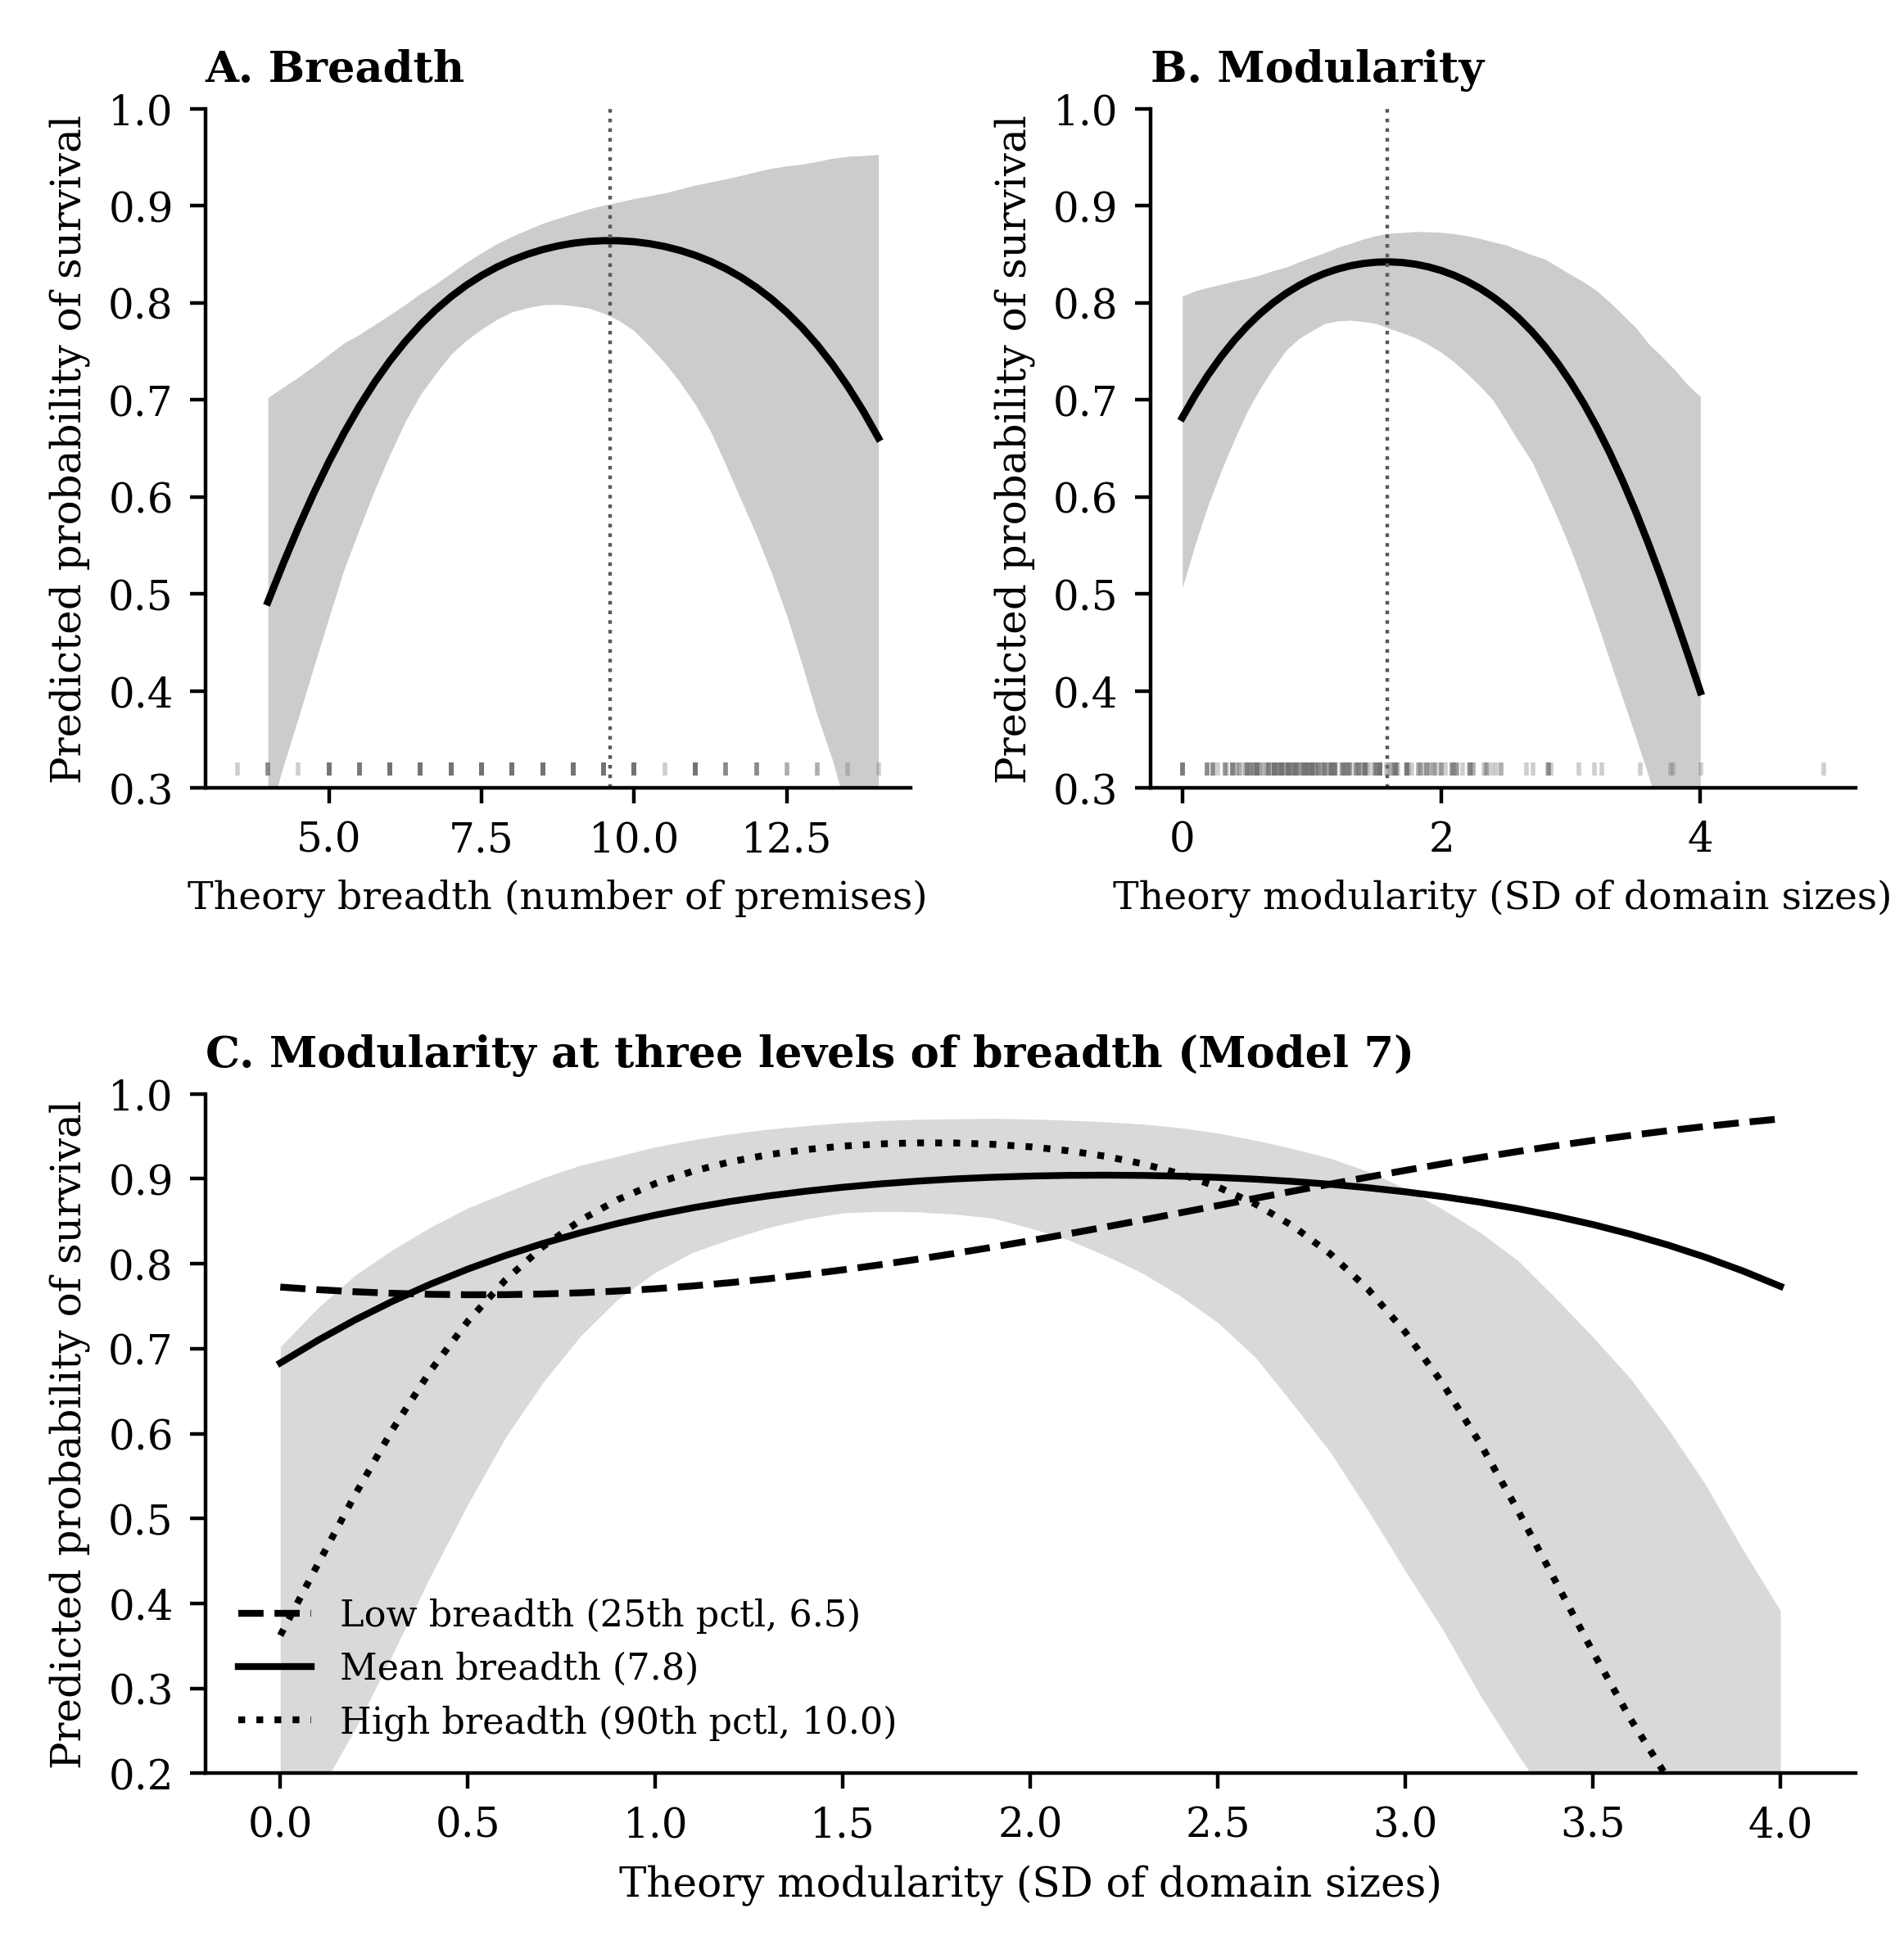
Note. Each point is the predicted probability of survival averaged over the observed values of all covariates, with the focal variable set to the value on the horizontal axis. Panels A and B are based on Model 6 and panel C on Model 7 of Table 2. Shaded bands are 95% intervals from 2,000 draws of the estimated coefficient vector; in panel C the band is shown for the high-breadth curve only. Vertical dotted lines in panels A and B mark the estimated turning points.

FIGURE 2
Specification Curve for the Breadth Squared Coefficient Across 13,824 Universes
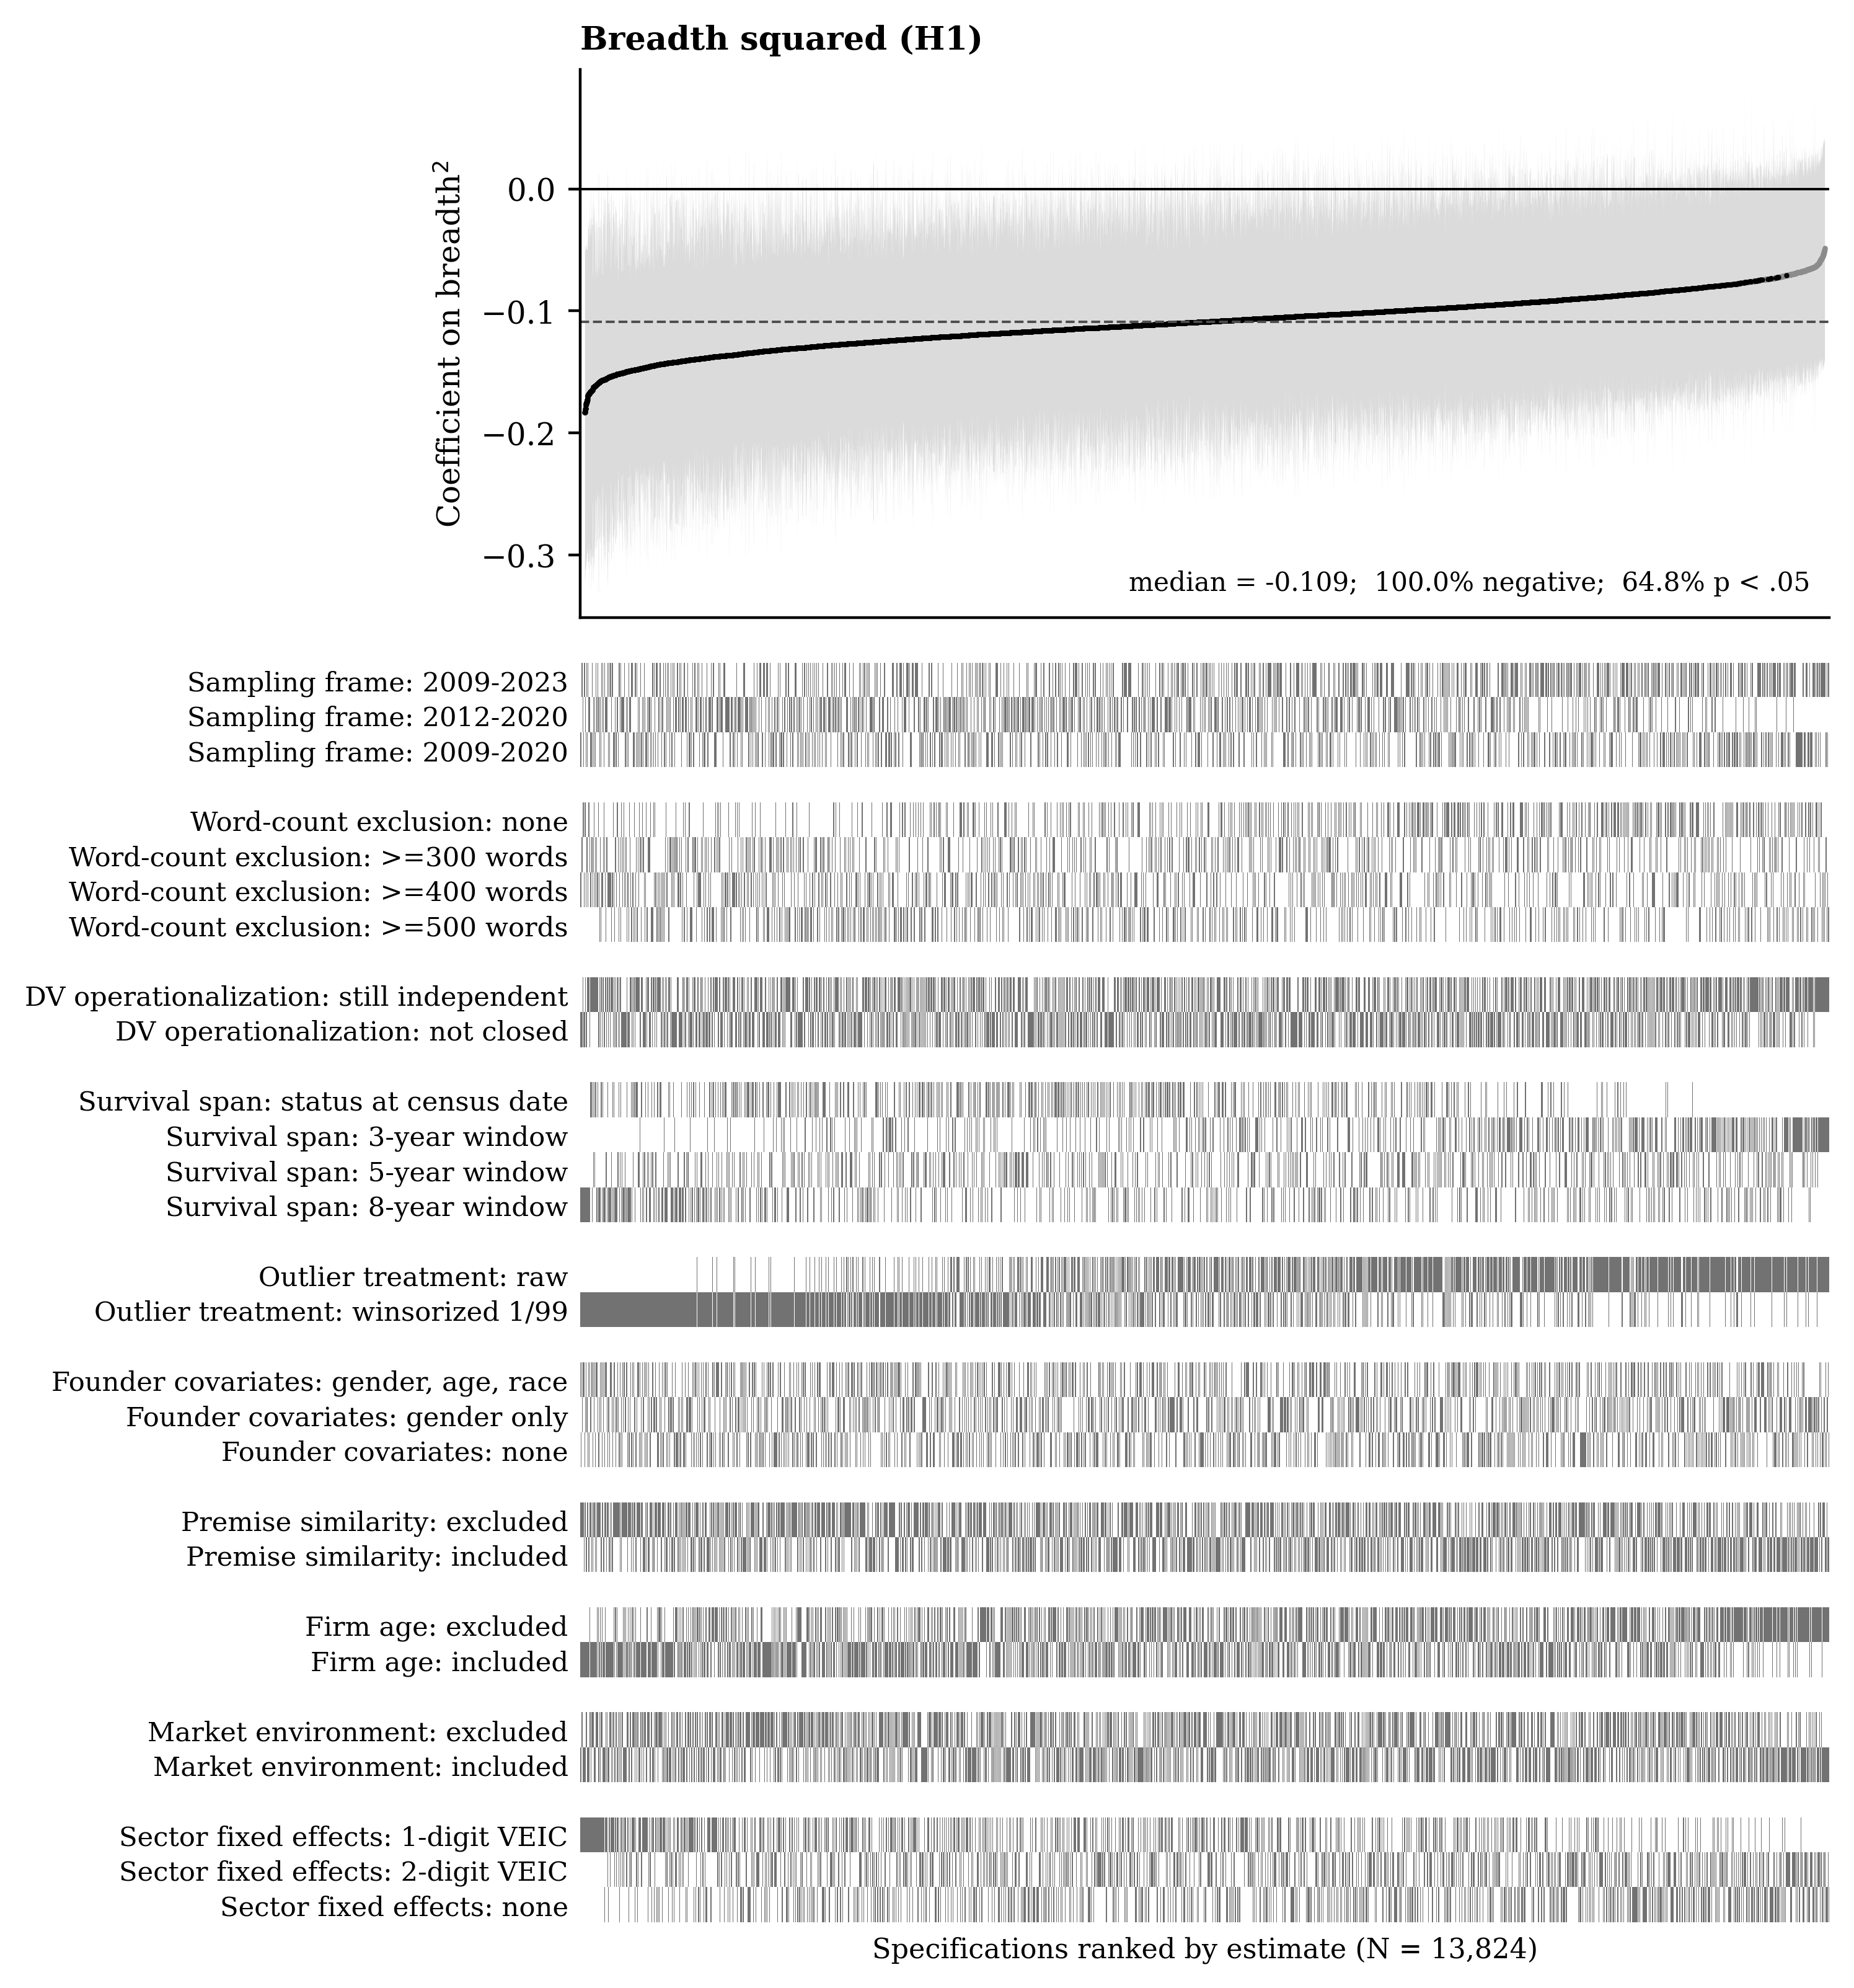
Note. Universes are ordered along the horizontal axis by the magnitude of the estimate. The upper panel plots each coefficient with its 95% confidence interval in light grey; estimates significant at p < .05 are drawn in black and nonsignificant estimates in grey. The dashed horizontal line is the median across universes. The lower panel indicates, for each universe, which option was selected at each of the ten decision nodes.

FIGURE 3
Specification Curve for the Modularity Squared Coefficient Across 13,824 Universes
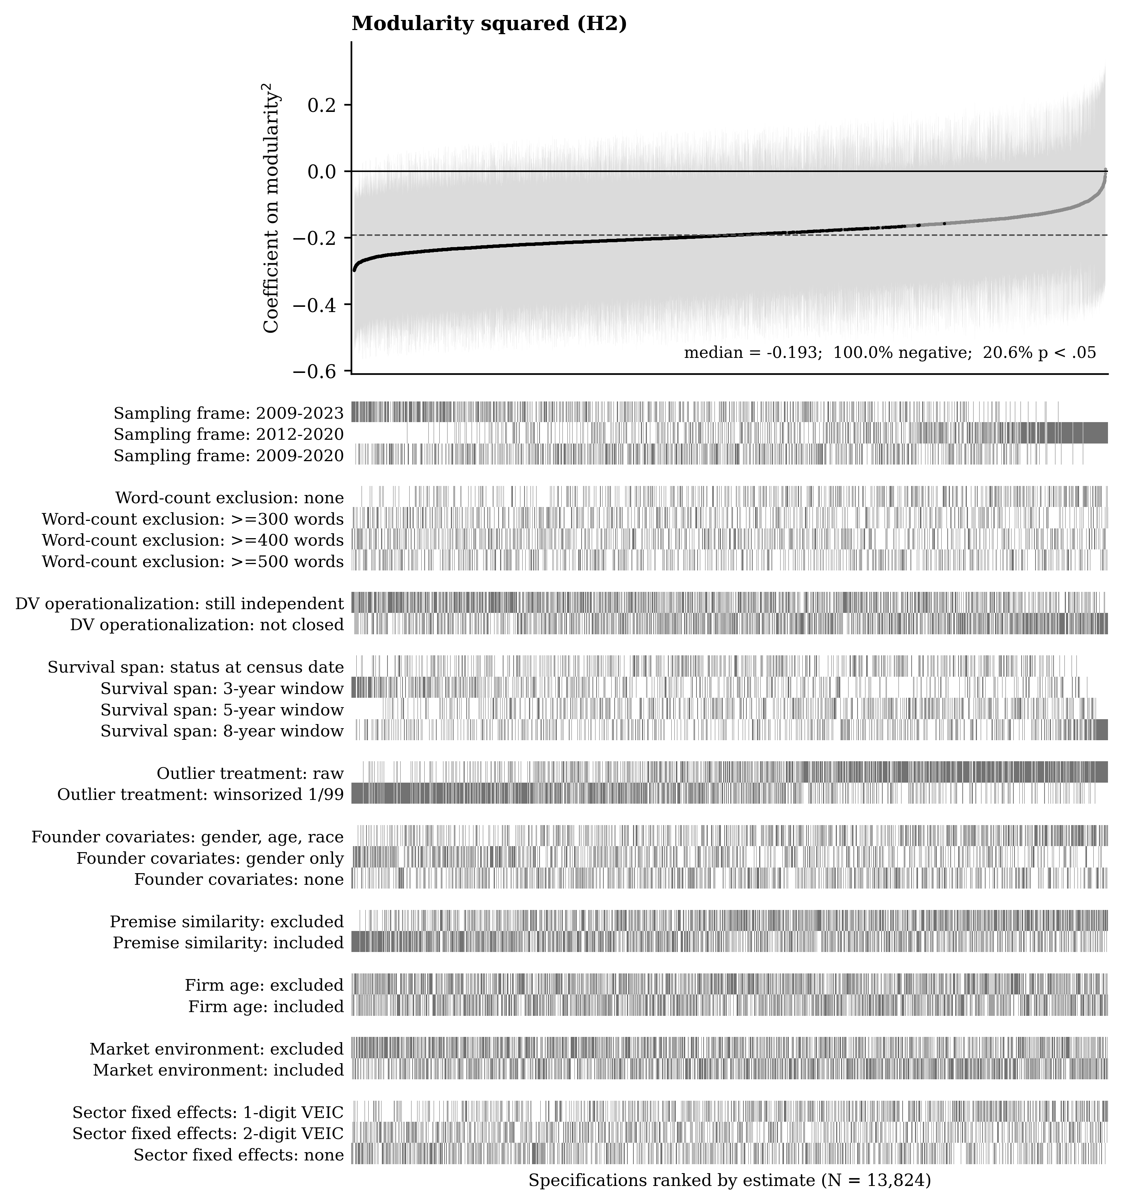
Note. Universes are ordered along the horizontal axis by the magnitude of the estimate. The upper panel plots each coefficient with its 95% confidence interval in light grey; estimates significant at p < .05 are drawn in black and nonsignificant estimates in grey. The dashed horizontal line is the median across universes. The lower panel indicates, for each universe, which option was selected at each of the ten decision nodes. Because every universe estimates the full model, the coefficient shown is the curvature of modularity at the mean level of breadth within that universe.

FIGURE 4
Specification Curve for the Modularity Squared × Breadth Coefficient Across 13,824 Universes
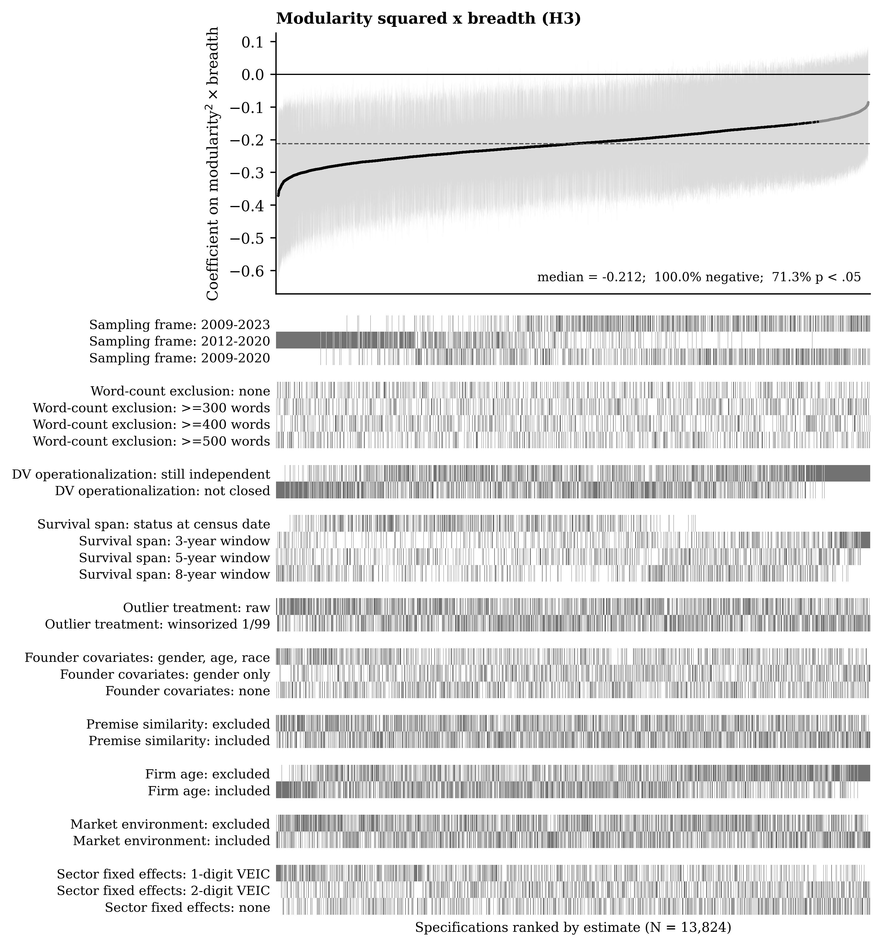
Note. Universes are ordered along the horizontal axis by the magnitude of the estimate. The upper panel plots each coefficient with its 95% confidence interval in light grey; estimates significant at p < .05 are drawn in black and nonsignificant estimates in grey. The dashed horizontal line is the median across universes. The lower panel indicates, for each universe, which option was selected at each of the ten decision nodes.

FIGURE 5
Module Emphasis and Venture Survival Across 384 Specifications per Module
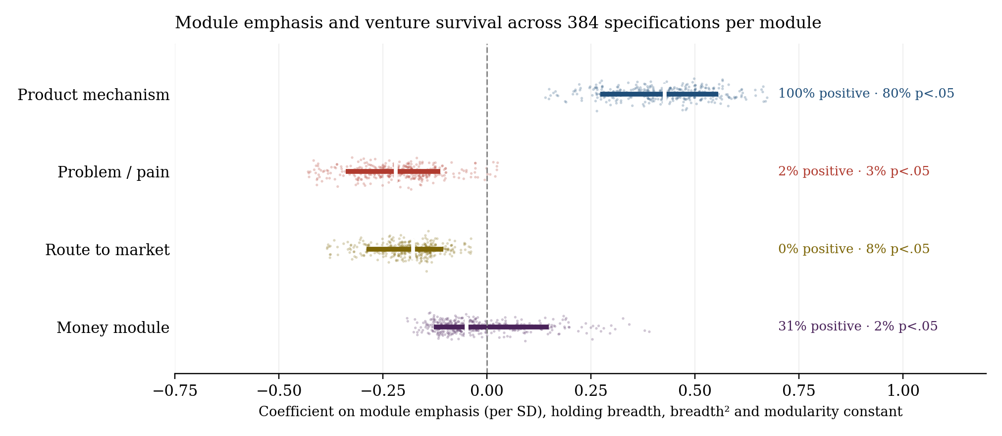
Note. Each point is one of the 384 specifications for that module; the bar spans the 10th to the 90th percentile of the coefficient distribution and the white mark is the median. The dashed line is zero. Every specification controls for theory breadth, breadth² and modularity.

Discussion

Literature
Adams, G. S., Converse, B. A., Hales, A. H., & Klotz, L. E. 2021. People systematically overlook subtractive changes. Nature, 592(7853): 258–261.
Agarwal, R., Bacco, F., Camuffo, A., Coali, A., Gambardella, A., Msangi, H., Sonka, S. T., Temu, A., Waized, B., & Wormald, A. 2023. Does a theory-of-value add value? Evidence from a randomized control trial with Tanzanian entrepreneurs. Organization Science, 36(2): 601–625.
Antretter, T., Lekkas, H. W., Djokovic, D., Souitaris, V., & Wincent, J. 2025. Not what you expected to see? Obesity stereotypes, expectancy violations, and angel investment decisions. Journal of Business Venturing, 40(5): 106510.
Antretter, T., Sirén, C., Grichnik, D., & Wincent, J. 2020. Should business angels diversify their investment portfolios to achieve higher performance? The role of knowledge access through co-investment networks. Journal of Business Venturing, 35(5): 1–19.
Baldwin, C., MacCormack, A., & Rusnak, J. 2014. Hidden structure: Using network methods to map system architecture. Research Policy, 43(8): 1381–1397.
Baldwin, C. Y. 2024. Design rules, Volume 2: How technology shapes organizations: MIT Press.
Baldwin, C. Y., & Clark, K. B. 2000. Design rules, Volume 1: The power of modularity: MIT press.
Bellman, R. 1961. Adaptive Control Processes: A Guided Tour. New Jersey: Princeton University Press.
Blohm, I., Antretter, T., Sirén, C., Grichnik, D., & Wincent, J. 2022. It’s a peoples game, isn’t it?! A comparison between the investment returns of business angels and machine learning algorithms. Entrepreneurship Theory and Practice, 46(4): 1054–1091.
Campagnolo, D., & Camuffo, A. 2010. The concept of modularity in management studies: a literature review. International Journal of Management Reviews, 12(3): 259–283.
Camuffo, A., Cordova, A., Gambardella, A., & Spina, C. 2020. A scientific approach to entrepreneurial decision making: Evidence from a randomized control trial. Management Science, 66(2): 564–586.
Camuffo, A., Gambardella, A., Messinese, D., Novelli, E., Paolucci, E., & Spina, C. 2024. A scientific approach to entrepreneurial decision‐making: Large‐scale replication and extension. Strategic Management Journal, 45(6): 1209–1237.
Coali, A., Novelli, E., Sirigiri, A., & Spina, C. 2024. A scientific approach to decision-making: Key tools and design principles. Journal of Business Venturing Design, 3: 100023.
Cowan, N. 2001. The magical number 4 in short-term memory: A reconsideration of mental storage capacity. Behavioral and Brain Sciences, 24(1): 87–114.
Cristofaro, M., Hristov, I., Cimini, R., & Lovallo, D. 2025. From start to stardom: The impact of resource allocation strategies on new venture survival and growth. Long Range Planning, 58(2): 102513.
DeLanda, M. 2019. A new philosophy of society. London: Bloomsbury Publishing.
Dong, A., Garbuio, M., & Lovallo, D. 2016. Generative sensing: A design perspective on the microfoundations of sensing capabilities. California Management Review, 58(4): 97–117.
Durand, R., & Vaara, E. 2009. Causation, counterfactuals, and competitive advantage. Strategic Management Journal, 30(12): 1245–1264.
Ehrig, T., & Schmidt, J. 2022. Theory‐based learning and experimentation. Strategic Management Journal, 43(7): 1287–1318.
Eisenhardt, K. M., & Bingham, C. B. 2017. Superior strategy in entrepreneurial settings: Thinking, doing, and the logic of opportunity. Strategy Science, 2(4): 246–257.
Ethiraj, S. K., & Levinthal, D. 2004. Modularity and innovation in complex systems. Management Science, 50(2): 159–173.
Felin, T., Gambardella, A., & Zenger, T. 2024. Theory-Based Decisions: Foundations and Introduction. Strategy Science, 9(4): 297–310.
Felin, T., & Zenger, T. R. 2017. The theory-based view: Economic actors as theorists. Strategy Science, 2(4): 258–271.
Funk, R. J. 2014. Making the most of where you are: Geography, networks, and innovation in organizations. Academy of Management Journal, 57(1): 193–222.
Gelman, A., & Loken, E. 2013. The garden of forking paths: Why multiple comparisons can be a problem, even when there is no “fishing expedition” or “p-hacking” and the research hypothesis was posited ahead of time. Department of Statistics, Columbia University, 348(1-17): 3.
Geroski, P. A., Mata, J., & Portugal, P. 2010. Founding conditions and the survival of new firms. Strategic Management Journal, 31(5): 510–529.
Götz, M., Carnes, C. M., Hill, A. D., & O’Boyle, E. H. 2025. Multiverse analysis to advance theory and practice: Illustrating and investigating variability in CEO gender pay inequality. Academy of Management Journal(ja): amj. 2024.0355.
Huang, X., Ivković, Z., Jiang, J. X., & Wang, I. Y. 2023. Angel investment and first impressions. Journal of Financial Economics, 149(2): 161–178.
Josefy, M. A., Harrison, J. S., Sirmon, D. G., & Carnes, C. 2017. Living and dying: Synthesizing the literature on firm survival and failure across stages of development. Academy of Management Annals, 11(2): 770–799.
Johnson, J. W. 2000. A heuristic method for estimating the relative weight of predictor variables in multiple regression. Multivariate Behavioral Research, 35: 1–19.
Kanze, D., Huang, L., Conley, M., & Higgins, E. T. 2018. We ask men to win and women not to lose: Closing the gender gap in startup funding. Academy of Management Journal, 61(2): 586–614.
Linder, C., Lechner, C., & Pelzel, F. 2020. Many roads lead to Rome: How human, social, and financial capital are related to new venture survival. Entrepreneurship Theory and Practice, 44(5): 909–932.
Matusik, S., & Fitza, M. 2012. Diversification in the venture capital industry: leveraging knowledge under uncertainty. Strategic Management Journal, 33(4): 407–426.
Lind, J. T., &amp; Mehlum, H. 2010. With or without U? The appropriate test for a U-shaped relationship. Oxford Bulletin of Economics and Statistics, 72: 109–118.
Miller, G. A., & Johnson-Laird, P. N. 1976. Language and perception. Boston (MA): Harvard University Press.
Murphy, G. L., & Medin, D. L. 1985. The role of theories in conceptual coherence. Psychological Review, 92(3): 289.
Newell, A., & Simon, H. A. 1972. Human problem solving. Englewood Cliffs: Prentice-Hall.
Nickerson, J. A., & Argyres, N. 2018. Strategizing before strategic decision making. Strategy Science, 3(4): 592–605.
Nickerson, J. A., & Zenger, T. R. 2004. A knowledge-based theory of the firm—The problem-solving perspective. Organization science, 15(6): 617–632.
Nisbett, R. E., & Ross, L. 1980. Human inference: Strategies and shortcomings of social judgment. Englewood Cliffs, NJ: Prentice-Hall.
Ott, T. E., & Eisenhardt, K. M. 2020. Decision Weaving: Forming Novel, Complex Strategy in Entrepreneurial Settings. Strategic Management Journal, 41(12): 2275–2314.
Pearl, J. 2018. The book of why: the new science of cause and effect. New York: Basic Books.
Raz, O., & Gloor, P. A. 2007. Size really matters—new insights for start-ups’ survival. Management Science, 53(2): 169–177.
Sanchez, R., & Mahoney, J. T. 1996. Modularity, flexibility, and knowledge management in product and organization design. Strategic Management Journal, 17(S2): 63–76.
Schmidhuber, J. 2015. Deep learning in neural networks: An overview. Neural Networks, 61: 85–117.
Scott, E. L., Shu, P., & Lubynsky, R. M. 2020. Entrepreneurial uncertainty and expert evaluation: An empirical analysis. Management Science, 66(3): 1278–1299.
Sasabuchi, S. 1980. A test of a multivariate normal mean with composite hypotheses determined by linear inequalities. Biometrika, 67: 429–439.
Serengil, S. I., & Ozpinar, A. 2020. Lightface: A hybrid deep face recognition framework. Paper presented at the Innovations in Intelligent Systems and Applications Conference (ASYU).
Serengil, S. I., & Ozpinar, A. 2021. Hyperextended lightface: A facial attribute analysis framework. Paper presented at the International Conference on Engineering and Emerging Technologies (ICEET).
Simmons, J. P., Nelson, L. D., & Simonsohn, U. 2011. False-positive psychology: Undisclosed flexibility in data collection and analysis allows presenting anything as significant. Psychological science, 22(11): 1359–1366.
Simon, H. A. 1962. The architecture of complexity. Proceedings of the American Philosophical Society, 106(1): 467–482.
Simon, H. A. 1996. The Sciences of the Artificial. Boston (MA): MIT press.
Soto‐Simeone, A., Sirén, C., & Antretter, T. 2020. New venture survival: A review and extension. International Journal of Management Reviews, 22(4): 378–407.
Steegen, S., Tuerlinckx, F., Gelman, A., & Vanpaemel, W. 2016. Increasing transparency through a multiverse analysis. Perspectives on Psychological Science, 11(5): 702–712.
Tenenbaum, J. B., Griffiths, T. L., & Kemp, C. 2006. Theory-based Bayesian models of inductive learning and reasoning. Trends in Cognitive Sciences, 10(7): 309–318.
Tenenbaum, J. B., Kemp, C., Griffiths, T. L., & Goodman, N. D. 2011. How to grow a mind: Statistics, structure, and abstraction. Science, 331(6022): 1279–1285.
Van den Steen, E. 2017. A formal theory of strategy. Management Science, 63(8): 2616–2636.
Wennberg, K., Delmar, F., & McKelvie, A. 2016. Variable risk preferences in new firm growth and survival. Journal of Business Venturing, 31(4): 408–427.
Wennberg, K., & Lindqvist, G. 2010. The effect of clusters on the survival and performance of new firms. Small Business Economics, 34(3): 221–241.
Wesemann, H., & Antretter, T. 2022. The internationalization of business angel networks: do syndicates increase cross-border investment returns? Venture Capital, 25(4): 487–514.
Whetten, D. A. 1989. What Constitutes a Theoretical Contribution? Academy of Management Review, 14(4): 490–495.
Wiklund, J., Baker, T., & Shepherd, D. 2010. The age-effect of financial indicators as buffers against the liability of newness. Journal of Business Venturing, 25(4): 423–437.
Wry, T., Lounsbury, M., & Jennings, P. D. 2014. Hybrid vigor: Securing venture capital by spanning categories in nanotechnology. Academy of Management Journal, 57(5): 1309–1333.
Yayavaram, S., & Ahuja, G. 2008. Decomposability in knowledge structures and its impact on the usefulness of inventions and knowledge-base malleability. Administrative Science Quarterly, 53(2): 333–362.
Yue, Q., Newton, A. T., & Marois, R. 2025. Ultrafast fMRI reveals serial queuing of information processing during multitasking in the human brain. Nature Communications, 16(1): 3057.

Entrepreneurial practice has its own jargon for the essential premises underlying an entrepreneurial theory, such as “success factors,” “must-win battles,” “mission-critical tasks,” “vital fews,” and “first principles.”

