Gramatika:

- Stmts -> Stmts;Stmt
- Stmts -> Stmt
- Stmt -> Assign
- Stmt -> WhileStmt
- WhileStmt -> while(RelExp):{Stmts}
- RelExp -> Term less Term
- RelExp -> Term
- Term -> ID
- Term -> CONST
- Assign -> ID:=Term

- Kreiranje kanoničkog skupa LR pravila:

  - I₀:
    - Stmts' -> Stmts
    - Stmts -> .Stmts;Stmt
    - Stmts -> .Stmt
    - Stmt -> .Assign
    - Stmt -> .WhileStmt
    - Assign -> .ID:=Term
    - WhileStmt -> .while(RelExp):{Stmts}
  - goto(I₀, Stmts) = I₁:
    - Stmts' -> Stmts.;Stmt
  - goto(I₀, Stmt) = I₂:
    - Stmts -> Stmt. (R2)
  - goto(I₀, Assign) = I₃:
    - Stmt -> Assign. (R3)
  - goto(I₀, WhileStmt) = I₄:
    - Stmt -> WhileStmt. (R4)
  - goto(I₀, ID) = I₅:
    - Assign -> ID.:=Term
  - goto(I₀, while) = I₆:
    - WhileStmt -> while.(RelExp):{Stmts}
  - goto(I₁, ';') = I₇:
    - Stmts' -> Stmts;.Stmt
    - Stmt -> .Assign
    - Stmt -> .WhileStmt
    - Assign -> .ID:=Term
    - WhileStmt -> .while(RelExp):{Stmts}
  - goto(I₅, ':=') = I₈:
    - Assign -> ID:=.Term
    - Term -> .ID
    - Term -> .CONST
  - goto(I₆, '(') = I₉:
    - WhileStmt -> while(.RelExp):{Stmts}
    - RelExp -> .Term less Term
    - RelExp -> .Term
    - Term -> .ID
    - Term -> .CONST
  - goto(I₇, Stmt) = I₁₀:
    - Stmts -> Stmts;Stmt. (R1)
  - goto(I₇, Assign) = *I₃
  - goto(I₇, WhileStmt) = *I₄
  - goto(I₇, ID) = *I₅
  - goto(I₇, while) = *I₆
  - goto(I₈, Term) = I₁₁:
    - Assign -> ID:=Term. (R10)
  - goto(I₈, ID) = I₁₂:
    - Term -> ID. (R8)
  - goto(I₈, CONST) = I₁₃:
    - Term -> CONST. (R9)
  - goto(I₉, RelExp) = I₁₄:
    - WhileStmt -> while(RelExp.):{Stmts}
  - goto(I₉, Term) = I₁₅:
    - RelExp -> Term.less Term
    - RelExp -> Term. (R7)
  - goto(I₉, ID) = *I₁₂:
  - goto(I₉, CONST) = *I₁₃:
  - goto(I₁₄, ')') = I₁₆:
    - WhileStmt -> while(RelExp).:{Stmts}
  - goto(I₁₅, less) = I₁₇:
    - RelExp -> Term less.Term
    - Term -> .ID
    - Term -> .CONST
  - goto(I₁₆, ':') = I₁₈:
    - WhileStmt -> while(RelExp):.{Stmts}
  - goto(I₁₇, Term) = I₁₉:
    - Relxp -> Term less Term. (R6)
  - goto(I₁₇, ID) = *I₁₂
  - goto(I₁₇, CONST) = *I₁₃
  - goto(I₁₈ , '{') = I₂₀:
    - WhileStmt -> while(RelExp):{.Stmts}
    - Stmts -> .Stmts;Stmt
    - Stmts -> .Stmt
    - Stmt -> .Assign
    - Stmt -> .WhileStmt
    - Assign -> .ID:=Term
    - WhileStmt -> .while(RelExp):{Stmts}
  - goto(I₂₀, Stmts) = I₂₁:
    - WhileStmt -> while(RelExp):{Stmts.}
  - goto(I₂₀, Stmt) = *I₂
  - goto(I₂₀, Assign) = *I₃
  - goto(I₂₀, WhileStmt) = *I₄
  - goto(I₂₀, ID) = *I₅
  - goto(I₂₀, while) = *I₆
  - goto(I₂₁, '}') = I₂₂:
    - WhileStmt -> while(RelExp):{Stmts}. (R5)
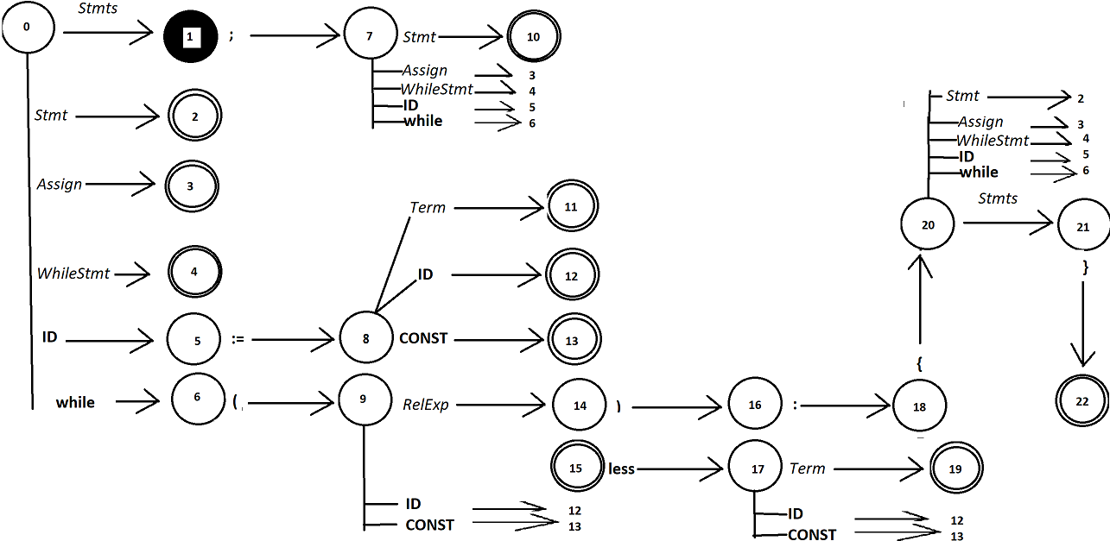
- Crtanje grafa automata:

- Follow f-je
  - FOLLOW(Stmts) = {'}', #, ';'}
  - FOLLOW(Stmt) = {'}', #, ';'} - FOLLOW(Stmts)
  - FOLLOW(RelExp) = {'}', #, ';', ')'} - FOLLOW(WhileStmt)
  - FOLLOW(Assign) = {'}', #, ';'} - FOLLOW(Stmt)
  - FOLLOW(WhileStmt) = {'}', #, ';'} - FOLLOW(Stmt)
  - FOLLOW(Term) = {'}', #, ';', ')', less} – FOLLOW(RelExp)
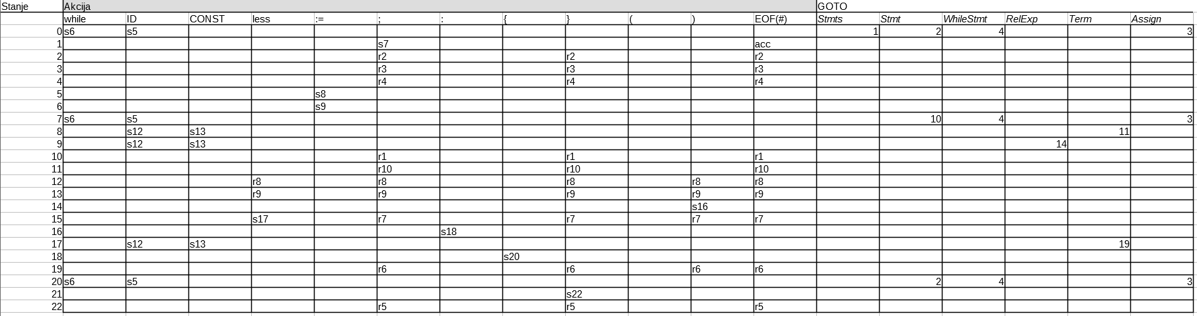
- Sintaksna tabela

