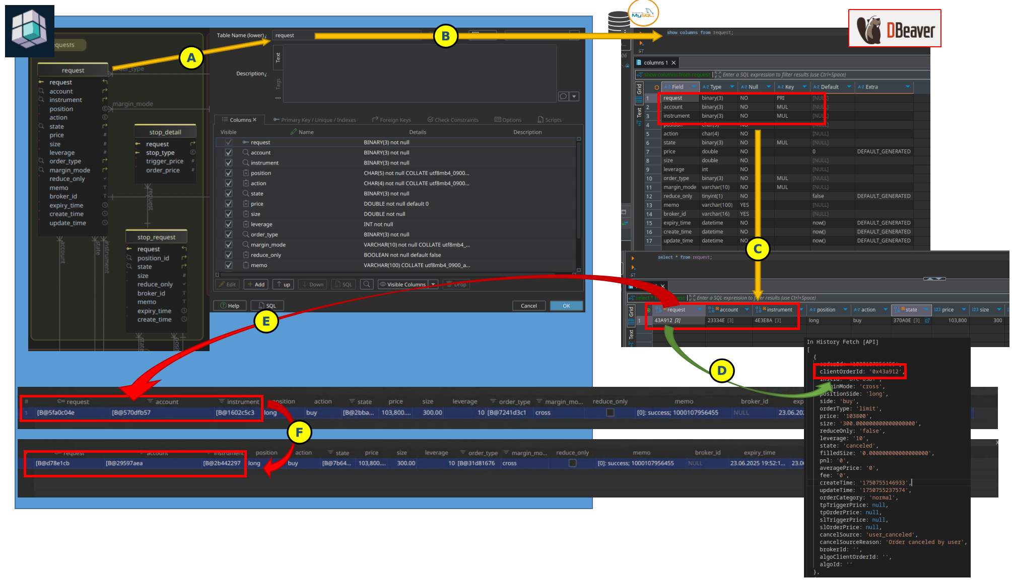

1. Designed using DbSchema Pro
2. Implemented in MySQL db
3. Populated by our app (shown in DBeaver)
4. Binary values are successfully transmitted to/from API - no change, same value
5. Opened in DbSchema data view, binary values \*never match and, ...
6. ... they change with each new click;