To the Blofin API Team:

First and foremost, thank you for building a truly state-of-the-art API/WSS brokerage interface. I would hope that other brokers, exchanges, and financial institutions would follow your lead and implement the same. With that said, our efforts integrating our systems and algorithms with the Blofin API/WSS interface is operational and, after just over four months in the making, we are now prepared to go live.

During our development, we made a few assumptions on the interface behavior that we would like to address and, additionally, have a few more questions pertaing to the order lifecycle. Due to the complexity of the material, we hope the illustrations provided will serve to clarify our concerns.

# Overview

1. Application produces request objects that are triggered by an algorithm event. These requests are keyed internally (client_order_id) and published locally.

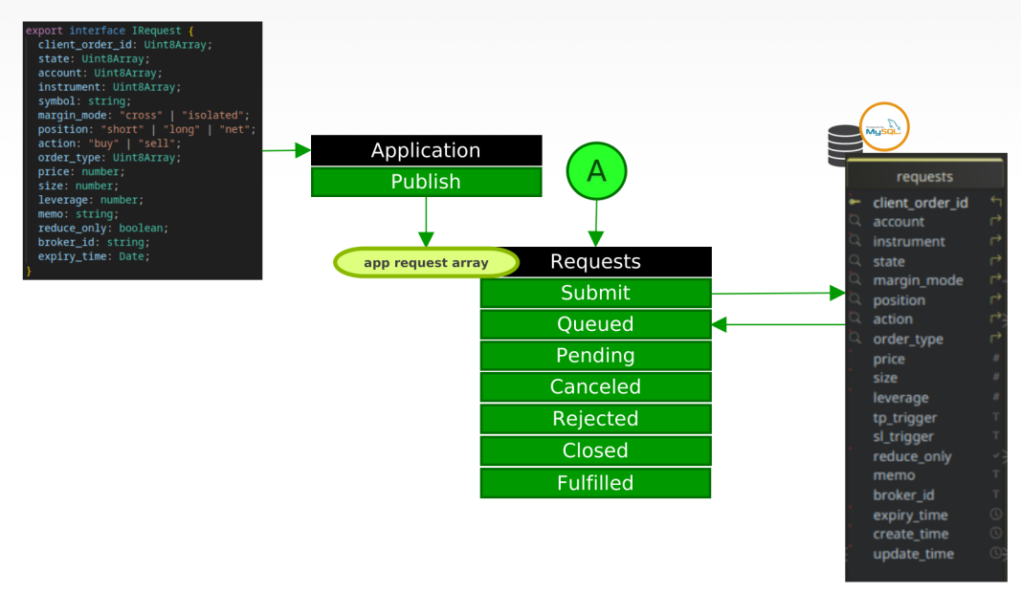

1. 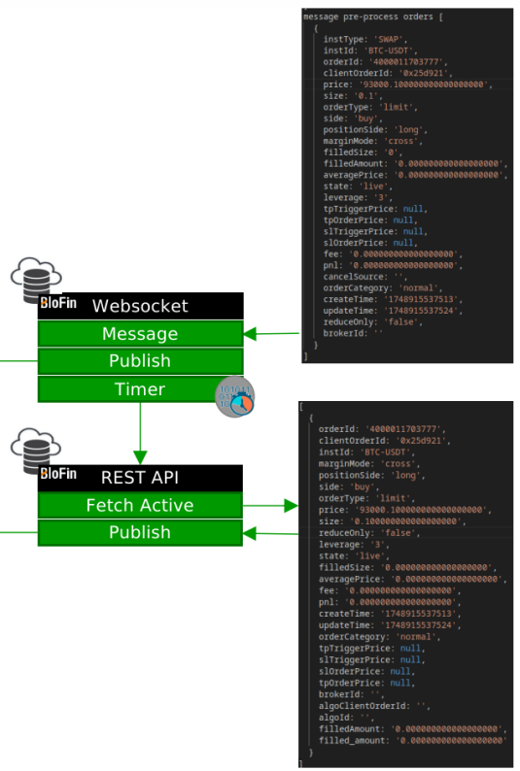Process timer launches an audit thread that pulls active requests from the REST API which are then sent to a publisher process. Active Orders recieved via the WSS channel are sent directly to the publisher process for reconciliation.
2. Orders recieved from API/WSS are then matched internally and are published, or canceled, or idententified as missing (untracked, orphan).

