HRMFoam Guide
Version 5.1
5 August 2016

Important notes
Before starting, a vital thing to note about OpenFOAM is that everything is case-sensitive, so the case of each filename, option and command should be followed exactly as given in this manual.

All variables should be in SI units

This document only covers the methods that we recommend for running HRMFoam, based on our experience. There are many other options that can be used and are covered in more detail in the OpenFOAM user guide
(http://foam.sourceforge.net/docs/Guides-a4/UserGuide.pdf)

The main body of the document provides information about setting up and running cases using HRMFoam. For information about the version that uses United Technologies' JP-8 model, known as utcHRMFoam, see the description given in Appendix A.

In case of any specific questions about HRMFoam, please contact
David Schmidt (schmidt@ecs.umass.edu)
Kshitij D. Neroorkar (kneroork@engin.umass.edu)
Ronald Grover, Jr (ronald.grover@gm.com)

Acknowledgements:
Different researchers have contributed to the work documented in this manual. Thanks Shivasubramanian Gopalakrishnan
Calvin Mitcham for his help with the moving mesh.

Table of Contents
Important notes 1
1. Test case directory 5
1.1. The 'constant' directory 5
1.1.1. polyMesh 5
1.1.2. thermophysicalProperties 7
1.1.3. turbulenceProperties and RASProperties 9
1.2. The '0' directory 10
1.3. The 'system' directory 12
1.3.1. controlDict 12
1.3.2. fvSolution 15
1.3.3. fvSchemes 18
1.3.4. decomposeParDict 20
1.4. The 'fluid.dat' file 21
2. Preprocessing 22
2.1. Using a mesh file from another software 22
2.2. Two dimensional cases 22
2.3. Axisymmetric cases 22
2.4. Cases with cyclic boundaries 23
2.5. Parallel Cases 24
2.6. Setting Non-Uniform Initial Conditions 24
2.7. Generating fluid property file “fluid.dat” 25
3. Boundary Conditions 27
3.1. Two Dimensional Cases 27
3.2. Axisymmetric Cases 29
3.3. Three dimensional cases 29
3.4. Cyclic Cases 30
3.5 Boundary Conditions for Turbulent Flows 30
4. Moving Mesh Setup 32
4.1 Mesh generation requirements 32
4.2 Setting up transient cases 32
4.2.1 Mesh setup 32
4.2.2 Flow setup 38
4.2.3 Mesh motion control 39
4.3 Post Processing 40
5. Tracer Setup 42
5.1 Pre-Processing 42
5.2 Flow Setup 43
5.3 Running Case 44
6. Running and Post-Processing HRMFoam 45
6.1. Serial Cases 45
6.2. Parallel Cases 45
6.3. Postprocessing 47
7. Coupling with External Spray 47
7.1 Extracting Data 47
7.2 Injector SprAy Automated Coupling (ISAAC) 49
7.3 Running Converge Spray Solver 51
7.3.1 spray.in file 51
7.3.2 user.in file 52
7.3.3 Nozzle outlet files 53
Appendix A 55
A.1 Public Functions 55
A1.1 getArrayInfo() 55
A1.2 getWorkingArray() 55
A1.3 getPropertiesUTRC() 55
A.2 Public Variables 55
A.3 FORTRAN wrapper 56
A.4 thermophysicalProperties dictionary 58

1. Test case directory
The first step in running HRMFoam is to create a directory for the test case. This directory should contain three directories viz, constant, 0, and system, and the file fluid.dat. Each of these units will be covered in the consecutive sections. The Fig. 1 below shows the organization of the test case directory
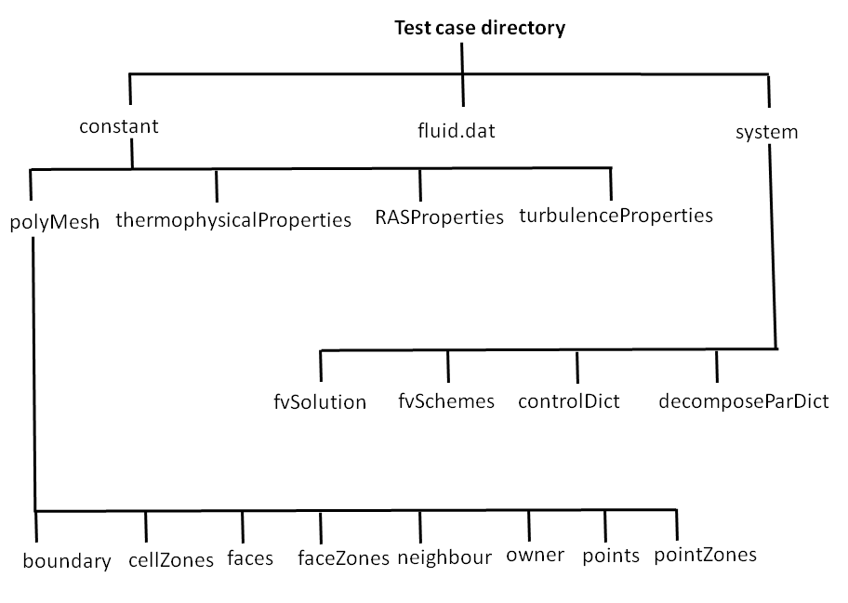Figure 1: Organization of the test case directory

1.1. The 'constant' directory
This directory contains four items viz, a directory called polymesh, the files thermophysicalProperties, RASProperties, and turbulenceProperties.

1.1.1. polyMesh
The polyMesh directory is OpenFOAM's mesh format and you can create this directory from a gambit mesh file as will be covered in the section Error: Reference source not found. Inside this directory, there is a file called boundary which has the following format.

5
(
wall
{
type wall;
nFaces 25646;
startFace 591010;
}
periodic
{
type cyclic;
nFaces 8722;
startFace 616656;
}
plenum_wall
{
type wall;
nFaces 1828;
startFace 625378;
}
outlet
{
type patch;
nFaces 1460;
startFace 627206;
}
inlet
{
type patch;
nFaces 528;
startFace 628666;
}
)

The boundary file has the names of the different boundaries in the mesh for example, in the above case, the boundaries are wall, periodic, plenum_wall, outlet and inlet. Each boundary is associated with its type and information about the faces that lie in that boundary. The type in the boundary file is defined as follows:

patch - for all boundaries except those which have some geometrical constraint applied to them. Usually applied to inlet and outlet.

wall – for both slip and no-slip walls

cyclic – for cyclic or periodic boundaries

symmetryPlane – for symmetry planes

empty – for the front and back planes of 2D cases. These are the planes which have normals in the 3rd direction, in which no solution is required.

wedge – The axisymmetric faces of an axisymmetric case should be assigned a wedge type boundary condition

1.1.2. thermophysicalProperties
This file contains information about the thermodynamic properties required to run HRMFoam. This file has the following format.
// [kg m s K mol ampere candela]
aL aL [ 0 1 -1 0 0 0 0] 1.0e15;

aV aV [ 0 1 -1 0 0 0 0] 1.0E15;

theta_0 theta_0 [ 0 0 1 0 0 0 0] 3.84E-7;

alphaFracExp alphaFracExp [ 0 0 0 0 0 0 0] -0.54;

pNonDimExp pNonDimExp [ 0 0 0 0 0 0 0] -1.76;

theta_floor theta_floor [0 0 1 0 0 0 0] 1.0E-8

rhoMin rhoMin [ 1 -3 0 0 0 0 0] 0.01;

Rgas rhoNCgas [ 0 2 -2 -1 0 0 0 ] 297;

cpGas cpGas [ 0 2 -2 -1 0 0 0 ] 1040;

cpL cpL [ 0 2 -2 -1 0 0 0 ] 1800;

cpV cpV [ 0 2 -2 -1 0 0 0 ] 1040;

hDatum hDatum [ 0 2 -2 0 0 0 0 ] -695120;

pcritical yes;
lBoundRho no;
thermModel refprop;

adiabatic yes;

compressible no;

tracerON yes;

tracerNames
(
nozzle1_tr
nozzle2_tr
nozzle3_tr
nozzle4_tr
nozzle5_tr
);

Most of the inputs in this file are in the following format

Va Va [1 -1 -1 0 0 0 0 ] 0.5;

This indicates that the variable named Va has dimensions of kg/(m s) which is indicated by the numbers in the square brackets. Finally, 0.5 is the value of the variable.
The thermophysicalProperties file has the following inputs:

aL and aV : these are the liquid and vapor sound velocities. These are used in the code only when running in compressible mode. Note that, compressibility modeling is still a work in progress and has not been fully tested.

theta_0, alphaFracExp and pNonDimExp, theta_floor : these are parameters of the relaxation model and do not need to be modified

rhoMin : this is a lower limit on the density for the stability of the code and does not need to be modified.

Rgas : this is the universal gas constant for the non condensible gas

cpGas : the specific heat for the non condensible gas

cpL : the specific heat for liquid

cpV : the specific heat of vapor

hDatum : this allows temperature readings of the gas to be accurate while avoiding large jumps in enthalpy, as a cell changes from NCG to fuel.

To solve for hDatum, use the following equation:

h_{datum}= h – T_{gas} *cpGas

Typically h is the enthalpy of your uniform h value set in your initial condition of your case. T_{gas} and cpGas should be a prescribed case parameter.

pcritical : there are two forms of the relaxation model, one uses the critical pressure information of the fluid and another which does not. Specifying “yes” will use the form of the model which includes the critical pressure. This value will be automatically read in from the fluid.dat file which will be explained later.

lBoundRho : this invokes a method used to ensure that the density field is smooth while remaining positive and conserving mass. (Warning: if negative density cells occur at the boundaries between processors, this may cause slight variations between results obtained on single and multiple processors)

thermModel : this refers to the method being used to provide the HRMFoam code with the required fluid properties. If the fluid.dat file is generated using the REFPROP code, this should be set to refprop.

adiabatic : this indicates if you want to turn on the enthalpy equation or not.

compressible : This indicates whether you want to solve the compressible or incompressible form of the pressure equation. Note that, compressibility modeling is still a work in progress and has not been fully tested. Currently, users should select “no” for this option.

tracerOn : This indicates that the passive scalar tracer equations will be solved if “yes” is chosen for this field. The problem needs to be setup as mentioned in the section 5. Tracer Setup. The names of the different tracers need to be specified in the next field

tracerNames: This field provides the list of the names of the passive tracers. The number of tracers usually equals the number of nozzles in the injector. In the current case, the names of the tracers are nozzle1_tr, nozzle2_tr, etc.

1.1.3. turbulenceProperties and RASProperties
These two dictionary files are required for turbulent cases. The format of these files are as follows

turbulenceProperties:
simulationType RASModel;
This indicates that we are using a Reynolds Averaged Navier-Stokes model for turbulence.

RASProperties:

RASModel kEpsilon;
turbulence on;
printCoeffs on;

The model kEpsilon is the standard compressible k-ε turbulence model.

1.2. The '0' directory
This directory includes the initial and boundary conditions for the different variables. HRMFoam requires boundary conditions for the variables h (enthalpy), p (pressure), rho (density), U (velocity), and if running with a turbulence model k (turbulent kinetic energy) and epsilon (turbulence dissipation rate). The 0 directory must contain a file corresponding to the name of each of these variables. Each of these files has a similar overall structure. Consider the structure of the velocity file as an example

dimensions [0 1 -1 0 0 0 0];

internalField uniform (0 0 0);

boundaryField
{
wall
{
type fixedValue;
value uniform (0 0 0);
}

periodic
{
type cyclic;
value uniform (0 0 0);
}

plenum_wall
{
type fixedValue;
value uniform (0 0 0);
}

outlet
{
type zeroGradient;
}

inlet
{
type fixedValue ;
value uniform (10 0 0);
}
}

These files start with the dimensions of the variable. The next line, named internalField, refers to the initial condition to be imposed on the variable. In this case, we set a uniform velocity of 0 throughout the domain. It is important to remember that since velocity is a vector, its value will be specified as 'uniform (a b c)', where a, b, and c are the components of the vector in the x, y and z directions. In case we were setting the value of a scalar, the method for setting a uniform value of the variable would be 'uniform d', where d is the value of the field.

The next part of the above file, named boundaryField, includes the boundary conditions of the variable on the different boundaries of the mesh. In this section, the names of the boundaries should exactly match the names specified in the boundary file in the polyMesh directory. In this case, the following boundary conditions have been set:

- The walls are set to a fixed velocity value of 0, which corresponds to a no-slip wall boundary condition
- The periodic boundary condition is set to cyclic and its value is set to 0 (This will be overwritten as the solution proceeds)
- The outlet is a zeroGradient boundary condition
- The inlet is given a fixed velocity value of 10 m/s in the x direction.

There are a number of different types of boundary conditions available for use in OpenFOAM, and these will be considered later in the section 3. Boundary Conditions .

NOTE: In setting the initial field for density, note that the HRMFoam code overwrites the initial field specified in the rho file in the 0 directory with the value of density consistent with the thermodynamic condition. This is only done when the code is started from time 0 and a warning is written to the output. When the code is restarted from an intermediate time, the density is simply read in from the file in the time directory and is not overwritten.

1.3. The 'system' directory
This directory includes the files required to run the flow solver. Usually this directory will include the following files: controlDict, decomposeParDict, fvSchemes, fvSolution. In addition, a rotationDict file is also required for running 2D axisymmetric cases which will be covered in the section 2.3. Axisymmetric cases.

1.3.1. controlDict
This file includes the options required to control the starting and ending times and the writing of solution data. This file has the following structure

application HRMFoam;

startFrom latestTime;

startTime 0.0;

stopAt endTime;

endTime 1.0E-2;

deltaT 1.0e-08;

maxDeltaT 0.5e-4;

writeControl timeStep;

writeInterval 500;

purgeWrite 0 ;

writeFormat ascii;

writePrecision 6;

writeCompression compressed;

timeFormat general;

adjustTimeStep yes;

maxCo 0.8;

timePrecision 6;

runTimeModifiable yes;

This file requires the following inputs:
startFrom: this keyword can take three options : firstTime, latestTime or startTime.
-firstTime - start case from the earliest time step from the list of time directories
-latestTime - to start the case from the latest time directory available.
-startTime - is used when you wish to start the case from the time specified in the startTime keyword.

startTime: the solution will start at the time mentioned here only if the startTime keyword is specified in the startFrom option above

stopAt: this keyword can take the following options
- endTime - solution will stop at the time specified in the endTime keyword
- writeNow - solution will stop at the conclusion of the current time step and output will be written. Make sure runTimeModifiable is set to “yes” (explained below)
- noWriteNow – similar to writeNow, but doesn't write out data.
-nextWrite – will quit the solution at the conclusion of the next scheduled write time as mentioned in the keyword writeControl. Make sure runTimeModifiable is set to “yes” (explained below)

endTime: the solution will stop at this time if the endTime keyword is specified in the stopAt option above

deltaT: the time step of the solver. This will be overwritten by the time step based on the Courant number depending upon the input to adjustTimeStep

maxDeltaT: the maximum acceptable time step

writeControl: This keyword can take the following options
- timeStep - writes data after every multiple of number of time steps given in the writeInterval option
- runTime -writes data after the number of seconds of simulation time specified in writeInterval
- cpuTime - writes data after the number of seconds of CPU time as specified in writeInterval
- clockTime – writes data after number of seconds of real time as specified in writeInterval

writeInterval: this denotes the frequency of writing outputs as given in writeControl
purgeWrite: indicates how many time step directories are stored. If a value of 10 is used, then there will always be 10 latest time directories. As the solution progresses, consecutive time step directories will overwrite the existing ones so that there will always be 10 latest directories. This option can be disabled by a value of 0. This can only be used when writeControl is set to timeStep.

writeFormat: specifies the format of the written files. This takes two options
- ascii – ASCII format written to the number of significant figures mentioned in writePrecision
- binary -Binary format

writePrecision : integer used in conjunction with writeFormat described above, default value is 6

writeCompression : specifies the compression of the data files.
- uncompressed - No compression.
- compressed - gzip compression.

timeFormat : choice of format of the naming of the time directories.
- fixed - ±m.dddddd where the number of ds is set by timePrecision.
- scientific - ±m.dddddde±xx where the number of ds is set by timePrecision.
- general - specifies scientific format if the exponent is less than -4 or
greater than or equal to that specified by timePrecision.

timePrecision : integer used in conjunction with timeFormat described above, 6 by default

adjustTimeStep : indicates whether to allow adjustment of time step according to Courant number or just use the time step set in the deltaT option

maxCo : maximum Courant number. Recommended values are 0.5 to 0.9

runTimeModifiable : yes/no switch for whether dictionaries, e.g. controlDict, are re-read by OpenFOAM at the beginning of each time step.

1.3.2. fvSolution
This file specifies the equation solvers, tolerances, and algorithms required. The format is as below
solvers

{
rho {
solver PBiCG;
preconditioner DILU;
tolerance 1e-07;
relTol 0;
minIter 1;
}

x {
solver PBiCG;
preconditioner DILU;
tolerance 1e-07;
relTol 0;
minIter 1;
}

y {
solver PBiCG;
preconditioner DILU;
tolerance 1e-07;
relTol 0;
minIter 1;
}

U {
solver PBiCG;
preconditioner DILU;
tolerance 1e-08;
relTol 0;
minIter 1;
}

p {
solver PBiCG;
a preconditioner DILU;
tolerance 1e-07;
relTol 0;
minIter 1;
}

k {
solver PBiCG;
preconditioner DILU;
tolerance 1e-07;
relTol 0;
minIter 1;
}

epsilon {
solver PBiCG;
preconditioner DILU;
tolerance 1e-07;
relTol 0;
minIter 1;
}

h {
solver PBiCG;
preconditioner DILU;
tolerance 1e-05;
relTol 0;
minIter 1;
}
Tracer {
solver PBiCG;
preconditioner DILU;
tolerance 1e-07;
relTol 0;
minIter 1;
}

}

PISO
{
nCorrectors 20;
NRepsilon 2.0e-6;
nNonOrthogonalCorrectors 0;
}

relaxationFactors
{
p 0.1;
U 0.1
pFlux 0.1;
k 0.1;
epsilon 0.1;
}

Solver options:
This section specifies the solvers used for solving for the different variables and the tolerances for iterative convergence. This section can remain the same as above. Since the sample above is set for a compressible case, the solver chosen for pressure is PBiCG, which is a preconditioned bi-conjugate gradient solver for asymmetric lduMatrices using a run-time selectable preconditioner, in this case DILU. ,

GAMG is another solver that is favored for large matricies since it converges in very few iterations and is robust, but has a larger fixed overhead cost. PBiCG is used for smaller problems.

Note that the pressure equation will be symmetric when solving a case with compressibility turned off. ICCG is a conjugate gradient method suitable for symmetric matricies.

MinIter was introduced to address overshoots in liquid density in compressible cases by ensuring a minimum number of iterations. In this case, minIter is set to 1, so the solver will perform 1 iteration even if the tolerance is met.

PISO iteration options :
nCorrectors
These are the total number of PISO correctors to be used.
NRepsilon
This is the error tolerance on the pressure between consecutive PISO iterations. Usually recommended to be between 1.0E-6 to 1.0E-4.
nNonOrthogonalCorrectors
This indicates corrections due to non-orthogonality of the grid.
relaxationFactor options :
The relaxation factor for the pressure, velocity, the pressure equation flux, turbulent kinetic energy, and the turbulence dissipation rate. Smaller values mean more under relaxation.

1.3.3. fvSchemes
This file sets the numerical schemes for solving the different terms in the equations. This file has the following format
ddtSchemes
{
default Euler;
}

gradSchemes
{
default Gauss linear ;
}

divSchemes
{
div(phiv,rho) Gauss blended 0.2;
div(phi,h) Gauss limitedLinear 1;
div(phi,U) Gauss limitedLinearV 1;
//turbulence
div((muEff*dev2(grad(U).T()))) Gauss linear;
div(phi,epsilon) Gauss upwind;
div(phi,k) Gauss upwind;
}

laplacianSchemes
{
default Gauss linear corrected;
}

interpolationSchemes
{
default linear;
}

snGradSchemes
{
default corrected;
}
fluxRequired
{
default no;
rho;
p;
}

There are a large number of schemes available in OpenFOAM and all of them will not be covered in this document. Those interested should refer the OpenFOAM users guide for more detailed information. The different sections are explained below
Time Stepping scheme (ddtSchemes ) :
Euler- stands for the implicit Euler method.
Gradient scheme (gradSchemes ) :
the numerical scheme to calculate the gradient.
Divergence scheme (divSchemes) :
For the divergence schemes, a default scheme is not specified for all divergence terms. However, specific schemes are used for specific divergence terms in the code.

Laplacian scheme (laplacianSchemes ) :
Refers to the solution scheme for the Laplacian terms in the code

Interpolation scheme (interpolationSchemes):
Refers to the scheme used to interpolate variable from cell centers to face centers.

Surface normal gradient schemes (snGradSchemes):
A surface normal gradient is evaluated at a cell face; it is the component, normal to the face, of the gradient of values at the centers of the 2 cells that the face connects.

fluxRequired:
This lists the fields for which fluxes are generated in the code. HRMFoam requires flux from the rho and p equations.

1.3.4. decomposeParDict
This file is required in order to run HRMFoam in parallel. This file mainly specifies the method used for mesh decomposition and the number of domains required. The format of the file is as follows
numberOfSubdomains 2;
method metis;

simpleCoeffs
{
n (2 2 1);
delta 0.001;
}

hierarchicalCoeffs
{
n (1 1 1);
delta 0.001;
order xyz;
}
manualCoeffs
{
dataFile "";
}
distributed no;

roots
(
);
The only input that needs to be modified in this file is the numberOfSubdomains which is equal to the number of processors on which the job is to be run.

1.4. The 'fluid.dat' file
This is the table which provides the fluid properties required by HRMFoam. The fluid.dat file is generated by the genTab pre-processing code, which takes REFPROP data and creates the look-up data required for HRMFoam. This file must have the following format:

fluids/HEXANE.FLD Fluid Data
P_start 1000.0 P_end 10000000.0 Step 1000.0
H_start -200000.0 H_end 200000.0 Step 50000.0
Points 90000 P_res 10000 H_res 9
CriticalPressure 3034E+03
Pressure(Pa) Enthalpy(KJ/Kg) Quality Density(kg/m3) DensityVapor DensityLiquid Temperature(K) Viscosity Conductivity Cv(KJ/KgK) Cp(KJ/KgK) SoS(m/s) PSat(Pa)
0.100000E+04 -0.200000E+06 0.493844E-01 0.861782E+00 0.426082E-01 0.703467E+03 0.243665E+03 0.536185E+01 0.905770E-02 -0.116042E+06 -0.116042E+06 -0.999998E+07 0.189434E+04
0.100000E+04 -0.150000E+06 0.174403E+00 0.244239E+00 0.426082E-01 0.703467E+03 0.243665E+03 0.534555E+01 0.901656E-02 -0.116042E+06 -0.116042E+06 -0.999998E+07 0.733616E+04
0.100000E+04 -0.100000E+06 0.299422E+00 0.142281E+00 0.426082E-01 0.703467E+03 0.243665E+03 0.533975E+01 0.900984E-02 -0.116042E+06 -0.116042E+06 -0.999998E+07 0.212928E+05
0.100000E+04 -0.500000E+05 0.424441E+00 0.100378E+00 0.426082E-01 0.703467E+03 0.243665E+03 0.533636E+01 0.900709E-02 -0.116042E+06 -0.116042E+06 -0.999998E+07 0.501681E+05

The first line gives information about the fluid being used. In this case it is Hexane. The next three lines give the range and resolution of the table. The following variables are used
P_start and H_start – the lowest pressure and enthalpy in the table
P_end and H_end – the highest pressure and enthalpy in the table
Step – the step sizes between consecutive pressures and enthalpies in the table.
Points – total number of points in the table
P_res – number of pressure values covered
H_res – number of enthalpy values covered
The next line gives the critical pressure of the fluid used. Finally, the different properties are listed out. It should be noted that if the format of this table is changed, an error message will be printed and the code will exit. Because genTab creates the fluid.dat file, editing fluid.dat should not be necessary.

2. Preprocessing

2.1. Using a mesh file from another software
The polyMesh directory may be created from a fluent mesh file. The fluent mesh file (*.msh) should be placed in the case directory and then the following command should be executed
fluentMeshToFoam “fileName” -scale “scale_option”

Where, “fileName” should be replaced by the fluent mesh filename, and “scale_option” should be replaced by the scale that needs to be multiplied to the mesh. If the mesh is to be in millimeters, the scale_option should be 0.001. This will create the polymesh directory in the constant directory. In addition to the scale option, the fluentMeshToFoam command has some additional options like writeZones and writeSets (to maintain the fluid zone information from the original mesh file)
Similarly, for starCCM+ meshes, the converter used is called ccm26ToFoam. Unfortunatelym this converter does not have the same options as the fluent mesh converter and so the scale of the geometry has to be maintained in starCCM+ .

2.2. Two dimensional cases
For a 2D case, on running the above command, the mesh created will be one cell thick, since OpenFOAM is an inherently 3D code. The boundary file in the polymesh directory will have the front and back planes set to type empty.

2.3. Axisymmetric cases
For setting up a test case for an axisymmetric run, the fluent mesh must be a 2D mesh. After running fluentMeshToFoam, the following command has to be executed

makeAxialMesh
In order to execute this command, a dictionary file has to be added to the system directory known as rotationDict. This file has the following format

makeAxialAxisPatch axis_name;
makeAxialWedgePatch frontAndBackPlanes;

makeAxialOffset 0.05;

rotationVector (1 0 0);
originVector (0 0 0);

wedgeAngle 5;
revolve 0;
Here, axis_name should be replaced by the name of the boundary corresponding to the axis. The rotationVector refers to the axis about which the mesh is to be rotated; in this case it is the X axis. The originVector refers to the origin of this axis; in this case it is the coordinate (0 0 0). The wedgeAngle refers to the angle of the wedge which is to be created, this is usually 5 degrees. All the other variables can be left the same as above.
This command creates an axisymmetric mesh and the polymesh directory generated is written to the time directory 2e-8. This polymesh directory has to be copied to the constant directory before running the next command.
Finally, the following command has to be run to delete unnecessary faces formed due to makeAxialMesh.
collapseEdges “edge_length” “merge_angle”

The argument “edge_length” tells the program to collapse any edges which are shorter than a certain length. This keyword should be replaced by a small number like 1e-9. The argument “merge_angle” tells the program to merge two edges if they are in line. This keyword should be replaced by an angle which is close to 180 deg, like 179.
Again, the polymesh directory generated is written to the time directory 2e-8. This has to be copied to the constant directory.

2.4. Cases with cyclic boundaries
For cases with cyclic boundaries, the face meshes should be linked when making the mesh in gambit and their boundary type should be set to wall. Suppose that the names of two patches to be linked are periodic0 and periodic1. First, fluentMeshToFoam must be run as shown above. An additional dictionary file has to be added to the system directory known as createPatchDict and is shown below

matchTolerance 1E-3;
pointSync true;

patches
(
{
name periodic;
type cyclic;
constructFrom patches;

patches (periodic0 periodic1);
set f0;
}
);

In this case, the name keyword stands for the name of the new periodic boundary to be generated from linking the two boundaries periodic1 and periodic0. The type keyword gives the type that the new patch periodic should have; in this case it is cyclic since it is a periodic boundary. The keyword patches indicates the patches from which the new patch periodic is to be created. The other inputs can be kept the same.
Once the createPatchDict file is created, the following command is executed

createPatch
The polymesh directory generated is written to the time directory 2e-8. This has to be copied to the constant directory.

2.5. Parallel Cases
For parallel cases, the number of sub domains in the decomposeParDict should be equal to the number of processors that will be used to run the case. Then, the following command must be run in the test case directory
decomposePar
Executing this command will create directories in the test case directory named processor0,processor1 .... processorN, where N is one less than the number of subdomains specified in decomposeParDict.

2.6. Setting Non-Uniform Initial Conditions
In order to set up different values for variables in different sections of the domain, the funkySetFields utility can be used. To use this utility, a sampleSurfaceDict file needs to be created in the system directory. The format of this file is as follows

expressions
(
Enthalpy_set
{
field h;
expression "500";
condition "pos().x < 2.8 ";
}
pressure1
{
field p;
expression "6.5375-29.88*(2.8-pos().x) ";
condition "((pos().x) > 2.8) && ((pos().x) < 3.6)";
}
pressure2
{
field p;
expression "U&U";
condition "pos().x > (max(pos().x)+min(pos().x))/2";
}
);

The keyword expressions should not be modified.
In this case, three different conditions have been applied. These are named Enthalpy_set, pressure1 and pressure2. It should be noted that these names do not correspond to boundary names and are just used to differentiate between the different conditions.
The condition Enthalpy_set sets the enthalpy to 500 j/kg for all cells whose centers have x-coordinates less than 2.8 m.
The condition pressure1 will be executed only when the cell center x-coordinate is greater than 2.8m and less than 3.6m. In this case, the pressure is set equal to 6.5375-29.88*(2.8- x), where x stands for the cell center x coordinates.
Finally, pressure2 sets the pressure equal to the dot product of U with itself. This will be executed only when the cell center x-coordinate is greater than the average x location in the domain.
In addition to the above mentioned operators, there are a number of options available in funkySetFields. These can be found at
http://openfoamwiki.net/index.php/Contrib_funkySetFields

2.7. Generating fluid property file “fluid.dat”
A directory known as generateTable is provided with the HRMFoam source code. This directory contains the source code for the REFPROP database and code library (version 8.0) along with the file gentab.f90 which calls subroutines from the library and generates the fluid.dat file. The table.info file in the generateTable directory controls the type of fluid and size of the fluid.dat file (see section 1.4. The 'fluid.dat' file for information on the fluid.dat file). The format of the table.info file is as follows
#Fluid data file, Units - Pressure(Pa),Enthalpy(J/Kg)
"fluids/WATER.FLD"
P_start 1000 P_end 1.5e7 Step 1000
H_start 450000.0 H_end 800000.0 Step 5000.0

The first line in the table.info file is a comment and gives the units to be used for pressure and enthalpy.
The second line in this file gives the name of the fluid file for the working fluid required, in this case it is water. There are a number of fluid files available in the REFPROP database and these can be found in the fluids directory inside the generateTable directory. These have file names like WATER.FLD, ETHANOL.FLD, etc. In some cases, the fluid files are named by the commonly used names, for eg., R12.FLD. Additional information about the fluid, like the chemical formula, CAS numbers, molecular weight, etc, can be found in the header of the consecutive FLD file.
The next line in the table.info file gives the range of pressures required in the fluid.dat table. In the above example the table goes from 1000 Pa to 1.5*10⁷ Pa with a step of 1000 Pa between two values.
The last line in the table.info file gives the range of the enthalpies required. In the above example the table goes from 450000 J/kg to 800000 J/kg with a step of 5000 J/kg between two values.
Once the table.info file is completed, the executable gentab is run to generate the fluid.dat table. The fluid.dat table is then copied to the test case directory to run the code.
Note:
- To use REFPROP, you will need to purchase a license (please see http://www.nist.gov/srd/nist23.htm)
- While setting limits for pressure it is to be noted that pressures have to be above the triple point. All conditions should be on the saturated liquid side of the critical point i.e. on the left. If any of the above conditions are violated, the gentab code will print an error and quit.

3. Boundary Conditions
This section will mention the different boundary conditions that are recommended for use with HRMFoam. These are the boundary conditions which are set in the 0 directory.

3.1. Two Dimensional Cases
For a two dimensional case, the following boundary conditions are recommended
Pressure boundary conditions :
Inlets: the inlet pressure boundary condition can be of fixed value type which is specified as below

inlet
{
type fixedValue;
value uniform 788325;
}

Outlets: for the outlets, for stability, it is recommended that the pressure value be ramped down from the inlet value to the final outlet pressure value. This can be achieved as shown below

outflow
{
type timeVaryingUniformFixedValue;
timeDataFileName "outflowP.dat";
value uniform 788325;
}

This indicates that the pressure will vary in time and the values will be obtained from the file named outflowP.dat. This file should be placed in the main test case directory and should have the following format

(
(0.0 7.88325e+05)
(1e-4 1.01325e+05)
(100.0 1.01325e+05 )
)
This means that the pressure will start at 7.8bar but will be ramped down to 1 bar over a period of 1e-4 seconds and will remain at that value till the end of the simulation. The final time value specified should be larger than the time at which the simulation is scheduled to terminate.

Walls: for pressure, the wall boundary conditions should be set to zeroGradient

Front and back planes: these are the planes whose normal lies in the third direction. For example, while solving in the XY plane, these planes will be such that their normals lie along the Z axis. In this case the boundary conditions for all variables should be set to empty

Velocity boundary conditions :
For velocity, both the inlet and outlet can have boundary conditions of zeroGradient

Walls: two options are available for wall boundary conditions
fixedValue – This will set a velocity to the wall. For a no-slip wall, a fixed value of zero is provided.
slip – this will make the wall a slip wall
Front and back planes: these will be set to empty

Density boundary conditions:
Inlets and Outlets: the thermDensity boundary condition is provided with HRMFoam which will set density value of incoming flow to be equal to the equilibrium density calculated by interpolation in the fluid.dat table. Outgoing flow will automatically be set to zero gradient. The syntax for this boundary condition is as follows

type thermDensity;
phi phiv;
value uniform 944.2;

It is to be noted that the 'value' mentioned in the example can be arbitrary and will be overwritten with the correct density before the continuity equation is solved
Walls: the walls should be zeroGradient
Front and back planes: these will be set to empty

Enthalpy boundary conditions:
Inlets: the inlet enthalpy must have a fixed value which should be consistent with the values set for pressure and density
Outlets and Walls: the outlets and walls should be zeroGradient
Front and back planes: these will be set to empty

3.2. Axisymmetric Cases
For axisymmetric cases, the recommended boundary conditions are the same as those mentioned above, but instead of the front and back planes being set to empty, in this case, they should be set to wedge

3.3. Three dimensional cases
For three dimensional cases, fixing the total pressure at both the inlet and outlet boundaries is quite common. When dealing with re-entrant flows, the totalPressure boundary condition is very helpful for stability. The format for using this boundary condition is as follows

outlet
{
type totalPressure;
U U;
phi phiv;
rho rho;
psi none;
gamma 1;
p0 uniform 50000;
value uniform 50000;
}

In this case, p0 is the static pressure being set at the boundary

It is recommended to set the velocity at both boundaries to zeroGradient. For three dimensional cases also, the thermDensity boundary condition is recommended. The wall boundary conditions remain the same as for the two dimensional cases.

3.4. Cyclic Cases
The boundary conditions for inlets, outlets and walls are the same as above. But for the boundaries which are periodic , a boundary condition of cyclic should be used.

3.5 Boundary Conditions for Turbulent Flows
In general, the usual rule to setup turbulent initial and boundary conditions are as follows.
Illustration 1: Equations for calculating the turbulence quantities

Where I is the turbulent intensity which is assumed to be around 1 % and C_{µ} is a turbulence model constant with value of 0.09. The velocity U is estimated from the Bernoulli’s equation. The turbulent length scale l is assumed to be equal to 7 % of the diameter of the nozzle. Once the values of k and ε are calculated from the above equations, the internal fields for the k and epsilon files in the 0 directory can be set as shown previously in the section 1.2. The '0' directory.
There are two options for the inlet boundary condition for k and epsilon. The first option is to use fixedValue boundary condition with the value being equal to those calculated by Illustration 1 above. The second involves using boundary conditions that use the equations in Illustration 1 to calculate the values of k and epsilon from the local velocity. The syntax for these are as follows
for kinetic energy
type turbulentIntensityKineticEnergyInlet;
U U;
intensity 1;
Where U indicates the name of the velocity field and intensity requires the value of the turbulent intensity which is 1% in the current case.
Similarly, for epsilon
type turbulentMixingLengthDissipationRateInlet;
mixingLength 1e-3;

Where mixingLength is the turbulent length scale which is taken to be 7% of the diameter of the nozzle.

The outlet conditions for these two variables can be either zeroGradient or

type inletOutlet;
inletValue uniform 2;
value uniform 2;
This boundary condition acts like a zero gradient boundary condition when the flow is going out of the domain and switches to a fixedValue when the flow is reversed. The value of the reversed flow is set equal to the value mentioned next to inletValue.

The boundary conditions for the walls are usually wall functions which have the following syntax
for kinetic energy

type compressible::kqRWallFunction;
value uniform 2;

For epsilon

type compressible::eWallFunction;
value uniform 62089;

4. Running with Dynamic Mesh Motion
OpenFOAM includes a variety of dynamic mesh motion libraries which can be used with HRMFoam. In addition, several libraries and utilities have been made to support HRMFoam. These will be described further in this section.

4.1 Constructing the Initial Mesh
First, it is best to initially mesh the geometry with the needle at a low lift position. This is because the surface normal of a fuel injector needle is not typically parallel to the direction of needle motion. For this reason, lowering the needle on a mesh generated at full lift will quickly result in highly skewed cells. To help visualize this best-practice, see below.
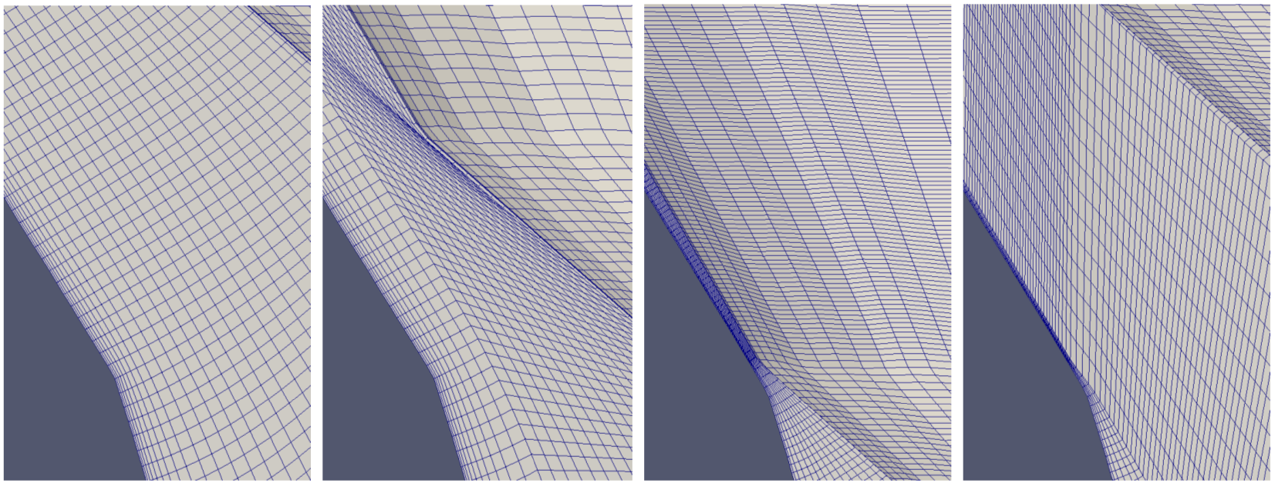Illustration 2: Seat region mesh of diesel nozzle subjected to needle motion. Two meshing approaches shown. Initial mesh generated at full lift (left-most image), lowered (left-center image), results in highly skewed cells. Initial mesh generated at low lift (right-center image), raised (right-most image), results in minimized cell skewness.
Next, generating a mesh at low lift is best done with cells that have a high aspect ratio in the direction of the flow. This must be done to keep the total cell count down. A good visualization of this best-practice can be seen below.
Finally, if using the layer motion with layer addition/removal approach, it is best to start with a non-zero number of uniform layers. This is because it allows the initial mesh motion to be distributed and it reduces and distributes the inherent mesh-dependency error introduced with the addition of cell layers. For example, taking this approach will allow for the first topology change to result in the flow solution being mapped from say 6 cell layers to 7, rather than from 1 to 2.

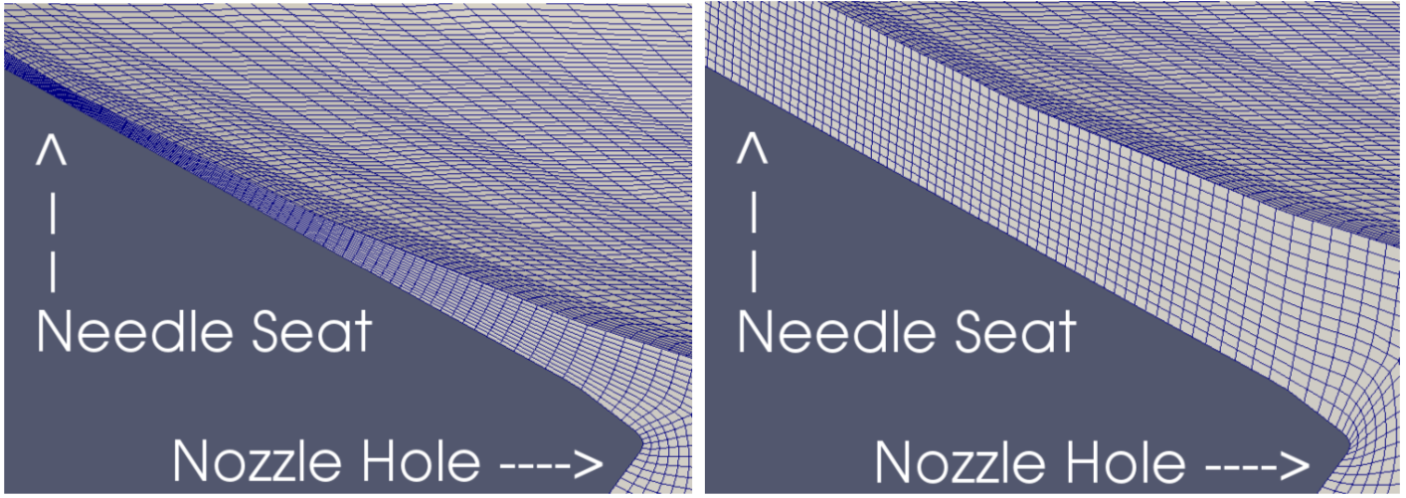Illustration 3: Mesh shown for the region between needle and nozzle wall at 5 μm lift(left) and 50 μm lift (right) for the ECN spray G injector.

4.2 Laplacian motion
One common method used to obtain a solution for internal mesh motion is to solve Laplace’s equation for the mesh. This is easy to set up, provides a good solution for moderate to small deformations, and works with a structured or unstructured grid.
At the present moment (8/05/16), there appears to be a bug in the foam-extend libraries which prevents this approach from scaling well across multiple nodes on high performance computing clusters. Therefore, it should be avoided when running on multiple nodes.
The setup for Laplacian motion consists of four steps:
1) The laplacian motion equation required a tetFemSolution file placed in the system folder. An example file is shown below.

solvers
{
motionU
{
solver PCG;
preconditioner DIC;
tolerance 1e-07;
relTol 0.001;
maxIter 25;
}
}

2) Next, the dynamicMeshDict in the constant folder must be setup as follows:
dynamicFvMesh dynamicMotionSolverFvMesh;
solver laplace;
diffusivity deformationEnergy;//quadratic;
diffusivityExponent 2;

distancePatches 2 (Needle Wall);
frozenDiffusion no;
This link provides a good description of the various settings: (http://www.tfd.chalmers.se/~hani/kurser/OS_CFD_2009/AndreuOliverGonzalez/ProjectReport_Corrected.pdf)

3) The boundary conditions for the moving boundaries must be set. This can be done by prescribing the boundary motion velocity in a motionU file as follows:
FoamFile
{
version 2.0;
format ascii;
class tetPointVectorField;
location "0";
object motionU;
}
// * * * * * * * * * * * * * * * * * * * * * * * * * * * * * //

dimensions [0 1 -1 0 0 0 0];

internalField uniform (0 0 0);

boundaryField
{
Inlet
{
type timeVaryingUniformFixedValue;
fileName "NeedleVelocity.dat";
outOfBounds error;
value uniform (0 0 0);
}

Wall
{
type fixedValue;
value uniform (0 0 0);
}

Needle
{
type timeVaryingUniformFixedValue;
fileName "NeedleVelocity.dat";
outOfBounds error;
value uniform (0 0 0);
}

4) Here, the needle velocity is described by NeedleVelocity.dat file:
(
( 0.0 ( 0.0E+00 0.0E+00 0.0E+00 ) )
( 12.999e-6 ( 0.0 0.0E+00 0.0E+00 ) )
( 13e-6 ( -0.7833 0.0E+00 0.0E+00 ) )
( 599.999e-6 ( -0.7833 0.0E+00 0.0E+00 ) )
( 600e-6 ( 0.5222 0.0E+00 0.0E+00 ) )
( 1 ( 0.5222 0.0E+00 0.0E+00 ) )
)
Where the left column is the time, and on the right is the corresponding velocity vector for needle and inlet, as defined in the motionU file.

4.3 PacMan Layer Addition/Removal with Uniform Layer Motion

4.3.1 Mesh setup with ccm mesh file
- First, copy the ccm mesh file into the case directory. Then make sure all the variable files in the 0 directory have all the boundaries from the ccm mesh. This should include the interface boundaries named something like “Boundary_Body_1_Body_2” & Boundary_Body_2_Body_1. These correspond to the interface that was created in the CAD model.
To confirm that you have all the names, you could just run the ccm26ToFoam command and look at the boundary file in the polyMesh directory. In the polyMesh directory, you can also see a folder called sets in which there will be two files. These correspond to two sets of cells: 1) Including the needle1 and inlet and 2) Including the nozzles and needle2. For the moment lets assume that they are called cellZone_1 and cellZone_2 respectively as shown in Figure 2.
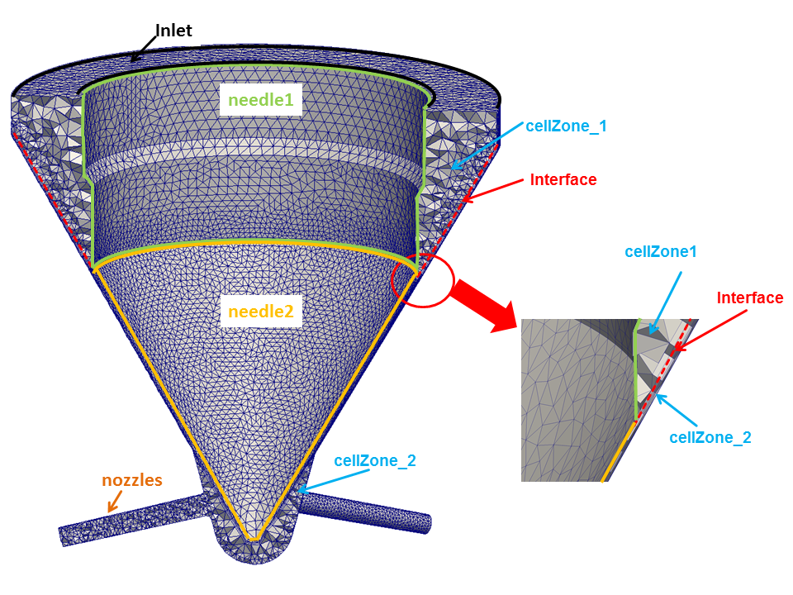Figure 2: Boundaries and cell zones for mesh motion setup

You can look at these sets by running the command
foamToVTK -cellSet cellZone_1
foamToVTK -cellSet cellZone_2
And then visualize in paraview. Remember to note the bounding box of the entire nozzle and to calculate the coordinates of the points as shown in Fig. 3. These points will be required for decomposition of the mesh. To turn on the bounding box in paraview, check the box titled 'Show cube axes'.

As can be noted from the bounding boxes in Fig. 3, this case will be decomposed into 4 regions and can be run only on 4 processors. A second method is also available to decompose the mesh into more regions. For this method, refer to the Fig. 4. The image on the left shows the different sections into which the geometry will be divided. The image on the right indicates the method for specifying one of these sections. 4 coordinates are required to specify each of these sections, namely, the Origin, and the coordinates at the end of the three spanning vectors A,B, and C.

Finally, be sure to delete the polyMesh directory after doing these steps.
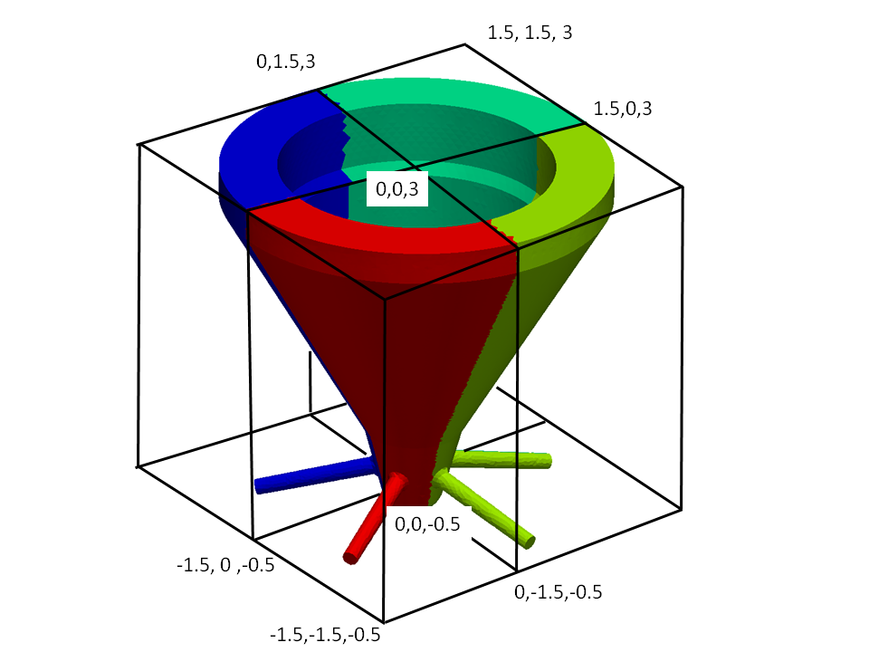Figure 3: Bounding box and coordinates required for mesh decomposition

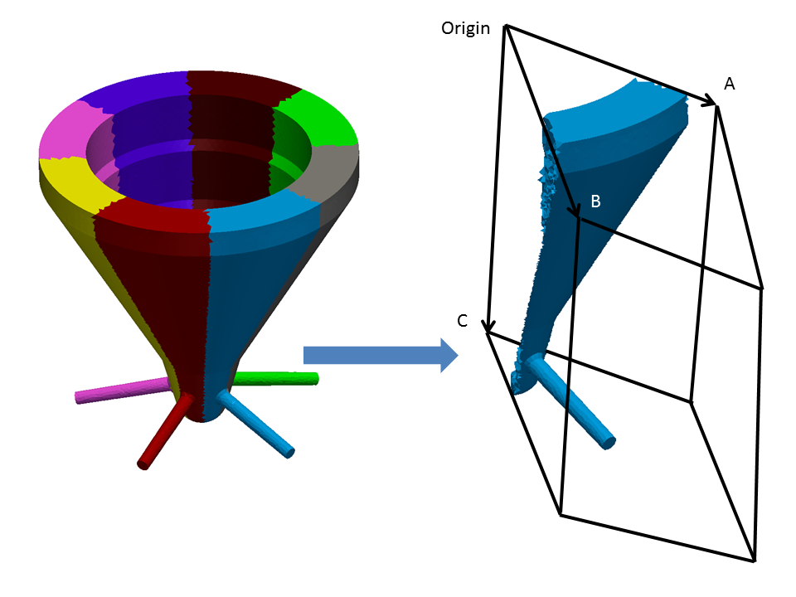Figure 4: Second method for domain decomposition for moving mesh cases

- Next, navigate to the system directory and open the decomposeParDict file (for more information on the decomposeParDict file look at section 1.3.4. decomposeParDict). For running the transient needle cases, the decomposeParDict should look as follows

numberOfSubdomains 4;
method manual;
manualCoeffs
{
dataFile "cellDecomposition";
}

- Automatic decomposition is also possible with the use of metis or scotch. This, approach, however, commonly results in processor boundaries to exist which will interfere with the layer/addition and removal routine. This can be avoided by following the instructions described in section 4.3.2.
- Now move up to the case folder and open the script Allrun. This script does all the necessary steps required to setup the mesh for the transient simulations. The Allrun script should look as follows

!/bin/sh
cd ${0%/*} || exit 1 # run from this directory

# Source tutorial run functions
. $WM_PROJECT_DIR/bin/tools/RunFunctions

runApplication ccm26ToFoam tetmesh.ccm

cd constant/polyMesh/

rm cellZones*

cd ../../

rm ./0/cell*
rm ./0/meshPhi*

runApplication stitchMesh Boundary_Body_1_Body_2 Boundary_Body_2_Body_1 -perfect -overwrite

runApplication setSet -batch setBatch

cd constant/polyMesh/sets/

\rm *old*

cd ..
\rm cellZones* faceZones* meshModifier*

cd ../..

runApplication setsToZones

runApplication makeCellDecomposition

runApplication decomposePar

The words marked in red need to be changed corresponding to the case being run. tetmesh.ccm corresponds to the filename of the ccm file. Boundary_Body_1_Body_2 and Boundary_Body_2_Body_1 correspond to the interface boundaries.
- Next open the setBatch file. It should look as follows

faceSet movingZone new patchToFace needle2

faceSet movingZone add zoneToFace Boundary_Body_1_Body_2Boundary_Body_2_Body_1CutFaceZone

cellSet movingZoneMasterCells new cellToCell cellZone_2

cellSet processor0 new boxToCell (-1.5 -1.5 -0.5) (0 0 3)

cellSet processor1 new boxToCell (0 -1.5 -0.5) (1.5 0 3)

cellSet processor2 new boxToCell (0 0 -0.5) (1.5 1.5 3)

cellSet processor3 new boxToCell (-1.5 0 -0.5) (0 1.5 3)

quit

The first line identifies the needle2 boundary which is associated with cellZone_2 as mentioned in the section 4.3.1 Mesh setup with ccm mesh file. For the second line simple concatenate the names of the interface boundaries and add the string CutFaceZone at the end to give
Boundary_Body_1_Body_2Boundary_Body_2_Body_1CutFaceZone
The third line identifies the cellZone_2. Finally, the different bounding boxes for the mesh decomposition are provided. As can be seen from Figure 3, these correspond to the coordinates calculated before.
A second method was mentioned previously in this section in reference to Fig. 4, for decomposing the mesh into more than 4 domains. For this method, the setBatch file will look as follows

faceSet movingZone new patchToFace needle2

faceSet movingZone add zoneToFace Boundary_Body_1_Body_2Boundary_Body_2_Body_1CutFaceZone

cellSet movingZoneMasterCells new cellToCell cellZone_2

cellSet processor0 new rotatedBoxToCell (0 0 -0.5) (0 -1.7 0) (1.7 -1.7 0) (0 0 3.5)

cellSet processor1 new rotatedBoxToCell (0 0 -0.5) (1.7 -1.7 0) (1.7 0 0) (0 0 3.5)

cellSet processor2 new rotatedBoxToCell (0 0 -0.5) (1.7 0 0) (1.7 1.7 0) (0 0 3.5)

cellSet processor3 new rotatedBoxToCell (0 0 -0.5) (1.7 1.7 0) (0 1.7 0) (0 0 3.5)

cellSet processor4 new rotatedBoxToCell (0 0 -0.5) (0 1.7 0) (-1.7 1.7 0) (0 0 3.5)

cellSet processor5 new rotatedBoxToCell (0 0 -0.5) (-1.7 1.7 0) (-1.7 0 0) (0 0 3.5)

cellSet processor6 new rotatedBoxToCell (0 0 -0.5) (-1.7 0 0) (-1.7 -1.7 0) (0 0 3.5)

cellSet processor7 new rotatedBoxToCell (0 0 -0.5) (-1.7 -1.7 0) (0 -1.7 0) (0 0 3.5)

quit

As can be noted, the first three lines are the same as before. The main changes are in the creation of the processor cellSets. The format for creating each of these is as follows

cellSet processor* new rotatedBoxToCell (X_{o} Y_{o} Z_{o}) (X_{a} Y_{a} Z_{a}) (X_{b} Y_{b} Z_{b}) (X_{c} Y_{c} Z_{c})

Where X_{o}, Y_{o} and Z_{o} are coordinates of the origin; X_{a},Y_{a}, and Z_{a} are coordinates of the point A, etc. from Fig 4.

- Finally, run the following command
./Allrun
This will setup the case. Look at all the log files generated to make sure that everything worked correctly.

4.3.2 Mesh Setup with Automatic Decomposition
Two limitations with the layer addition/removal and uniform motion libraries exist. The first prevents the removal of a face which is also a processor boundary. The second prevents uniform layer motion from occurring through processor boundaries. These limitations can be avoided by never removing cells which were not previously added by the motion routine. This, however, is also a limitation of its own, as it makes it impossible to start the simulation with a non-zero number of uniform layers.
For this reason, a program and script were written to help setup parallel cases in a way which ensures that all of these limitations are avoided. The process works in the following way:
1) In serial, lower the needle with a mesh motion only solver, removing as many layers of mesh as desired. These will be built back again in parallel and utilized for uniform mesh motion at the start of the simulation.
2) Decompose the case so that it can be run in parallel.
3) In parallel, lift the needle with a mesh motion only solver, adding as many layers as had previously been removed.
4) Set up the initial fields for the CFD simulation.
This script and the directions needed to run it are found in the folder: HRMFoam/dynamicMeshSetupScript
This script requires the noHydro solver and the cleanParallelFaceZones utility (both in the svn repo).

4.3.3 Additional Setup Steps
addCellLayer.C
A bug exists in the way the the layer addition/removal routine in the dynamicMesh source code in foam-extend. The problem is that when a face is generated where multiple processor boundaries exist, the code doesn't know how to determine which processor should own the new face. This is indicated in the figure below.
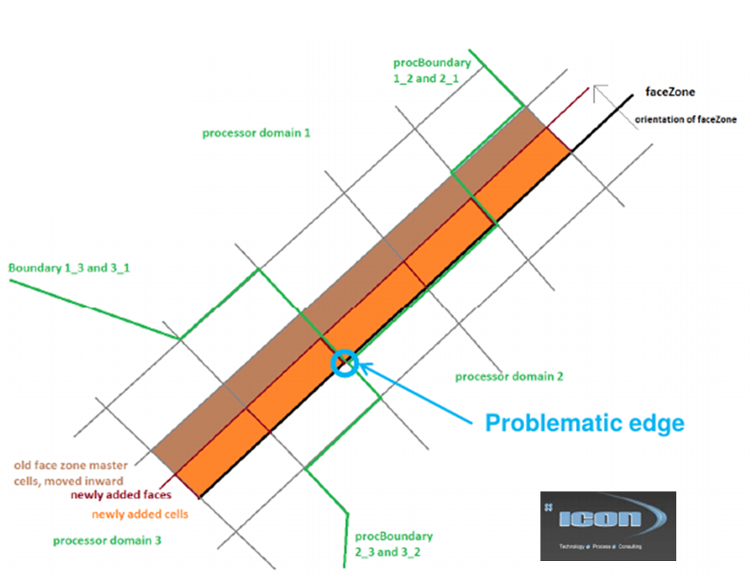
This bug has been fixed, but the fix must be installed. To do this, replace the stock foam version of addCellLayer.C located here:
$FOAM_SRC/dynamicMesh/dynamicMesh/polyMeshModifiers/layerAdditionRemoval/
with the version which is HRMFoam/dynamicMeshSetupScript/ folder. Then cd to $FOAM_SRC/dynamicMesh/dynamicMesh and type “wclean” and “wmake libso”
cleanParallelFaceZones Utility
The master face operations conducted by the pacMan library can only be done by the processor which owns the master cell for any given master face. On the mesh shown below, both processor 1 and 2 will try to conduct these operations. Running cleanParallelFaceZones fixes this by assigning the master face only to the appropriate processor.
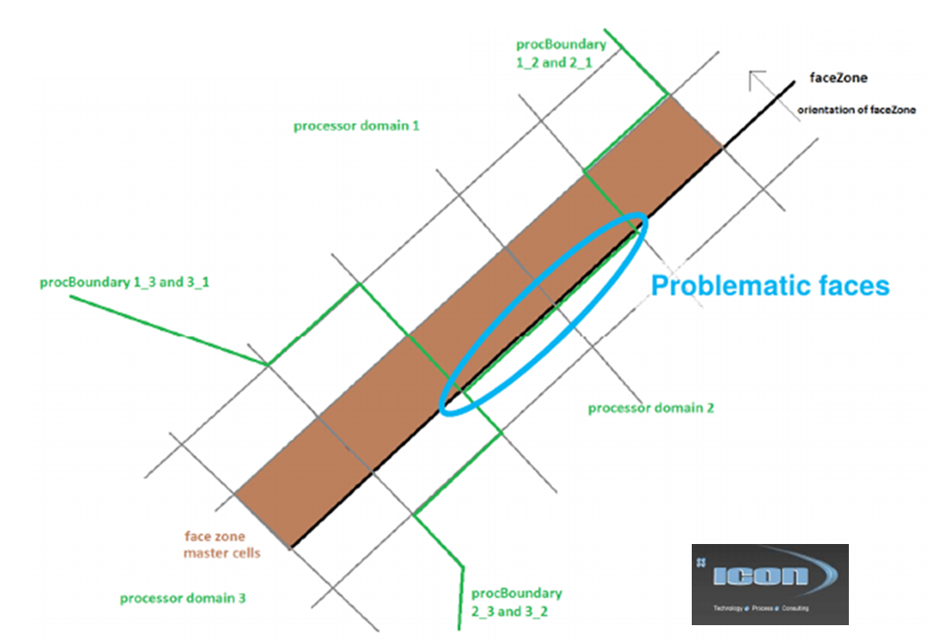
To run cleanParallelFaceZones run:
>>mpirun -np $np cleanParallelFaceZones -parallel -overwrite
Where $np is the number of processors which your case is decomposed to run on.

4.3.4 Flow setup
Now that the mesh is ready for the simulation, we need to set the boundary conditions. Most of the rules for setting the boundary conditions are the same as those for the static cases mentioned in section 3. Boundary Conditions . The only differences are that the velocity for moving walls needs to be set to

needle2
{
type movingWallVelocity;
value uniform (0 0 0);
}

4.3.5 Mesh motion control
Finally, to control the mesh motion, two more files need to be added in the constant directory. The first file is called dynamicMeshDict and its format is as follows
dynamicFvMesh pacManTopoFvMesh3;

pacManTopoFvMesh3Coeffs
{
movingCells zone1;
frontFaces movingZone;

solidBodyMotionFunction needleMotion;

needleMotion2Coeffs
{
profileFile "./constant/needleStroke.dat";
axis (1 0 0);
sideProfileFile "./constant/pistonStrokeSide.dat";
}

front
{
minThickness 1e-6;
maxThickness 5e-6;
}
}

The explanation of the different fields in the above file are as follows
dynamicFvMesh: this is the name of the driver routine that handles the mesh motion and topological changes. The routine pacManTopoFvMesh was developed for transient needle applications and the section pacManTopoFvMeshCoeffs includes the various inputs that the routine requires.
movingCells: this is the name of the zone which includes the moving cells which is zone1 in our case. This was either created by the Allrun script in 4.3.1, or the setSet -batch setBatch step of the script described in section 4.3.2.
frontFaces: is a zone including faces that move. This was either created by the Allrun script in 4.3.1, or the setSet -batch setBatch step of the script described in section 4.3.2.
solidBodyMotionFunction: this is the name of the function that controls the mesh motion. For injector simulation, the needleMotion2 function was developed to use a needle profile file to prescribe the mesh motion.
needleMotion2Coeffs: these are the inputs required for the needleMotion2 function.
- profileFile: this is the needle lift profile file. The format for this will be as follows
(
( 0 0 )
( 5E-05 3.44E-07 )
( 0.002 0 )
( 100 0 )
)

The first column is the time and the second column is the displacement in meters. This file indicates that the needle is at its initial position at the initial time. Then it linearly increases to 0.344 microns at 50 microseconds and then returns to the initial location at 2 milliseconds. It remains at the initial location till the end of the simulation which is hopefully less than 100seconds.
- sideProfileFile: this is the needle wobble profile file. The format for this will be as follows
// Time x,y,z
(
( 0 (0 0 0))
( 0.0002 (0 2.5e-6 0))
( 0.0003 (0 5.0e-6 0))
( 0.0004 (0 2.5e-6 0))
( 0.0005 (0 0 0))
( 0.0006 (0 3e-6 0))
( 0.0007 (0 6e-6 0))
( 0.0008 (0 3e-6 0))
( 0.0009 (0 -3e-6 0))
( 0.0010 (0 0 0))
( 100 (0 0 0))
)

The first column is the time and the second column is the displacement vector in meters.
- axis: This is the axis along which the needle will move. In this case, it is moving along the positive x direction.

front: this section gives details about the minimum and maximum cell sizes that are acceptable adjacent to the movingZone. In the current case, if a cell layer becomes smaller than 1 micron, it will be removed and if the cell layer becomes larger than 5 microns, a new cell will be added.
.

5. Tracer Setup
The main function of the the tracers is to identify the flow coming from the different nozzles. CellSets are created that cover the entire crossection of each nozzle. Next, tracers are defined with names corresponding to the cellSets created. At each time step, transport equations will be solved for each of the tracers.

5.1 Pre-Processing
The main pre-processing step involves creating the cell sets corresponding to the different nozzles. For this, identify a section of each nozzle that covers the entire crossection and find its bounding box, as shown in the Fig 5

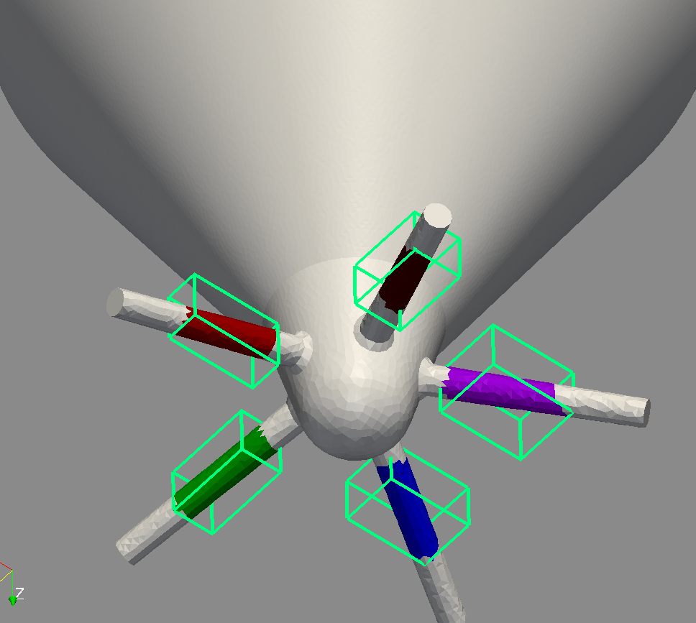Figure 5: Bounding boxes for setting up tracers

The next step is to create a file named setBatch as shown below

cellSet nozzle1_tr new boxToCell (0.05 -3.0E-5 0.002) (0.09 0.0001 0.0022)
cellSet nozzle2_tr new boxToCell (5.E-5 0.04 0.002) (0.0002 0.09 0.0026)

cellSet nozzle3_tr new boxToCell (-0.008 0.0001 0.002 ) (-0.0036 0.0004 0.0026)
cellSet nozzle4_tr new boxToCell (-0.0007 -0.0006 0.002) (-0.0002 -0.0002 0.0026)
cellSet nozzle5_tr new boxToCell (0.0001 -0.0009 0.002) (0.0004 -0.0005 0.0027)

The 5 lines in this file will create 5 cell sets named nozzle1_tr, nozzle2_tr,..nozzle5_tr. The 2 sets of three coordinates on each line represent the limits of the bounding box. The formAn alternative viewing method is from the case directory, run the following:

echo “” > CaseName.foam
paraview CaseName.foam

This will create a .foam file that allows each timestep to be viewed in Paraview, and launch Paraview. Note that the CaseName.foam file must be in the same directory as the time step directories from your case, or Paraview will have nothing to show. You can replace “CaseName” with anything as long as it has the extension *.foam. at for this is
cellSet “name_of_set” new boxToCell (Xmin Ymin Zmin) (Xmax Ymax Zmax)

Additionally, in the thermophysicalProperties file (see section 1.1.2. thermophysicalProperties) the tracerON, and the tracerNames fields need to be set.

5.2 Flow Setup
Most of the case is setup as shown for system (section 1.3. The 'system' directory), constant (section 1.1. The 'constant' directory ), 0 directories (section 1.2. The '0' directory), and fluid.dat file (section 1.4. The 'fluid.dat' file ).
Additionally, in the 0 directory, a boundary file needs to created with the format shown in section 1.2. The '0' directory for each of the tracer names denoted by the tracerNames field. For eg, in the current case, we will have 5 files named nozzel1_tr...nozzle5_tr. For these files, all the walls and the inlet boundaries are set to zeroGradient. For the outlet, a special boundary condition is used which has the following syntax

outlet
{
type tracer;
inletValue uniform 0;
value uniform 0;
}

This will set the outgoing flow to zeroGradient and the recirculating flow to 0.

5.3 Running Case
Once the case is setup, before decomposing for running in parallel, the following command needs to be executed

setSet -batch setBatch

This will create the necessary cellSets for the tracers. If running in parallel, after executing decomposePar (as mentioned in section 2.5. Parallel Cases ), the command decomposeSetsKDN needs to be executed. The case is now ready to be run in parallel.

If running the tracer in combination with the moving mesh method mentioned in section 4. Running with Dynamic Mesh Motion, two main steps are required
- The contents of the setBatch file mentioned in the current section can be appended to the setBatch file mentioned in section 4.3.1 Mesh setup with ccm mesh file before the statement “quit”.
- The following line needs to be added to the end of the Allrun script mentioned in section 4.3.1 Mesh setup with ccm mesh file
runApplication decomposeSetsKDN

Once the above changes are completed, the Allrun script will setup the case to run both the moving mesh as well as the tracers.

Note: Since reconstruction of the moving mesh cases is not possible with the current version of OpenFOAM-1.6-ext, the post processing for coupling with external spray (see section 7. Coupling with External Spray) is a little difficult since the sample utility will have to be run in each of the processor directories. The output files generated in all the processor directories will have to be combined and then the ISAAC code can be run on these files.

ENTIRE HIGHLIGHTED AREA IS NEW!

6. Running and Post-Processing HRMFoam
This section covers the basics of running and post processing HRMFoam. The basics of running in serial and parallel will be covered. Capturing outfiles will also be discussed. Instructions for getting cases into Paraview, a visual analysis tool useful for evaluating cases.

6.1. Serial Cases
When running using one processor, HRMFoam is very simple to run. From the case directory, simply run:
HRMFoam
Assuming your case is set up correctly, the case will begin to run and the output of the residuals, magnitudes, iterations, etc will fill the terminal. It is recommended to capture this output using the following:
HRMFoam > outfile_Name &
This will write the output into the file “outfile_Name” in the case directory. The & suppresses the command and allows you to use the terminal for other tasks. To view the output as it runs, run:
tail -f outfile_Name
This will populate the terminal as if you just ran HRMFoam alone.

6.2. Parallel Cases
In case of parallel simulations, the results will be written to different processor directories which are created by running from the case directory:
decomposePar
This creates multiple directories as described in 2.5. Parallel Cases . Use the following syntax to run in parallel:
mpirun -np number_of_processors HRMFoam -parallel > outfile_Name &
Or for example:
mpirun -np 4 HRMFoam -parallel > outputLog &
Where the case is run with 4 processors and the output is written to a file named “outputLog” in the background. As described in 6.1. Serial Cases, you can view the output by using the “tail -f” command.

When the case has concluded, you must reconstruct the case. Use the following command:
reconstructPar -time time_Name
This will reconstruct the output for the time mentioned in place of “time_name”. If no time is specified, all time steps will be reconstructed.

6.3. Post-Processing

The screen output from the HRMFoam program writes out the mass flux and momentum flux through each of the boundaries in the mesh. This information can be extracted by redirecting the HRMFoam screen output to a file and then using a script to extract this information.
The HRMFoam output can be directly visualized using the command paraFoam however, if paraFoam is not installed or does not work, there are several converters available with OpenFOAM to visualize the output in different visualizers.
An alternative viewing method is from the case directory, run the following:

echo “” > CaseName.foam
paraview CaseName.foam

This will create a *.foam file that allows each timestep to be viewed in Paraview, and launch Paraview. Note that the CaseName.foam file must be in the same directory as the time step directories from your case, or Paraview will have nothing to show. You can replace “CaseName” with anything as long as it has the extension *.foam.

As for using Paraview, refer to the official tutorial at: http://www.paraview.org/Wiki/The_ParaView_Tutorial

7. Coupling with External Spray
This section covers the steps involved in extracting the data from the nozzle flow simulation and using it for the converge spray simulations. The first step is to run the HRMFoam nozzle simulations with the tracers as shown in section 5. Tracer Setup.

7.1 Extracting Data
In the system directory, a file named as sampleDict should be present which has the following format.
setFormat raw;

surfaceFormat raw;

interpolationScheme cellPoint;

// Fields to sample.
fields
(
U
rho
alphaFrac
x
Tracer
nozzle1_tr
nozzle2_tr
nozzle3_tr
nozzle4_tr
nozzle5_tr
nozzle6_tr
nozzle7_tr
nozzle8_tr
);

sets
(
);

surfaces
(
outlet
{
type patch;
patchName outlet;
// Optional: whether to leave as faces (=default) or triangulate
// triangulate false;
}
);

The words marked in red are the ones that need to be modified depending on the cases being run. For the detailed information regarding the different options available for this file, one can refer to the sampleDict located in
$FOAM_UTILITIES/postProcessing/sampling/sample/
For our case, the only parameters to be changed are the fields and the surfaces sections.

The format of the fields section is as follows

// Fields to sample.
fields
(
U
rho
alphaFrac
x
nozzle1_tr
nozzle2_tr
nozzle3_tr
nozzle4_tr
nozzle5_tr
nozzle6_tr
nozzle7_tr
nozzle8_tr
);

The fields U, rho, alphaFrac, and x are the flow variables that will be extracted from the outlet of the nozzle. The next is the list of the tracers that should correspond to the names specified in section 5. Tracer Setup.
In the surfaces section, the field named patchName needs to be changed to represent the name of plenum boundary in the mesh.
Once the sampleDict is generated as shown above, the next step involves running the following command
sample -latestTime

This will create a directory called surfaces with a time directory inside it. Inside the time directory, there will be files named as U_outlet.raw, rho_outlet.raw, etc corresponding to the names of the variables and the tracers entered in the sampledict. Each of these files will include the value of the respective variable or tracer at every face-center on the plenum boundary. The next step is the run the ISAAC code as will be explained in the next section

7.2 Injector SprAy Automated Coupling (ISAAC)

The ISAAC code needs to be executed in the time directory inside the surfaces directory which is created due to the execution of the sample command as shown in the previous subsection. The ISAAC code requires two input files, input.dat and coordTrans.dat.
The input.dat file has the following format

1 number of boundaries
#boundaries
outlet
12 number of variables
# variables
U VECTOR
alphaFrac SCALAR
x SCALAR
rho SCALAR
nozzle1_tr TRACER
nozzle2_tr TRACER
nozzle3_tr TRACER
nozzle4_tr TRACER
nozzle5_tr TRACER
nozzle6_tr TRACER
nozzle7_tr TRACER
nozzle8_tr TRACER
# tracerThreshold
0.25

The words marked in red are the ones that need to be modified depending on the cases being run. The first line indicates the number of boundaries. The next input is the word in the file names after the name of the variable, for eg. if file names are “U_outlet.raw, etc“ the entry will be “outlet”. The next input is the number of variables which is 12 in our case including the tracers. The next set of inputs indicates the names of the variables which correspond to the names in the fields section of the sampleDict file, followed by the type of variable it is. The three valid types are VECTOR, SCALAR and TRACER. The final input is the tracer threshold. This means that only the part of the outlet with a tracer value greater than 0.25 will be used.

The coordTrans.dat files has the following format

#Point in injector CAD model
Xtranslation(m) Ytranslation(m) Ztranslation(m)
6.5E-7 6.6E-6 0.002
#Corresponding point in Engine Coordinate
Xtranslation(m) Ytranslation(m) Ztranslation(m)
0 0 0
Xrotation(deg) Yrotation(deg) Zrotation(deg) (order is X-Y-Z)
180 0 0

This file mainly controls the coordinate transformations required to correctly align the injector inside the engine coordinate system. For this, find the coordinates of a point on the injector model w.r.t the injector coordinate system. This is the first set of inputs in the above file. The next step is to find the location of the same point in the engine coordinate system. This is the second set of inputs in the above file. Finally, the rotation angles above the x,y and z axes in the engine coordinate system are entered to properly align the injector for engine simulations. On running the ISAAC code, files will be created corresponding representing different tracers i.e the flow coming out of different nozzles in the injector. These files are named as nozzle_outlet0.dat, nozzle_outlet1.dat.... These files need to be copied to the directory where the spray solver will be run.

Remember that the files generated by ISAAC correspond to the coordinate transformations given in coordTrans.dat. If you have multiple injectors in one simulation, you will need to run ISAAC multiple times with different coordTrans.dat files.

7.3 Running Converge Spray Solver

For running the Converge solver, there are several steps to be followed

7.3.1 spray.in file
Most of the file is the same as the file used for multi-hole injectors using the GM spray UDFs. The main changes are in the specification of the location of the injector and the nozzles, since the coordinates for these are already present in the outlet files generated by the ISAAC code. For the spray.in file
noz_init_flag =0
x_cen, y_cen, z_cen =0 (x,y,z coordinates of the injector)
angle_xy_inj, angle_xz_inj = 0 (injector rotation angles)
num_noz= number of nozzles per injector
radius_inject =0 (circular injection radius for hollow cone)
rad_noz, axi_noz, theta_noz=0 (nozzle positions)
angle_xy_noz, angle_xz_noz = 0.0 (tilt angle of nozzles)

If using noz_init_flag=1, then set
xx_noz, yy_noz, zz_noz =0
xx_vec, yy_vec, zz_vec =0

Since noz_init_flag is not equal to 2 (polar with copying), the nozzle variables for each nozzle in the injector will have to set, even though they will have the same 0 values as mentioned above.

7.3.2 user.in file
The first variable to be modified is the injector_type which should be set to 10. Next move to the section that specifies the ramps

# --- 1. Ramp Up
1
160.0e-6
0.5 19.0 4.5e-6 4.5e-6
10.0 10.0 1.5 1.5
# --- 2. Steady/Transient Plateau
0
0.358e-3
19.0 19.0 4.5e-6 4.5e-6
10.0 10.0 1.5 1.5
# --- 3. Ramp down
2
400.0e-6
19.0 0.5 4.5e-6 4.5e-6
10.0 10.0 1.5 1.5

The words marked in red are the ones that need to be modified depending on the cases being run. For each section of the ramp, there are 4 rows of inputs
The first line indicates the type of section, for eg 1 represents ramp-up, 2 represents ramp down, and 0 represents the steady plateau

The second line represents the time for corresponding section

The third line has 4 values. The first two values represents slope of the mass flow rate in the corresponding section. The next two values represent the Sauter Mean Radius (SMR) at the beginning and end of the current section

The forth line again has four values. The first two indicate the plume angle modification factor (α) at the beginning and end of the section. This is used as follows

radial velocity component(Vrad) = Vrad+Vrad * α*ϕ

Where ϕ will be explained further in the next subsection. Hence a larger value of
α corresponds to a higher value of the plume angle for every plume. The third and forth value on the forth line represent the velocity scale (β ) at the beginning and end of the section. This velocity scale is a multiplier for the total velocity and is used for adjusting the penetration of the spray as follows

total velocity (V) = V* β*γ

Where γ will be explained in the next subsection.

7.3.3 Nozzle outlet files
These are the files that were generated from the HRMFoam code. The first step is to rename these files to have the names like “injector0_nozzle_outlet0.dat, injector0_nozzle_outlet1.dat, etc” , for. eg, for a case with 2 injectors and 6 nozzles per injector, you should have injector numbers from 0 to 1, and nozzle numbers from 0 to 5.

At the top of each of these files there are several lines which can be used to control the coupling method. The format of the top of the files is as follows

174 noz_outlet_size
1.0 vel_scale
0.1 theta_scale
1.0 plume_scale
1 massBiasSwitch (0 no bias, 1 momentum , 2 density, 3 velocity)
0 smrBiasSwitch (0 no bias, 1 momentum , 2 density, 3 velocity)

The noz_outlet variable indicates the number of points in the current files. The vel_scale variable represents γ mentioned in the previous subsection. This is used in case one nozzle needs to have a different velocity multiplier as compared to the others. The theta_scale controls the overall angle of the plume with the injector axis. This is used as follows
angle with injector axis (κ) = κ+ κ*theta_scale

It must be noted that theta_scale can have negative values to reduce the cone angle. The variable plume_scale represents ϕ from the previous subsection.
The massBiasSwitch is a switch to control the mass biasing. This will add more droplets in areas of higher momentum (massBiasSwitch =1), density ( massBiasSwitch =2), and velocity ( massBiasSwitch =3). A value of 0 turns off biasing
The smrBiasSwitch is a switch to control biasing of SMD. This will lead to higher SMD in areas of higher momentum (smrBiasSwitch =1), density (smrBiasSwitch =2), and velocity (smrBiasSwitch =3). A value of 0 turns off biasing.

Appendix A

This appendix describes the thermodynamicPoint class employed in utcHRMFoam. The sources for this class are located in the files utc.C and utc.H. This class provides the functionality to read in the JP8 thermophysical property tables and perform point calculations via C++-FORTRAN interface. The public variables and functions accessible are described below.

A.1 Public Functions

A1.1 getArrayInfo()
This function reads in the size of the property table. It needs to be called first, immediately after the object of this class type is declared.

A1.2 getWorkingArray()
This function is called after getArrayInfo(). It allocates the required arrays and reads in the property tables from disk.
Both the functions getArrayInfo() and getWorkingArray() are called only once at the start of the program

A1.3 getPropertiesUTRC()
Property evaluation is done using this function. In order to use it correctly, the public variables P,H,X need to be set with values for thermodynamic point of interest. The units for these variables is given below. The output is obtained via the array prop[14].

A.2 Public Variables
The input variables for the thermodynamic state need to be set before a calculation is performed by calling getPropertiesUTRC(). This is done by assigning appropriate values to the following variables.
• P - input pressure [Pa]
• H - input enthalpy [J/kg]
• X - input quality [non-D]

Once the value is set and the calculation is performed. The results are obtained through the array prop[14]. The detailed specification of the output is given below.
• prop[0] - molecular weight [g/mol]
• prop[1] - density of vapor [kg/m^3]
• prop[2] - density of liquid [kg/m^3]
• prop[3] - Cp of vapor [J/kg]
• prop[4] - Cp of liquid [J/kg]
• prop[5] - viscosity of vapor [Pa-s]
• prop[6] - viscosity of liquid [Pa-s]
• prop[7] - thermal conductivity of vapor [W/m-K]
• prop[8] - thermal conductivity of liquid [W/m-K]
• prop[9] - acoustic speed of vapor [m/s]
• prop[10] - acoustic speed of liquid [m/s]
• prop[11] - equilibrium quality [non-D]
• prop[12] - bubble point pressure [Pa]
• prop[13] - temperature [K]

A.3 FORTRAN wrapper
The FORTRAN subroutine is called using a private function interpCppWrapper(). The use of this function is shielded from the user of the thermodynamicPoint class. All public functions internally call this private function. The prototype of this function is given below.

void interpCppWrapper(
int *opflag, //INPUT:integer flag -1:get array size and index strides;
// 0:initialize; 1:get thermo properties;
// 2:get Pbub for given H; 3:get xbar for P,H
double *Pinout, //INOUTPUT: double pressure in [bar](absolute) from 0.1 to 20
// as input, , when opflag.eq.2, it is output
double *Hin, //INPUT: double enthalpy in [J/mol] from -1d5 to -5d4
double *xin, //INPUT: double quality (mass fraction of vapour) [non-D]
//from 0-0.1
double *wtm, //OUTPUT: double overall molecular weight [g/mol]
//set when opflag.eq.0
double *rhoV, //OUTPUT: double density of vap [kg/m^3]
double *rhoL, //OUTPUT: double density of liq [kg/m^3]
double *cpV, //OUTPUT: double Cp of vap [J/kg]
double *cpL, //OUTPUT: double Cp of liq [J/kg]
double *muV, //OUTPUT: double viscosity of vap [Pa-S]
double *muL, //OUTPUT: double viscosity of liq [Pa-S]
double *lambdaV,//OUTPUT: double thermo conductivity of vap [W/m-K]
double *lambdaL,//OUTPUT: double thermo conductivity of liq [W/m-K]
double *aV, //OUTPUT: double acoustic speed of vap [m/S]
double *aL, //OUTPUT: double acoustic speed of liq [m/S]
double *TV, //OUTPUT: double temp of vap [K]
double *TL, //OUTPUT: double temp of liq [K]
double *Teq, //OUTPUT: double temp of system in eql. (P can differ) [K]
double *SurfTen,// OUTPUT: double Surface Tension [N/m]
int *superheat,//OUTPUT: integer 1: superheated, 0: otherwise
int *supercool, //OUTPUT: integer 1: supercooled, 0: otherwise
double *xbar, //OUTPUT: double [non-D]
double *Pbub,
int *sizep, //INOUTPUT: array size in the p dimension,
//output when opflag=0, else input
int *sizeh, //INOUTPUT: array size in the h dimension,
//output when opflag=0, else input
int *sizex, //INOUTPUT: array size in the x dimension,
//output when opflag=0, else input
int *sizebub, //INOUTPUT: array size of bubble point curve data
int *sizexbarp, //INOUTPUT: array size in the p dimension,
//output when opflag=0, else input
int *sizexbarh, //INOUTPUT: array size in the h dimension,
//output when opflag=0, else input
double *dP, //INOUTPUT: delta P in thermo-transport data array,
//output when opflag=0, else input
double *dH, //INOUTPUT: delta H in thermo-transport data array,
//output when opflag=0, else input
double *dx, //INOUTPUT: delta X in thermo-transport data array,
//output when opflag=0, else input
double *dbubH, //INOUTPUT: delta H in bubble point data array,
//output when opflag=0, else input
double *dxbarP, //INOUTPUT: delta P in xbar data array,
//output when opflag=0, else input
double *dxbarH, //INOUTPUT: delta h in xbar data array,
//output when opflag=0, else input
double *rhoVD, //INOUTPUT: double array (sizep,sizeh,sizex)
//e.g. (100*60*20) array size passed down
double *rhoLD, //INOUTPUT: double array (sizep,sizeh,sizex)
double *cpVD, //INOUTPUT: double array (sizep,sizeh,sizex)
double *cpLD, //INOUTPUT: double array (sizep,sizeh,sizex)
double *muVD, //INOUTPUT: double array (sizep,sizeh,sizex)
double *muLD, //INOUTPUT: double array (sizep,sizeh,sizex)
double *lambdaVD, //INOUTPUT: double array (sizep,sizeh,sizex)
double *lambdaLD, //INOUTPUT: double array (sizep,sizeh,sizex)
double *aVD, //INOUTPUT: double array (sizep,sizeh,sizex)
double *aLD, //INOUTPUT: double array (sizep,sizeh,sizex)
double *TVD, //INOUTPUT: double array (sizep,sizeh,sizex)
double *TLD, //INOUTPUT: double array (sizep,sizeh,sizex)
double *TeqD, //INOUTPUT: double array (sizep,sizeh,sizex)
double *SurfTenD, //INOUTPUT: double array (sizep,sizeh,sizex)
int *superheatD, //INOUTPUT: double array (sizep,sizeh,sizex)
double *PbubD, //INOUTPUT: double array (sizebub ) e.g. (100)
double *HbubD, //INOUTPUT: double array (sizebub ) e.g. (100)
double *xbarD, //INOUTPUT: double array (sizexbarp,sizexbarh)
//e.g. (100*60) array size passed down
double *H0, //INOUTPUT: double lower limit of H
double *H1, //INOUTPUT: double upper limit of H
double *P0, //INOUTPUT: double lower limit of P
double *P1, //INOUTPUT: double upper limit of P
double *x0, //INOUTPUT: double lower limit of x
double *x1, //INOUTPUT: double upper limit of x
int *ierr); //OUTPUT: error flag: 0 normal; -1 opflag out of range(OOR);
//-2 P OOR;-3: H OOR;-4 x OOR;-5:nonuniform
//interpolation pts

A.4 thermophysicalProperties dictionary
The thermophysicalProperties dictionary in the constant/ directory needs to have the following inputs.

// kg m s + + + +
Pcrit pCrit [ 1 -1 -2 0 0 0 0] 23.83E5;
//Critical pressure

aL aL [ 0 1 -1 0 0 0 0] 345.933;
//acoustic speed in liquid - used only for compressible calculations.

aV aV [ 0 1 -1 0 0 0 0] 162.016;
//acoustic speed in vapor - used only for compressible calculations.

theta_0 theta_0 [ 0 0 1 0 0 0 0] 6.51e-4;
//Constant from Downar-Zapolski equation.

alphaExp alphaExp [ 0 0 0 0 0 0 0] -0.54;
//Exponent for void fraction from Downar-Zapolski equation.

pNonDimExp pNonDimExp [ 0 0 0 0 0 0 0] -1.76;
//Exponent for non-dimensional pressure from Downar-Zapolski equation.

alphaMin alphaMin [ 0 0 0 0 0 0 0] 1e-5;
//Minimum void fraction - nucleation constant.

theta_floor theta_floor [0 0 1 0 0 0 0] 1.0E-9;
//Minimum theta - to prevent infinitely fast vaporization.

rhoMin rhoMin [ 1 -3 0 0 0 0 0] 0.1;
//Minimum rho - to prevent density from being numerically negative.

// ************************************************************************* //
compressible no;
//Switch for compressibility.

pcritical yes;
//Switch for expression for non-dimensional pressure
//yes - |P - Psat| no - |P - Psat|
______________ __________
|Pcrit - Psat| Psat

adiabatic yes;
//Switch for energy equation.

