**PROJECT – ETL PLAN:**

* This part of the project is mainly about creating a ETL plan to extract and load data from the source database into the data warehouse
* The data from the source is imported and final pushes are made to the data warehouse.
* First an Integration Services Project is initiated.

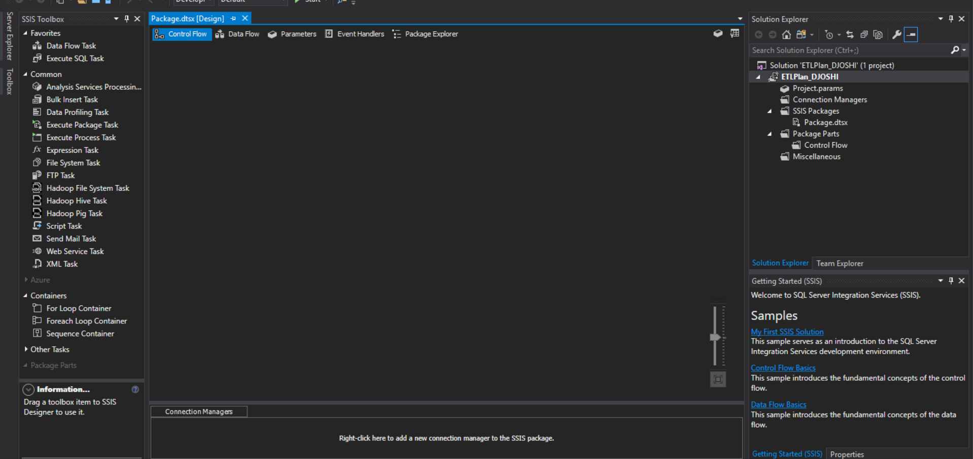

Control flow tasks are created:

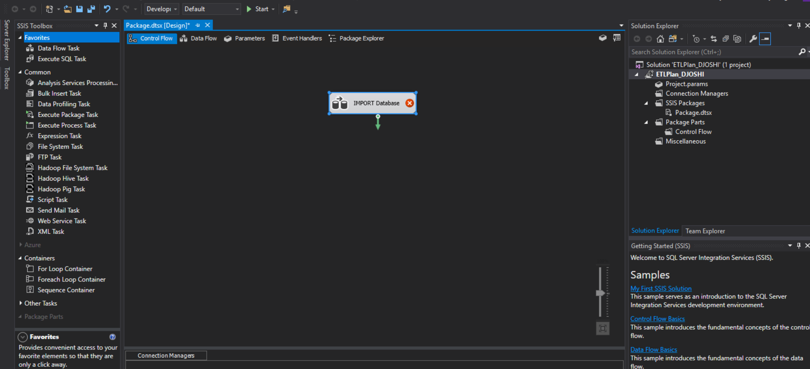

* Creating data flow:

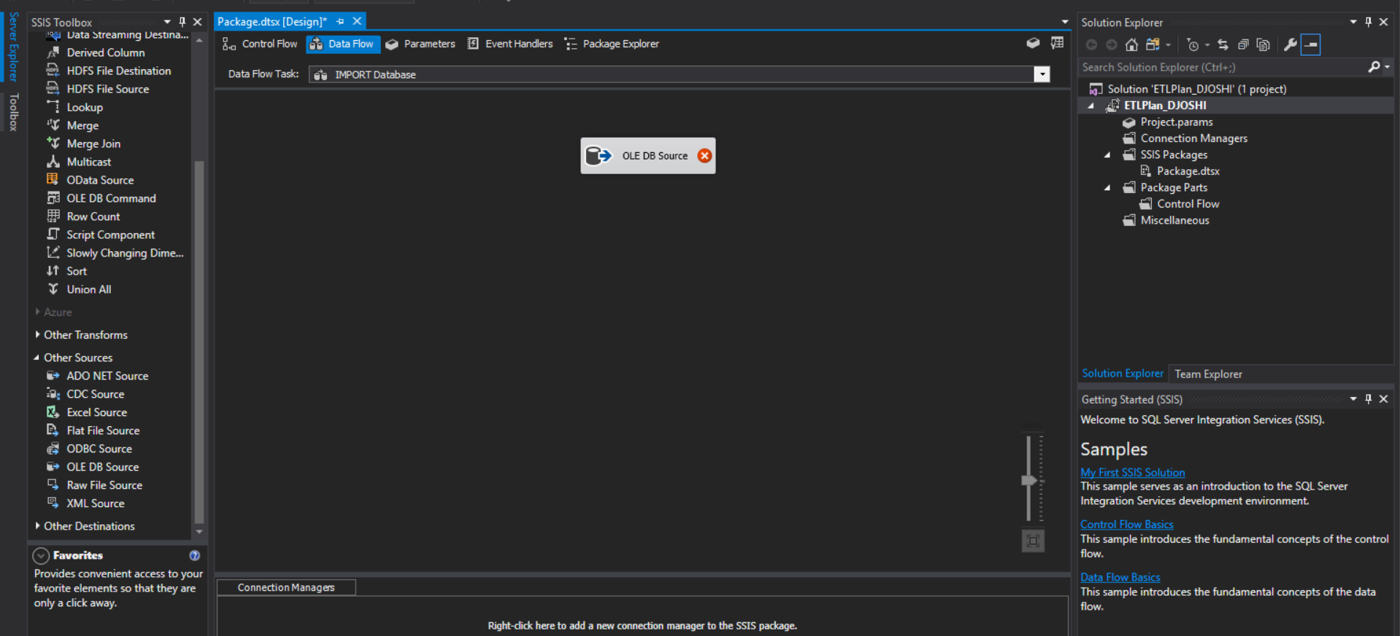

* Connection to the local host and the database source from Adventure works.

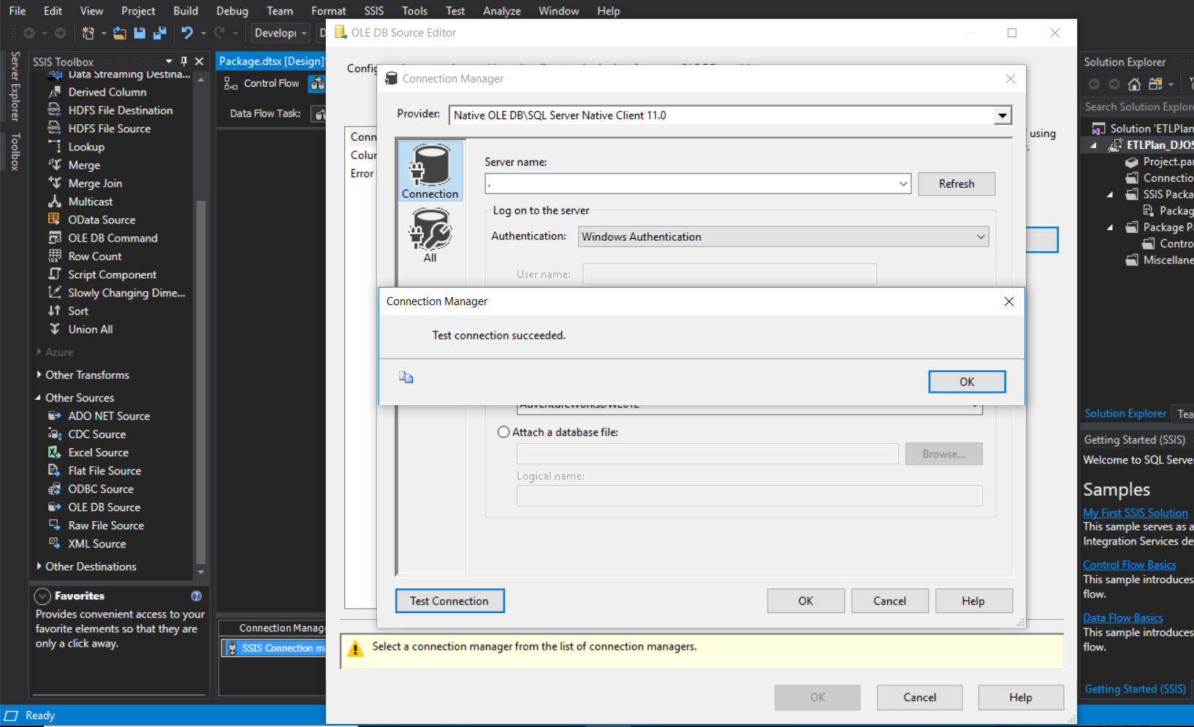

* Destination table and the SQL query along with the table name updated for Internet Sales Data

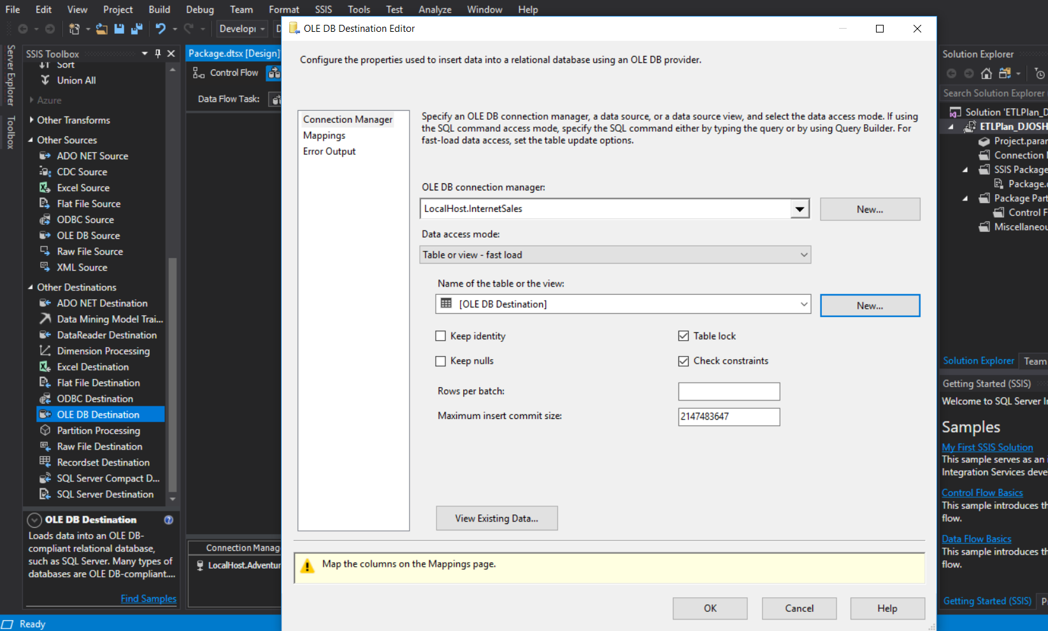

Other Dimension Tables created with the flow and appropriate truncation:

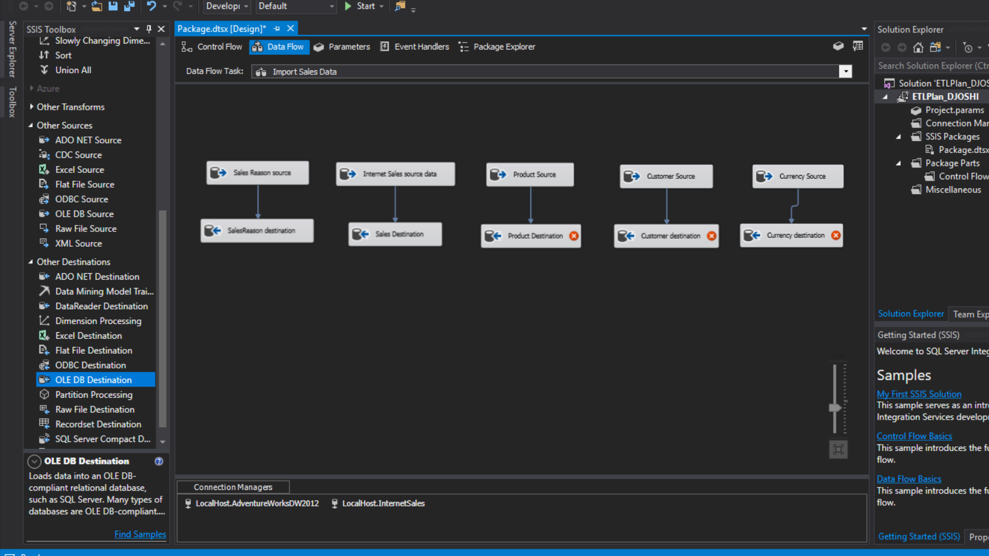

* Execute SQL queries added to control flow/

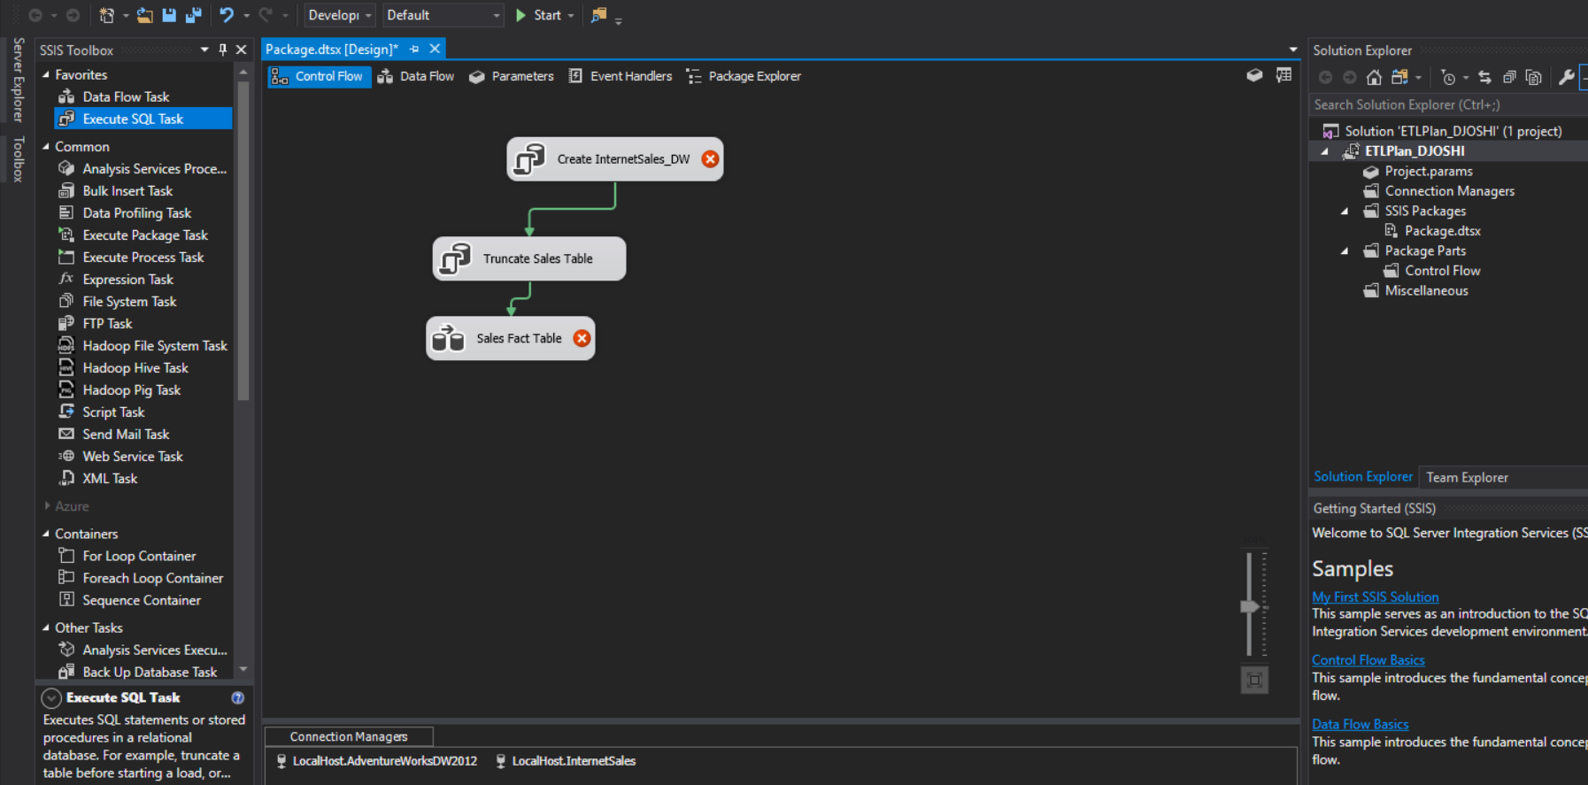

* Execute SQL query 🡪 create database if it doesn’t exist query added.

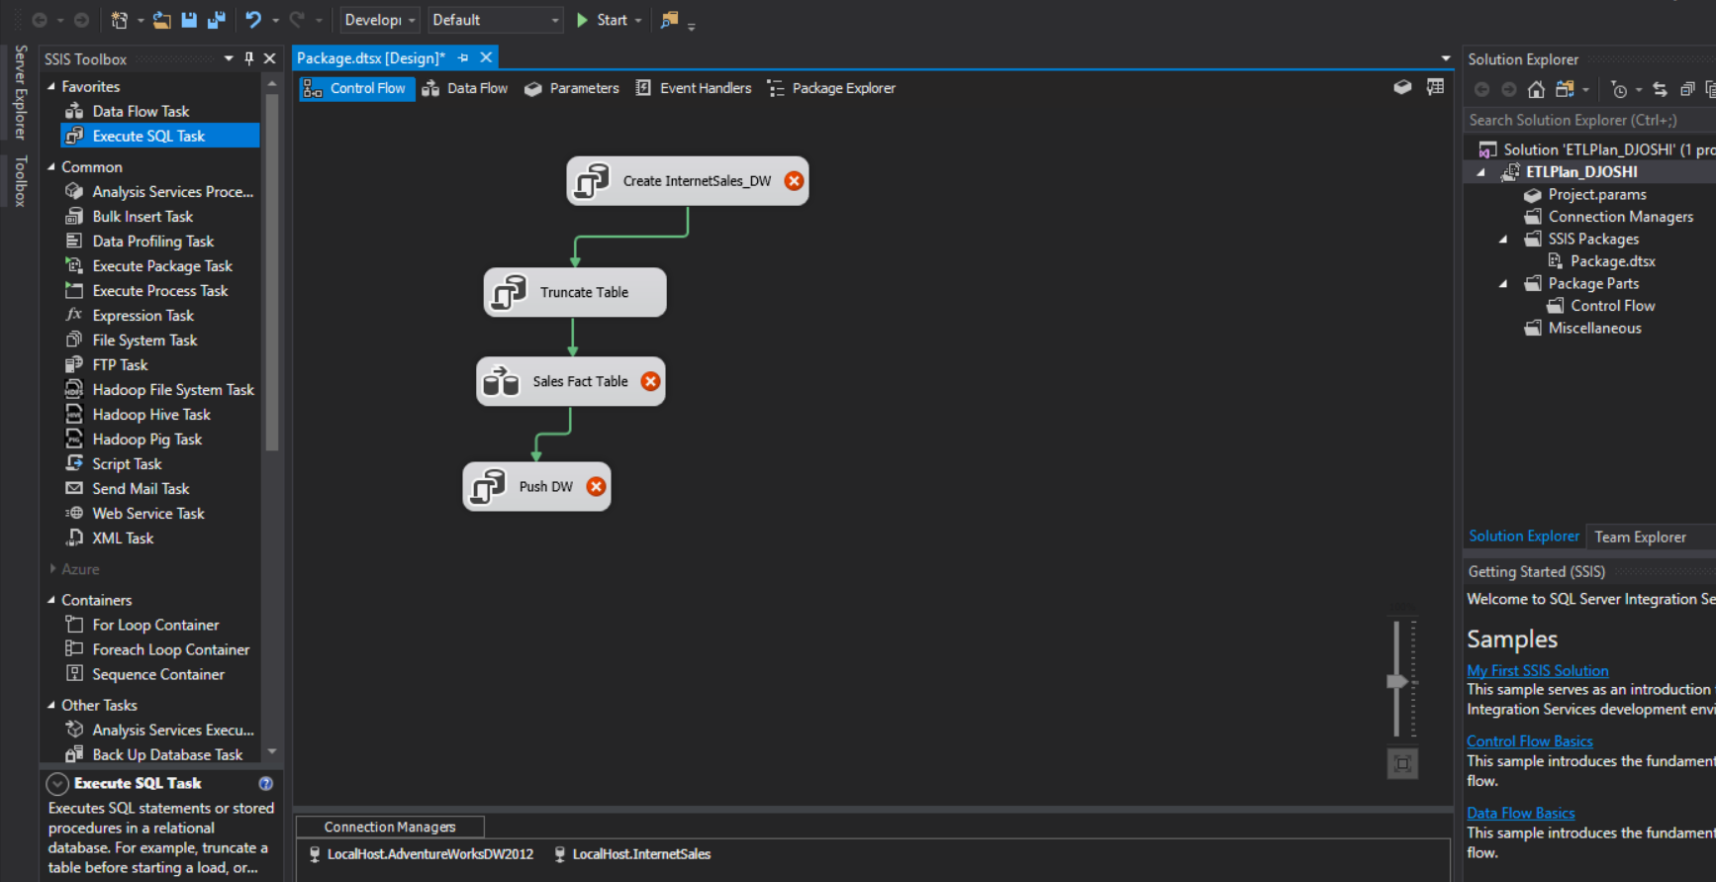

Execute SQL query with push all the updates and changes to the data warehouse.

* The process was all executed using the SSIS tools with visual studio 2017.