Magnetism and Its Applications in Modern Computing
Academic Research Paper — Electronics / Physics Module
First Year — Computer Science Department
Academic Year: 2025-2026

Abstract
This paper examines magnetism from an integrated physical and technical perspective. We explore the fundamental principles of magnetic fields and field lines, Maxwell's four equations that completely describe electromagnetism, and key applications in computer science including Hard Disk Drives (HDD), Magnetic Levitation trains (Maglev), and Magnetic Resonance Imaging (MRI). The paper is accompanied by an interactive 3D simulation built with Three.js that illustrates the distribution of magnetic field lines around a bar magnet.

Table of Contents
1. Introduction
2. Physical Principles of Magnetism
3. Dipole Model and Algorithm
4. Maxwell's Four Equations
5. Applications in Computer Science
6. Interactive 3D Simulation
7. Conclusion
8. References

1. Introduction
Magnetism is not merely a classical physics concept confined to lecture halls — it is, in reality, the silent backbone that powers most of the digital technologies surrounding us. From the hard disk that stores our files, to trains that fly without touching the rails, to medical imaging devices that see inside our bodies — all share a common foundation in exploiting magnetic field forces.
This paper aims to provide a progressive understanding of magnetism, starting from fundamental physical laws, moving through a computational mathematical model for field simulation, and concluding with practical applications in computer science and electrical engineering. It targets first-year Computer Science students seeking to understand the bridge connecting foundational physics with the modern computing world.

2. Physical Principles of Magnetism

2.1 Magnetic Field and Field Lines
A magnetic field is an invisible influence that spreads through the space surrounding a magnet or current-carrying conductor. It is expressed as the vector B, and its spatial distributions are visualized using hypothetical lines called magnetic field lines. These lines always emerge from the North pole and enter the South pole outside the magnet, completing their path inside in the opposite direction.
A fundamental property of these lines is that they never intersect — if they did, it would imply two different field directions at a single point, contradicting its definition as a unique vector.

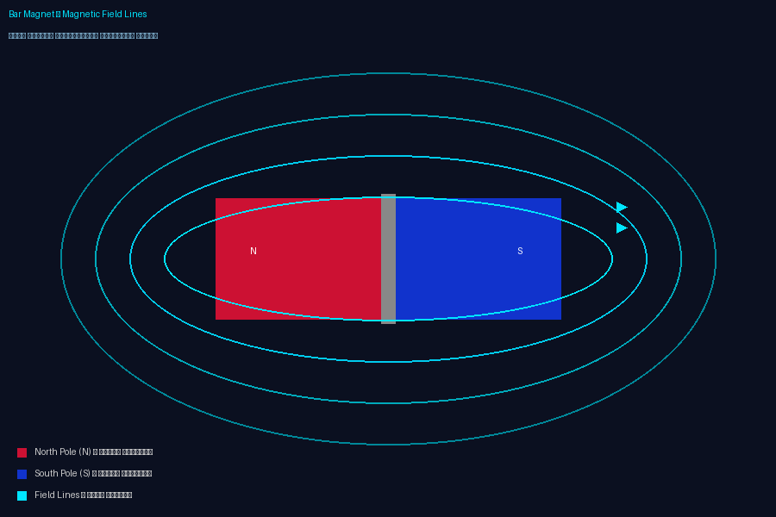
Figure 1: Magnetic field line distribution around a bar magnet

2.2 Magnetic Flux
Magnetic flux (Φ) is the quantitative measure of the number of field lines passing through a given surface. This concept is the cornerstone of Faraday's law of electromagnetic induction.
Φ = B · A · cos(θ)
Where: B = magnetic field strength (Tesla) | A = surface area (m²) | θ = angle between B and the surface normal

2.3 Lorentz Force
This force states that a charged particle moving within a magnetic field experiences a force perpendicular to both its velocity and the field direction. This principle is the basis for electric motors and particle accelerators.
F = q(v × B)
Where: q = particle charge | v = particle velocity | B = magnetic field vector

2.4 Ampere's Law
Ampere's law relates the magnetic field to the electric current that generates it. It is widely used to calculate the field inside electromagnetic coils and around conductors.
∮ B · dl = μ₀ · I
Where: μ₀ = magnetic permeability of free space = 4π × 10⁻⁷ H/m | I = electric current

3. Maxwell's Four Equations
Between 1861 and 1862, James Clerk Maxwell formulated a system of four differential equations that completely describe electromagnetism. These equations form the theoretical foundation for every technology relying on electricity and magnetism — from the simplest generator to the most advanced wireless communication system.


Figure 2: Maxwell's four equations

Equation | Mathematical Form | Description
Gauss's Law (Electricity) | ∇ · E = ρ/ε₀ | Electric charges produce electric fields
Gauss's Law (Magnetism) | ∇ · B = 0 | No magnetic monopoles exist
Faraday's Law | ∇ × E = −∂B/∂t | Changing B field induces an electric field
Ampere-Maxwell Law | ∇ × B = μ₀J + μ₀ε₀∂E/∂t | Currents and changing E fields produce B

The third equation (Faraday's Law) is particularly relevant here as it explains the working principle of generators and induction devices: whenever a magnetic field changes over time, a rotational electric field emerges that produces an induced current.

4. Magnetic Dipole Model and Computational Algorithm

4.1 Point Dipole Model
In computational simulation, a bar magnet is simplified to two point poles representing the North (N) and South (S) poles. The magnetic field vector B at any spatial point P can be calculated by applying the superposition principle:
B(P) = rN/|rN|³ − rS/|rS|³
Where rN = P − N is the displacement vector from N to P, and rS = P − S is the displacement vector from S to P. The equation expresses the inverse-square law: field strength is inversely proportional to the cube of the distance from the pole.

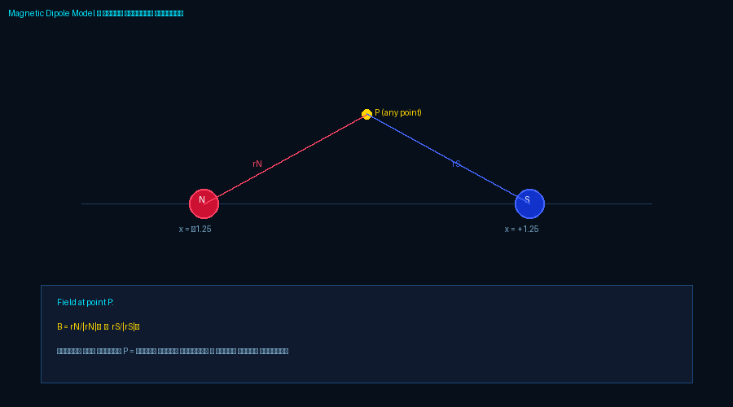
Figure 3: Magnetic dipole model

4.2 Field Line Tracing Algorithm (Euler Integration)
To draw field lines computationally, we use the simple numerical integration algorithm known as Euler integration. The algorithm starts from a point near the North pole and traces the path step by step:
- Calculate vector B at the current position P
- Normalize the direction: B̂ = B / |B|
- Advance to next position: P_new = P_old + B̂ × dt
- Repeat until reaching the South pole or exceeding a boundary

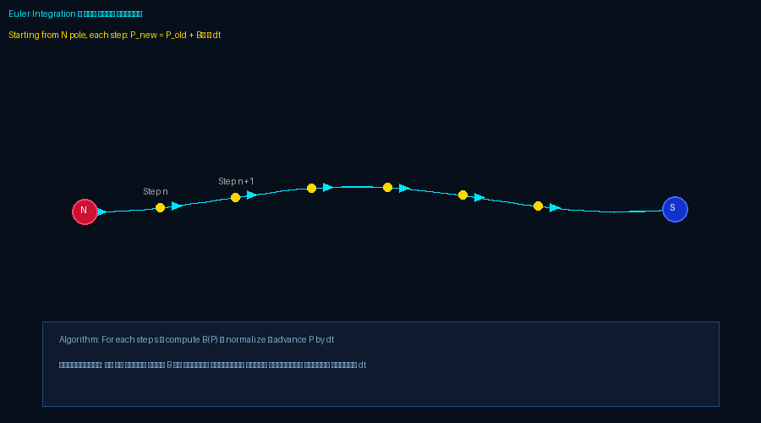
Figure 4: Euler integration for field line tracing
Technical note: In the 3D simulation, the field lines group (fieldLinesGroup) is made a child of the magnet group (magnetGroup) in Three.js. This automatically ensures that field lines rotate with the magnet when it rotates, without requiring any additional calculations — a key bug fix over common implementations.

5. Applications of Magnetism in Computer Science

5.1 Data Storage — Hard Disk Drive (HDD)
The Hard Disk Drive is among the most prominent magnetic applications in computing. It operates on the principle of Bipolar Magnetization to encode digital data:
- Disk platters contain a thin layer of ferromagnetic material
- The Read/Write Head generates a local magnetic field that flips the magnetization of tiny regions
- Each Magnetic Domain represents a binary bit: rightward = 1, leftward = 0
- Modern storage density exceeds 2 terabytes per single platter

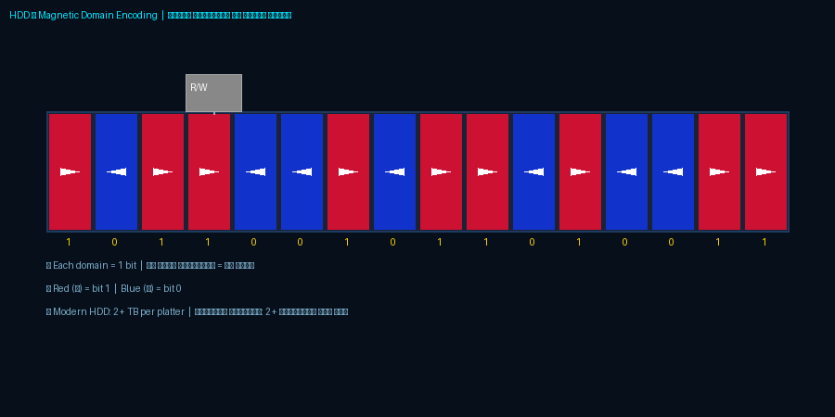
Figure 5: HDD magnetic domain encoding

5.2 Magnetic Levitation Trains (Maglev)
Maglev trains exploit the principle of magnetic repulsion to completely lift the train off the track, eliminating mechanical friction and enabling extraordinary speeds:
- They rely on Superconducting Magnets operating below −200°C
- Japan's SCMaglev line set a world record of 603 km/h in 2015
- Seriously studied for connecting massive Data Centers with ultra-fast transport networks

5.3 Medical Magnetic Resonance Imaging (MRI)
MRI combines magnetism and computing in a vital medical application:
- Creates a powerful magnetic field between 1.5 and 7 Tesla to align hydrogen protons in the patient's body
- Radio frequency pulses disturb this alignment, causing protons to emit signals processed by advanced algorithms
- Output: precise 3D images of internal tissues without harmful radiation

5.4 Electric Motors and Generators
All modern electric motors fundamentally rely on interacting magnetic fields:
- BLDC (Brushless DC) motors drive cooling fans and HDD spindles in computers
- Linear Motors drive the Read/Write head arm in hard drives with nanometer precision
- All electrical power generation plants rely on Faraday's law of electromagnetic induction

6. Interactive 3D Simulation
As part of this research, an interactive 3D simulation was developed using the Three.js library and WebGL technology. The simulation allows the user to:
- Observe magnetic field lines rotating synchronously with the magnet
- Watch virtual particles moving according to real magnetic field forces
- Control field strength and rotation speed
- Full bilingual support (Arabic/English) with RTL/LTR switching

Technologies used in building the simulation:
Technology | Usage | Purpose
Three.js r128 | WebGL 3D engine | Building the scene and 3D objects
TubeGeometry | Rendering field lines | Converting point arrays to 3D tubes
BufferGeometry | Particle system (900 particles) | High-performance per-frame position updates
ResizeObserver | Responsive canvas | Adaptive experience across all devices
CatmullRomCurve3 | Smoothing field line paths | Physically accurate smooth curves

7. Conclusion
This paper examined magnetism from multiple complementary angles: the fundamental physics of magnetic fields, field lines, Faraday's law and Ampere's law; the comprehensive mathematical framework of Maxwell's four equations that form the backbone of modern electromagnetism; and the practical applications connecting these concepts to everyday computing — from hard drives and motors to medical devices.
The paper concludes that bridging fundamental physics and computational application is not an academic luxury but a necessity in training the modern computer engineer. Understanding how a hard disk, electric motor, or MRI scanner works is impossible without grasping the underlying magnetic principles that make them function.

8. References
1. Griffiths, D.J. (2017). Introduction to Electrodynamics, 4th Edition. Cambridge University Press.
2. Hayt, W.H. & Buck, J.A. (2019). Engineering Electromagnetics, 9th Edition. McGraw-Hill.
3. Sadiku, M.N.O. (2018). Elements of Electromagnetics, 7th Edition. Oxford University Press.
4. IEEE Magnetics Society Journal — Magnetic Storage Density Advances (2023).
5. Nature: "High-density magnetic recording" — Vol. 598, 2021.
6. MIT OpenCourseWare — Physics 8.02: Electricity and Magnetism.
7. Three.js Documentation — https://threejs.org/docs/
8. Khan Academy: Magnetism and Faraday's Law — https://www.khanacademy.org

