Contents

Introduction

Colour Measurement
Colour Perception
History of Colour Science
Colour Measurement Systems
The CIE Colour System

Design
Colour Space
Hardware

Colour Measurement

Colour Perception:
"Colour is the attribute of visual experience that can be described as having quantitatively specifiable dimensions of hue, saturation, and brightness."
From R. W. Burnham, R. M. Haynes and C. J. Bartleson, “Colour: A Guide to Basic Facts and Concepts”

Colour is best described as the human perception of electromagnetic radiation in the visual part of the spectrum. The human eye is sensitive to light in the range 380 to 740nm, although the sensitivity falls off at the extremes, so 400 to 700nm is a better approximation. This suggests that humans perceive green more strongly than they perceive red and blue, which is the case.
The retina is the light-sensitive part of the eye, but it is in fact itself a dual-organ. The retina is composed of cells of two different types, namely rods and cones. Rods give no information on colour; they are responsible for the detection of light intensity only. They are operative in weak light, inactive in strong light, and have a maximum sensitivity at 507nm. There are three different types of cones, each with a different pigment, responsible for the detection of colour. Cones are active in strong light, inactive in weak light, and have a maximum sensitivity at about 550nm. Whereas rods are distributed uniformly throughout the retina, cones are concentrated at the back of the retina in a small area called the fovea, which is approximately 2 to 3mm in diameter. The signals from these cells are sent to the brain via the optic nerve and an image is constructed for us to interpret.

History of Colour Science:
It is important to remember that colour is a perception of the human brain, rather than a physical quantity. It is therefore extremely difficult to quantify colour, as different individuals perceive it differently. The first person to propose a theory on the nature of colour was Aristotle, who hypothesised that colour was a result of the attenuation and modification of light. He believed that “the visual sense is a form of feeling, of active perception, not the passive reception of stimuli”. To many, the property of colour was attributed to the modification of a stream of particles of light by the bodies that it encountered on its way to the eye. For example, De la Hire (1711) believed that colour was a result of the impact of particles of light upon the optic nerve. This lack of distinction between the physical nature of light and the perception of colour remained until Newton’s famous experiments involving the splitting of white light into its constituent components.
Although defective in several areas, Newton’s theory of colour is the foundation for our modern understanding of the subject. Essentially, Newton said that red light was not ‘red’; this was simply how humans perceived it to be. His views were met with much opposition from his peers, who long believed that different colours represented different physical forms of light. Brewster (1831) for instance, claimed that light was of three forms, red, yellow and blue, each of which exhibited different physical properties. Goethe (1810) also discredited Newton’s theory, believing that colour was physically quantifiable. Like Aristotle, he postulated that colour was the result of the modification of light particles by the bodies they encountered. In fact, Newton’s theory was not widely accepted until 1819, when Fresnel presented the consequences of the wave nature of light, which had earlier been established by Young in 1801. Helmholtz and Maxwell then developed the modern theory of colour, which has been verified by various investigations since, most notably the discovery of three different photosensitive proteins in the cones of the retina.

Colour Measurement Systems:
There are several different ‘sensations’ of colour that are perceptible to humans:
- Brightness: a measure of how much light is exhibited by a surface, but is dependent on the luminance of the surface and its reflectivity.
- Hue: related to the dominant wavelength(s) of a colour, e.g. ‘red’ and ‘blue’ are primarily describing hue. Not all hues can be represented by spectral colours; e.g. there is no single wavelength of light that has the magenta hue.
- Colourfulness: a measure of how much of its hue a surface exhibits.
- Lightness: a measure of an area’s brightness relative to a reference white.
- Chroma: a measure of the colourfulness of an area relative to the brightness of a reference white.
- Saturation: a measure of the colourfulness of an area relative to its brightness. Pink may be thought of as having the same hue as red but is less saturated. A fully saturated colour has no mixture of white. In quantifying saturation, it must be remembered that certain hues appear more saturated than others, e.g. monochromatic red and monochromatic blue appear more saturated than monochromatic yellow. There are also different levels of saturation perceptible for different hues.
As humans, we may describe a colour by specifying its hue, brightness and saturation. A colour space, or colour system, is a method by which a colour may be visualised or created by specifying certain (usually three) parameters. These parameters then tell us where the colour lies within whatever colour space is being used – they do not tell us what the colour is.
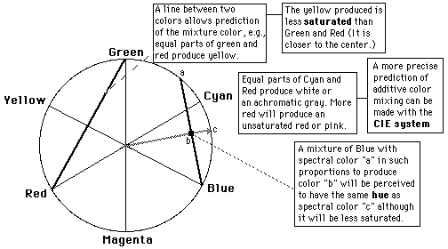
Newton was the first to represent colours in this way. He arranged the red, green and blue hues around the circumference of a circle, each of them 120 degrees apart, as these are thought of as the additive primaries. Their complementary hues are then placed opposite them on the circumference of the circle. In this way, the hues are arranged in order of wavelength of the corresponding spectral colours, with the exception of magenta, which is not a spectral colour.
Various predictions can be made using Newton’s system. If a line is drawn connecting two points on the circle’s circumference, then this line represents all the colours that can be produced by mixing the two hues present at the two points that the line connects. To illustrate, if a line is drawn from ‘red’ to ‘green’, then the midpoint of this line represents yellow. However, the yellow produced is less saturated than that located on the circle’s circumference, i.e. it is closer to the circle’s centre. Also, if a fully saturated hue is mixed in equal proportion with its complementary fully saturated hue, the result is white or an achromatic grey. If the proportion of the complementary hue that is mixed is reduced, the result will be a less saturated version of the original hue.
Newton’s system, although useful, was flawed in several ways. Perhaps most significantly, there is no ‘brightness’ scale incorporated into the system. This would suggest that specifying values for hue and saturation could represent an infinite number of colours, i.e. no information on brightness is given. Munsell resolved this problem.
In Munsell’s colour system, a colour is created by specifying values for hue, saturation and brightness. Perhaps the most significant difference between Munsell’s
system and Newton’s, is that the values for each of the parameters in Munsell’s system are quantised. In Newton’s system, the hues vary continuously around the circumference of the circle. In Munsell’s system however, hue can only take on one of 100 different values. The values for saturation are also quantised, but the number of available saturation levels depends on the hue, as some hues have more perceptible levels of saturation than others. For example, there may be 18 different saturation levels for red, but only 10 for yellow. Perpendicular to the plane formed by the
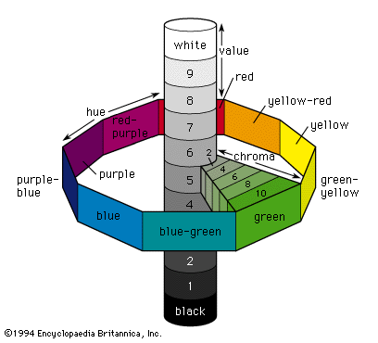
hue and saturation planes is a brightness scale, ranging from 0 (black) at the bottom to 10 (white) at the top. One of the major disadvantages of using the Munsell system is the fact that complementary hues are not necessarily opposite each other, which would seem to suggest the system gives misleading information about the additive mixing of colours.
The Ostwald colour system represents colours using parameters other than hue, saturation and brightness. These values are mapped to a new set of co-ordinates, namely dominant wavelength, purity and luminance. Establishing values for these
parameters is done using a disc colorimeter. Different amounts of the spectral colour at the dominant wavelength, white and black are mixed on a disc. A point in the colour space is thus represented by the percentage of the circle occupied by each of the components C, W and B. For instance, 25,15,60 would represent 25% full colour, 15% white and 60% black.
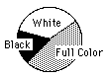
The major disadvantage of the Munsell and Ostwald systems is that they both depend on colour comparisons. There must exist a standard set of colour samples to which a test sample may be compared. These standard samples will fade with time, rendering the systems inaccurate.
Many different colour spaces exist today, which have evolved from these earlier systems, some of which are listed here:
- RGB (Red, Green, Blue): an additive colour system based on tri-chromatic theory. Often found in systems using CRT’s to display images. Widely used in computer systems, television, video, etc.
- CMY(K) (Cyan, Magenta, Yellow, (Black)): a subtractive colour system widely used in printing and hard copy applications. Black ink is sometimes included to remove the need for the CMY components to produce a good neutral black, thus improving the available colour gamut (the number of colours that can be created by mixing the chosen primaries) and the general colour reproductive capabilities of the system.
- HSL (Hue, Saturation, Lightness): linearly transferred from RGB system. Has advantages in applications such as image processing.
- YIQ, YUV, YCbCr, YCC (Luminance – Chrominance): the television transmission colour spaces. RGB parameters are separated into luminance-chrominance information. Useful in compression applications.

The CIE Colour System:
The CIE (Commission Internationale d'Eclairage) has defined a colour system according to the human visual system. Specifying a colour in this system using the CIE co-ordinates, one can be confident that the specified colour will match any other with the same CIE co-ordinates. In other words, there is a one-to-one mapping in the system; no two distinguishable colours can have the same co-ordinates.
The CIE system specifies a colour using three parameters, two colour co-ordinates, x and y, and a luminance parameter Y. The parameters are based on the spectral power distribution of the light emitted from a coloured surface and are factored by sensitivity curves measured for the human eye.
The CIE have produced a new set of primaries by using red, green and blue in positive and negative combinations. This new set of primaries or tristimulus values,
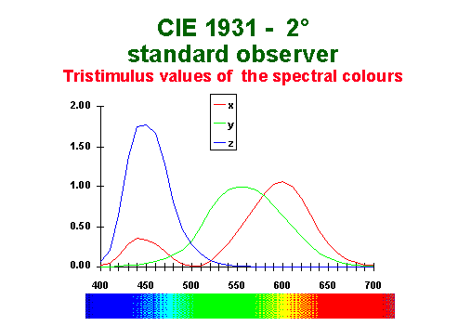
X, Y and Z, are related to the sensitivity of the human eye by using the colour matching functions shown. The CIE primaries are not real colours, but rather mathematical expressions. Nevertheless, X, Y and Z uniquely represent any perceivable hue; different combinations of wavelengths that give the same tristimulus values will be indistinguishable to the human eye.
The tristimulus values represent a colour by
C = XX + YY + ZZ
Where X, Y and Z are ‘unit values’ of each of the primaries X, Y and Z. If this equation is now normalised, the CIE colour co-ordinates can be obtained:
x + y + z = 1
Any colour can now be expressed on the 2D CIE chromaticity chart using the colour co-ordinates x and y. This diagram represents the mapping of human colour
perception in terms of the two colour co-ordinates, x and y. The ‘horseshoe-shaped’ outline represents all the spectral colours at maximum saturation, except the straight line joining red and blue, termed the ‘line of purples’. This line is merely included on the diagram for completeness, and rather than representing individual spectral components, it contains all the hues that can be created by mixing light at 700nm and light at 400nm in different proportions.
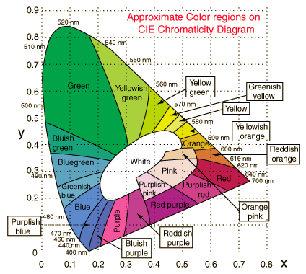
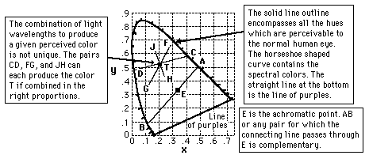

The diagram has serious technological implications. For example, it is impossible to represent the complete gamut of human colour perception on an RGB monitor. The range of normal human colour vision encompasses the entire CIE diagram, while the gamut of an RGB monitor would be displayed as a triangular region of the diagram, the vertices of which are located at the R, G and B primaries. Adding to this the fact that the hue and saturation associated with a given colour name can vary over a considerable range, along with the variations with different kinds of monitors, it may be concluded that completely accurate colour representation in this way is impossible.

Design

Colour Space:
Having obtained knowledge of various colour systems and colour science itself, we were now in a position to develop our own colour space for use within this application. There were of course certain constraints involved when making this decision, the most restrictive perhaps being the limited computational ability of the microconverter (AduC812). It would be extremely difficult, if not impossible, to perform complex mathematical operations with such a device. Therefore, in choosing a colour space, we were restricted to selecting a system that would involve little, if any, mathematics.
A simple RGB colour space seemed to fulfil our requirements, whereby a colour is represented by certain amounts of red, green and blue as follows:

C = rR + gG + bB
where r, g and b represent the ‘values’ of red, green and blue respectively that are required to produce the colour C. If r, g and b are all at a maximum (1 in a normalised system) then white will be produced. Similarly, if r, g and b are at a minimum (typically 0) then black will be produced.
Having decided on the basic nature of the colour space, it was no necessary to assign to it specific properties. Considering the fact that all processing within the colour sensor would be performed digitally, it seemed logical to assume that only a finite number of colours would be decipherable from a predetermined set. A decision was needed on the number of colours our sensor would be capable of recognising. Of course, the sensor would have to capable of ‘recognising’ all colours; otherwise it would be of little practical use. The question is how many quantised colour samples should the sensor be able to choose from to assign to a test surface. Obviously, the greater this number, the greater the accuracy of the completed sensor.
The finalised colour space is shown in basic form below. Each of the three
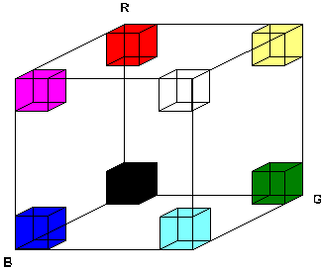
Primaries can take on one of five different values, giving a total of 125 possible colours. Considering the ‘colour cube’ shown, any colour in the space may be specified using three-dimensional co-ordinates. All colours within the space would now have to be named and numbered (for reasons which will become clear later) from 0 to 125. The colours are numbered according to their co-ordinates within the cube as follows:

R G B Colour Number
4 4 4 White 125
4 4 3 Cream 124
4 4 2 Pale Yellow 123
4 4 1 Yellow 122
4 4 0 Bright Yellow 121
4 3 4 Light Pink 120

4 3 0 Dirty Yellow 116
4 2 4 Pale Purple 115
etc.

Hardware:
Since our colour space for the sensor was based on RGB tristimulus values, it seemed logical to design our hardware using this principle, therefore removing the need to perform conversions between different systems. All that is required therefore of the hardware is to provide signals representing the amount of red, green and blue reflected from the test surface. These signals can then be used to determine the colour of the test surface.
The first step of hardware design was to devise a system for providing these signals. The sensor head we designed was based on the fact that an object appears to be a certain colour due to the wavelengths of light that it reflects. For example, an object that appears red primarily reflects light around 700nm and absorbs all other wavelengths. It is therefore possible to determine the colour of an object by examining the light that it reflects. We extended this principle to our colour space. Since we were using red, green and blue as the primary colours in our colour space, measuring the amount of red, green and blue light reflected from a surface would enable us to determine the colour of that surface. We considered to approaches to this technique:
- 3 Light Sources and 1 Detector: Measure the amount of light reflected from three separate red, green and blue light sources. Each light source is turned on individually and a value determined for each at the detector.

