Login/Registration using SpringBoot/SpringMVC

**Author**: Rabi

**Date**:27th March2022

1. Database connection

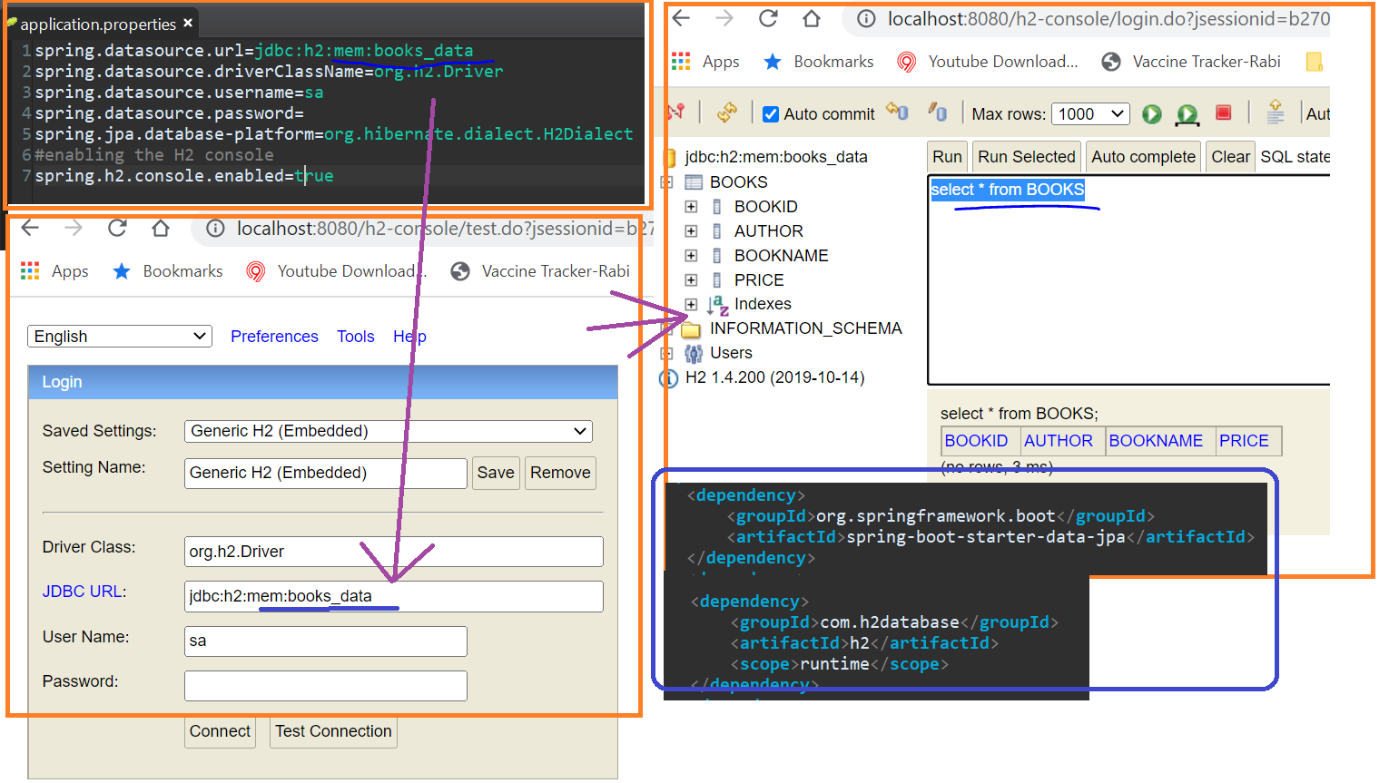

1. Insert some record in Static Table “Role”

INSERT INTO ROLE( ROLEID,ROLE) VALUES ('1','ADMIN');

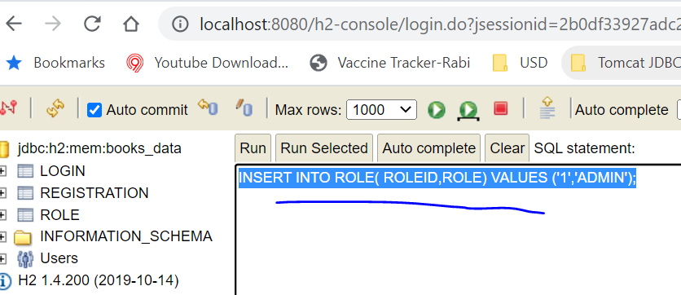

1. Register the user

http://localhost:8080/

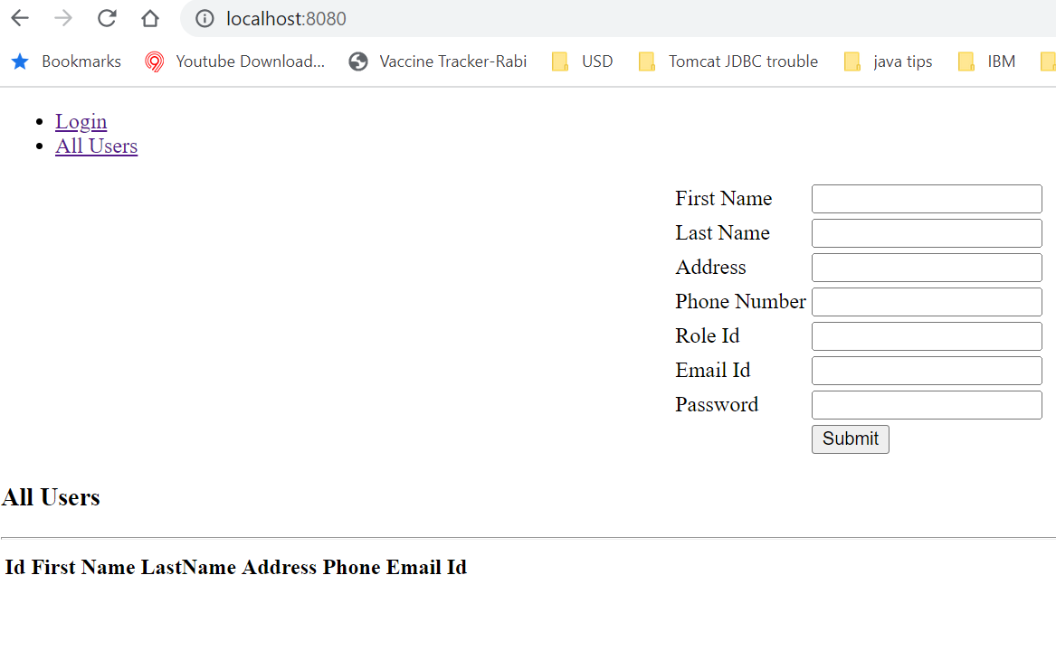

* 1. Entering Data

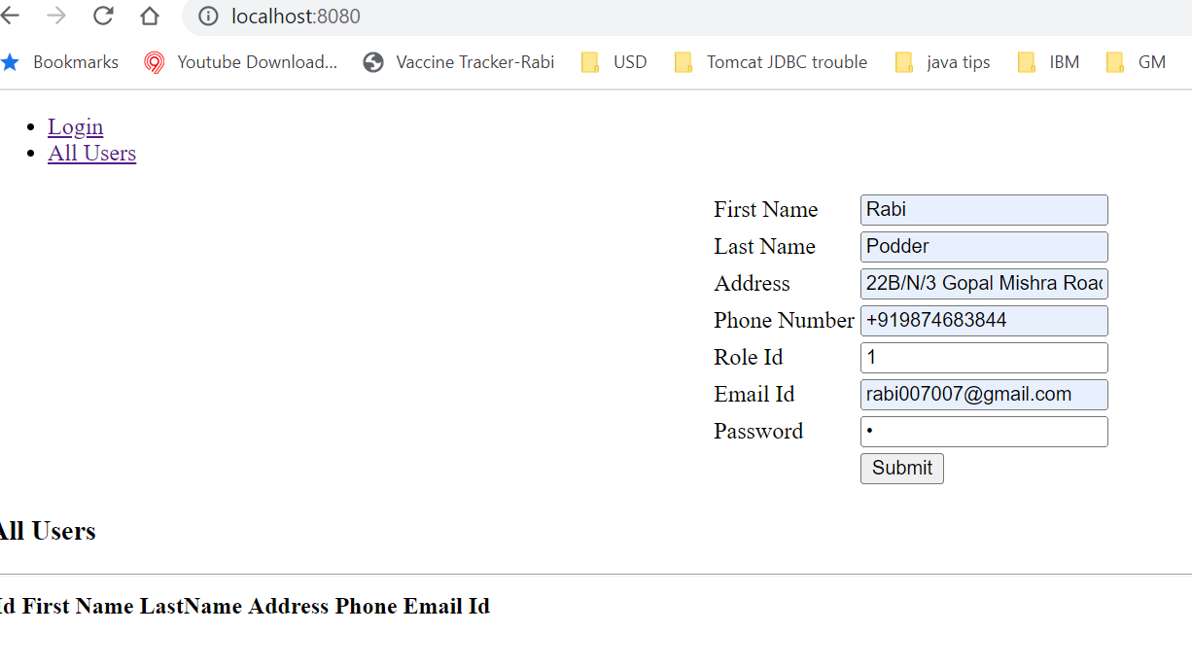

* 1. Login and check

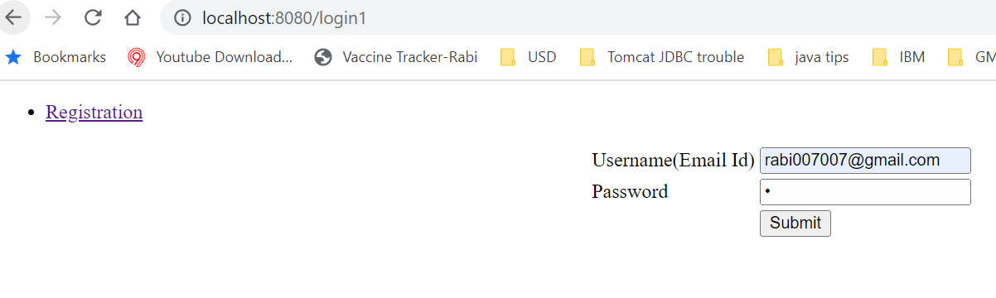

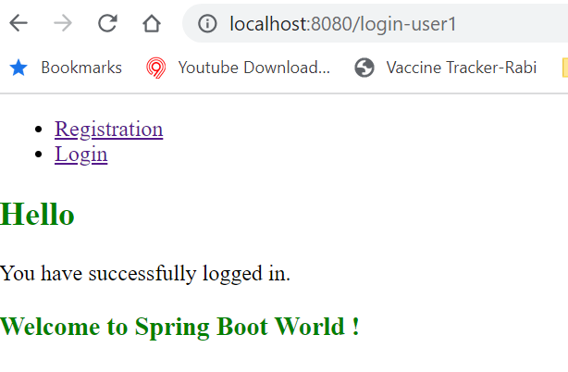

* 1. Check All Users

