ChatGPT & SpringBoot integration

**Source**: <https://www.youtube.com/watch?v=HlDkuFy8xRM>

**Date**: 29th May 2023

**Author**: Rabi

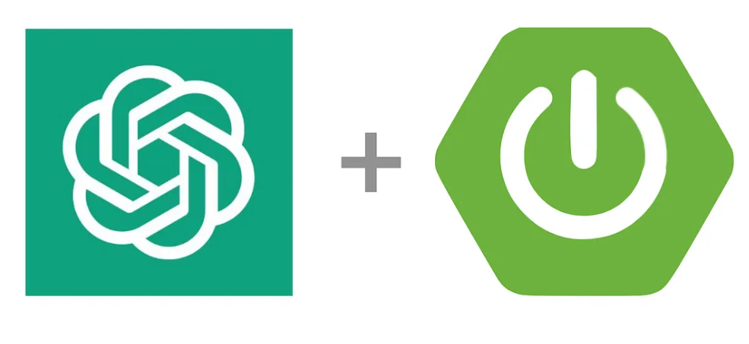

**What is ChatGPT?**

* ChatGPT is one of the most popular terms today.
* ChatGPT is the result of AI technology based on GPT architecture.

I will be creating a new REST API using Spring Boot to interact with **OpenAI**.

* Simply you can ask your question from it and get the result.
* I am using **RestTemplate** to make the API simple.
* As you can see, the **API KEY** is used as the Bearer token. You can generate it from <https://platform.openai.com/account/api-keys>

1. **API KEY :-**

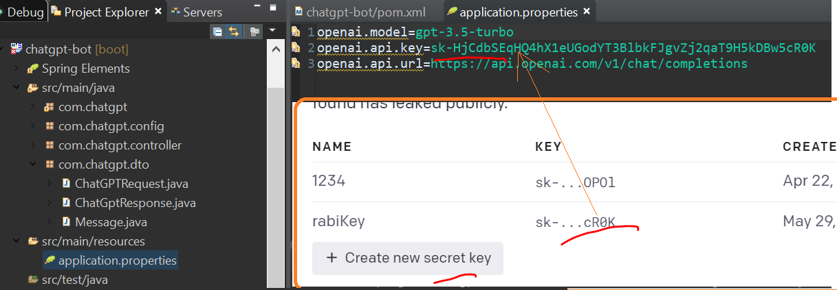

1. **URL : -**

https://api.openai.com

<https://api.openai.com/v1/chat/completions>

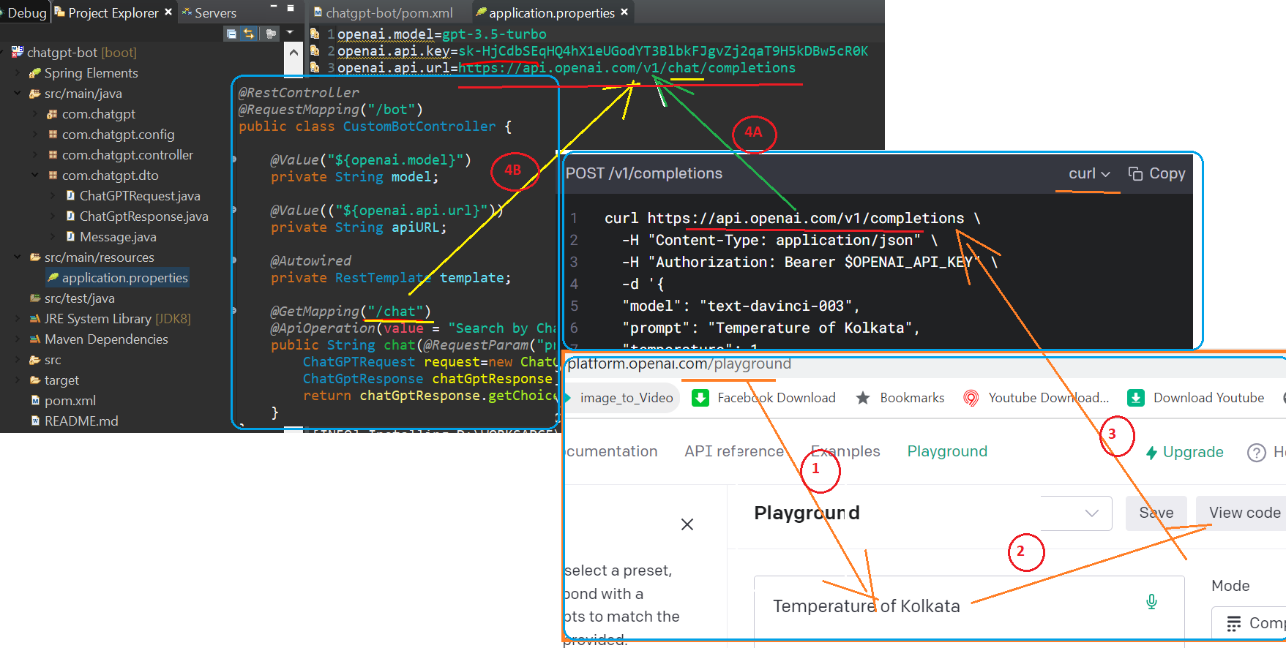

1. **Accept Question & Answer:-**

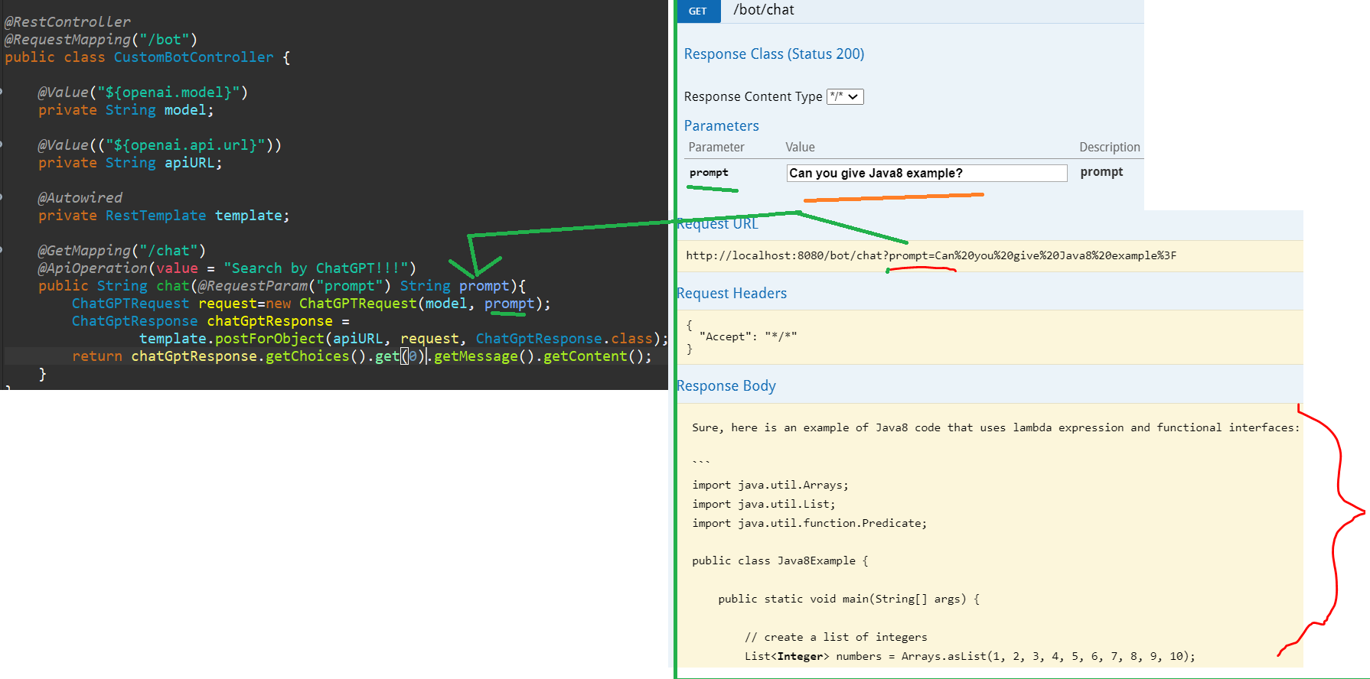

1. **API Key and RestTemplate** (put in Authorization)

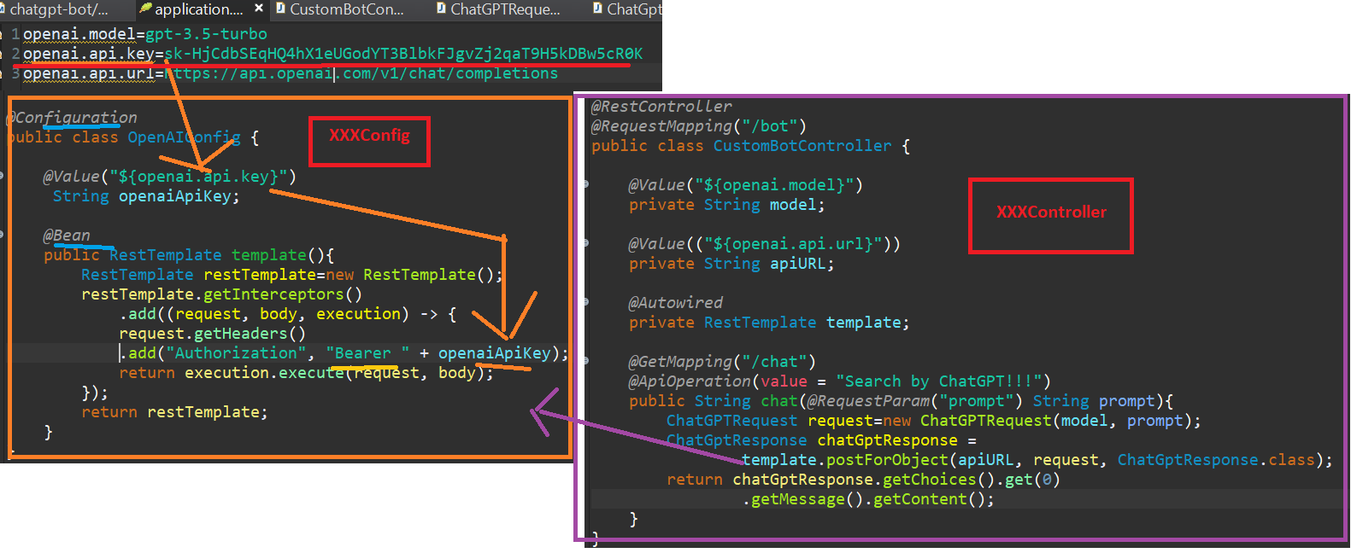

1. **Response and Authorization Key (using Postman)**

e.g . (POSTMAN)

Show Temparature of Dhaka :-

