Java8 Sort – String and Employee

**Author**: Rabi

**Date**: 25th Dec 2022

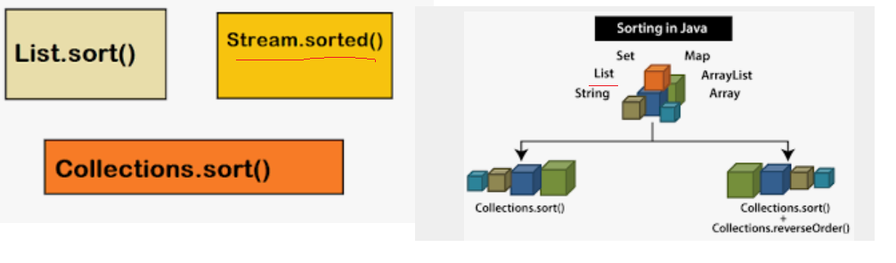

1. **Sort String - compareTo -Ascending**

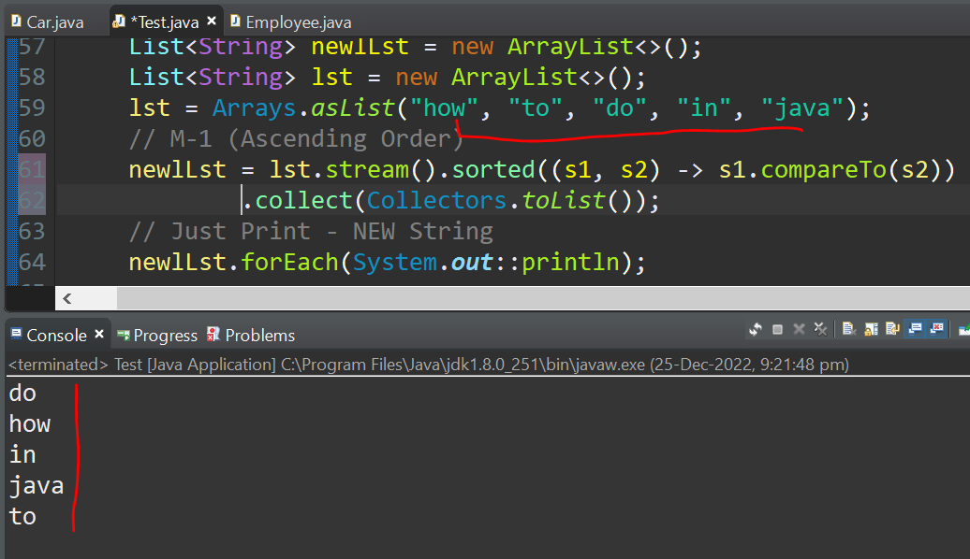

1. **Sort String - compareTo -Descending**

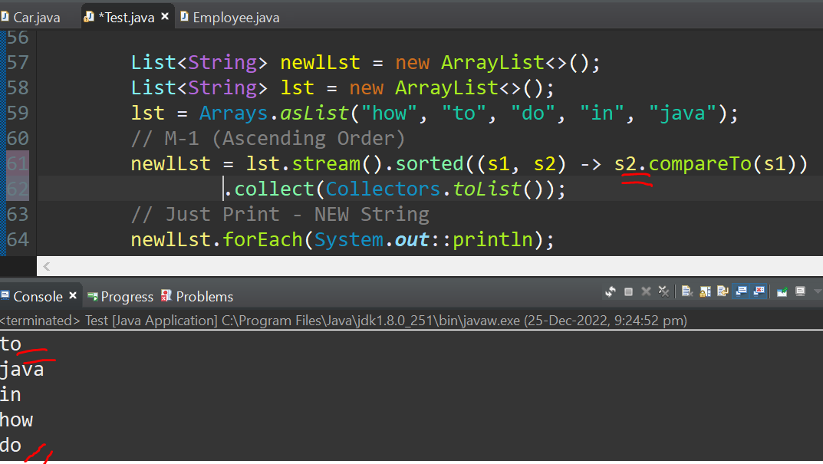

1. **Sort String - String::compareTo -Ascending**

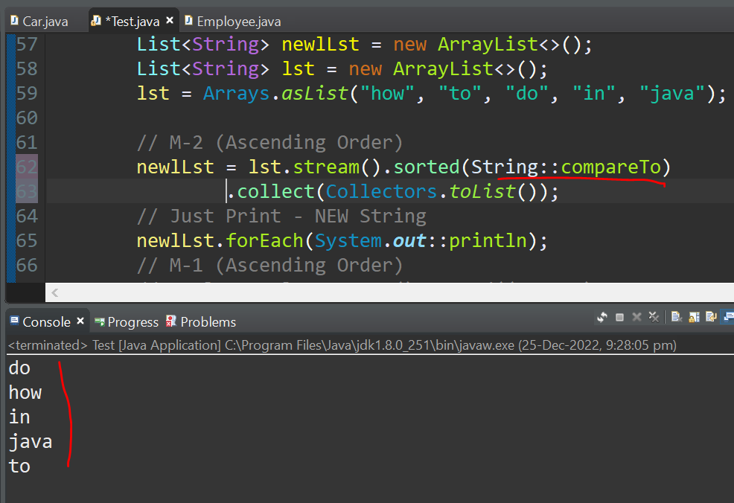

1. **Employee Test Data –**

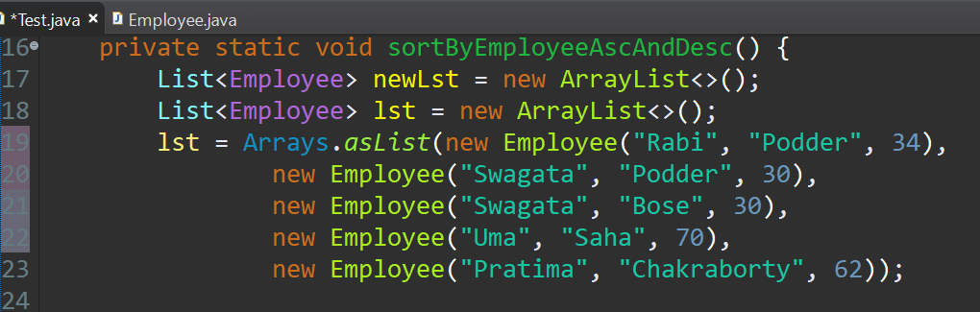

1. **Employee- Sort By First Name - Ascending**

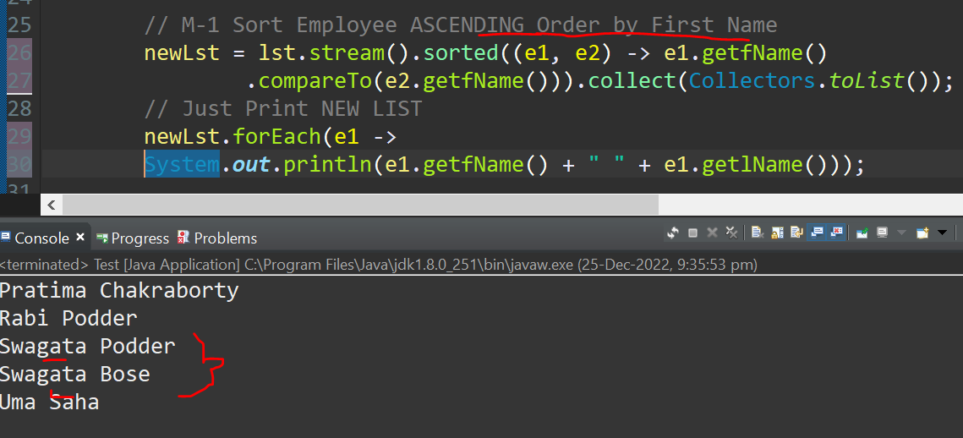

1. **Employee- Sort By First Name - Descending**

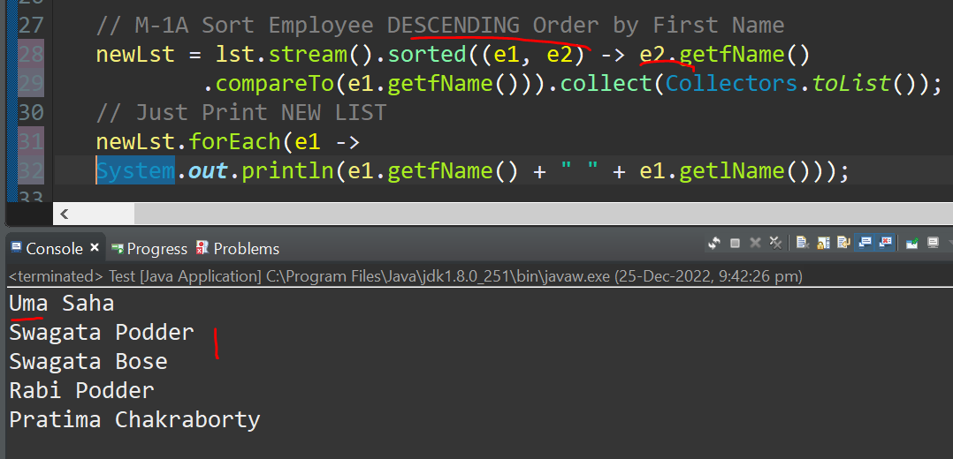

1. **Employee- Sort By First Name – Ascending (Comparator.comparing)**

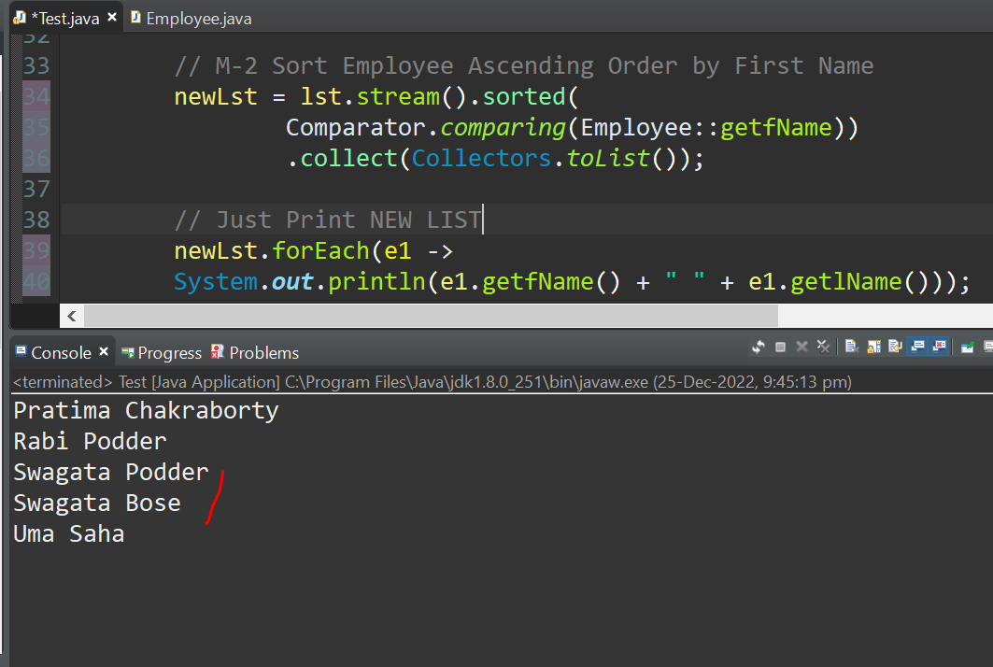

1. **Employee- Sort By First Name +Last Name– Ascending**

**(Comparator.comparing … thenComparing)**

