**Java8 -Sort Lambda vs Stream**

1. **Using Lambda**

**M-1 (By Name…Issue with SWAGATA 2 times)**

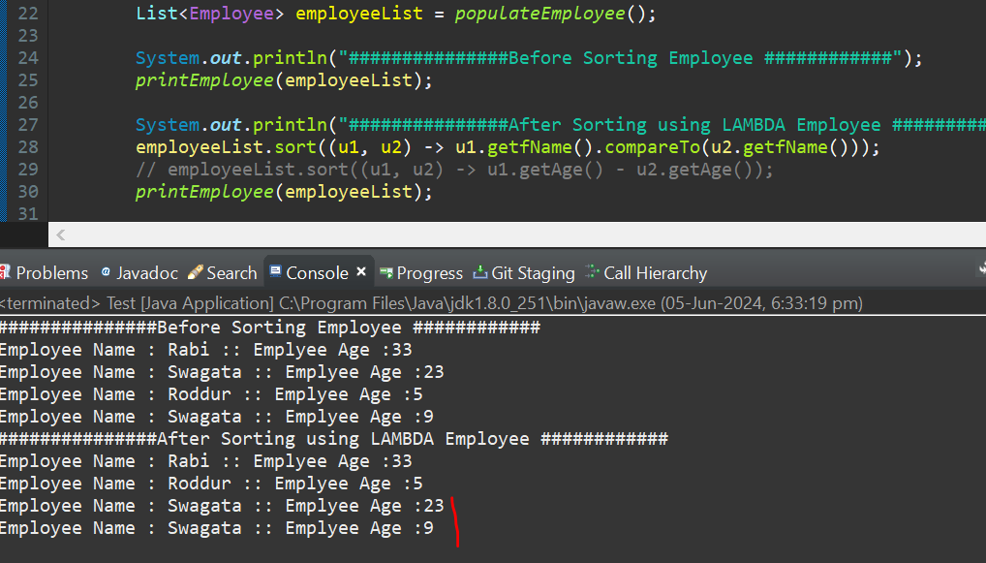

**M-2 (By Age)**

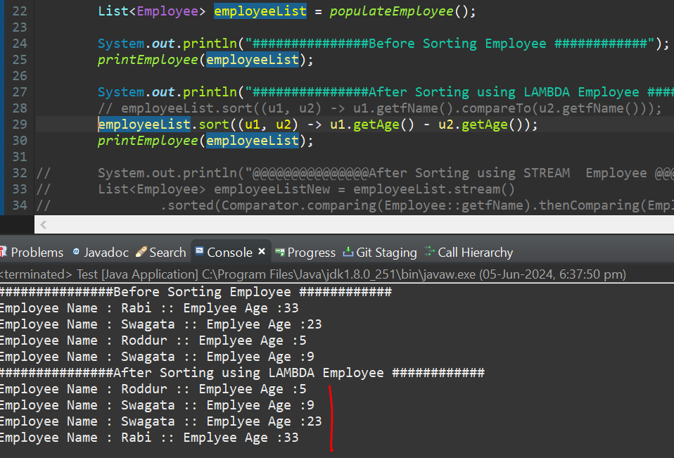

1. **Using Stream API (issue fix with Same Name)**

