1 to M using SpringBoot+H2 Database (JPA)

**Author**:Rabi

**Date**:12thFeb,2020



1. 1 to M (By HardCoded)

* Category(1) has (Many) Books!!!
* @Transactional

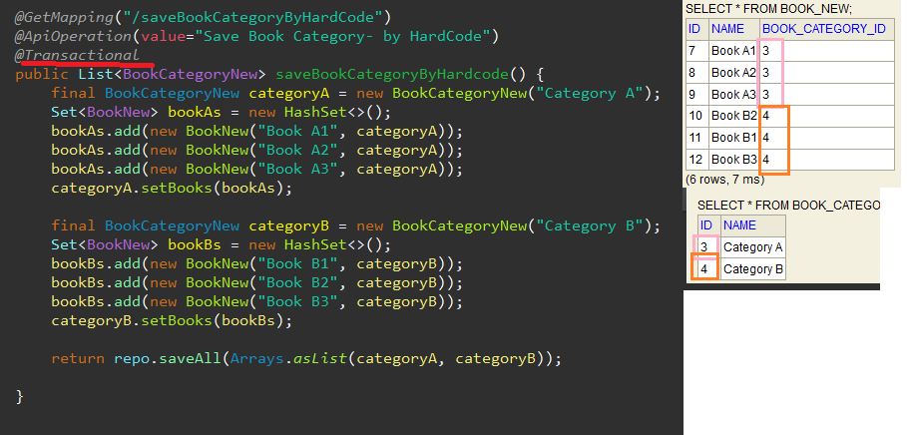

II. **Annotation :- (1 Category and Many Books!!)**

* @oneToMany+fetch+Cascade+mappedBy
* @ManyToOne +@JoinColumn
* @JsonIgnore

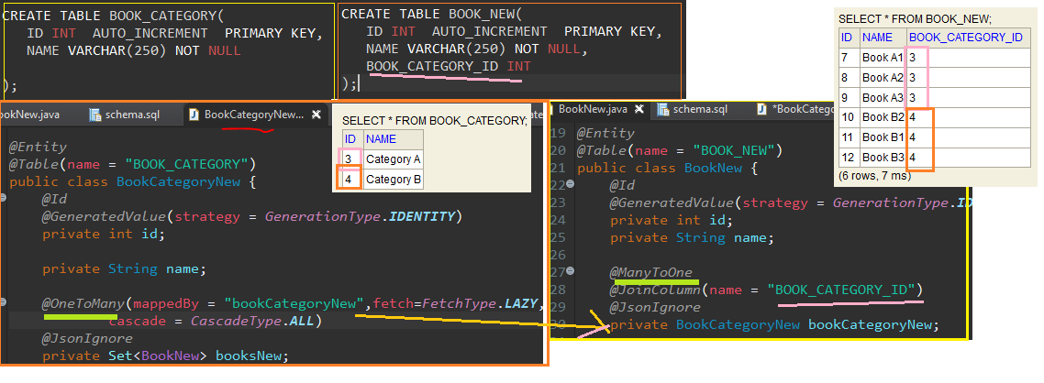

**III. 1 to M (By Service)**

