**Audit Report Generation using SpringBoot**

**& AJAX / Thymeleaf**(html)

**Date**: 24th July 2023

**Author**:Rabi

**url**: https://github.com/djrabi007/springboot-web-swagger-chatgpt



I am thrilled to share with you a significant project I have been working on – the Audit Report Generation using SpringBoot, AJAX, Thymeleaf, and an in-memory H2 database. The report is specifically **tailored** (customized) to benefit financial institutions like **banks**.

1. Adding Data using Front end or Backend to populate Test Data

* I am updating from Backednd

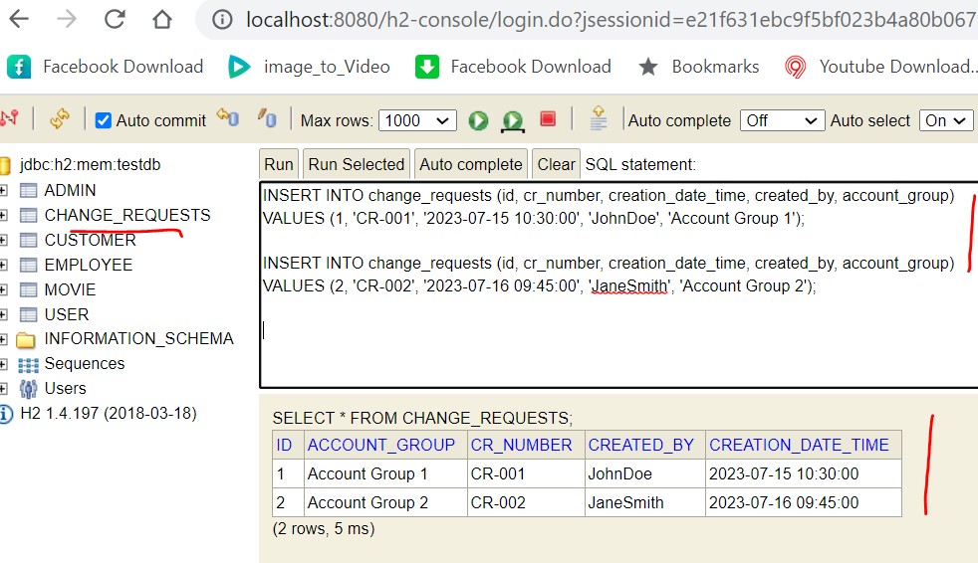

**Why H2 Database?**

One of the highlights of the project is the use of an in-memory **H2 database**. This decision was made to ensure **data integrity and security** while also providing the flexibility for easy testing and development

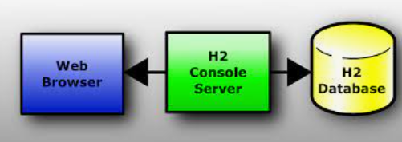

1. Show the data using thymeleaf & SpringBoot (& in-memory H2 database)

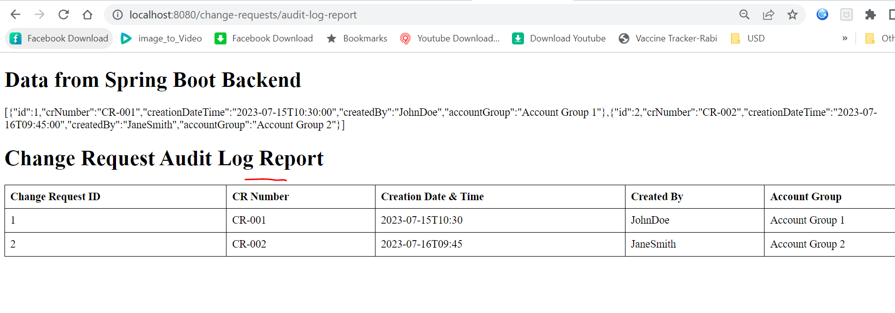 **Why SpringBoot ?**

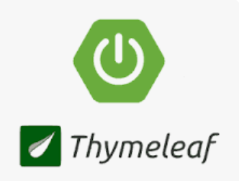

The project's main objective was to create a **seamless** and efficient audit report generation system that aids financial institutions in keeping track of their **financial data and transactions**.we have ensured a **robust** and **reliable back-end**, facilitating **quick data processing** and retrieval.

* 1. **Show Data from H2 database**(through JPA) :-

-use @Controller (not @RestController to support jsp/html )

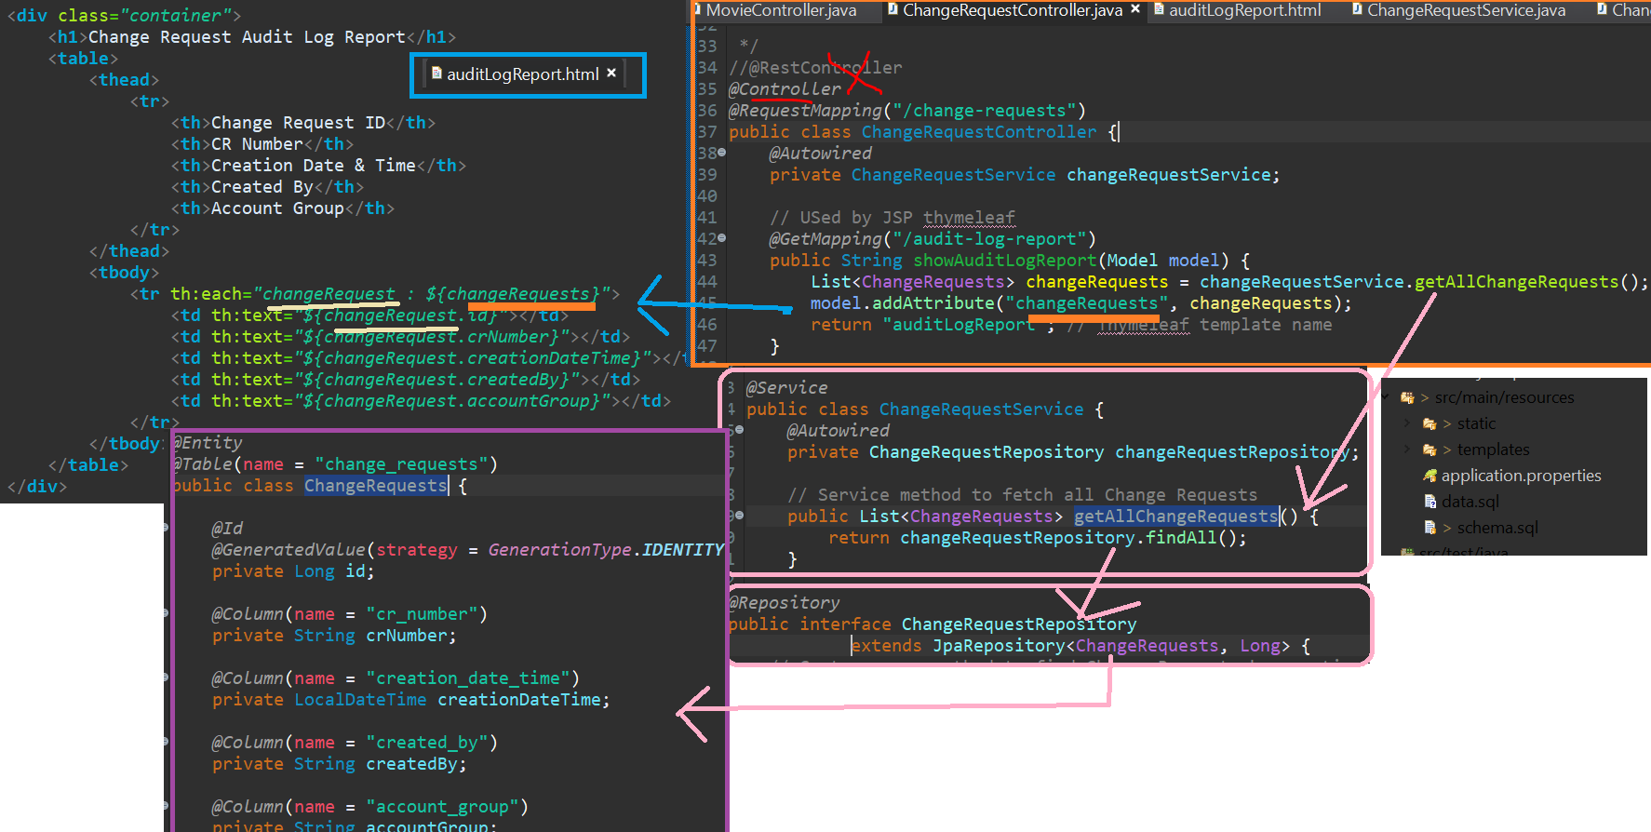

* 1. **Table Mapping**

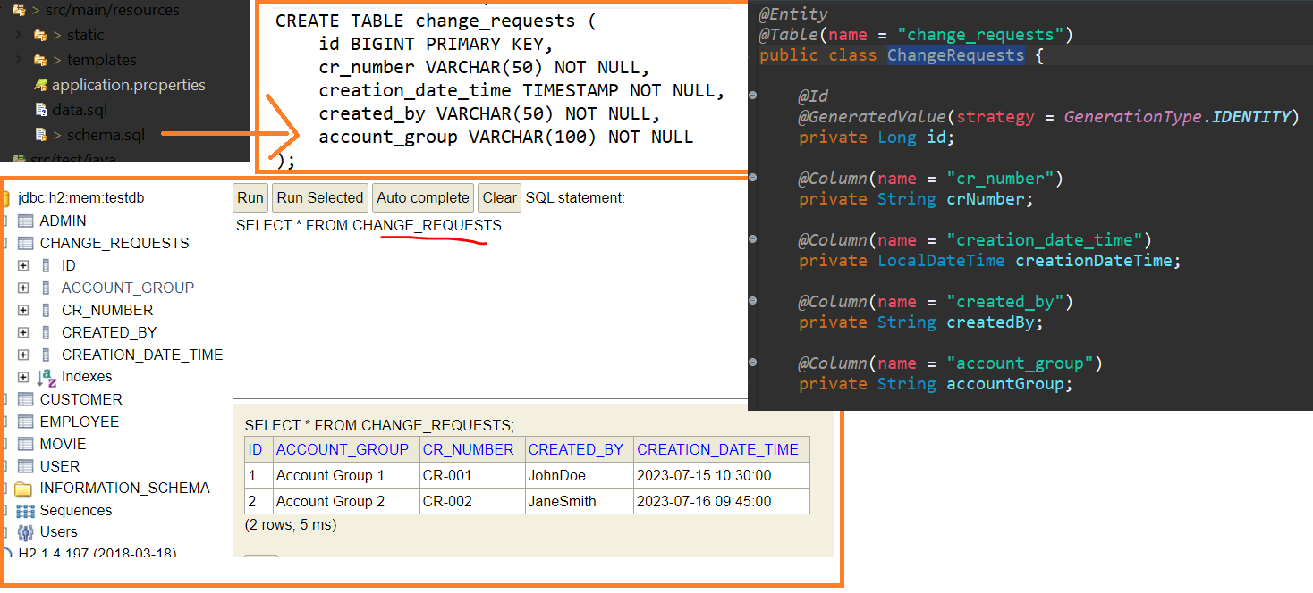

1. **Show data using Ajax**

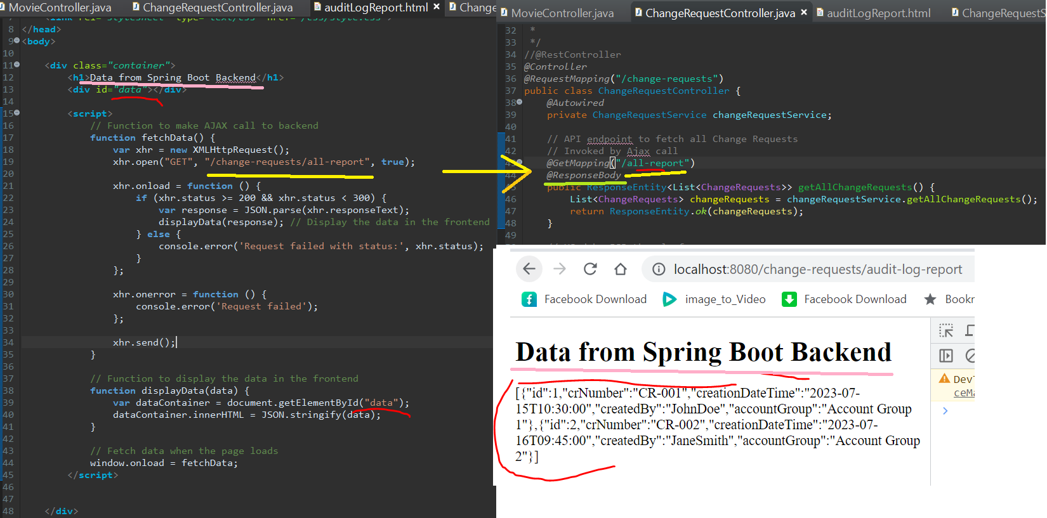

**Why Thymeleaf and Ajax?**

The integration of AJAX and Thymeleaf has enabled us to build a **dynamic and user-friendly** front-end interface. This **feature-rich web application** allows users to interact with the system seamlessly and obtain **real-time insights** into their financial data.