Sentiment Analysis for Customer Reviews

**Author**:Rabi

**Date**:30th July 2023

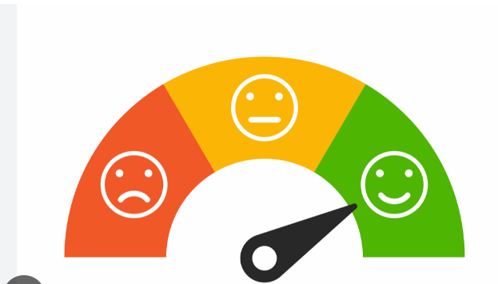

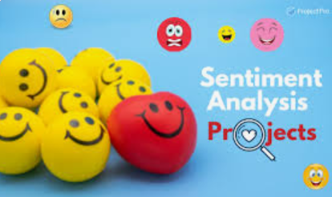

* we will be showcasing ….
* **sentiment analysis model** - Real-life Example of a sentiment analysis model implemented in Java with SpringBoot, H2 Database, and Thymeleaf
* **Prediction**- it will predict sentiment in customer reviews
* **What is Sentiment Analysis ?**

**Ans**:- Sentiment analysis is a valuable technique that automatically determines the sentiment expressed in a piece of **text**, whether **it's positive, negative, or neutral**. Our goal with this application is to provide businesses and organizations with **valuable insights** into customer feedback and sentiments.

We will **dive into** our **Java** application to establish the model.

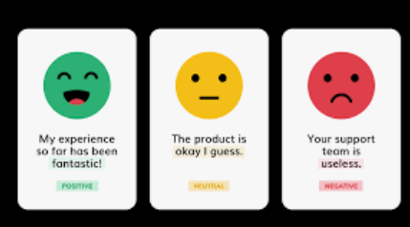

* We'll start by introducing the concept of sentiment analysis and its significance in understanding customer sentiments. You'll get a clear understanding of how this technology can be **leveraged** to gain valuable **insights**.

1. **Landing html page**

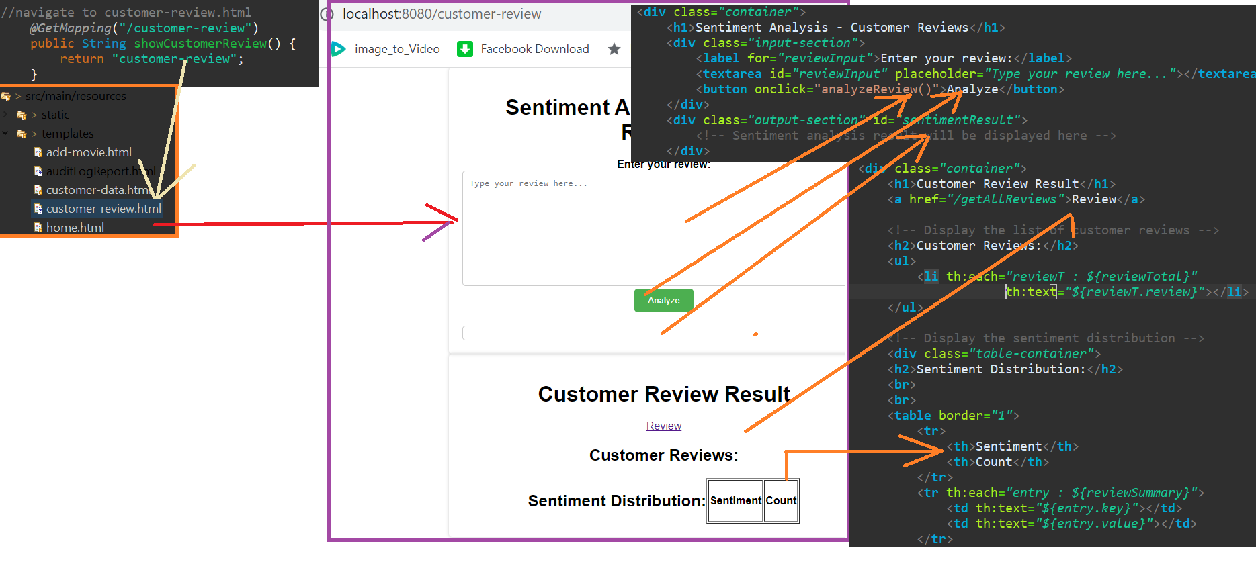

1. **Data Stored for Customer Review (…@ResponseBody.. since not using @RestController)**

-Before Storing converting JSON🡪String value

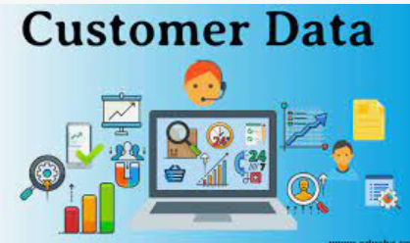

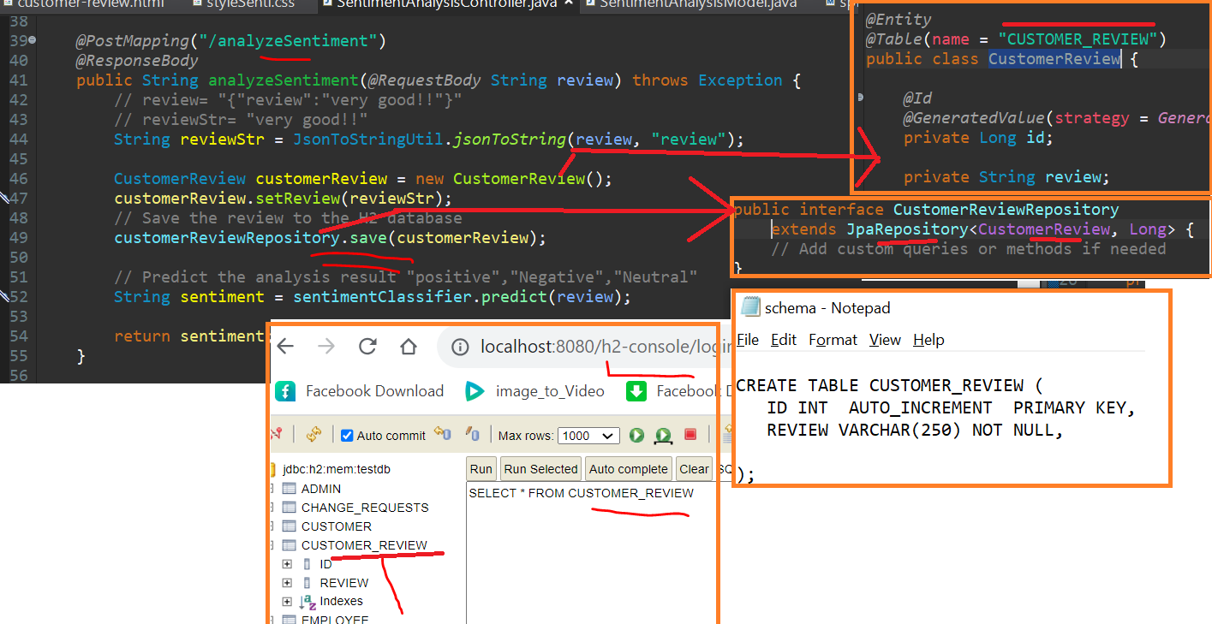

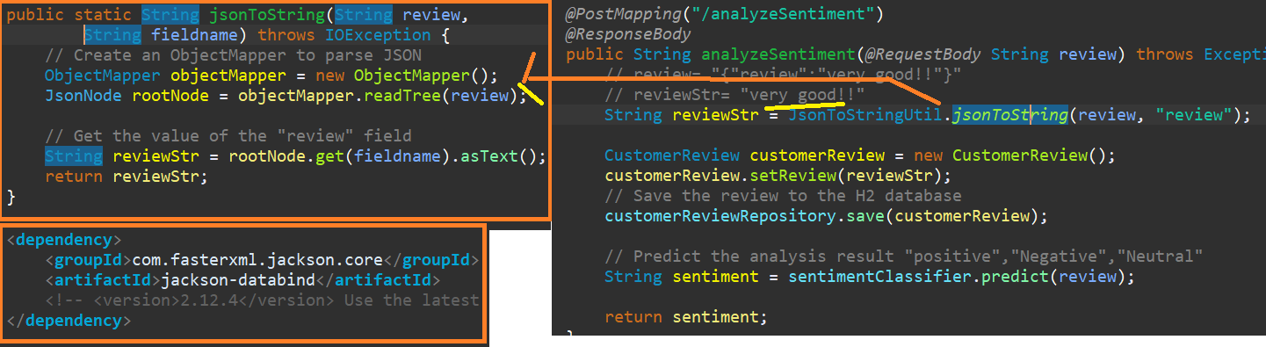

1. **Data collection and Processing for Customer Review**
   * **Data Cleaning** - we collected customer reviews and pre-processed the text data by **removing special characters**, numbers, and converting it to **lowercase**. Proper data **cleaning** is essential for accurate sentiment analysis.



String[] words = text.split("\\s+");

// Remove special charater ".,!@#%^*$()-=" from String

public String removeTrailingPunctuation((String inputString) {

String result = inputString.replaceAll("[.,!@#%^*$()-=]+$", "");

return result;

} }

* + **Identify Positive/Negative word**- Discover how we used a set of **positive and negative words** to determine the sentiment in the customer reviews. While we **initially hardcoded** these words, we'll discuss how we can **enhance the functionality** by invoking powerful APIs for sentiment analysis.



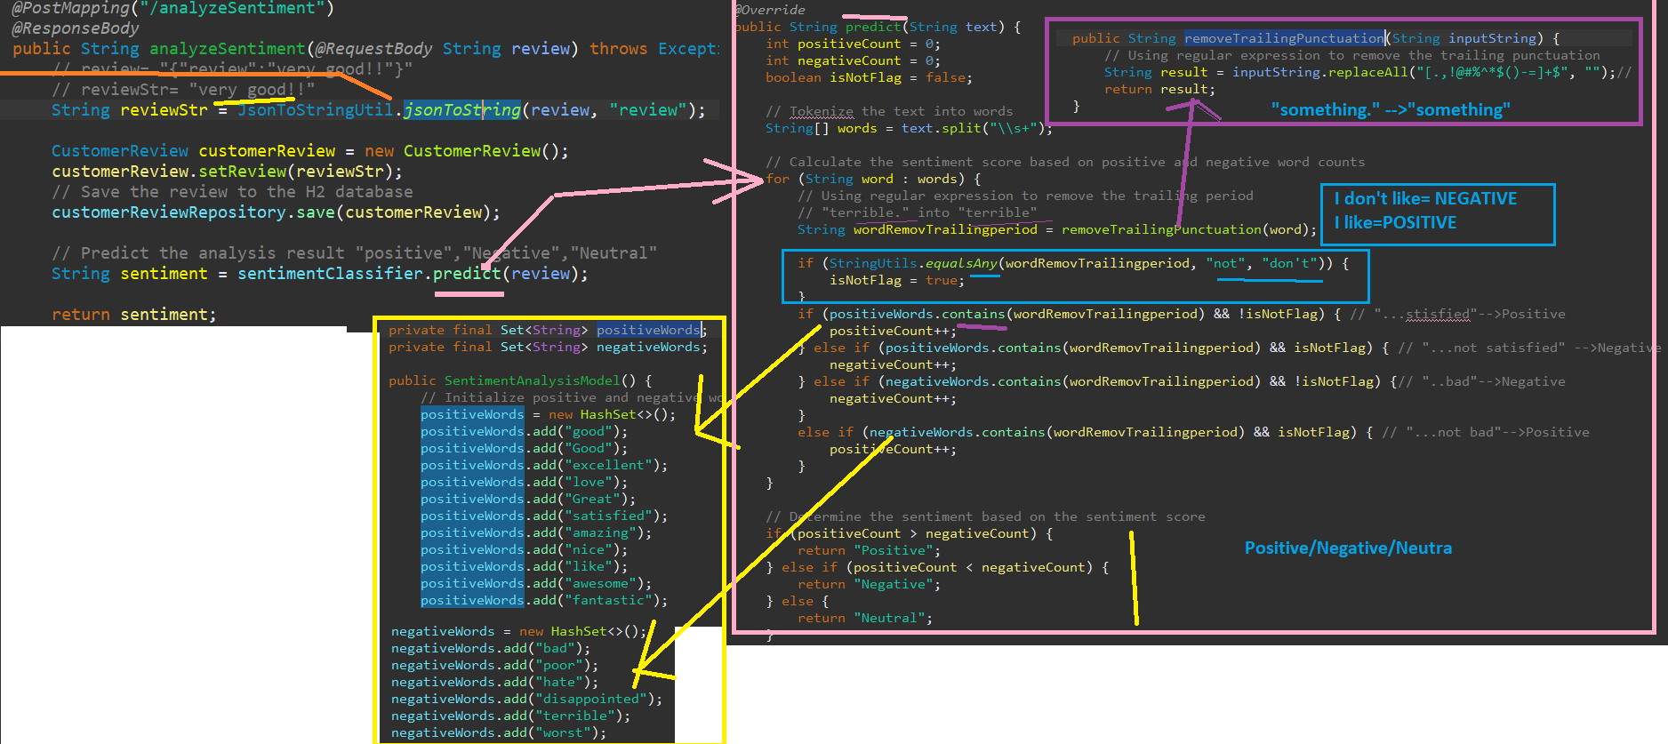

* 1. Positive/Negative word detection by positive/Negative word

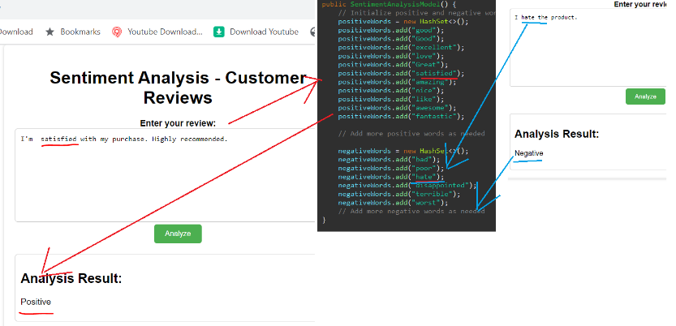

* 1. Using **NOT** + positive=Negative

NOT+Negative =Positive

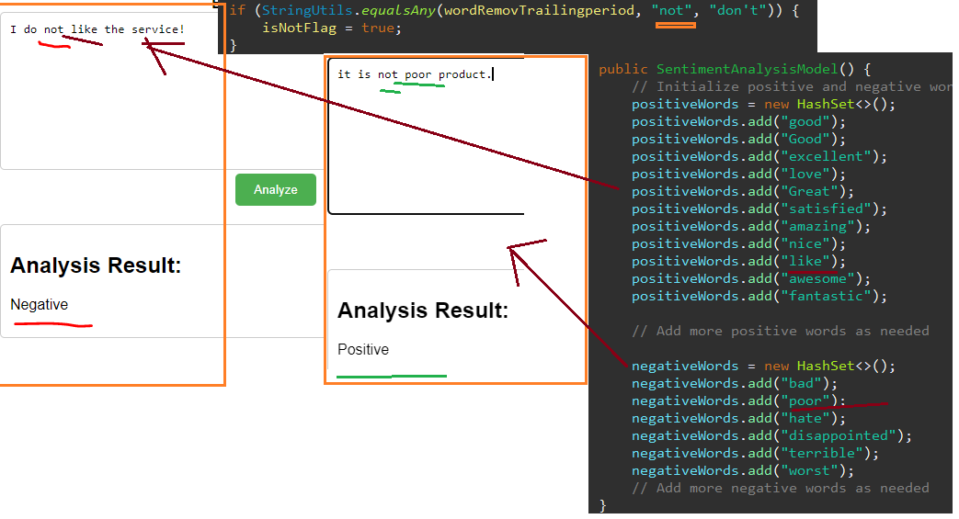

1. Get the list of positive and Negative word Count

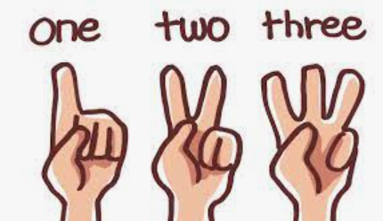

* **User Interface**: We have developed a user-friendly UI using Thymeleaf, HTML, and CSS, allowing users to input their reviews and view the sentiment analysis results in real-time.
* **Sentiment Distribution**: Witness the sentiment distribution of the customer reviews, displaying the count of positive, negative, and neutral sentiments. This visualization provides a comprehensive overview of the customer feedback

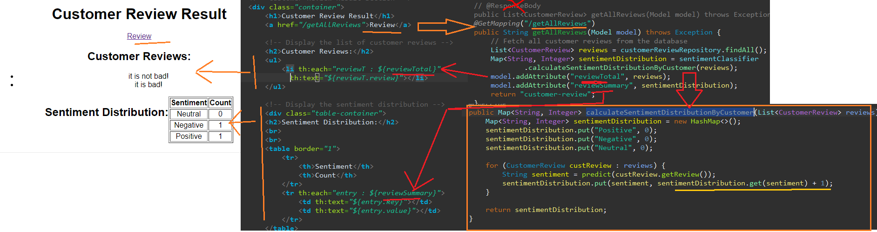

* **Future Scope**: We'll discuss the potential improvements and future enhancements for the application, including integrating more advanced NLP libraries and APIs to boost the accuracy and efficiency of sentiment analysis.



1. **Conclusion**:

Sentiment analysis plays a **crucial** role in various industries, and its significance lies in providing valuable insights into customer **sentiments**, **preferences**, and **opinions**. Here are some key points highlighting the importance of sentiment analysis across different sectors:

\*\***Financial Services**\*\*: Banks and financial institutions can use sentiment analysis to monitor customer sentiments about their **services**, such as **online banking**, customer **support, or credit card offerings**. This data can be leveraged to enhance customer satisfaction and **loyalty**.

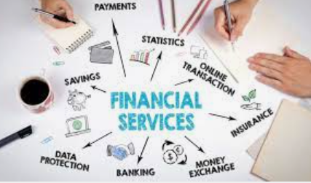

\*\***Retail and E-commerce**\*\*: In the retail industry, sentiment analysis helps businesses understand customer **feedback about products and services**. Positive sentiments can identify **popular products**, while negative sentiments can indicate areas for **improvement**. This data can be used for targeted **marketing**, customer support, and product development.



\*\***Hospitality and Tourism**\*\*: Sentiment analysis enables **hotels**, **restaurants**, and travel companies to gauge customer satisfaction. Positive reviews can be used for marketing and attracting new customers, while **negative** feedback can be addressed to **enhance customer experiences.**



\*\***Healthcare**\*\*: In the healthcare industry, sentiment analysis can be used to analyze patient feedback about medical services and treatments. Positive sentiments can indicate successful treatments, while negative sentiments can highlight areas of concern that need attention.



\*\***Social Media and Brand Management**\*\*: Sentiment analysis is widely used on social media platforms to understand public perception of brands. Companies can track brand mentions and analyze sentiments to manage their online reputation effectively.

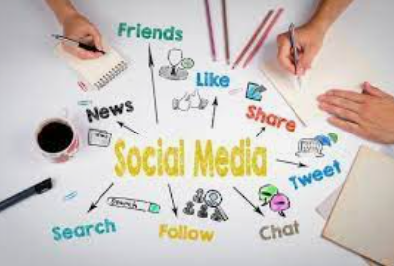

\*\***Market Research**\*\*: Sentiment analysis is an essential tool for market research to understand consumer preferences and behavior. It helps businesses identify trends, assess product acceptance, and make data-driven decisions.



\*\***Product Reviews and Recommendations**\*\*: Sentiment analysis is often used in recommendation systems to personalize product recommendations based on users' sentiments and preferences.



**Expanding the Real-Life Example:**

1. \*\***Customization**\*\*: Businesses can customize the sentiment analysis model by training it on industry-specific datasets to make more accurate predictions for their domain.

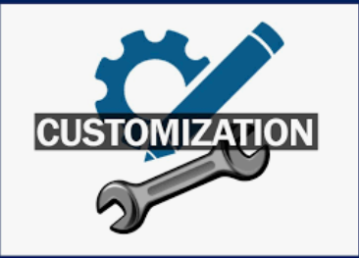

2. \*\***Multilingual Support**\*\*: The real-life example can be expanded to support multiple languages, allowing businesses to analyze sentiments in different regions and demographics.



3. \*\***Real-Time Analysis**\*\*: Implementing real-time sentiment analysis can help businesses respond quickly to customer feedback and address issues promptly.



4. \*\***Deep Learning Techniques**\*\*: The example can be enhanced by incorporating deep learning techniques, such as using **neural networks**, to capture more **complex sentiment** patterns.



5. \*\***Sentiment Trends**\*\*: By analyzing sentiment trends over time, businesses can identify patterns and make informed decisions for long-term strategies.



6. \*\***Sentiment Classification for Product Features**\*\*: Businesses can further categorize sentiments based on specific product features or services to focus on areas that require improvement or marketing.



**In conclusion**, sentiment analysis has widespread applications across **industries**, enabling businesses to gain **valuable insights**, make **data-driven decisions**, and improve overall **customer experiences**. The real-life example can be adapted and expanded to cater to **specific business needs**, making it a **powerful tool for any organization** aiming to harness customer sentiments for growth and success.

Don't forget to like, share, and subscribe to our channel for more exciting data science and machine learning projects. Stay tuned for more informative and innovative content!