Loan application using SpringBoot with

* Thymeleaf (html instead of JSP)
* H2 database (in-memory database)
* PDF generation (using iText)

**Date**: 4th July 2023

**Author**: Rabi

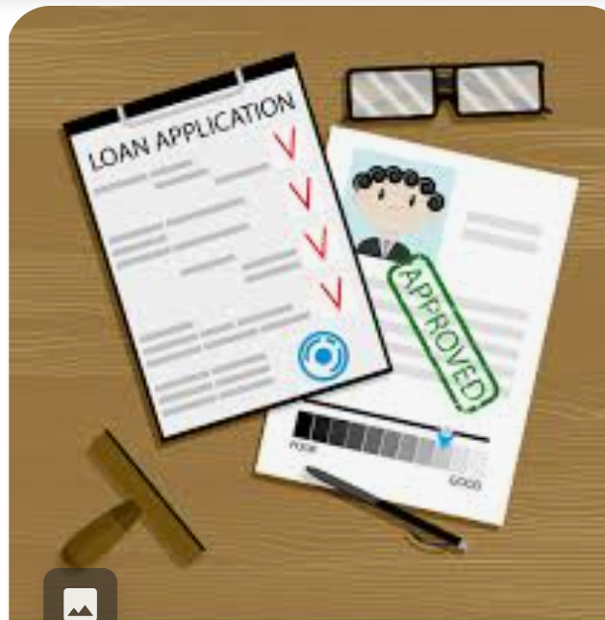

Why SpringBoot ?

* Imagine you're working on a project that involves **loan** approval.
* You need a robust, efficient, and user-friendly application to streamline the process. That's where Spring Boot comes in.
* It eliminates the need for extensive configuration, allowing developers to focus more on writing code and less on infrastructure setup

1. Support SpringBoot+Thymeleaf Engine (Alternate to jsp)

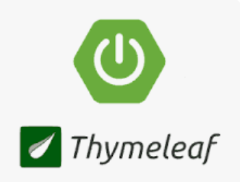

* With Thymeleaf, we can combine HTML templates with Java code, making our application more flexible and interactive

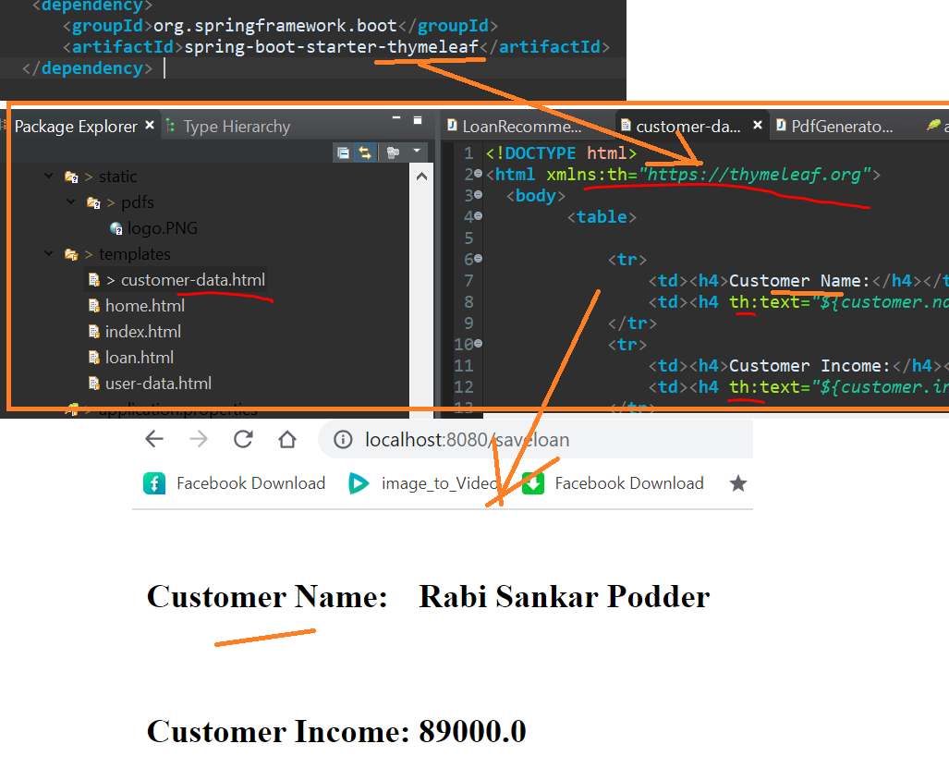

1. **SpringBoot +H2 Database integration**

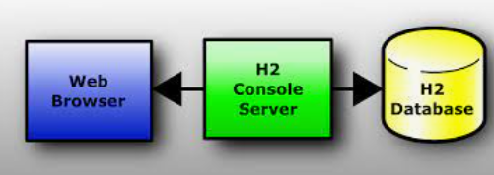

* in-memory database
* It provides a lightweight and efficient solution for storing loan-related data.
* Using in-memory database, we can achieve high performance and quick response times, ensuring a smooth loan approval process

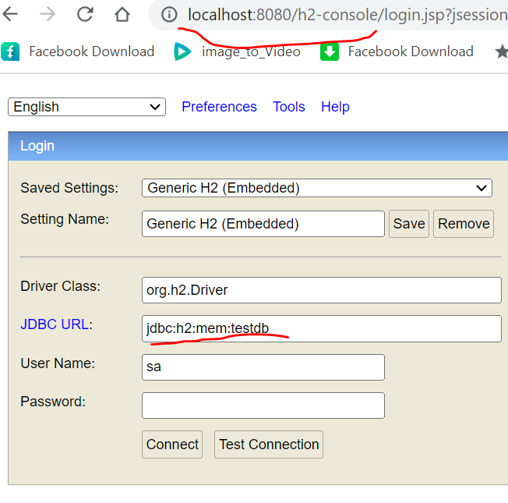

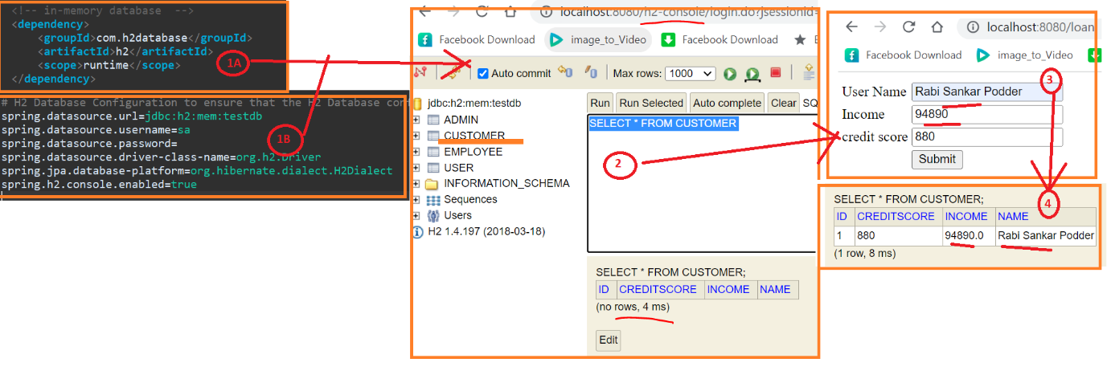

1. SpringBoot +PDF generation using iText (After Refresh it is visible)

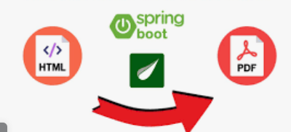

* we can generate professional-looking PDF documents dynamically
* This functionality allows us to generate loan approval letters, statements, or any other necessary documents automatically, saving time and effort

- By default, Spring Boot serves static files from the "classpath:/static" or * "classpath:/public" directories

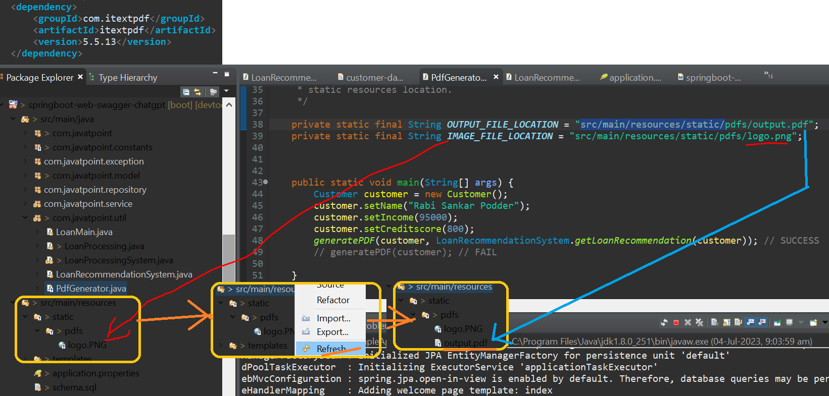

1. Flow of Page :-

(Need to refresh “pdfs” folder before clicking “Download PDF”)

* Now, let's dive into a live demonstration of our Loan Approval application.
* I'll showcase some of its key features and walk you through the workflow, highlighting how Thymeleaf, the H2 database, and PDF generation work together seamlessly

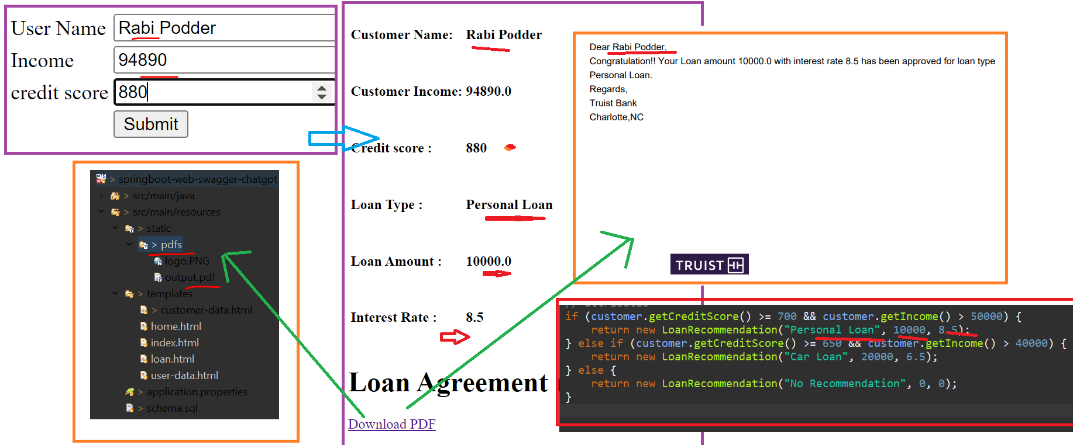

1. Conclusion

* And there you have it!
* We've explored the world of Spring Boot and how it empowers us to develop **robust** applications like our **Loan** Approval system.
* **Thymeleaf** enhances our web page's **interactivity**, the H2 database provides efficient data storage, and PDF generation simplifies document creation.
* The possibilities with Spring Boot are endless, and we hope this presentation has inspired you to explore and utilize its capabilities

1. Closing :-

* Thank you all for joining us today.
* We hope you found this technical presentation insightful and informative.
* If you have any questions or suggestions, please feel free to leave them in the comments section below.
* Don't forget to like and subscribe to our channel for more exciting content.
* Until next time, happy coding!