<http://www.pwc.com/us/en/careers/campus/programs-events/personal-brand/index.jhtml>

**Homepage:**

**Overview tab**

**Main header image text**

In today’s marketplace, it’s tough to stand out. Good grades and lots of extracurricular activities won’t guarantee that you’ll land the job or your dreams—or that you’ll even land the interview. There are many qualified candidates out there. The secret to standing out is to impress recruiters with the unique *you*—in person, on paper and online. You need to create career marketing tools that will make the true *you* shine and leave them wanting more. It all starts with building your personal brand.

**What is your personal brand?**

It’s your reputation. It’s about bringing *who* you are to *what* you do and *how* you do it. It’s about making your mark by being yourself—your best self. Think of your personal brand as your calling card—your unique promise of value. It is what you’re known for and how people experience you.

What are your unique strengths, skills and attributes?

How do you choose the career that’s right for you?

What do you want to be known for?

What will make you stand out in the eyes of potential employers?

Well…what are you waiting for?

**PwC’s Personal Brand Experience includes:**

Steps to finding the right career path for you

Activities to discover your unique strengths, skills and talents

Tips to help create a compelling story of you through:

Delivering a memorable elevator pitch

Crafting a winning cover letter, resume and bio that capture the interest of recruiters

Guidelines to project a positive professional presence

Interviewing tips that will help you stand out among the competition

Strategies to build your network in person and online

Steps to developing a professional online presence on LinkedIn

**Box 1: Get started**

It’s a tough market. You need to stand out from the crowd to get the opportunities you want. Click here to get started.

**Box 2: Make your plan**

Find out what makes you tick. The personal brand plan workbook to help you build a plan that will make you stand out by being your best self.

**Box 3: Market yourself**

It’s time to get known. Showcase your best self to prospective employers in person, on paper, and online.

**Get started tab**

**Body copy**

Find and showcase your strengths so you can stand out from the crowd. By tapping into your unique skills, talents and passions, you can leap off the pages of your resume and stay top of mind to your recruiters.

Watch this video to see the impact a strong personal brand can have as you begin to launch your career.

**Assess your strengths**

People with strong brands are clear about who they are. They know and maximize their strengths. They get feedback from others to validate how others experience them. Now is your chance to uncover and define the unique skills and strengths that will help you stand out from the crowd.

Download this survey to complete a self-assessment of your strengths. Then, give others the opportunity to provide feedback on your strengths. This activity will provide you with valuable information to get started on your personal brand journey. If possible, take a few minutes to initiate this step before you launch into the *Make Your Plan* workbook activities.

**How to use the survey and access Survey Gizmo >**

**Template to upload into Survey Gizmo >**

**TAB 2: Make your plan**

**Main header image text**

**Make your plan: Complete this workbook to find out what makes you tick.**

**Body copy -**

At this point, you’re likely making important decisions about your future. What career path is right for you? What will make you feel fulfilled—both personally and professionally?

Be introspective. Think about your unique skills and interests and how you can use them to differentiate yourself. Tap into your values, passions and purpose to figure out what makes you tick and what will get you noticed.

Get feedback. Reach out to your inner circle and ask questions to find out what others see as your greatest strengths and talents.

Expand your thinking. Explore your options. Fuel your opportunity engine and start building your plan.

Use this workbook to guide you through a series of interesting and revealing activities to help you:

* Discover your strengths
* Define your values
* Tap into your passions
* Find your purpose

After completing these activities, click on the ***Market Yourself*** tab above to guide you through how to convert your workbook inputs into tangible career marketing tools such as:

* Your resume
* Your bio
* Your online profiles

Once you make your plan, it’s easy to market yourself and get noticed!

**Download the workbook >**

**TAB 3: Market yourself**

**Main header image text**

Market yourself

**Body copy**

Stand out. Get noticed. Be remembered. Get hired. Watch this video below to see how you can use your assets to market yourself to prospective employers.

**SUBHEADER #1**

**Tell your story**

Whether you’re interviewing, networking, or just in a conversation, use the art of storytelling to make your mark. In today’s competitive marketplace, you need to be memorable and convey the genuine *you* while setting yourself apart from others who may be competing for the same opportunities.

**SUBHEADER #2**

**Market yourself—In person**

How well do you market yourself in person? Do you know it only takes seven seconds to make a first impression? Make your time count!

**Elevator Pitch**

The secret to leaving a positive first impression is having a powerful introduction. An elevator pitch is a summarization of who you are and the value you bring. Your goal is to help the listener understand your key attributes and interests and leave them wanting more.

Be sure to practice and refine your pitch until it rolls off your tongue and doesn’t sound forced or overdone.

A good elevator pitch should be:

Brief: Keep it to 30 seconds or less

Easy to understand: Avoid jargon

Compelling: Show your passion

Relevant: Make it appropriate for the event, the audience and your goals

Differentiated: Share what’s unique about you

Authentic: Communicate the essence of who you are and provide a window into your values (what’s important to you/what motivates you), your passions (what excites you) and your purpose (your goals for the future).

Creating a strong elevator pitch will help you soar above the competition at campus events, career fairs and in other professional settings. Watch this video for tips on how to increase the “wow factor” in your pitch.

**Watch the *Elevator pitch* video >**

**Interviewing**

Be authentic in your interactions so you can make sure that the organization you’re pursuing is a good fit for you. Remember, as much as they are interviewing you, you are interviewing them, too!

Engage prospective employers with a story that shares who you are - not just a laundry list of what you’ve done. Be genuine. Use emotion. Let your voice, demeanor and body language complete the picture of who you are.

Here are some tips on how to ace your interview:

**Don’t get stumped by basic questions**

Common interview questions can choke your performance if you’re not prepared. Don’t let these basic queries catch you off guard.

• Tell me about yourself.

The interviewer doesn’t want to hear your life history. Talk about some of your accomplishments that showcase your best professional qualities.

• How do you handle conflict?

The interviewer knows you don’t get along great with everyone, so don’t portray yourself as the ultimate people person. They’re looking for examples that show you can handle it when things don’t go your way. Demonstrate that you listen to other’s opinions, you’re open-minded and flexible and that you can reasonably state your objections and views.

• What’s your greatest weakness?

Don’t be tempted to reveal your worst moments. When describing your weakness, give a concrete example with an explanation of how you turned things around. The best answer shows you are proactive and are continually working to improve.

• Describe a situation when you failed.

Don’t fear this question. It presents a perfect opportunity to show you’re accountable. Demonstrate that you can recover from a mistake by talking about what you learned from the experience and how it strengthened your skills.

**Roll with the oddball interview questions**

In addition to having responses for routine questions on your strengths and weaknesses, you should also expect to answer some odd ones, too. You may get projective questions such as “What animal best represents you?” The interviewer won’t care about the animal that you choose – he or she is listening for the “why” behind your response. The “why” provides a window into how you see your key attributes. Don’t get tripped up. This is your chance to show that you can think on your feet. Remain relaxed and be yourself.

**Project professional presence**

You never get a second chance to make a first impression, particularly when it comes to your professional presence. Your behavior, demeanor and outward appearance impact how others perceive you. The moment an interviewer sees you, he or she will form opinions about your professionalism, credibility and abilities. Dressing for an interview isn’t rocket science, but it can be a problem if done as an after- thought or at the last minute. Your outfit should show you’ve got your act together. As a general rule, if you’re interviewing for a professional, managerial or executive position, wear a suit. If it’s a more casual role, choose an outfit that’s crisp. This means no jeans, wrinkled shirts or chinos, as well as anything with lint, holes or snags. Check out the First Impressions and Attire sections below for additional tips to make sure you’re putting your best foot forward.

Watch the video below to hear a recruiter’s perspective on what matters most to them, and see the difference first hand between what makes you a sleeper or a keeper.

**Watch the *Amp up your interview* video >**

**Networking**

Networking is an important tool that can open the doors to opportunity. It is about making and building relationships, not just about making connections.

Studies show that 60-80% of all job offers are the direct result of networking. The job market is tough, and *who* you know can make the difference in getting the job that you want. Here are some tips to help you learn how to network like a pro!

**Give and take**

* Networking a two way street—make sure that there’s a *give* and a *take* in the interaction.
* Show interest in what the other person has to say and they will be more interested in listening to you.
* Find a human connection that can spark a memorable conversation.
* Share interests and passions to help form connections and open the doors to a deeper conversation.

**Plan ahead**

* Networking is a planned and ongoing effort.
* Set goals, develop strategies for achieving them, take action, evaluate how well your plan is working and make changes as necessary.
* Do your homework - know your audience and who you want to meet.
* If you are going to a career fair or a company hosted event, do research ahead of time so you are prepared.
* Arrive on time and dress appropriately for the situation.

**At the event**

* Push yourself out of your comfort zone and strive to meet new people.
* Offer a firm handshake and a warm smile, and use your first and last name when introducing yourself.
* Make eye contact—don’t look around or act distracted when you’re talking to someone.
* Take a genuine interest in what others are saying and don’t dominate the conversation.
* Ask questions, listen to others and find common ground.
* Try to find a personal connection at the event, and make sure to stay connected by exchanging cards or connecting on LinkedIn after the event.

Remember, networking can happen anywhere, anytime and under a variety of circumstances— both formal and informal. The key is to find ways to build relationships and make meaningful connections that can help you throughout your career. Watch the video below to get a recruiter’s perspective at how to stand out at a networking event.

**Watch the *Networking nitrogen* video >**

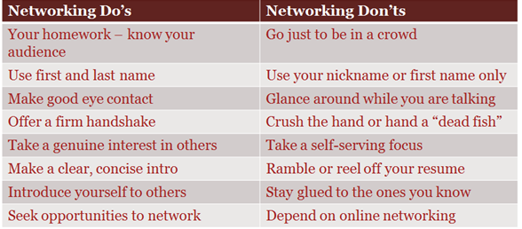

**First Impressions**

It takes 7 seconds to make 11 impressions. Every detail counts, so remember your ABC’s!

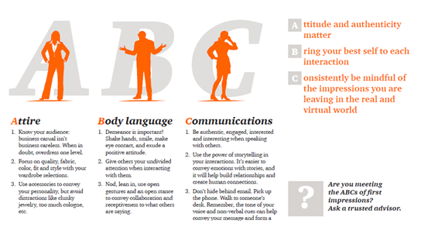

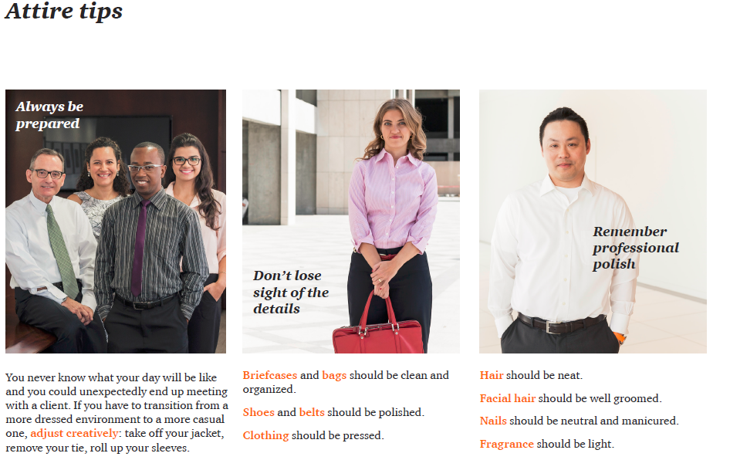

**SUBHEADER #3: Market yourself—On paper**

**Resumes, bios, and the basics**

Paper-based tools work as a virtual representative of the true and unique you. They can make or break your chances of getting an interview. Use them to get noticed for the right reasons.

A well-done resume and bio express an authentic picture of who you are and what makes you unique. They create an experience of you in the mind of the reader before they even meet you.

These tools can build emotional connections so others want to get to know you better. Use them wisely.

Access the quick tips guide below to find out how to leap off the page and become top of mind to recruiters.

**Ten tips to an excellent resume:**

**1. Limit your brilliance to one page**

Remember that your resume is a marketing tool and not a laundry list of everything you’ve ever done. By keeping your resume short, you’re demonstrating that you can edit yourself and sell your skills clearly and concisely.

**2. Professionalize your contact info**

Resumes featuring email addresses like ILovePuppies@internetserviceprovider.com may not seem professional to the company to which you are applying. Make sure your email address and the voice mail messages on any phone numbers you list are 100% professional and appropriate.

**3. Include unpaid experience**

Just because you didn’t get compensated for certain work doesn’t mean it shouldn’t count as experience for your resume. Include internships, volunteer work and part-time jobs if you achieved significant results or learned important skills in those positions.

**4. Quantify your results**

Employers don’t want to know just what you did; they also want to know what results you achieved. How many people did you oversee as a store manager? How much money did you save the junior class as Treasurer? Quantifying your accomplishments demonstrates not only what you achieved, but also the fact that you track your results.

**5. Prioritize your points**

When you list bullet points under each position or activity on your resume, be sure to place the most important task, accomplishment or responsibility first. Most readers of your resume will pay close attention to what you’ve chosen to feature as the first item on each list.

**6. Customize your resume for different opportunities**

Employers can tell when they’re seeing a generic resume that is being blasted out to anyone and everyone. It’s fine to have such a resume as a template, but customize it for various opportunities by featuring the experience, keywords and activities that best suit the requirements of that particular position.

**7. Include only interesting interests**

When it comes to listing interests or hobbies on your resume, only mention something that is particularly unique, uncommon or memorable. For example, “Founding president of first-ever Taekwondo Club at my university” or “three-time finisher of Chicago Marathon.” Generic interests such as “travel and reading” are nice, but they don’t add much.

**8. Delete the reference to “references”**

Don’t waste precious space on your resume with “References available upon request.” Potential employers will request a list of references if they want it.

**9. Never lie, exaggerate, or stretch the truth**

There are so many reasons not to lie on a resume. First of all, if your lie or truth stretching gets discovered, you’ll lose a job opportunity with that company forever. Second, if you exaggerate your skills, such as being fluent in French when you really just studied it in junior high, your lie will become extremely obvious the day you start your job and lack the skills you said you had. You should certainly cast yourself in the most positive light, but never take it too far.

**10. Proofread, and then proofread again**

There is absolutely, positively no excuse for a single typo or grammar mistake on a resume. Once you’ve proofread your resume and feel confident it’s perfect, have at least two other people review it for mistakes, misspellings and formatting glitches. You can never check your resume too many times.

**Your branded bio**

A resume is a start to an interview; a branded bio is a start to a relationship.

A well-worded bio conveys your values, passions, purpose and goals. It goes deeper than a resume since it tells the story of who you are versus listing what you’ve done. It is a great way to create a connection since you can use more emotional and evocative language in paragraph format.

Branded bios do not have to be job-specific since they represent the core of who you are, how you engage with others and the impact you create. You can also include your headshot in a branded bio to allow the reader to put a face with a name.

Once you’ve drafted a branded bio, you can use it in multiple places – both as a paper based tool and as an online tool, such as the “summary” of your Linked In profile. This is well worth your time since you’ll get many miles out of it.

**Cover letters**

Cover letters are still a necessity in the job marketplace. The purpose of a cover letter is to get the prospective employer to read your resume and create the hook to set up an interview. It provides them with a window into your written communication skills, your attention to detail and your desire for the position at hand.

Don’t overlook the importance of this document. Follow the steps below in case your cover letter needs CPR:

**C**onnect

Don’t address the cover letter to a nebulous “to whom it may concern.” Do your research on the appropriate point of contact and get his/her name in the salutation.

If applicable, state your connection to him/her.

Share what appeals to you about the opportunity—–demonstrate curiosity and show you’ve done your research. It’s a snooze when you open with *“Hello, I’m John Doe and I’m applying for the position of accounting associate.*” Grab their interest with why this is a good fit.

**P**roject

Elaborate on relevant experience without restating what’s on your resume. Let them know what you could and would bring to this position.

**R**equest

Ask for what you want, which is an interview. Leave with a call to action.

**Thank you notes**

Don’t overlook the thank you note either. It’s a great opportunity to put your name in front of prospective employers and colleagues once again, so take advantage of it! In addition to thanking them for their time, remind them of any connection points you made or something that was special and memorable about your interaction.

Whether you hand write the note or do it electronically is your call. Whatever feels authentic to you is the way to go.

**SUBHEADING #4:**

**Market yourself—Online**

Social media is becoming more ingrained into how people communicate and connect with one another. In many cases, someone may meet you online before they meet you in person.

**What does your online brand say about you?**

Your current network can access online information - along with future contacts, employers and network influencers. At lightning speed, you can positively or negatively impact your brand. Remember that what you put on the Internet is captured there forever.

Now that you’re stepping into the corporate world, it’s a good idea to make sure that your social media persona reflects you appropriately. Research yourself on the web to see what can be found about you. Take action to remedy anything you think might impact your reputation negatively. Use tools like LinkedIn to build your credibility and visibility with your professional network.

Get started by accessing the online ID calculator for a pulse check on your current brand on the web.

**Access the *Online ID calculator* >**

**LinkedIn tips**

Review the tips below to build a strong LinkedIn profile. It’s a SNAP!

|  |  |
| --- | --- |
| **Show yourself** | * Make sure your profile is complete and accurate. The more complete your profile, the easier it is for others to find you through LinkedIn's search function. Don’t forget to add a professional headshot - people are more likely to believe content that has a face attached to it. * Describe who you are, not just what you do. Include interests and hobbies and join groups. This will help people find genuine connection points from which to build a relationship. * Avoid acronyms so the general public will know what you’re talking about.   TIP: Turn off activity broadcasts when in edit mode so people don’t get notified of every little change. |
| **Network** | * Leverage your personal and professional connections, such as old friends, college roommates, teachers, current and former colleagues, etc. The larger your network is on LinkedIn, the better connected you are to LinkedIn's entire network. * Use the "People you may know" feature to help build your network. * If someone you’d like to know is connected to someone in your network, ask them to make an introduction. * On the other side, if someone who you don’t know reaches out to you, be selective in deciding whether to accept their invitation. See how they know you and think about the value they may bring to your network before automatically selecting “accept.” |
| **Attract** | * Leverage your status update in LinkedIn to draw people to your profile. Comment on a post. Share an article. Recommend a book or a webcast. * Engage in conversations via your groups. * Remain active with relevant postings or new connections so that your name and photo remain in front of your online community. |
| **Promote** | * Ensure your profile focuses on your top strengths. Repeat these keywords over and over, which will boost your visibility during a keyword search. * Reorder your content. You can customize your LinkedIn profile page, so make sure most relevant information is at the top. * Don’t accept all endorsements, which can actually dilute your brand. Only ask to be endorsed for your top skills to boost your credibility in those areas that you wish to be known for.   Tip: To add a badge to your LinkedIn profile, click here. |

**SUBHEADING #5**

**Make your mark**

FwBranding is a journey, not a destination – and each interaction is an opportunity to build your brand.

Be clear on what you want to be known for. Be compelling in how you share your story with others. Be authentic. Be passionate. Be your best self.

*Engage, commit and step up to stand out.*

If you missed the opportunity, click here to get back to the workbook so you can download it and complete the activities.

**Download the workbook >**