**Assignment 1**

**Dong Joo Rhee**

**1. Backpropagation in a Simple Neural Network**

a) Dataset

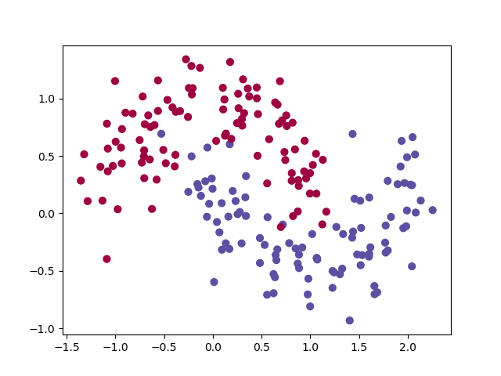

Fig 1. Distribution of Make-Moons dataset

b) Activation Function

1)

2) Derivatives of Tanh, Sigmoid, and ReLU

$$\frac{d}{dz}\left(Tanh(z)\right)=\frac{d}{dz}\left(\frac{1-e^{-2z}}{1+e^{-2z}}\right)=\frac{\left({2e}^{-2z}\right)\left(1+e^{-2z}\right)-\left(1-e^{-2z}\right)\left(-2e^{-2z}\right)}{{(1+e^{-2z})}^{2}}=\frac{4e^{-2z}}{{(1+e^{-2z})}^{2}}$$

$$\frac{d}{dz}\left(Sigmoid(z)\right)=\frac{d}{dz}\left(\frac{1}{1+e^{-z}}\right)=\frac{0-1∙(-e^{-z})}{{(1+e^{-z})}^{2}}=\frac{e^{-z}}{{(1+e^{-z})}^{2}}$$

$$\frac{d}{dz}\left(ReLU\left(z\right)\right)=\left\{\begin{aligned}0 if z<0 \\ 1 if z>0\end{aligned}\right.$$

Mathematically, the derivative of ReLU(z=0) is undefined, but it is necessary to define the value for computational reasons. Therefore, the derivative of ReLU(z=0) is defined to be 0 in my code.

3)

c) Build the Neural Network

d) Backward Pass – Backpropagation

1) Derive the gradients

dL/dW2, dL/db2, dL/dW1, dL/db1

**2. Training a Simple Deep Convolutional Network on MNIST**

a) The final test accuracy : 0.9856

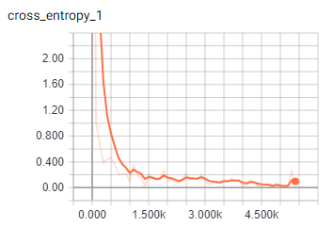

Fig. cross_entropy curve

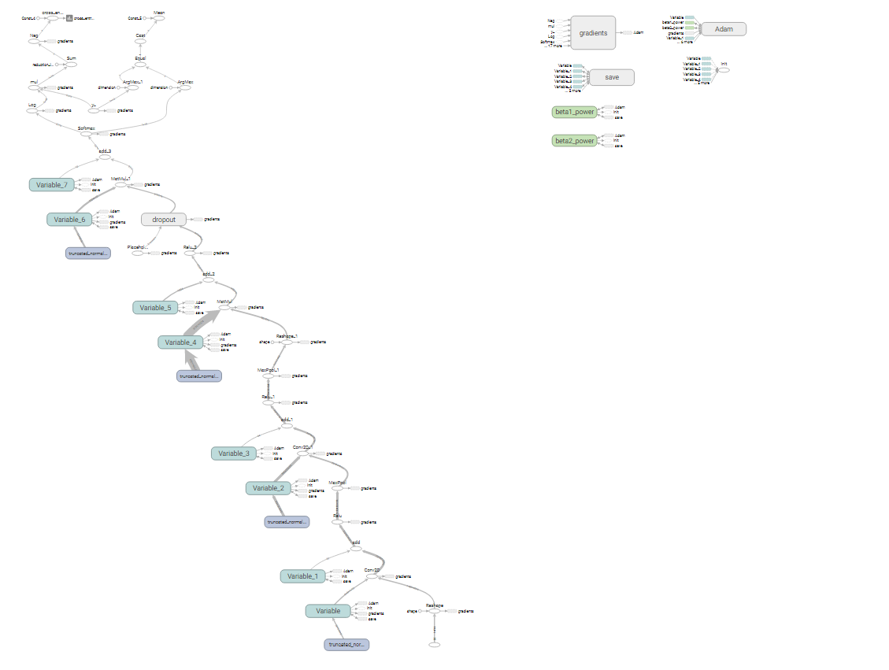

Fig. Curve

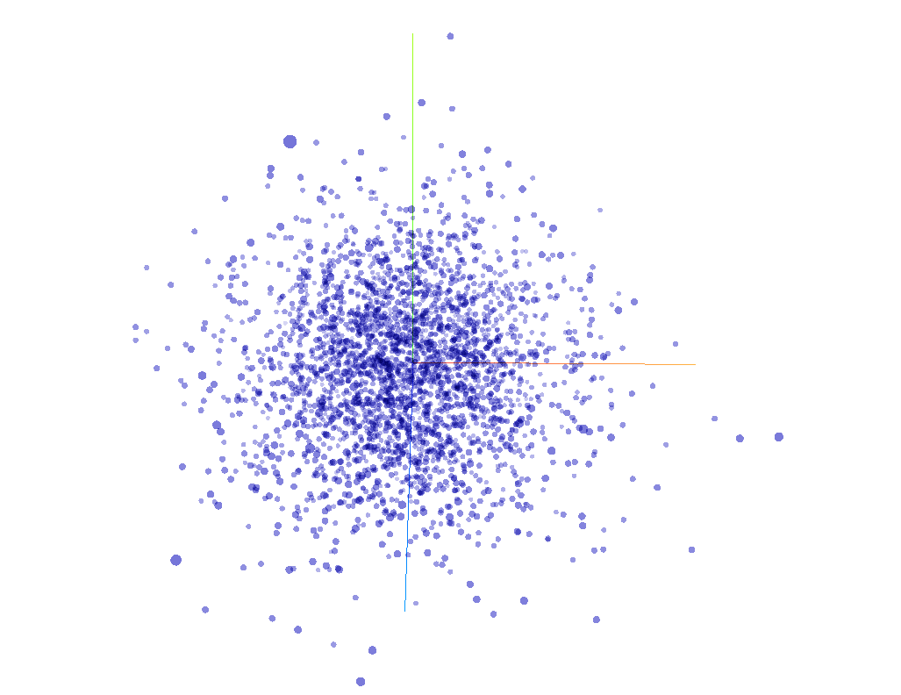

Fig. Distribution

For the latest version of TensorFlow, some functions given in the dcn_mnist.py are outdated, so needed to be replaced as shown below.

* tf.initialize_all_variables() 🡪 tf.global_variables_initializer()
* tf.scalar_summary() 🡪 tf.summary.scalar()
* tf.merge_all_summaries 🡪 tf.summary_merge_all()
* tf.train.SummaryWriter() 🡪 tf.summary.FileWriter()