Motivation for LangGraph

- A solitary language model is fairly limited. It does not have access to tools, external context (like documentation). It cannot alone perform multi-step workflows.
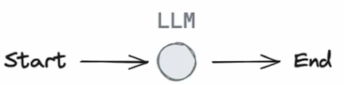
- So many LLM applications use a control flow some kind with steps before and after LLM calls. These could be tool calls. This could be retrieval steps and so forth.
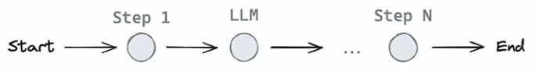
- This control flow forms a chain. That is a set of steps before and after an LLM call.
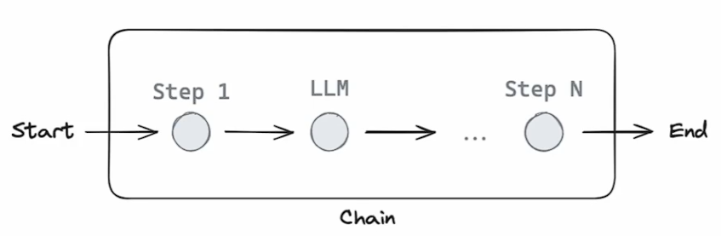
- Chains are very reliable. That is the same flow of steps occur every time you invoke the chain.
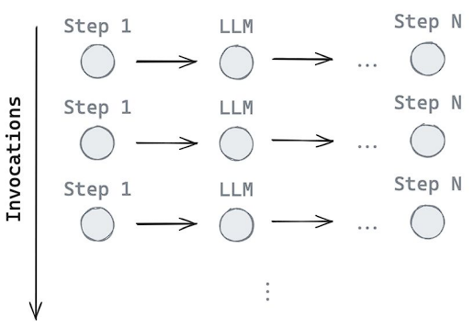
- But what if we want LLM systems that can pick their own control flows for certain kind of problems. That is you want an LLM application that can choose its own set of steps depending on the problem being faced.
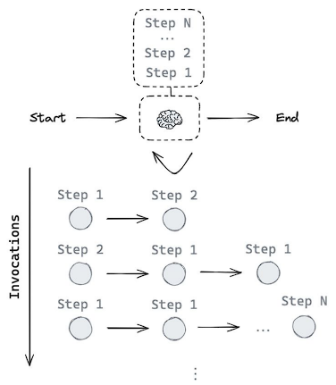
- And this is really what an Agent is. Agent ~= control flow defined by an LLM.
- Fixed Control Flows vs LLM-defined Control Flows
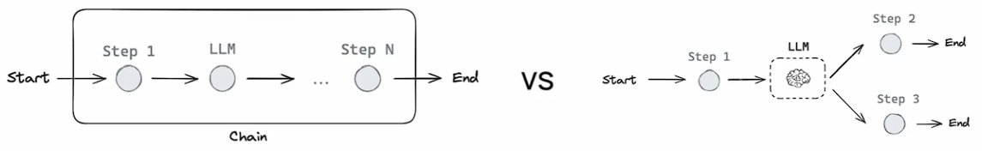
- Agents can be of many kinds, depending upon the amount of control you give to the LLM from Low to High.
  - Low – Routers – The LLM controls a single step in a flow and may choose between a narrow set of options.
  - High – Fully Autonomous Agent – The Agent can pick any sequence of steps through some set of given options, or even generate its own set of steps (based on some potentially available resources).
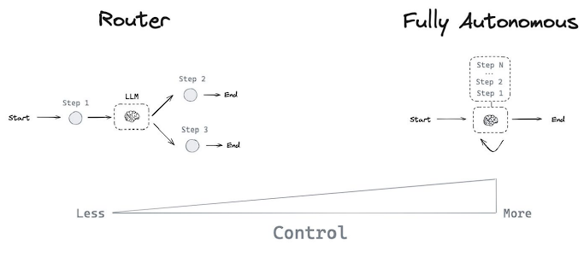
- As we give more autonomy to the agents, their reliability decreases.
LangGraph Motivation: LangGraph aims to help us bend this reliability curve, allowing us to build agents that maintain reliability, even as we push out the level of control we actually give to the LLM or agent.
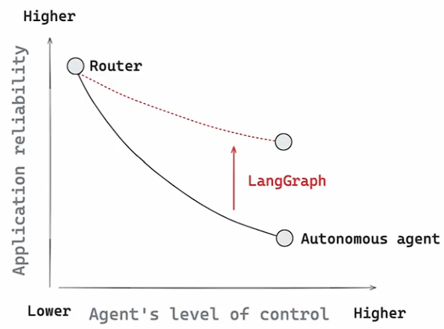
- Do I need to use LangChain to use LangGraph? What’s the difference?
  - No.
LangGraph is an orchestration framework for complex agentic systems and is more low-level and controllable than LangChain agents.
On the other hand, LangChain provides a standard interface to interact with models and other components, useful for straight-forward chains and retrieval flows.
- How is LangGraph different from other agent frameworks?
  - Other agentic frameworks can work for simple, generic tasks but fall short for complex tasks bespoke to a company’s needs. LangGraph provides a more expressive framework to handle companies’ unique tasks without restricting users to a single black-box cognitive architecture.
- Does LangGraph impact the performance of my app?
  - LangGraph will not add any overhead to your code and is specifically designed with streaming workflows in mind.
- Is LangGraph open source? Is it free?
  - Yes. LangGraph is an MIT-licensed open-source library and is free to use.
- Is LangSmith Deployment (formerly LangGraph Platform/Cloud) open source?
  - No. LangSmith Deployment is proprietary software that will eventually be a paid service for certain tiers of usage.
- How are LangGraph and LangSmith Deployment different?
  - LangGraph is a stateful, orchestration framework that brings added control to agent workflows.
LangSmith Deployment is a service for deploying and scaling LangGraph applications.
- How does LangGraph fit into the LangChain ecosystem?
  - LangChain’s open source frameworks help you build agents:
    - LangChain helps us quickly get started building agents, with any model provider of your choice.
    - LangGraph allows us to control every step of your custom agent with low-level orchestration, memory, and human-in-the-loop support. We can manage long-running tasks with durable execution.
    - LangSmith is a platform that helps AI teams use live production data for continuous testing and improvement. LangSmith provides:
      - Observability to see exactly how your agent thinks and acts with detailed tracing and aggregate trend metrics.
      - Evaluation to test and score agent behavior on production data and offline datasets for continuous improvement.
      - Deployment to ship your agent in one click, using scalable infrastructure built for long-running tasks.

