Here are two poems I wrote a long time ago...

# Motion

The tides rise and fall

Years go on with lightning speed

You are ever still

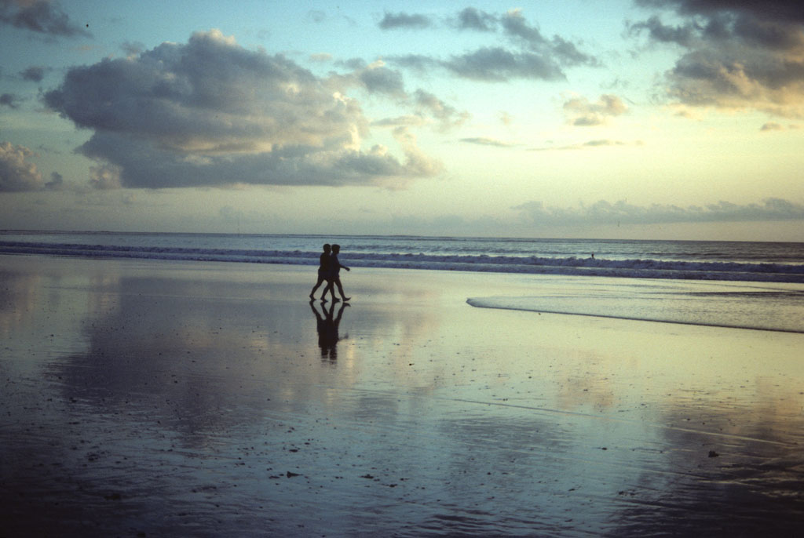

Together

# Plan ah

I seem to have lost my way Have I been led astray? Do my words no longer hold weight? Is this what they call fate?

Not all who wander are lost Not one effect without a cause Even if the cost was nothing at all We'd give it all we've got

One day the pieces all fall into place, Fit, as do the stars in space Constellations of a future near and bright Shine in the moonlight

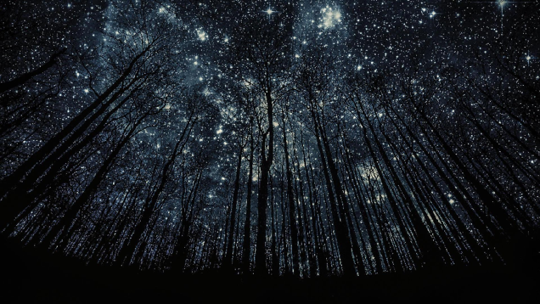

Night