**Output**

Simple Selectors

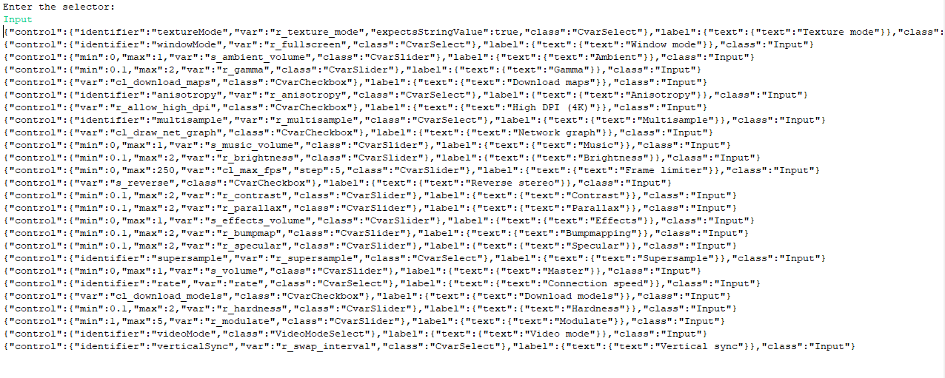

Compound Selectors



Chain Selectors

