**Program 1**

**Aim:** To create a student management program that takes in student marks, roll no., year, branch as input and searches by roll no., calculates average and percentage.

**Theory:** A structure is a user defined data type in C/C++. A structure creates a data type that can be used to group items of possibly different types into a single type. Struct defines a physically grouped list of variables to be placed under one name in a block of memory, allowing the different variables to be accessed via a single pointer, or the struct declared name which returns the same address.

**Algorithm :**

* Create a structure with data members (name,rollno. Etc).
* Take input from the user.
* Calculate the average of marks.
* Input rollno. to be searched.
* Search and display results.

**Program :**

#include <stdio.h>

#include <stdlib.h>

struct student{

char name[25];

int rollno,year;

float marks[5];

char branch[3];

float avg;

};

void display(struct student s1){

printf("\nName : %s\n",s1.name);

printf("RollNo : %d\n",s1.rollno);

printf("Year : %d\n",s1.year);

printf("Branch : %s\n",s1.branch);

printf("Average : %0.2f\n\n", s1.avg);

}

int main() {

int n;

printf("Enter no. of students whose data you want to enter : " );

scanf("%d",&n);

struct student students[n];

for(int i = 0 ; i<n ; i++){

printf("\nEnter details of student %d\n\n",i+1);

printf("Enter Name : ");

scanf("%s",students[i].name);

printf("Enter RollNo : ");

scanf("%d",&students[i].rollno);

printf("Enter Year : ");

scanf("%d",&students[i].year);

printf("Enter Branch : ");

scanf("%s",students[i].branch);

printf("Enter marks in 5 subjects : ");

students[i].avg = 0;

for(int j = 0 ; j<5 ; j++){

scanf("%f",&students[i].marks[j]);

students[i].avg+=students[i].marks[j];

}

students[i].avg*=0.2;

}

int r = 0,check = 0;

printf("\n\nEnter RollNo to be searched : ");

scanf("%d",&r);

for(int i = 0 ; i<n; i++){

if(students[i].rollno == r){

check = 1;

display(students[i]);

break;

}

}

if(!check){

printf("\nRollNo doesn't exist\n\n");

}

return 0;

}

**OUTPUT:**

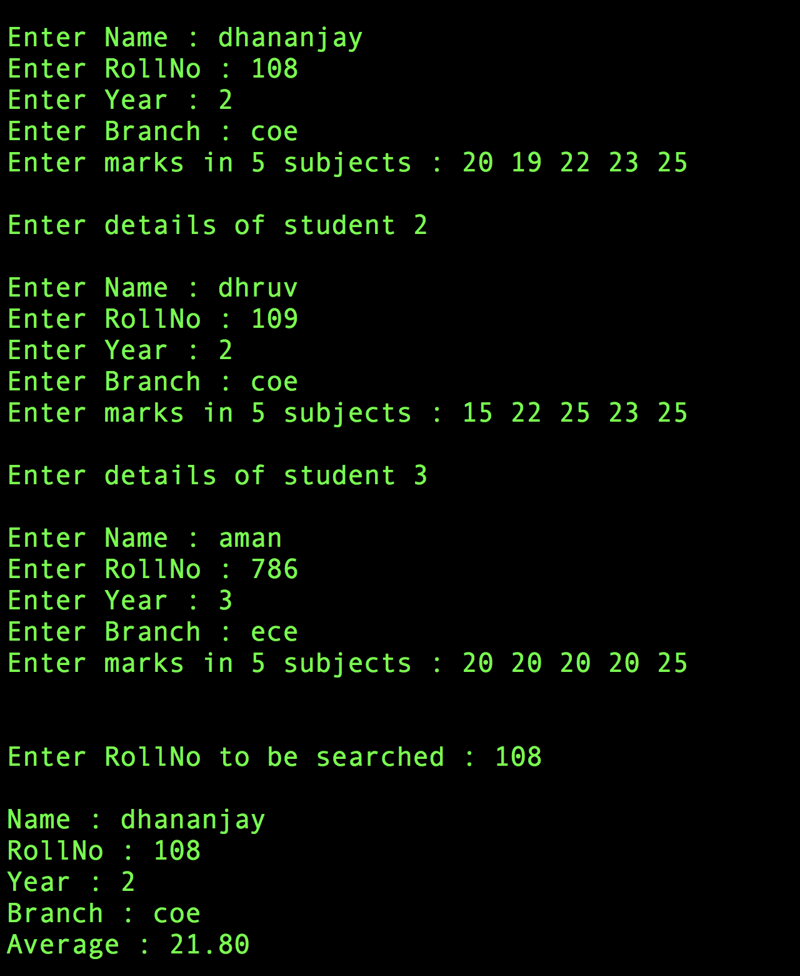

**Learning :** We learnt how to use structures in C and their basic implementation for a student management program.