EXPERIMENT 6

Aim : Write a program to accept the student detail such as name and 3 different marks by get_data() method and display the name and average of marks using display() method. Define a friend class for calculating the average of marks using the method mark_avg().

Theory :

Friend Class - A friend class can access private and protected members of other class in which it is declared as friend. It is sometimes useful to allow a particular class to access private members of other class.

Following are some important points about friend functions and classes:

- Friends should be used only for limited purpose. If too many functions or external classes are declared as friends of a class with protected or private data, it lessens the value of encapsulation of separate classes in object-oriented programming.
- Friendship is not mutual. If a class A is friend of B, then B doesn’t become friend of A automatically.

- Friendship is not inherited

Code :

#include <iostream>

using namespace std;
class avg;
class student;

class avg{

public:
float mark_avg(student);
};
class student{
int marks[3];
string name;
public:
void get_data(){
cout<<"Enter name : ";
cin>>name;
cout<<"Enter marks in 3 subjects : ";
cin>>marks[0]>>marks[1]>>marks[2];
cout<<endl;
}

void display(){

avg a;
cout<<"Name : "<<name<<endl;
cout<<"Average Marks : "<<a.mark_avg(*this)<<endl;

}
friend class avg;

};

float avg::mark_avg(student s){
return (s.marks[0] + s.marks[1] + s.marks[2])/3.0;
}

int main() {

student s1;
s1.get_data();
s1.display();
}

Output :
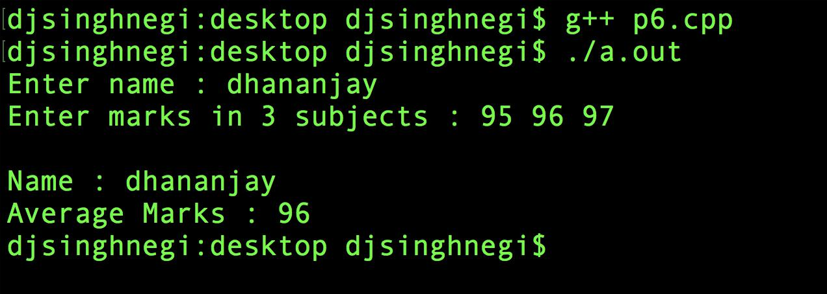

Discussion :

Here we created a friend class avg to the student class. The friend class consists of a single member function marks_avg() which returns the average marks. This class can access all members of student class. Therefore the function calculates the average using the data members of object of class student.

