Experiment 11

AIM:

Write a program to create three objects for a class named pntr_obj with data members such as roll_no and name. Create a member function set_data() for setting the data values and print() member function to print which object has invoked it using ‘this’ pointer.

Theory:

Every object in C++ has access to its own address through an important pointer called this pointer. The this pointer is an implicit parameter to all member functions. Therefore, inside a member function, this may be used to refer to the invoking object. Friend functions do not have

a this pointer, because friends are not members of a class. Only member functions have a this pointer.

Code:


#include < iostream >
using namespace std;

class pntr_obj {
char name[20];
int roll_no;
public:
void set_data() {

cin >> name >> roll_no;
}
void print() {
cout << "Name: " << this - > name << endl;
cout << "Roll#: " << this - > roll_no << endl;
}
};
int main() {
pntr_obj a, b, c;
a.set_data();
b.set_data();

c.set_data();
a.print();
b.print();
c.print();
return 0;
}
Output:
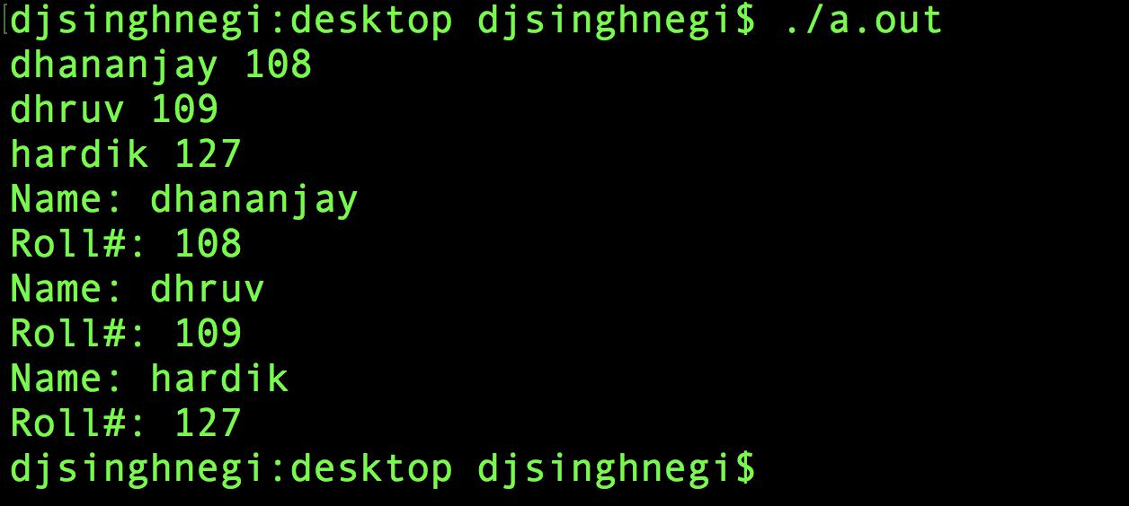

Discussion:

As it can be seen that we have printed the information of an object using ‘this’ pointer.

