**Module: 7 Segment Adapter**

**Tested By: Antonio Jimenez**

All tests passed with no errors.

Requirement Tag: SEG_ADAP_01

Test Case ID: SEG_ADAP_TC_01

* Passed
* Method of testing: Testbench Assertion

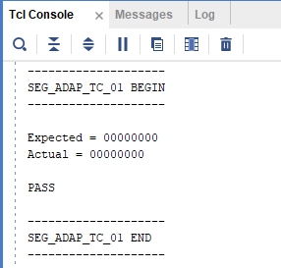

Requirement Tag: SEG_ADAP_02

Test Case ID: SEG_ADAP_TC_02

* Passed
* Method of testing: Testbench Assertion

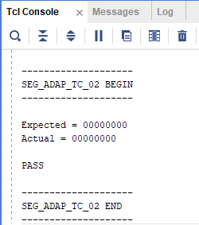

Requirement Tag: SEG_ADAP_03

Test Case ID: SEG_ADAP_TC_03

* Passed
* Method of testing: Waveform Observation

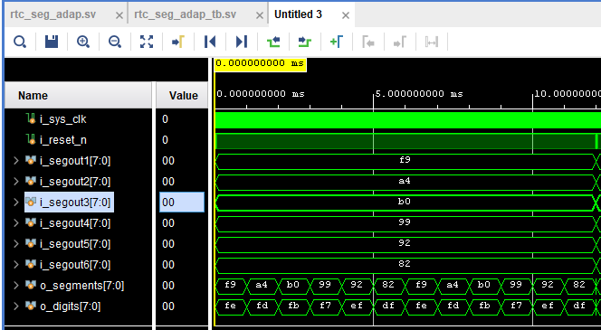

Requirement Tag: SEG_ADAP_04

Test Case ID: SEG_ADAP_TC_04

* Passed
* Method of testing: Waveform Observation

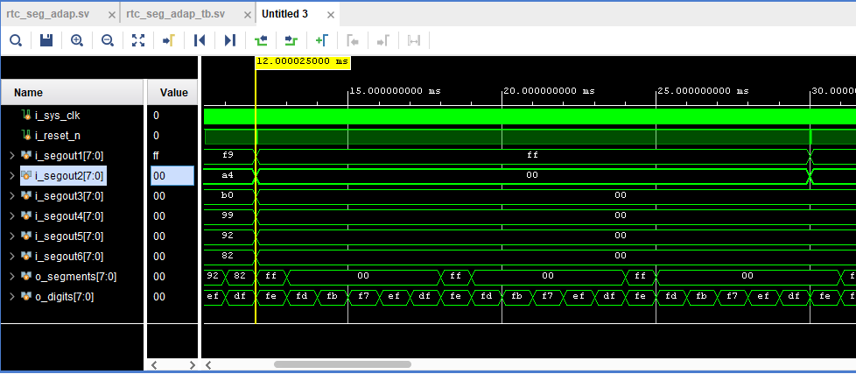

Requirement Tag: SEG_ADAP_05

Test Case ID: SEG_ADAP_TC_05

* Passed
* Method of testing: Waveform Observation

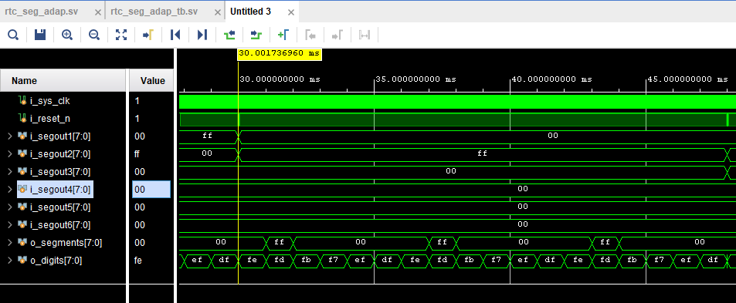

Requirement Tag: SEG_ADAP_06

Test Case ID: SEG_ADAP_TC_06

* Passed
* Method of testing: Waveform Observation

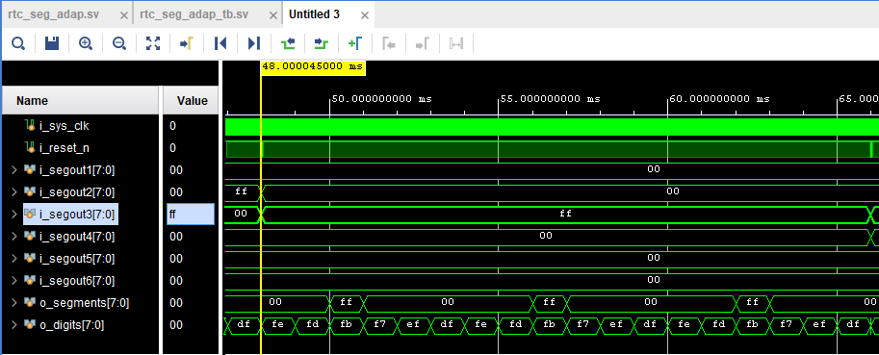

Requirement Tag: SEG_ADAP_07

Test Case ID: SEG_ADAP_TC_07

* Passed
* Method of testing: Waveform Observation

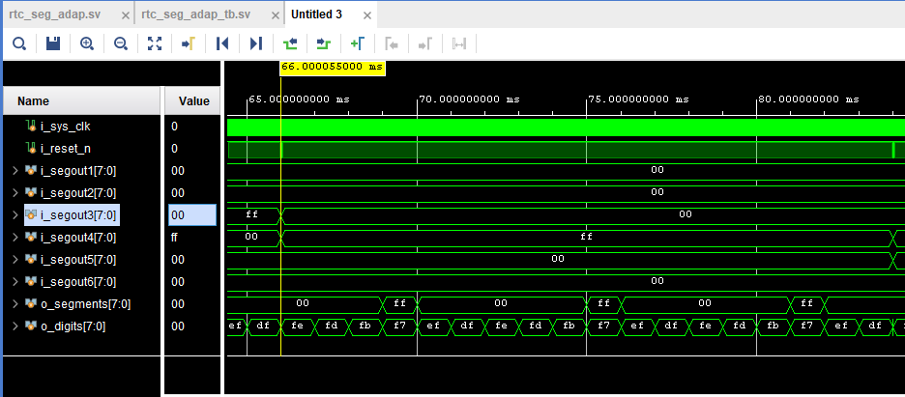

Requirement Tag: SEG_ADAP_08

Test Case ID: SEG_ADAP_TC_08

* Passed
* Method of testing: Waveform Observation

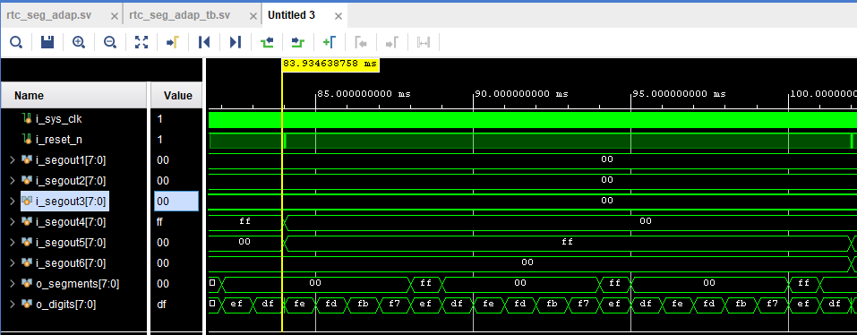

Requirement Tag: SEG_ADAP_09

Test Case ID: SEG_ADAP_TC_09

* Passed
* Method of testing: Waveform Observation

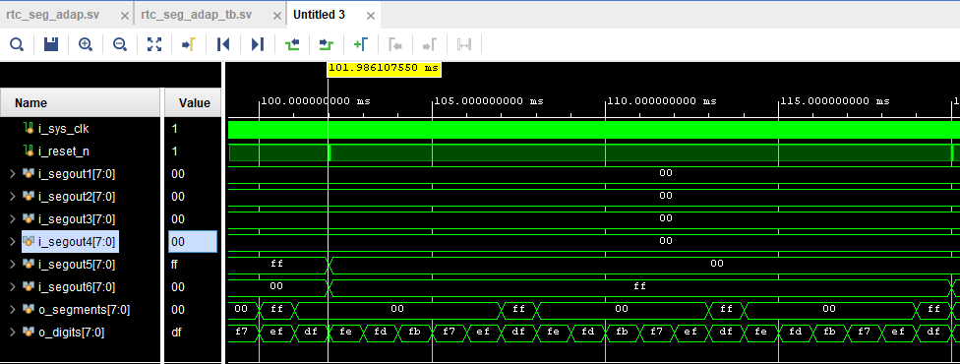

Requirement Tag: SEG_ADAP_10

Test Case ID: SEG_ADAP_TC_10

* Passed
* Method of testing: Waveform Observation

