**Module: Counter**

**Tested by: Waseem Orphali**

All tests passed with no errors.

* COUNTER_TC_01:
  + Requirement tested: COUNTER_INC_01
  + Passed.
  + Method of testing: Waveform observation.

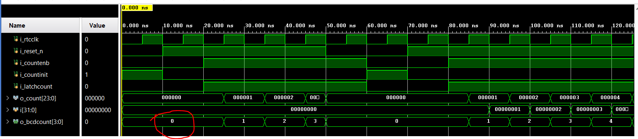

* COUNTER_TC_02:
  + Requirement tested: COUNTER_RESET_01
  + Passed.
  + Method of testing: Waveform observation.

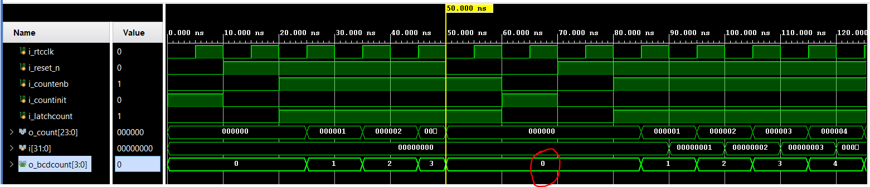

* COUNTER_TC_03:
  + Requirement tested: COUNTER_ROLLOVER_01
  + Passed.
  + Method of testing: Waveform observation.

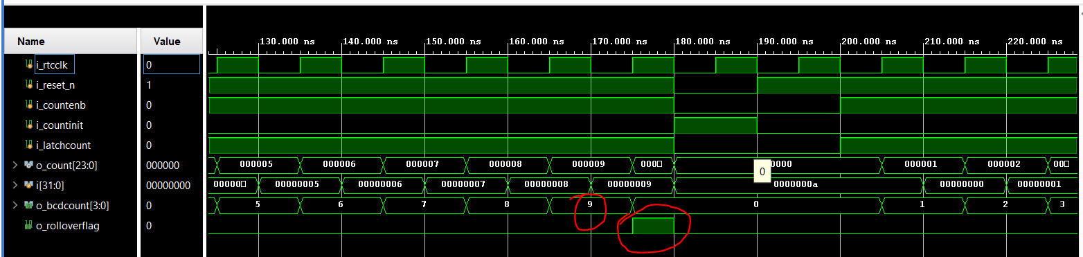

* COUNTER_TC_04:
  + Requirement tested: COUNTER_ROLLOVER_02
  + Passed.
  + Method of testing: Waveform observation.

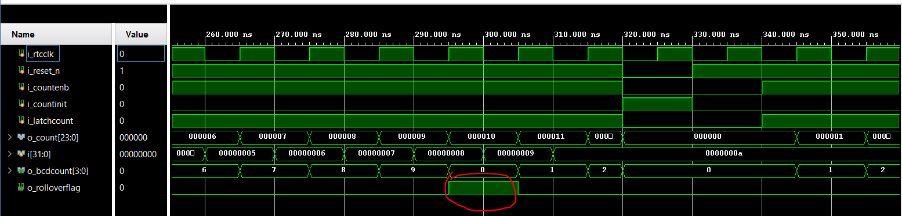

* COUNTER_TC_05:
  + Requirement tested: COUNTER_INC_02
  + Passed.
  + Method of testing: Waveform observation.

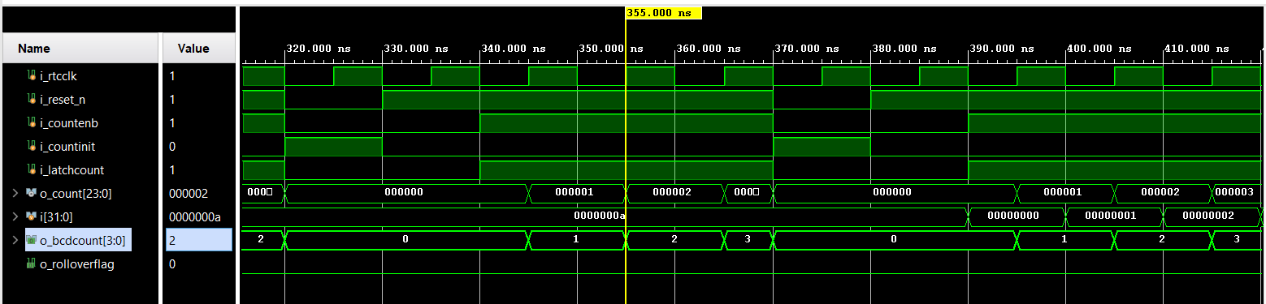

* COUNTER_TC_06:
  + Requirement tested: COUNTER_TOP_01
  + Passed.
  + Method of testing: port map observation.
* COUNTER_TC_07:
  + Requirement tested: COUNTER_TOP_02
  + Passed.
  + Method of testing: port map observation.
* COUNTER_TC_08:
  + Requirement tested: COUNTER_TOP_03
  + Passed.
  + Method of testing: port map observation.
* COUNTER_TC_09:
  + Requirement tested: COUNTER_TOP_04
  + Passed.
  + Method of testing: port map observation.
* COUNTER_TC_10:
  + Requirement tested: COUNTER_TOP_05
  + Passed.
  + Method of testing: port map observation.
* COUNTER_TC_11:
  + Requirement tested: COUNTER_TOP_06
  + Passed.
  + Method of testing: port map observation.
* COUNTER_TC_12:
  + Requirement tested: COUNTER_TOP_07
  + Passed.
  + Method of testing: port map observation.
* COUNTER_TC_13:
  + Requirement tested: COUNTER_TOP_08
  + Passed.
  + Method of testing: Waveform observation.

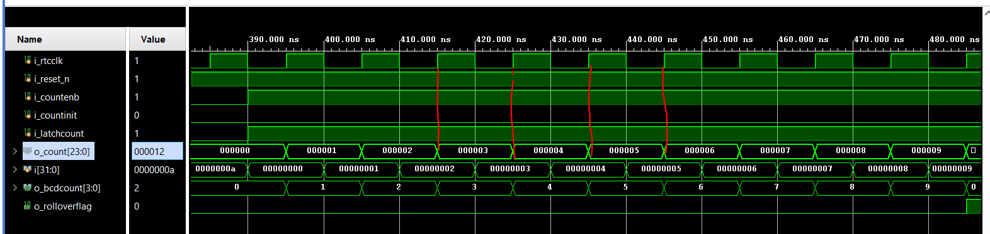

* COUNTER_TC_14:
  + Requirement tested: COUNTER_TOP_09
  + Passed.
  + Method of testing: Waveform observation and test bench assertion.

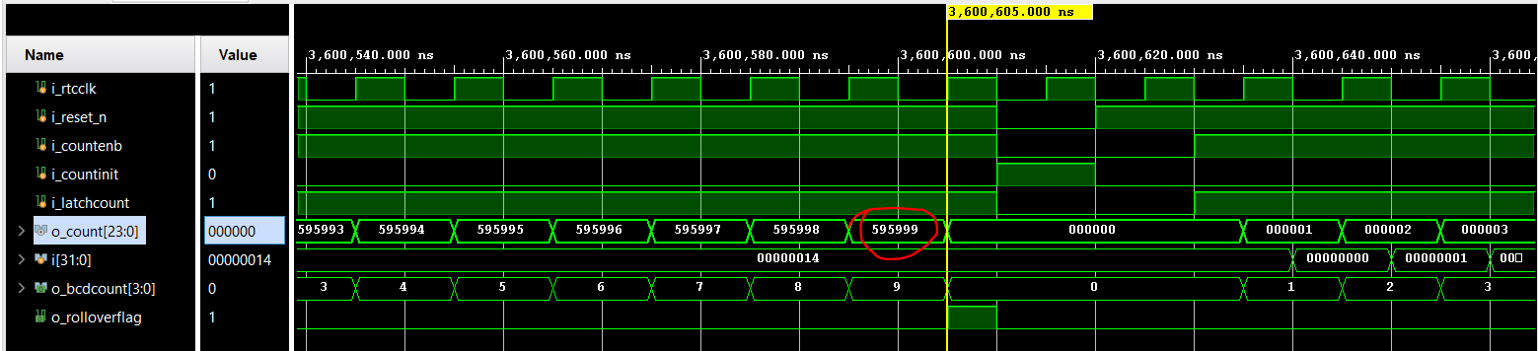

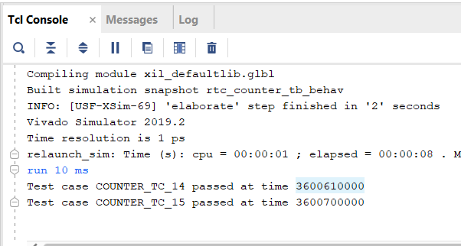

* COUNTER_TC_15:
  + Requirement tested: COUNTER_TOP_10
  + Passed.
  + Method of testing: Waveform observation and test bench assertion.

