**Stopwatch Top Module Simulation Results**

**TCL Console outputs:**

# run 1000ns

RESET FUNTION PASSED AT TIME 5

xsim: Time (s): cpu = 00:00:44 ; elapsed = 00:00:21 . Memory (MB): peak = 763.363 ; gain = 19.535

INFO: [USF-XSim-96] XSim completed. Design snapshot 'rtc_top_module_tb_behav' loaded.

INFO: [USF-XSim-97] XSim simulation ran for 1000ns

launch_simulation: Time (s): cpu = 00:01:08 ; elapsed = 00:02:03 . Memory (MB): peak = 763.363 ; gain = 30.566

run all

RESET FUNTION PASSED AT TIME 18000030

PAUSE FUNTION PASSED AT TIME 36000090

o_digit_0 RESET TO 0 PASSED AT TIME 115000195

o_digit_1 RESET TO 0 PASSED AT TIME 1016001695

o_digit_2 RESET TO 0 PASSED AT TIME 10017016695

**Reset function**

* Input: ‘i_reset_n’ = 0, ‘i_trigger_in = ‘0’
* Check if ‘o_digits’ and ‘o_segments’ = h’00 when ‘i_reset_n’=0
* Results: Passed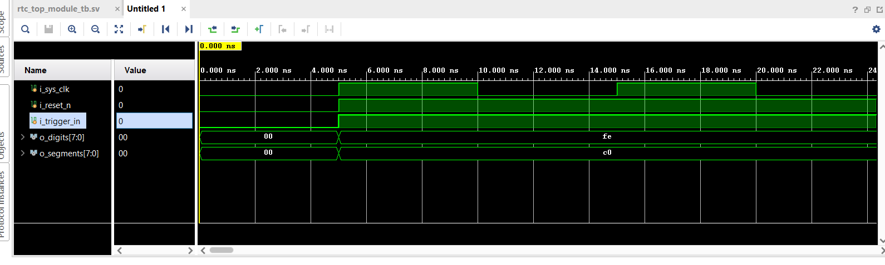

**Reset function**

* Input: ‘i_reset_n’ = 0, ‘i_trigger_in=’1’
* Check if ‘o_digits’ and ‘o_segments’ = h’00 when ‘i_reset_n’=0 and ‘i_trigger_in’=1
* Results: Passed

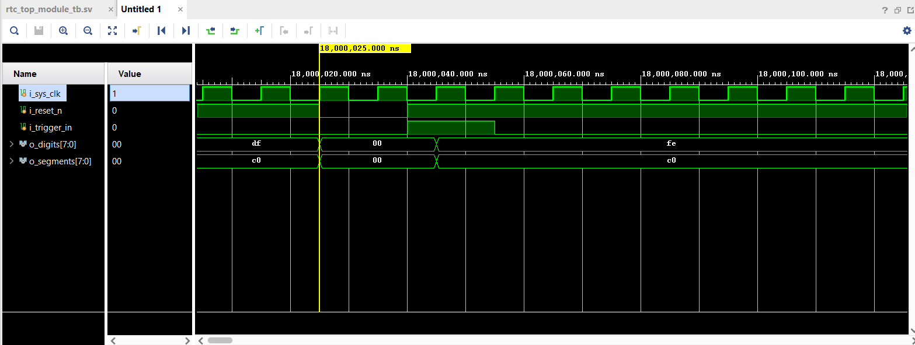

**Pause Funtion**

* Input: ‘i_reset_n’ = 1, ‘i_trigger_in=’1’
* Check if ‘o_digits’=h’fe and ‘o_segments’ = h’a4 when ‘i_reset_n’=1 and ‘i_trigger_in’=1

1. Set ‘i_trigger_in’ =1
2. Wait until ‘o_digits’=h’fe and ‘o_segments’=h’a4
3. Set ‘i_tigger_in’=1
4. Check if ‘o_digits’ and ‘o_segments’ = h’00 when ‘i_reset_n’=1 and ‘i_trigger_in’=1

* Results: Passed

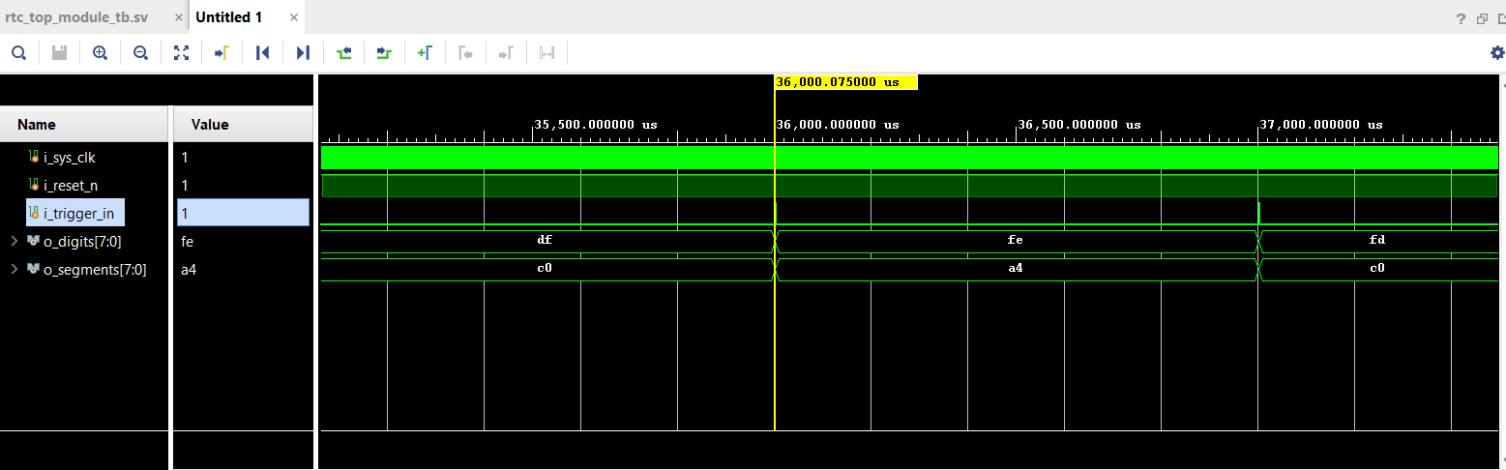

**‘o_digits[0]’(h’fe) Rollback**

* Check if ‘o_digits[0]’ is reset to h’c0 after it counts to h’90

1. Wait until ‘o_digits[0]’ counts to h’90
2. Check if ‘o_digits[0]’ is reset to h’c0 at next digit period

* Results: Passed

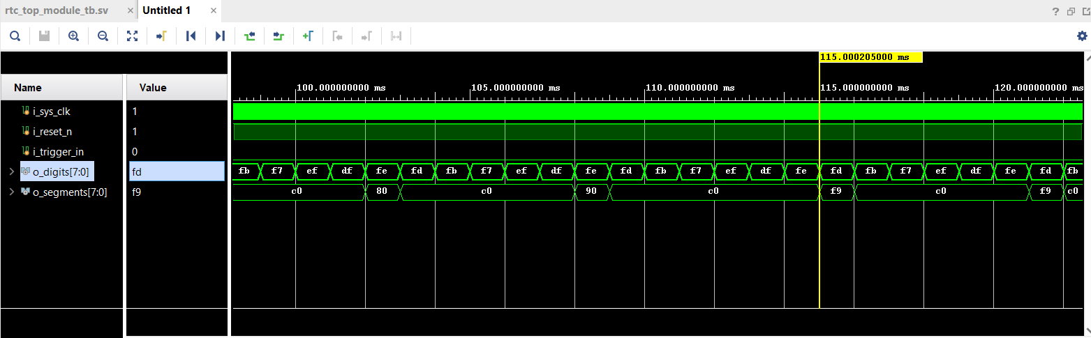

**‘**

**o_digits[1]’ (h’fd)Rollback**

* Check if ‘o_digits[1]’ is reset to h’c0 after it and ‘o_digits[0]’ counts to h’90
  + 1. Wait until ‘o_digits[1]’ counts to h’90
    2. Wait until ‘o_digits[0]’ counts to h’90
    3. Check if ‘o_digits[1]’ is reset to h’c0 at next digit period
* Results: Passed

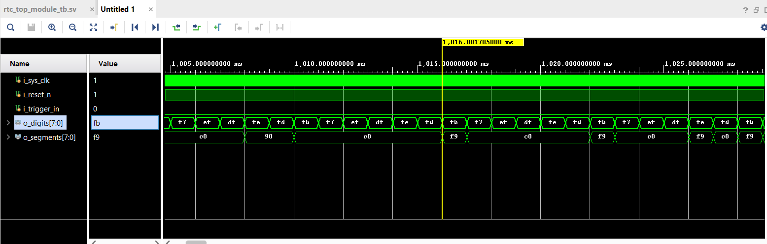

**‘o_digits[2]’(h’fb) Rollback**

* Check if ‘o_digits[2]’ is reset to h’c0 after it,‘o_digits[0]’ and ‘o_digits[1]’ counts to h’90

1. Wait until ‘o_digits[2]’ counts to h’90
2. Wait until ‘o_digits[1]’ counts to h’90
3. Wait until ‘o_digits[0]’ counts to h’90
4. Check if ‘o_digits[2]’ is reset to h’c0 at next digit period

* Results: Passed

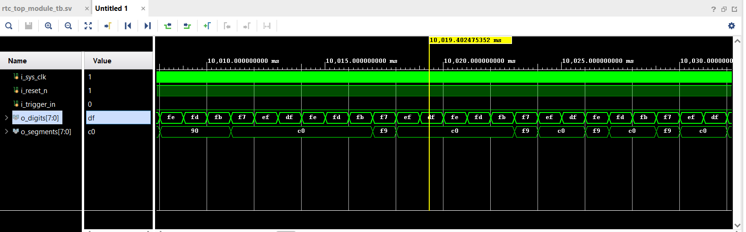

**Implementation Reports:**

Timing Report:

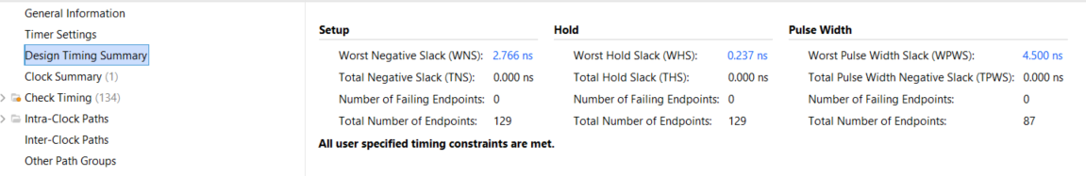

Utilization Reports:

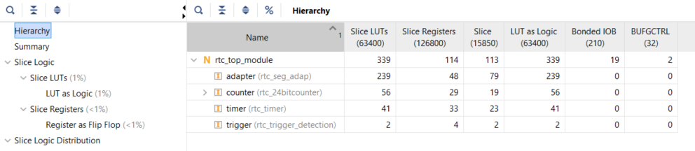

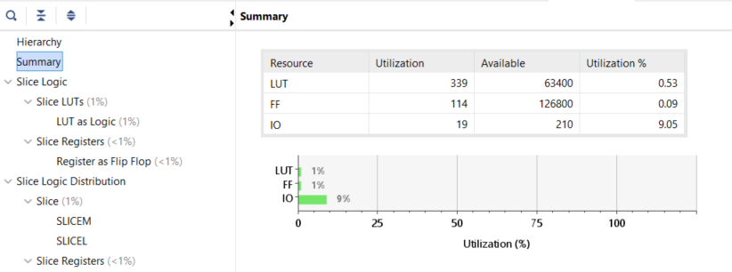

Power Report:

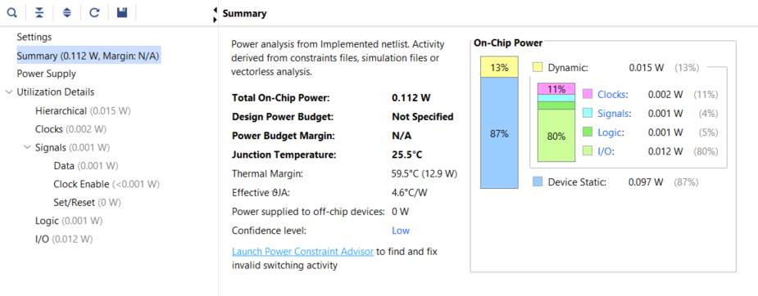

Schematic:

