Name : Donovan Sim Yew Wee (153492Y)
Foo Jing Ting (152856H) Comments :
Group : Group 32

Proposal/Report: Assignment 1 (Finite State Machine)
________________________________________________________________________

Design 2 FSMs (minimum 3 states) for your game scene by bolding states, conditions in written descriptive text in the space below. Draw the State Transition Diagram.

Game Scenario
In a robot factory production line, there are machines that produce parts to build robots. The maintenance men repair the machines if they break down. Workers assemble the parts to form up the robot at their own workstations. Sometimes, the people need to have a toilet break.
Completed robots come to life, and start to build ornaments that are to be delivered away. When the robot reaches the end of its lifespan, it shuts down and is brought away by the scrap-man. The scrap-man breaks down the robot into scraps at his station, then the maintenance man delivers the scraps to the machines to refill them.

Additional Features:
- Pathfinding is implemented for Robots, Workers, Scrap-man and Maintenance Man. Pathfinding will not work diagonally. (Done by Jing Ting)
- Waypoint Movement Pathfinding is implemented for GameObjects moving on the Conveyor Belt, namely the Robot Parts and Robot. (Done by Donovan)
- Toilet has a queue system, so the people need to queue up to use the toilet. (Done by Donovan)

FSM #1: Machine (Donovan)

States
The machine starts off in rest. After resting for 5 seconds, it goes into production state, where it produces the parts (takes 5 seconds). Each complete production increases the machine’s heat. During production, there is a chance the machine may break down based on the machine’s heat percentage and requires repairs before it can continue. When it finishes production, the part will be sent out onto the conveyor belt, and the machine returns to rest state. When it is to start production again, it will check for whether it has enough scrap parts. If it does not have enough, it will wait until scraps are delivered to it before it goes into production.

Conditions
The machine starts off in rest. After resting for 5 seconds, it goes into production state, where it produces the parts (takes 5 seconds). Each complete production increases the machine’s heat. During production, there is a chance the machine may break down based on the machine’s heat percentage and requires repairs before it can continue. When it finishes production, the part will be sent out onto the conveyor belt, and the machine returns to rest state. When it is to start production again, it will check for whether it has enough scrap parts. If it does not have enough, it will wait until scraps are delivered to it before it goes into production.

State Transition Diagram

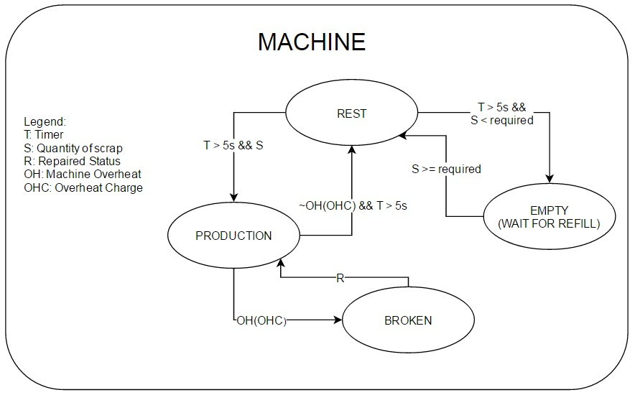

FSM #2: Worker (Donovan)

States
The worker stays idle until a machine’s product reaches his workstation. Then, he will go into work state to assemble the products (takes 4 seconds), then sends it continuing along the conveyor belt when completed. After completing his work, the worker goes back to idle state. Sometimes, the worker needs to take a break (based on a charge meter that increases at a random rate over time), so he will go to the toilet for a while (takes 4 seconds).

Conditions
The worker stays idle until a machine’s product reaches his workstation. Then, he will go into work state to assemble the products (takes 4 seconds), then sends it continuing along the conveyor belt when completed. After completing his work, the worker goes back to idle state. Sometimes, the worker needs to take a break (based on a charge meter that increases at a random rate over time), so he will go to the toilet for a while (takes 4 seconds).

State Transition Diagram

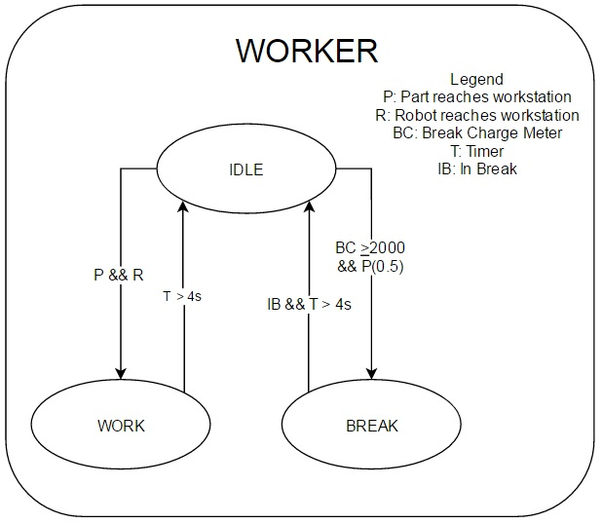

FSM #3: Maintenance Man (Donovan)

States
The maintenance man starts off idle. When a machine requires refills, he takes the scraps that the scrap-man has broken down, and brings them to the machines to refill them (takes 4 secs). When a machine breaks down, the maintenance man goes to the machine to repair it (takes 4 seconds). Sometimes, the maintenance man needs a break (based on a charge meter that increases at a random rate over time), so he will go to the toilet for a while (takes 4 seconds).

Conditions
The maintenance man starts off idle. When a machine requires refills, he takes the scraps that the scrap-man has broken down, and brings them to the machines to refill them (takes 4 secs). When a machine breaks down, the maintenance man goes to the machine to repair it (takes 4 seconds). Sometimes, the maintenance man needs a break (based on a charge meter that increases at a random rate over time), so he will go to the toilet for a while (takes 4 seconds).

State Transition Diagram

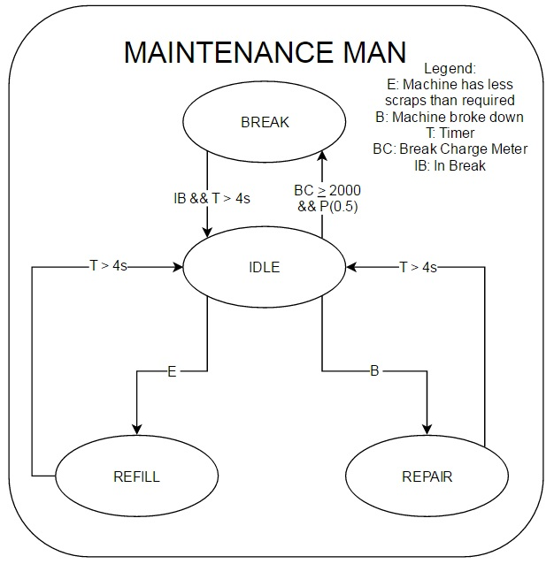
FSM #4: Robot (Jing Ting)

States
The robot starts in incomplete state and is worked on by workers. The robot goes into start-up state when it is fully assembled, where it takes 3 seconds to start up. After being booted up, the robot begins work. It walks to a pile of bricks, then picks up a brick. It then walks towards the final product assembly station, where it puts down the brick, then walks back. When one ornament is completed, all the robots will stop to do a victory cheer for 4 seconds, then continue work. When the robot has lived for more than 60 seconds, there will be an increasing chance where it will shut down and stop moving, with a guaranteed shut down at 100 seconds.

Conditions
The robot starts in incomplete state and is worked on by workers. The robot goes into start-up state when it is fully assembled, where it takes 3 seconds to start up. After being booted up, the robot begins work. It walks to a pile of building blocks, then picks up a part. It then walks towards the final product assembly station, where it puts down the block, then walks back. When one ornament is completed, all the robots will stop to do a victory cheer for 4 seconds, then continue work. When the robot has lived for more than 60 seconds, there will be an increasing chance where it will shut down and stop moving, with a guaranteed shut down at 100 seconds.

State Transition Diagram
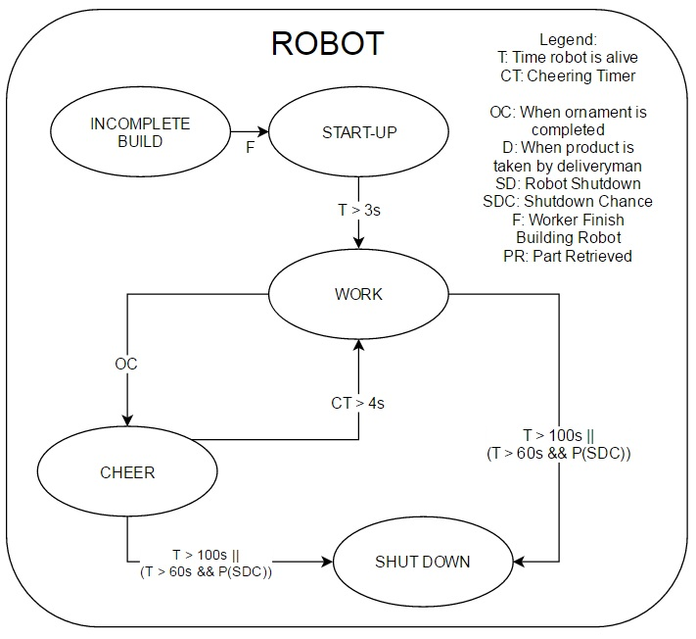
FSM #5: Deliveryman (Jing Ting)

States
The deliveryman is idle when there is no product to pick up. When the robots finish building the product, the delivery truck drives into view from the bottom of the screen. When the truck is near the product it comes to a stop, and the deliveryman comes out of the vehicle, walks to the product. When he reaches the product, he carries the product up and brings it back to the truck. Then, the deliveryman gets back onto the vehicle and drives off.

Conditions
The deliveryman is idle when there is no product to pick up. When the robots finish building the product, the delivery truck drives into view from the bottom of the screen. When the truck is near the product it comes to a stop, and the deliveryman comes out of the vehicle, walks to the product. When he reaches the product, he carries the product up and brings it back to the truck. Then, the deliveryman gets back onto the vehicle and drives off.

State Transition Diagram

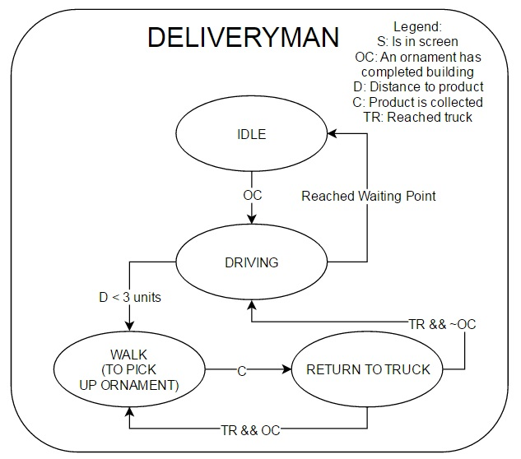
FSM #6: Scrap-man (Jing Ting)

States
The scrap-man starts idle. When a robot breaks down, he will walk to it, pick it up, and bring it to his workstation. At his workstation, he breaks down the robot into scraps (takes 5 secs). When completed, he will leave it in a pile of scraps. When his work is completed, he returns to idle state. Sometimes, the scrap-man needs a break (based on a charge meter that increases at a random rate over time), so he will go to the toilet for a while (takes 4 seconds).

Conditions
The scrap-man starts idle. When a robot breaks down, he will walk to it, pick it up, and bring it to his workstation. At his workstation, he breaks down the robot into scraps (takes 5 secs). When completed, he will leave it in a pile of scraps. When his work is completed, he returns to idle state. Sometimes, the scrap-man needs a break (based on a charge meter that increases at a random rate over time), so he will go to the toilet for a while (takes 4 seconds).

State Transition Diagram

