Foundations of Econometrics PSET-1

- (a) Provide the (sample) average weekly pay for people with no education. This value would be an estimate of which parameter?

241.48455 is the average weekly pay for people with no education. This is the conditional expectation of wages on the condition that years of education is 0. That is,
$$E(lwklywge|educ=0)$$

(b) Using Stata’s command hist produce the density histogram for the variable
weekly pay (wage). Using command summarize and option , detail find the basic descriptive statistics for wage. Given the density histogram are the values of the sample mean and sample median as expected? And the coefficient of skewness? Briefly comment.

Median=384.7117
Mean=439.4709
Coefficient of skewness=26.39001
The median is less than the mean, as expected from the histogram. The values are in line with the histogram data as well.
The coefficient of skewness is positive, indicating that the data is highly positively skewed to the right, ie, it has a very long tail to the right, as we can see from the histogram. This can also be inferred from the fact that the mean exceeds the median.
(c) Repeat question (1b) for lwklywge. Did the density histogram change in shape as expected? And the values of the statistics? Briefly comment.

Mean=5.899944
Median=5.952494
Coefficient of skewness= -2.061568
In this case, the median exceeds the mean, and the coefficient of skewness is negative, ie, the distribution is negatively skewed towards the left.

(d) Use datafile dataF ig311.csv to reproduce the plot of conditional sample means(black circles) and the thick black function joining them. Please do not reproduce the conditional densities, only the thick black line! Since the data file is
slightly different than the one used by the authors, you will not get exactly the same function, but it should be close enough. Include the plot and the set of Stata commands you used in your answer.

bysort educ: egen logmean = mean(lwklywge)
tab logmean educ
summarize logmean
twoway (line logmean educ, title("Average log weekly wages given schooling") ytitle("Log weekly earnings, $2003") xtitle("Years of complete education"))

(e) The thick black function is an estimate of . . . . . .. Complete the sentence using
an analytical expression. (Remember to use the variables included in this exercise, that is, do not use ’y’s and x’s)

The conditional expectation function (CEF) of average log weekly values given schooling.
$$lwklywage=E\left(lwklywage_{i} | educ_{i}=x\right)$$
(f) What does the thick black function you got allow you to say about the relationship between education and earnings? Explain in just a sentence. Try to
be as rigorous as possible.
Using the CEF, we can say that education and earnings are positively correlated.

(g) Under what condition do you think we could use the thick black function for
causal inference (i.e., to draw conclusions on the effect of education on wages)?
Causal inference can only be established on ceteris paribus conditions, that is, considering that other confounding variables remain the same.

(h) Consider that now, instead of focusing on conditional sample means, we focused on conditional sample medians. Calculate the conditional medians, and create a new plot including both, the function joining the conditional sample medians together with the function joining conditional sample means. Include the plot in your answer. Comment.

The behaviour of the conditional sample means and the conditional sample medians are quite similar.

(i) Let us focus our attention to the thick black function you got in (1d) joining all
the conditional sample means. You will notice that the function is not exactly linear. Your job now is to fit a linear polynomial through all the sample means, with the help of Stata’s lfit command. Present a plot including the original sample means, the thick black function joining them, and the line you fitted. What value did you get for the slope of the line? In a sentence, how would you interpret the slope of the line you fitted?

2. Simple/Discrete rate: $a≡\frac{z_{1}-z_{0}}{z_{0}}$
Continuous rate: $b≡\ln\left(z_{1}\right)-ln⁡(z_{0})$

- Show that $a= e^{b}-1$

$a≡\frac{z_{1}-z_{0}}{z_{0}}$ rearranging, we have $a=\frac{Z_{1}}{Z_{0}}-\frac{Z_{0}}{Z_{0}} → \frac{Z_{1}}{Z_{0}}=a+1 (i)$

We know that $b≡\ln\left(z_{1}\right)-\ln\left(z_{0}\right)$, then $b ≡\ln\left(\frac{z_{1}}{z_{0}}\right)$, applying $e$ on both sides we have:
$$e^{b}=e\left[\ln\left(\frac{Z_{1}}{Z_{0}}\right)\right]$$

$e^{b}=\frac{Z_{1}}{Z_{0}} (ii)$

Applying (i) in (ii):

$$e^{b}=a+1$$
$${a=e}^{b}-1$$

- Show that if a is small, $a ≈b$.

- With the help of your software of choice, create a plot where, for values of a between 0 (0%) and 1 (100%), illustrates how a and b differ as a increases.

For values of a between 0 and 1

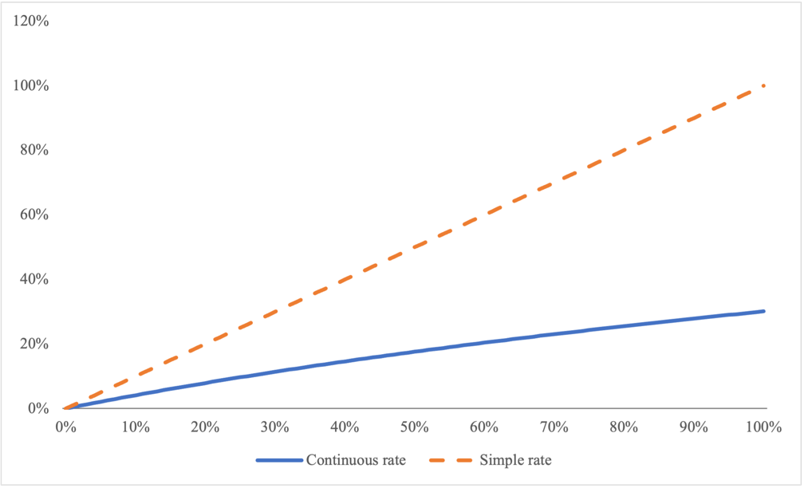

For values of a between -0.5 and 0.5
