TAKETE-IDE AMURO
Website Development Documentation Pack
Heritage • Unity • Progress
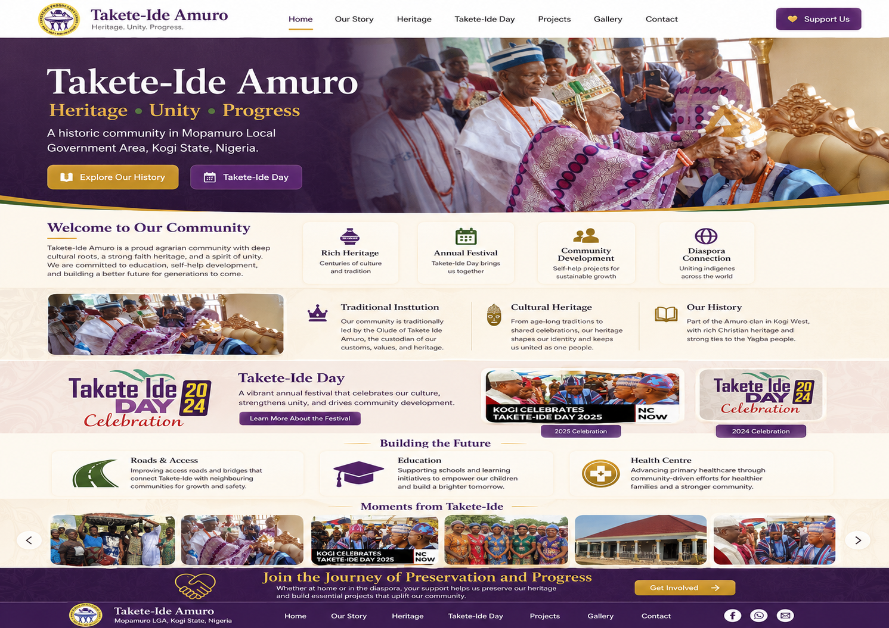
Purpose — A build-ready blueprint for design, development, content, governance, verification, launch and long-term maintenance of the Takete-Ide Amuro community website.

Prepared from the initial community material and landing-page concept • 12 August 2026

Document Control
Item | Working decision
Project | Takete-Ide Amuro Community Website
Location | Mopamuro Local Government Area, Kogi State, Nigeria
Working tagline | Heritage • Unity • Progress
Document status | Build-ready planning pack; historical claims marked for verification
Recommended MVP | Public heritage/development website + secure editorial admin
Primary governance principle | Community-controlled ownership and multi-person publishing authority

Contents
- 1. Executive Summary
- 2. Project Vision, Audiences & Scope
- 3. Product Requirements
- 4. Sitemap & Information Architecture
- 5. Page-by-Page Content Specification
- 6. Design System & Component Library
- 7. Technical Architecture
- 8. CMS & Data Model
- 9. Admin Portal & Permissions
- 10. SEO, Analytics & Performance
- 11. Accessibility, Privacy & Security
- 12. Historical Research & Content Governance
- 13. QA & User Acceptance Testing
- 14. Deployment & Launch
- 15. Maintenance & Governance
- 16. Roadmap & Backlog
- 17. Registers & Templates
- 18. Initial Fact Verification Matrix
- 19. Definition of Done
- 20. Official Technical/Policy References

1. Executive Summary
The Takete-Ide Amuro website should be built as the community’s trusted digital home, not simply as a promotional homepage. Its strongest long-term value is the combination of cultural preservation, an evidence-led historical archive, annual Takete-Ide Day records, transparent development updates and connection with residents and diaspora members.
Recommended launch position — Launch with excellent public content and a controlled admin workflow. Keep online payments, open directories and unmoderated public submissions out of the first release until governance, privacy and financial controls are approved.

Recommended MVP
- Responsive public website
- Our Story and heritage archive
- Traditional Institution
- Takete-Ide Day archive by year
- Development projects and updates
- News and announcements
- Gallery and document library
- People & achievements with approved criteria
- Diaspora connection page
- Contact form
- Privacy, accessibility, editorial and corrections policies
- Secure admin portal with draft/review/publish workflow
- Source and verification tracking for historical content

Recommended build stack
Layer | Recommendation | Why
Application | Next.js App Router | Structured routing, layouts and modern rendering patterns for public/admin pages
Styling | Tailwind CSS + reusable components | Fast implementation of the approved design system
Database | Supabase Postgres | Structured community, event, project and archive content
Authentication | Supabase Auth | Administrator identity integrated with the data layer
Media | Supabase Storage | Centralised image/document storage with access policies
Hosting | Vercel | Git-based production and preview deployments

2. Project Vision, Audiences & Scope

Vision
Create the trusted digital home of Takete-Ide Amuro: preserving heritage, connecting generations, documenting development and providing a reliable community archive for residents, diaspora members, students, researchers, journalists and future generations.

Strategic objectives
- Preserve history, culture and institutional memory.
- Create an authoritative source for community information.
- Archive Takete-Ide Day celebrations and documents by year.
- Document development priorities and verified progress.
- Showcase approved achievements without political or family bias.
- Enable authorised editors to maintain content without touching source code.
- Improve search discoverability using original, sourced community material.

Audience matrix
Audience | Primary need | Key content
Residents | Useful current information | News, events, projects, contact
Diaspora | Connection and trustworthy updates | Projects, events, volunteering, archive
Young people | Identity and learning | History, oral history, people, gallery
Researchers/media | Citable provenance | Sources, dates, archive, correction route
Leadership/editors | Controlled publishing | Admin workflow, approvals, audit trail

MVP boundaries
In MVP | Later / only after approval
Public pages and archive | Online donation/payment processing
Admin publishing | Public personal directory
Project updates | Member voting/elections
Contact form | Open comments/forum
Source tracking | Complex genealogy/private family records

3. Product Requirements

Core visitor journeys
1. Arrive from search/social → understand community identity → choose history/event/project/gallery.
2. Open Takete-Ide Day → choose a year → see programme, photos, speeches and verified outcomes.
3. Open Projects → filter/browse → read evidence-backed status updates.
4. Open Our Story → follow timeline and topics → see clearly attributed sources/traditions.
5. Open Contact → send a safe enquiry with clear expectation of how data is used.

Core editorial journey
1. Contributor creates draft and adds sources/media metadata.
2. Editor checks accuracy, style, rights and completeness.
3. Historian/verifier checks historical claims where required.
4. Publisher approves and publishes.
5. Audit record stores significant action; content can later be archived or corrected.

Functional requirements
Area | Requirements
Content | Pages, news, events, projects, gallery, people, documents, sources
Search/discovery | Metadata, sitemap, internal links, optional site search Phase 2
Forms | Contact plus optional private contribution/volunteering forms
Admin | Authentication, roles, preview, workflow, audit
Media | Upload, caption, alt text, rights, credit, album association
History | Claims linked to evidence and verification status

4. Sitemap & Information Architecture
Navigation | Route | Purpose
Home | / | Identity and highlights
Our Story | /our-story | History overview and timeline
Heritage | /heritage | Culture, institution, oral history
Takete-Ide Day | /takete-ide-day | Annual event archive
Projects | /projects | Development priorities and updates
News | /news | Announcements and reports
Gallery | /gallery | Photo/video archive
Diaspora | /diaspora | Connection and skills contribution
Contact | /contact | Enquiries and corrections

Secondary routes
- /heritage/traditional-institution
- /heritage/culture
- /heritage/oral-history
- /heritage/digital-archive
- /takete-ide-day/[year]
- /projects/[slug]
- /news/[slug]
- /people and /people/[slug]
- /privacy
- /accessibility
- /editorial-policy
- /corrections
- /admin/*

5. Page-by-Page Content Specification

Home
- Hero: Takete-Ide Amuro; Heritage • Unity • Progress; location
- Welcome / short community introduction
- Feature cards: Rich Heritage, Annual Festival, Community Development, Diaspora Connection
- Heritage + Traditional Institution
- Takete-Ide Day highlights
- Building the Future: roads, education, health
- Moments from Takete-Ide gallery strip
- Get involved CTA

Our Story
- Overview of evidence-led history
- Origins and settlement
- Relationship within Amuro
- Agriculture and livelihoods
- Christianity and education
- Self-help/community development
- Timeline with source notes

Heritage
- Traditional institution
- Culture and customs
- Oral history
- Digital archive
- Source/corrections guidance

Takete-Ide Day
- Overview
- Year selector/archive
- Year detail template: theme/date/venue/guests/programme/awards/projects/gallery/documents/sources

Projects
- Project cards by status/category
- Project page with problem, owner, status, timeline, updates, evidence and approval
- No fundraising figures unless formally approved

People & Achievements
- Transparent inclusion criteria
- Categories across leadership, education, business, public service, health, culture, sport, diaspora and youth
- Evidence + consent/rights

Diaspora
- Community connection
- Skills/volunteering expression of interest
- No default public directory
- Privacy-controlled future participation

Contact
- Name, email, category, message
- Spam protection
- Privacy notice link
- Correction/history submission routes

Core homepage copy
Takete-Ide Amuro
Heritage • Unity • Progress
A historic community in Mopamuro Local Government Area, Kogi State, Nigeria.
Takete-Ide Amuro is a proud community shaped by heritage, family, faith, agriculture, education and a long tradition of collective development. This website preserves our story, celebrates our people and connects Takete-Ide at home and across the world.
Publication rule — Use this copy as working copy. Replace broad historical statements with sourced language as the verification process produces evidence.

6. Design System & Component Library

Working visual identity
Token | Hex | Use
Deep Purple | #3B155D | Brand, headings, footer
Heritage Gold | #C99718 | Accent and CTA
Community Green | #2F6B43 | Development/land accent
Warm Ivory | #FFF8EC | Background
Charcoal | #2A2730 | Body text
Muted Grey | #6C6672 | Secondary text

Design rules
- Authentic Takete-Ide photography first; generic stock only where unavoidable.
- No more than two font families.
- Use gold as accent, not small low-contrast body text.
- Mobile-first; content remains legible without decorative effects.
- Cards and shadows should support hierarchy, not dominate it.
- Preserve ceremony/event context; do not fabricate documentary imagery.

Component inventory
- Header/nav
- Hero
- Breadcrumbs
- Section title
- Feature/stat card
- Heritage card
- Event/year card
- Project card/status badge
- News card
- People profile
- Gallery/lightbox
- Document card
- Source note
- CTA band
- Footer
- Form controls
- Admin tables/status toolbar

Landing-page concept

Concept reference only: final imagery, text, logo/emblem use and historical statements require approval.

7. Technical Architecture
Layer | Build decision | Implementation notes
Web app | Next.js App Router | Public routes + protected admin; server-first where possible
UI | Tailwind + component layer | Use design tokens and reusable accessible components
Database | Supabase Postgres | Content, source records, project/event/archive data
Auth | Supabase Auth | Admin identities; connect to role profile
Storage | Supabase Storage | Images/documents; track metadata in database
Security | Postgres RLS + server validation | Defence in depth; least privilege
Deployment | Vercel | Git-based preview → production workflow

Repository shape
/app /(public) /admin /api
/components /ui /content /admin
/lib /supabase /auth /validation /seo
/types /public /tests

Environment policy
- Local, preview/staging and production environments.
- Separate secrets; never expose service-role keys to the browser.
- Prefer production data separation from experimental preview data.
- Record owner and rotation/recovery path for every secret.

8. CMS & Data Model
Entity | Purpose | Important fields
pages | Static/editorial pages | slug, title, body, status, SEO, publish dates
news_posts | News | slug, title, excerpt, body, category, publish date
events | Takete-Ide Day and events | year, dates, venue, theme, content
projects | Development initiatives | category, status, owner, dates, visibility
project_updates | Progress evidence | date, body, evidence doc
gallery_albums | Photo collections | title, year, cover, status
media_assets | Images/documents | caption, alt, credit, rights, consent
people_profiles | Approved people pages | category, bio, achievement, consent
traditional_rulers | Historical ruler archive | title, reign, bio, verification
oral_histories | Interviews | interviewee, date, transcript, consent
sources + claims | Historical provenance | source details, claim, verification, links
content_reviews | Approval workflow | reviewer, decision, note, date
audit_logs | Governance/security | actor, action, object, timestamp

Key design decision — Store historical evidence separately from page prose. This allows a claim to be corrected or reclassified without losing the source trail.

9. Admin Portal & Permissions
Role | Key capability
Viewer | Read authorised admin content
Contributor | Create drafts and upload media
Editor | Edit assigned sections and review routine content
Historian/Verifier | Review sources and historical verification
Publisher | Approve/publish/archive
Administrator | Users, settings and full system access

Admin dashboard priorities
- Drafts awaiting review
- Media missing alt text/rights
- Historical claims awaiting verification
- Projects needing update
- Recent publications
- Recent admin activity
- Contact submission count without exposing message content unnecessarily

10. SEO, Analytics & Performance

Search topics
- Takete-Ide Amuro
- Takete Ide Kogi State
- Takete-Ide Day
- Takete-Ide history
- Takete-Ide Mopamuro

Technical SEO
- Descriptive titles and meta descriptions
- Canonical URLs
- XML sitemap and robots rules
- Meaningful internal links
- Open Graph/social preview metadata
- Structured data only where truthful
- Original community content and source attribution

Performance benchmark
Metric | Good target
LCP | ≤ 2.5 seconds
INP | ≤ 200 ms
CLS | ≤ 0.1
Evaluation | 75th percentile of visits

11. Accessibility, Privacy & Security
Accessibility target — Build and test toward WCAG 2.2 Level AA.

Accessibility checklist
- Semantic heading order
- Keyboard navigation
- Visible focus
- Alt text for meaningful images
- Sufficient contrast
- Labels and clear form errors
- Reduced-motion support
- No colour-only meaning
- Captions/transcripts where appropriate
- Adequate touch target size

Privacy baseline
The Nigeria Data Protection Act 2023 is the baseline Nigerian data-protection framework for the site. Apply data minimisation, purpose limitation, access control, retention and transparent notices. Other jurisdictions may apply depending on future services and the location of users; obtain legal advice before complex membership, payment or international-processing features.

Security baseline
- HTTPS only
- MFA where available
- Least-privilege roles
- RLS on exposed data
- Server-side validation
- Rate limiting/anti-spam
- Upload type/size allow-list
- Dependency updates
- Secret scanning
- Backups and tested recovery
- Audit logging
- Formal admin offboarding

12. Historical Research & Content Governance
Verification state | Meaning
Verified | Reviewed documentary evidence supports the statement
Documented secondary | Reputable published evidence; primary record not yet confirmed
Oral history | Attributed recorded testimony
Community tradition | Presented explicitly as tradition
Unverified | Do not publish as factual history

Initial research questions
- Exact origin/migration narrative
- Any 1926 relocation claim
- Any 1919 Christianity-introduction claim
- Early missionary/church history
- Agojo bell story and any 1939 date
- Full list of Olude and reign dates
- TIPU formation, constitution and logo authority
- Origin/first year of Takete-Ide Day
- Criteria/evidence for notable people

Source hierarchy
1. Community signed records/minutes
2. Traditional institution records
3. Church/school registers
4. Government archives/publications
5. Established newspapers/media
6. Family archives with provenance
7. Oral histories
8. Unsourced social/search snippets
Governance recommendation — Create a Takete-Ide Digital Heritage & Website Committee. Technical administrators should not have sole authority over historical truth, political inclusion or financial publication.

13. QA & User Acceptance Testing
Test group | Examples
Functional | Navigation, content pages, admin, workflow, forms, media, errors
Accessibility | Keyboard, headings, focus, labels, contrast, zoom, mobile targets
Content | Names, dates, spelling, citations, captions, verification
Security | Roles, protected routes, secrets, uploads, rate controls
Performance | Mobile images, page weight, layout shift, Core Web Vitals
Cross-browser | Chrome, Edge, Safari, Firefox; mobile/tablet/desktop

UAT sign-off owners
- Community content
- Traditional/history content
- Visual design
- Technical readiness
- Privacy/contact process

14. Deployment & Launch

Pre-launch gate
- Community-owned domain/account confirmed
- Production database/storage ready
- At least two trusted admin recovery paths
- Backup/export tested
- Privacy/accessibility/editorial/corrections pages published
- Contact routing tested
- Metadata/sitemap/robots reviewed
- Social preview tested
- Broken-link scan passed
- Mobile UAT signed off
- Historical approvals recorded
- Image rights reviewed

Launch sequence
1. Freeze approved content
2. Take pre-launch backup/export
3. Deploy production build
4. Run smoke tests
5. Verify domain/canonical URLs
6. Configure search/analytics tooling
7. Announce through approved channels
8. Monitor errors and form delivery for 72 hours

15. Maintenance & Governance
Cadence | Action
As required | News and announcements
Monthly | Material project updates
After annual event | Takete-Ide Day archive update
Quarterly | Admin access + backup recovery review
Monthly | Dependency/security review
Annually | Accessibility, privacy and policy review

Community asset ownership
- Domain registrar
- Git repository/organisation
- Hosting
- Database/storage
- Official email
- Analytics/search tooling

16. Roadmap & Backlog
Phase | Outcome
0 — Governance & discovery | Ownership, steering group, domain, brand, verification plan
1 — MVP | Public site + CMS/admin + archive foundations
2 — Archive growth | Oral history, document library, rulers/timeline
3 — Participation | Moderated submissions, diaspora skills, optional newsletter
4 — Support/fundraising | Only after financial/governance/privacy controls

MoSCoW priority
Must | Should | Could | Won’t yet
History, heritage, events, projects, gallery, news, contact, admin, source tracking | People, document archive, project timelines, richer metadata | Search, interactive timeline, map, multilingual | Open comments, public directory, elections, uncontrolled uploads

17. Registers & Templates
The accompanying ZIP contains editable CSV registers and Markdown templates so the build can be managed like a real product project rather than a one-off design exercise.
- Asset register
- User stories and acceptance criteria
- Roles/permissions matrix
- Risk register
- Indicative project timeline
- Fact verification register
- Historical fact submission template
- Oral history template
- Photograph intake template
- Project update template
- Person profile template
- Takete-Ide Day annual record template

18. Initial Fact Verification Matrix
Topic | Working claim | Decision before publication
Community name | Takete-Ide Amuro | Use as working official name; confirm preferred hyphenation/spelling
Location | Mopamuro LGA, Kogi State, Nigeria | Safe working location statement; confirm exact ward/district wording if needed
Traditional ruler title | Olude of Takete-Ide Amuro | Verify official styling and current office holder before publication
Agrarian character | Community described as agrarian | General wording acceptable once community approves
Takete-Ide Day | Annual socio-cultural/community event | Verify origin year, official purpose and annual programme
Christianity date | Claim of introduction in 1919 | Do not publish as fact until documentary/church evidence reviewed
Relocation date | Claim of move in 1926 | Do not publish as fact until corroborated
Agojo bell | Claim involving May 1939 and imported bell | Treat as oral/history research lead until source checked
TIPU | Takete-Ide Progressive Union exists/has emblem | Confirm legal/constitutional status, mandate and logo rights

19. Definition of Done
- All planned routes implemented and responsive.
- No placeholder copy remains.
- Public historical claims follow verification policy.
- Every meaningful image has alt text/caption/rights metadata as applicable.
- Admin roles enforce least privilege.
- Preview/review/publish workflow works.
- Contact form and privacy notice are tested.
- Accessibility checks and keyboard journeys pass the agreed standard.
- Core Web Vitals and image performance are reviewed on real mobile conditions.
- Backups and rollback are tested.
- Community content and traditional/history content are signed off by named owners.
- Repository, domain and core services have documented community ownership/recovery.

20. Official Technical & Policy References
The technical and governance recommendations in this pack were cross-checked against the following official sources on 12 August 2026:
- Next.js — App Router documentation — https://nextjs.org/docs/app
- Supabase — Documentation — https://supabase.com/docs
- Supabase — Row Level Security — https://supabase.com/docs/guides/database/postgres/row-level-security
- Vercel — Next.js deployment documentation — https://vercel.com/docs/frameworks/full-stack/nextjs
- W3C — Web Content Accessibility Guidelines (WCAG) 2.2 — https://www.w3.org/TR/WCAG22/
- Nigeria Data Protection Commission — Nigeria Data Protection Act 2023 resources — https://ndpc.gov.ng/resources/
- Google Search Central — SEO Starter Guide — https://developers.google.com/search/docs/fundamentals/seo-starter-guide
- web.dev — Core Web Vitals — https://web.dev/articles/vitals
Legal/compliance content in this pack is a planning baseline, not legal advice. Obtain professional advice before launching payment, membership, large-scale personal-data or sensitive-data features.

