Our experiments were conducted on a computer using a 64-bit Intel(R) Core(TM) i7 CPU-4710Q @ 2.50GHz with 8GB RAM memory and Windows 7.

We compare logcf (compiled by visual studio 2013) with ANewDsc, Mathematica’s RootIntervals (Version: Wolfram Mathematica 11.1) and Maple’s realroot (Version: Maple(TM) 2017,Windows(R) (64-bit)). Our test results is shown in testresult.xls.

The Benchmark we use are as follows:

(1)



(2)



(3)



(4)



in our experiments, we compute the root of 

(5)

.

More detail definition and description can be found in Maple or Methematica’s help system. In our experiments, we convert  to polynomials with integer coefficients.

(6)



(7)



In our experiments, we convert  to polynomials with integer coefficients.

(8)



 may have multiple roots,In our experiments, we compute the root of their square-free part.

(9)

.Randomly generated dense polynomials with integer coefficients ranging from -1024 to 1024.

(10)



(11)

(12)



With,wheremeans probability.

In our experiments, we consider the situation when r=0.1,0.2…0.9,1 and n=2000,b=17951.In testresult.xls,R=1-r.

We can use Maple or Mathematica to generate the polynomials we need(in this paper we use Maple),and save the generated polynomials as txt files. For example, we enter the instruction as follows:

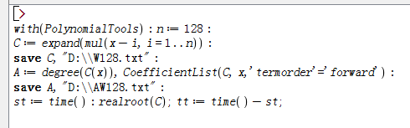

## We obtain original txt files W128 and AW128. Similarly, we get a series of txt files when n changes from 128 to 2048. Then we use maple_to_logcf.py to convert these polynomials into the form that logcf can compute in batches. In the same way, we use maple_to_AND.py to convert these polynomials into the form that ANewDsc can compute in batches. Finally, we use logcf_batchtest.py and AND_batchtest.py to compute the root of these polynomials in batches with the solver logcf and ANewDsc.

## Generally speaking, the efficiency of logcf outperforms other solvers we test especially the case when Randomly generated polynomials situations. Logcf also shows robustness while Mathematica’s RootIntervals would result in some errors in some particular time. More detail explanation can be seen in mathematicaRootIntervalError.docx