Vault Of Jukes – Character Generator Helper
WDD 330 Project Proposal
David Jukes
August 7, 2026

Overview
Character Generation Helper is intended to assist gamers create characters by providing random names and dice rolls as needed to generate a character for popular roleplaying games like Pathfinder and D&D.

Target Audience
This application is sole audience in games, both players and potentially game masters.

Major Functions
- View information about Vault of Jukes
- View list of games
- Select a game and create character
- Get character name through name API
- Get character attribute from game template
- Roll attribute scores using dice roll API
- Generate character sheet
- Save character

Wireframes
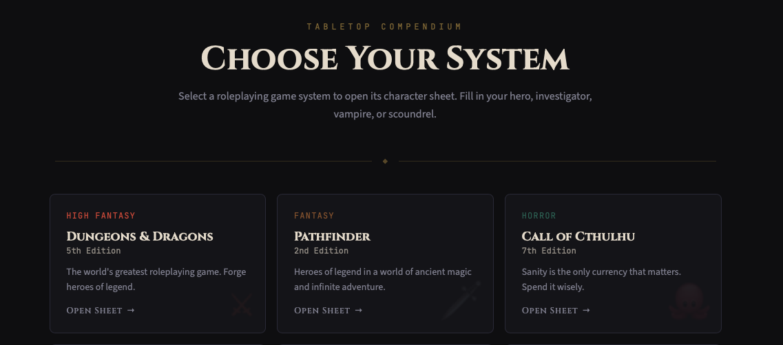
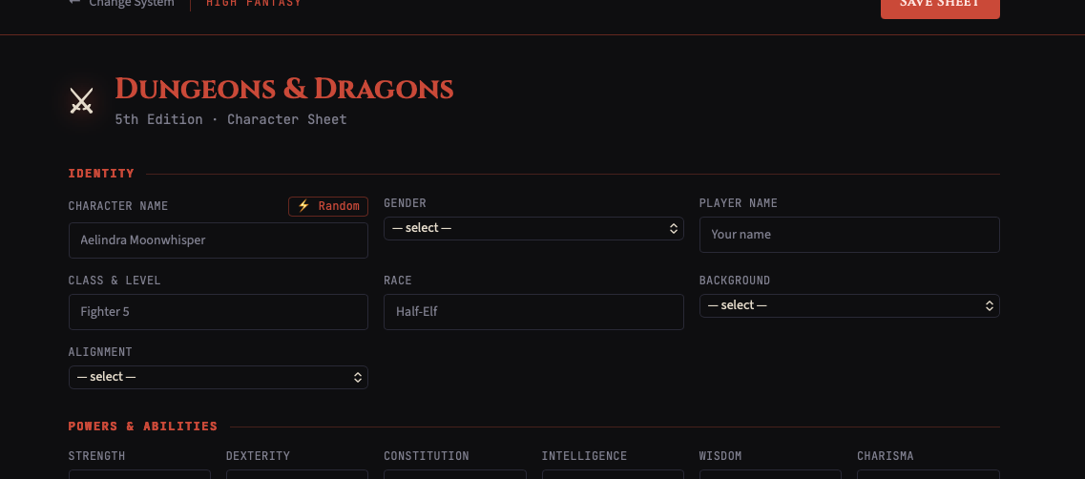

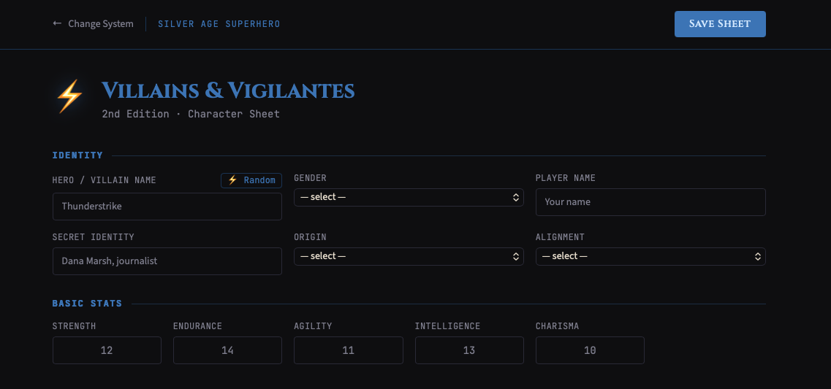
(wire frames generated through Figma free version (maker) so could not export out any code) This AI tool was really just to help generate the ui layout to a degree, the reality is, I suspect what I generate will be a little less complete but still professional. Also note, these wireframes do not convey the appropriate colors nor fonts.

External data
Here is the information about data

External API
Dice rolling API
Name generator

Local storage
Will use this to store serialized data for character

Json files
Stores game information
Module list
API Module
Data management module Local Storage and Json file module
UI Module
Event Handling Module

Graphic Identity
Color Scheme
Looking for two color palettes, one light and one dark. If I get stuck will only grab the dark scheme.
Will start with these colors and go from there:
:root {
color-scheme: light;

--background: #ffffff;
--surface: #f4f6f8;
--text: #1d2433;
--muted-text: #5f6878;
--border: #d8dde5;
--primary: #3457d5;
--primary-hover: #2947b8;
--focus: #006cff;

--toggle-background: #747b88;
--toggle-thumb: #ffffff;

--shadow:
0 12px 30px rgba(20, 30, 50, 0.12);
}

html[data-theme="dark"] {
color-scheme: dark;

--background: #11141a;
--surface: #1c212b;
--text: #f4f6fa;
--muted-text: #b5bdca;
--border: #3a4250;
--primary: #8fa7ff;
--primary-hover: #afbeff;
--focus: #8cc4ff;

--toggle-background: #526fda;
--toggle-thumb: #ffffff;

--shadow:
0 12px 30px rgba(0, 0, 0, 0.35);
}

Typography
Looking for an accessibility focused font, settled on Lato
font-family: 'Lato', 'Roboto', sans-serif;

Application Icons
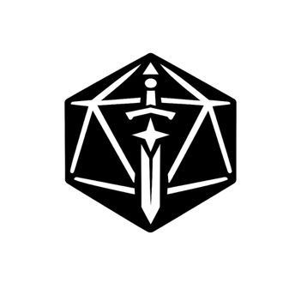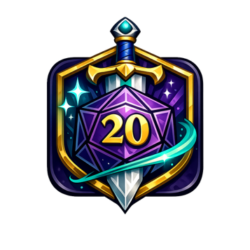

Project Planning
Trello Board: https://trello.com/invite/b/6a76691ed61020daf8a59ef8/ATTI280f6da091a5843d70f91847fa53194fECC7B3F6/wdd-330-final-project

Time Line
Basically just a week due to crazy events

